**Overview**

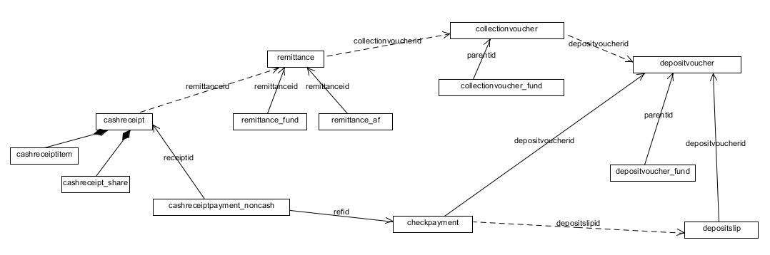

**Remittance UI Interaction**

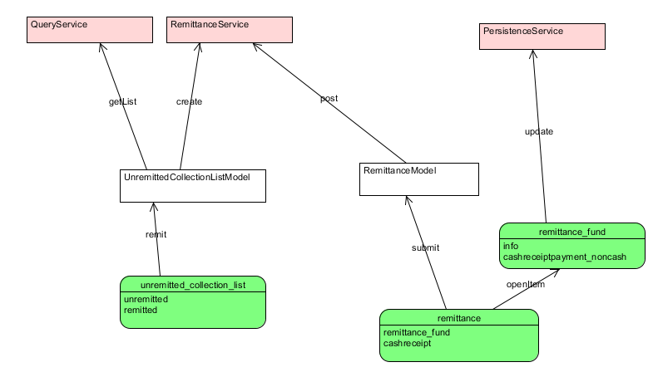

**Remittance ERD**

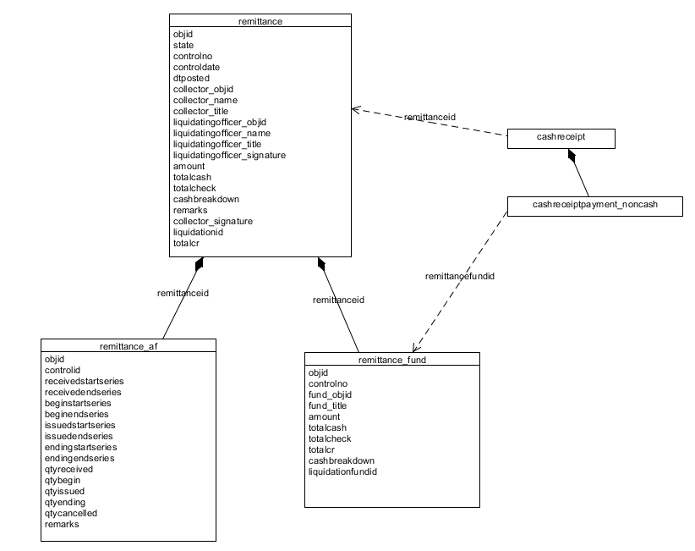

|  |  |  |
| --- | --- | --- |
| **Method** | **Validation** | **Steps** |
| create | Do not proceed if there is still a draft remittance for the collector | 1. Generate temporary remittance no 2. Set state as DRAFT 3. Summarize totalcash, totalcheck, totalcr 4. Create remittance 5. Update ***cashreceipt*** *remittanceid* that are NULL for this collector 6. Group *cashreceiptitem* by fund then insert into ***remittance_fund*** *( for objid use remittanceid + fundid combination )* 7. Update ***cashreceiptpayment_noncash*** *remittancefundid (use remittanceid + fundid combination )* 8. Group *cashreceipt* by controlid, find begin or receive and end series and insert into ***remittance_af*** |
| post | 1.Cash breakdown must be equal to totalcash  2.Cashreceiptpayment_noncash where reftype = ‘CHECK’ should be equal to totalcheck  3. other should be equal to totalcr | 1. Generate final remittance no. 2. Set state as PENDING 3. UPDATE **remittance** 4. UPDATE controlno of each ***remittance_fund***. (Control no should be remittanceno + fund code) 5. INSERT INTO afcontrol_detail for each remittance_af. Prevdetail should be the currentdetail of afcontrol 6. UPDATE afcontrol currentdetail should be objid of afcontrol_detail |
| validate |  | UPDATE remittance SET state to VALIDATED |
|  |  |  |

**Liquidation**

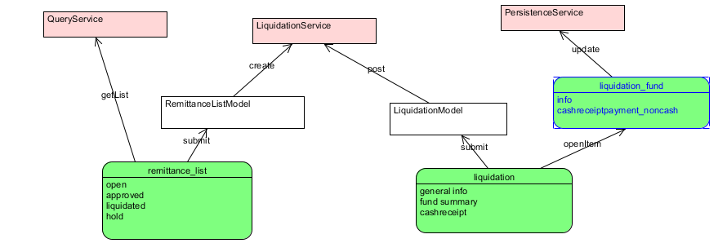

**Liquidation ERD**

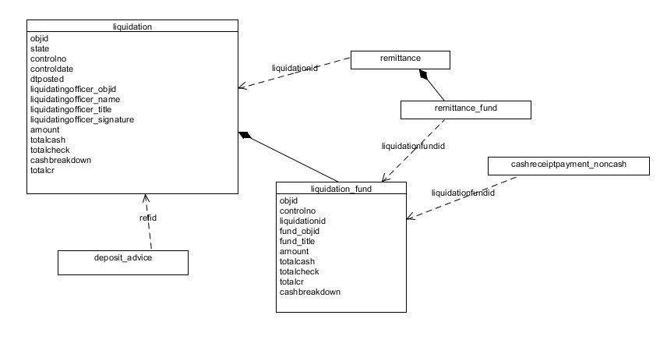

|  |  |  |
| --- | --- | --- |
| **Method** | **Validation** | **Steps** |
| create | 1. Date must be provided  2. Check if there are remittance having same control date but state is PENDING | 1. Generate Liquidation No. 2. Create ***liquidation*** 3. UPDATE ***remittance*** SET liquidationid to objid WHERE control date = liquidation date 4. INSERT INTO ***liquidation_fund*** SELECT corresponding remittance_fund (objid = liquidationid + fundid ) 5. UPDATE ***remittance_fund*** SET liquidationid = (liquidationid + fundid ) 6. UPDATE ***cashreceiptpayment_noncash*** liquidationid = (liquidationid + fundid ) |
| post | Balances must be correct | 1. For each item in liquidation_fund (see diagram) 2. INSERT INTO cash_summary 3. INSERT INTO bankaccount_summary 4. INSERT INTO payable_summary 5. INSERT INTO income_summary 6. UPDATE liquidation state = ‘POSTED’ 7. For each liquidation_fund CREATE ***cash_for_deposit*** (totalcash + totalcheck) |
|  |  |  |

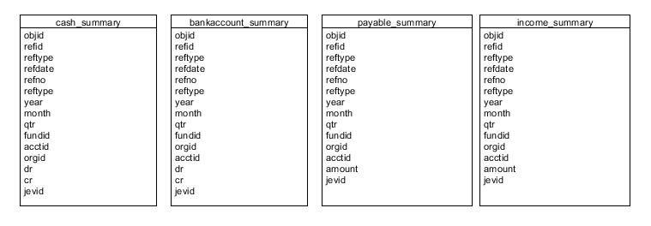

Liquidation Posting

|  |  |  |
| --- | --- | --- |
| **Target** | **Source** | **Fields** |
| cash_summary | liquidation_fund,  Itemaccount WHERE type=’CASH’ AND fund_objid = liquidation_fund.fundid | amount: totalcash + totalcheck,  acctid: itemaccount.objid |
| bankaccount_summary | cashreceiptpayment_noncash  INNER join creditmemo cm ON  refid =cm.objid | amount: amount  acctid: cm.bankaccountid |
| payable_summary | cashreceipt_share | amount: amount  acctid: payableacctid |
| income_summary | cashreceiptitem | acctid: item.objid,  amount: amount |
|  | UNION cashreceipt_share | acctid: payableacctid,  amount: amount |

**Deposit ERD**

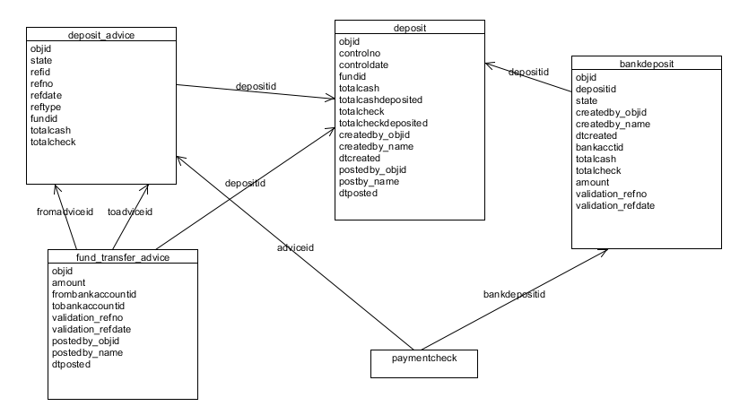

**Deposit UI Interaction**

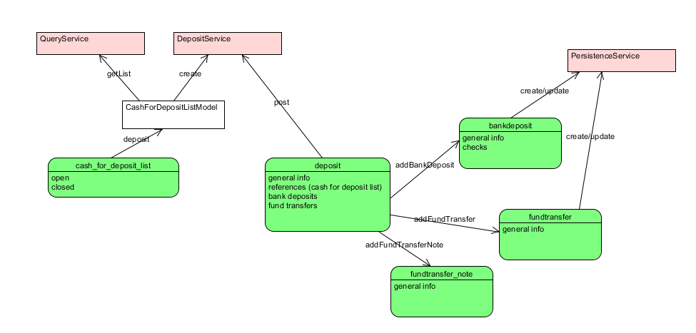

**DepositService**

|  |  |  |
| --- | --- | --- |
| **Method** | **Validation** | **Steps** |
| create | At least 1 or more cash_for_deposit selected | 1. generate deposit reference number AS **refid** 2. SET amount = SUM( cash_for_deposit ) selected 3. SET state = ‘PENDING’ 4. CREATE ***deposit*** 5. UPDATE ***cash_for_deposit*** SET depositid = **refid** |
| post | 1. cash_for_deposit total must be equal to bankdeposit, fundtransfer_note (negative value) and fundtransfer (positive value) 2. Bankdeposit and fundtransfer validation (refno and refdate) must not be null | 1. UPDATE state to ‘POSTED’ 2. INSERT INTO cash_summary negative values, refid, refno, reftype= ‘deposit’ 3. For each bankdeposit INSERT INTO bankaccount_summary 4. For each fundtransfer INSERT INTO bankaccount_summary |

Deposit Posting

|  |  |  |
| --- | --- | --- |
| **Target** | **Source** | **Fields** |
| cash_summary | SUM( cash_for_deposit ) | amount: amount,  acctid: <cash in itemaccount> |
| bankaccount_summary | bankdeposit | amount: amount  acctid: bankaccctid |
| bankaccount_summary | fundtransfer | acctid: item.objid,  amount: amount |
| bankaccount_summary | fundtransfer_note | acctid:  amount: amount * -1 |