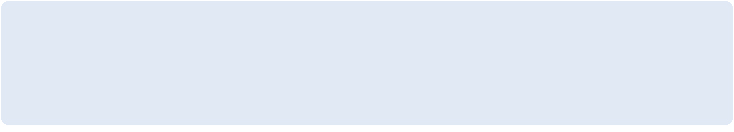

**Requirement Specification**

**MKC WIRAS Monitoring Solution**

**Markaz Knowledge City**

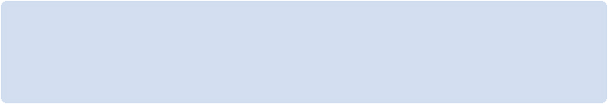

|  |  |  |  |  |  |
| --- | --- | --- | --- | --- | --- |
| **Project Name:** | | | WIRAS Monitoring Solution | | |
| **Client Name:** | | | Markaz Knowledge City | | |
| **Naico Project Manager**  **(Name and Email ID):** | | | Rajesh Kummil  [rajesh.kummil@naicoits.com](mailto:rajesh.kummil@naicoits.com) | | |
| **Naico Project Lead**  **(Name and Email ID):** | | | Muhad B K  [muhad.bk@naicoits.com](mailto:muhad.bk@naicoits.com) | | |
| **Naico QA Lead**  **(Name and Email ID):** | | | Manu C  [manu.c@naicoits.com](mailto:manu.c@naicoits.com) | | |
| **Customer Technical Contact**  **(Name and Email ID):** | | | Moosa Navas  [moosanavas@markazknowledgecity.com](mailto:moosanavas@markazknowledgecity.com) | | |
| **Customer Project Owner**  **(Name and Email ID):** | | | Moosa Navas  [moosanavas@markazknowledgecity.com](mailto:moosanavas@markazknowledgecity.com) | | |
|  | |  |  | |  |  | |



Connecting Intelligence and Information

Naico Information Technology Services (P) Ltd.

Infopark, Kochi, Kerala, India

[www.naicoits.com](http://www.naicoits.com)

**REVISION HISTORY**

|  |  |  |  |  |  |
| --- | --- | --- | --- | --- | --- |
| **Rev** | **Date of Revision** | **Description of Change** | **Prepared By** | **Reviewed By** | **Approved By** |
| 0.0 | 01/17/2022 | Initial creation of requirement specification document | Rajesh Kummil |  |  |
|  |  |  |  |  |  |
|  |  |  |  |  |  |
|  |  |  |  |  |  |
|  |  |  |  |  |  |

**Abbreviations**

|  |  |
| --- | --- |
| **Abbreviation** | **Description** |
| MKC | Markaz Knowledge City |
| WLS | Water Level Sensor |
| FM | Flow Meter |
| STP | Sewage Treatment Plan |

**List of Reference Documents**

|  |  |  |
| --- | --- | --- |
| **Document Name / Description** | **Revision** | **Dated** |
| Naico ITS_Proposal__Solution | 1.0 |  |
| NaicoITS_TL_MKC_Proposal_Estimate_v0.2_From BD | 1.0 |  |
|  |  |  |
|  |  |  |

Contents

1. Introduction 6

2. Context 6

3. Requirements in brief 6

4. Scope 6

5. Out of Scope 7

6. Overview 7

6.1 Application Overview 7

6.2 Feature Summary 9

6.3 User Classes and Characteristics 10

6.4 Operating Environment 10

6.5 Design and Implementation Constraints 11

6.5.1 Design Constraints 11

6.5.2 Implementation Constraints 11

6.6 User Documentation 11

6.7 Assumptions and Dependencies 11

6.7.1 Assumption 11

6.7.2 Dependencies 11

7. Interface Requirements 12

7.1 User Interfaces 12

7.2 Software Interfaces 12

7.3 Communications Interfaces 12

8. Detailed Requirements 12

8.1 Project Initial Design and Architecture Setup 12

8.1.1 Communication with Embedded Device 12

8.1.2 Data Format of the sensor readings 12

8.2 Admin User Module 12

8.2.1 Login 13

8.2.2 Dashboard 13

8.2.3 Profile Page 13

8.2.4 User Management 13

8.2.4.1 Manage Tenant Users 13

8.2.4.2 Manage the Tenant facility 13

8.2.4.3 Assign Tenant Facility to User 13

8.2.5 Information about Installed Sensors/ Devices 13

8.2.5.1 Manage information about Installed Sensors/ Devices 13

8.3 Tenant User Module 13

8.3.1 Login 13

8.3.2 Dashboard 13

8.3.3 Profile Page 13

8.3.4 Change Password 13

8.4 Power Resource Management 13

8.4.1 Dashboard & Reports 13

8.4.1.1 Power Consumption – Campus 13

8.4.1.2 Power Consumption - Tenant wise 13

8.4.1.3 Power Consumption - Block wise (Each tenant) 13

8.4.1.4 Comparison with allocated load (% of power consumption) 13

8.4.1.5 Reports with Export Option 13

8.5 Water Resource Management 13

8.5.1 Dashboard & Reports 14

8.5.1.1 Water availability -Campus 14

8.5.1.2 Water availability - Tenant wise 14

8.5.1.3 Consumption - Tenant wise 14

8.5.1.4 Consumption (Drill Down Block wise) 14

8.5.1.5 Availability forecast 14

8.5.1.6 Reports with Export Option 14

8.6 Sewage Treatment Plant Management 14

8.6.1 Dashboard & Reports 14

8.6.1.1 Treatment capacity available 14

8.6.1.2 % of treatment capacity utilized 14

8.6.1.3 Availability of treated water 14

8.6.1.4 Water quality monitoring 14

8.7 Embedded Initial Setup 14

8.7.1 Setup the Embedded device board 14

8.7.1.1 Setup the embedded board for reading data from the sensors 14

8.7.1.2 Communication between sensors and Board using RS-485 interface 14

8.8 Server Communication 14

8.8.1 Server Communication 14

8.8.1.1 Establish Communication with the server 14

8.8.1.2 Send Data from the device to the server 14

8.9 Power Resources Management 14

8.9.1 Smart Energy Meter 15

8.9.1.1 Collecting load capacity data from the sensor 15

8.9.1.2 Communication with the server 15

8.10 Water Resources Management 15

8.10.1 Digital Flow Meter Sensor 15

8.10.1.1 Collecting water capacity data from the sensor 15

8.10.1.2 Communication with the server 15

8.10.2 Water Level Sensor 15

8.10.2.1 Collecting water capacity data from the sensor 15

8.10.2.2 Communication with the server 15

8.10.3 Ph Sensor 15

8.10.3.1 Collecting Ph level data from the sensor 15

8.10.3.2 Communication with the server 15

8.10.4 Turbidity Sensor 15

8.10.4.1 Collecting Turbidity level data from the sensor 15

8.10.4.2 Communication with the server 15

8.10.5 TDS Sensor 15

8.10.5.1 Collecting Turbidity level data from the sensor 15

8.10.5.2 Communication with the server 15

8.10.6 COD and BOD Sensor 15

8.10.6.1 Collecting COD and BOD level data from the sensor 15

8.10.6.2 Communication with the server 15

9. Architecture Requirements 16

10. CI/CD Design Requirements 17

11. Non-functional Requirements 17

11.1 Performance Requirements 17

11.2 Security Requirements 18

12. Target Environment 18

13. Developing Environment 18

14. Acceptance Criteria 18

15. Installation Requirements 18

15.1 Various Sensors and their hardware specifications 18

15.1.1 PH Sensor: 18

15.1.2 Turbidity Sensor: 19

15.1.3 Total Suspended Solids: 19

15.1.4 TDS Sensor: 19

15.1.5 BOD/COD Sensor: 20

15.1.6 Flow Rate Sensor: 20

15.1.7 Liquid Level Sensor: 20

15.1.8 Sensor Installations: 21

15.1.9 Sensor Hardware Specifications: 22

# Introduction

This document will have a detailed requirement about the project with high level implementation diagram and high-level application architecture diagram

# Context

To develop an integrated monitoring system across the MKC campus enabling timely and informed decisions. The system will enable real time monitoring of various resources within MKC campus and provide actionable insights on the demand, consumption and forecast of resources for optimal utilization, result in increased productivity with enhanced customer experience.

# Requirements in brief

The project scope includes the following application modules:

1. Water Resources Management
2. Power Resources Management
3. Vehicle Parking Space Management
4. Environment Monitoring System

Naico will implement a central smart solution encompassing the above management systems. The data from each management system will be obtained from the above-mentioned management systems and utilized to gain insights.

# Scope

High level scope of the entire project is to make MKC Smart. There are many services that can be automated and controlled via Web Application. As an initial step, started with four main services as below

* Water Level Monitoring
* Sewage Treat Plan – Monitoring the quality parameters
* Power Consumption Monitoring
* Automated Vehicle Parking System
* Automated environment monitoring system

As a very beginning step of this mass automation, scope was drilled down further to implement monitoring system in one of the MKC facility called WIRAS (World Institute of Research And Studies) where Water Level Monitoring, STP Quality Parameter Checking and Power Consumption monitoring will be implemented (Phase 1 part of the Project).

As part of the project, Naico will be providing all the detailed specifications for the implementations of the sensors and related Data/Power Sources, MKC will be procuring and installing the same on premises.

Naico will be developing a responsive web application that will run on both web and mobile platforms. There will be 2 types of users: Admin & Tenant.

(Note: As of now, Naico is working with Tropical Environmental Solutions (TES) for developing the monitoring solution for sewage treatment plant, so MKC & TES together will decide the data integration between STP monitoring system with MKC monitoring dashboard application.)

* Admin & Tenant can login to the dashboard using registered username and password.
* Admin will have privilege to view the dashboard of all facilities inside MKC campus while Tenant will have privilege to view the dashboard of assigned facility. Admin will have the privilege to add new users and assign the privilege to view data of their respective facilities.
* Admin and Tenant dashboard will consist of data related to water resources, power resources and Sewage Treatment Plant. Major modules of Monitoring app dashboard include:

# Out of Scope

Anything not considered in the proposal will be out of scope.

* VSS Sensor for STP are not included in the proposal

# Overview

## Application Overview

WIRAS Monitoring Solution is an IoT based project where MKC Admin and MKC tenants wanted to see the Water consumption and Power consumption on a day to day basis to analyze. Control and Optimize the water and power consumption by various tenants in MKC campus.

### High level Implementation Diagram of Water Level and STP monitoring System is provided below (Figure 6.1.1)

In MKC facility there are three main sources of water. Mini Dam, Well and Open Pond. All the facilities within MKC campus is using water from above provided water resources. So, in order to know the water level of above water resources and control MKC facilities, MKC required to have a dashboard where it can be monitored and adequate actions can be taken on a timely manner.

Each water sources will have a water level sensor (WLS) installed and data from those sensors will be send via Edge device to Internet with the help of RS485 cables.

These data will be received by Web App on a timely manner, process it to convert into a logical data to display in the dashboard. Admin and respective facility owners can view these data as a dashboard with details like Current water availability, Forecasted usage and consumption of water per day.

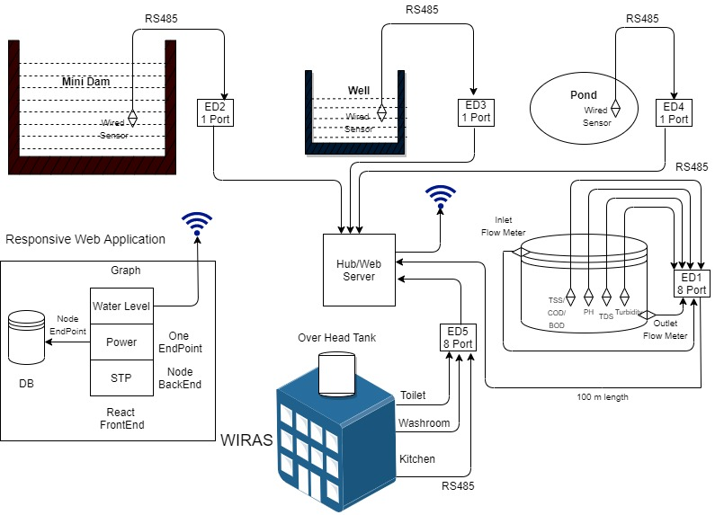

Figure 6.1.1

Water consumption will be calculated with the help of Flow Meters (FM) installed in WIRAS facilities like Toilets, Kitchen and Wash rooms.

FMs will be providing hexadecimal data from the sensors and which will be passed via RS485 cable to Internet and Web App on the other end, will be converting this raw data to a logical data and display the information in dashboard.

On the STP side, we have below sensors that will be used to measure the quality of the drainage and overflow water from septic tank

* TSS/COD/BOD
* TDS
* Turbidity
* Ph

Data from there sensors will be send to Web App via Internet and App will convert the raw data to a meaningful data and display in the dashboard. This option will be only applicable for MKC Admin

### High Level Power Resource Management:

The objective of Power Resource Management is to monitor and manage the power consumption at the MKC campus.

* Through Power Resource Management, we will able:
  + To find out the facility wise consumption and load capacity.
  + To determine the split-up of power consumption of each facilities by placing smart digital meters for each tenants/facility.
  + To track the load balancing on generator and inverter.

Bill of Materials will be shared to MKC team. Data from smart meters will be captured and fed into MKC Monitoring system. The billing calculation for power consumption will be done tenant-wise.

Power Resource Management – Dashboard Elements

* Power consumption in the Campus will be captured using smart digital meters installed at the facilities.
* Power distribution from multiple sources will be tracked through smart Digital meters.
* To compare Load versus source-wise consumption
* Naico Dynamic Monitoring Dashboard will provide High level view of Power consumption in the campus with a detailed view of consumption at each tenant and consuming units as required by the tenant to optimize their power consumption.

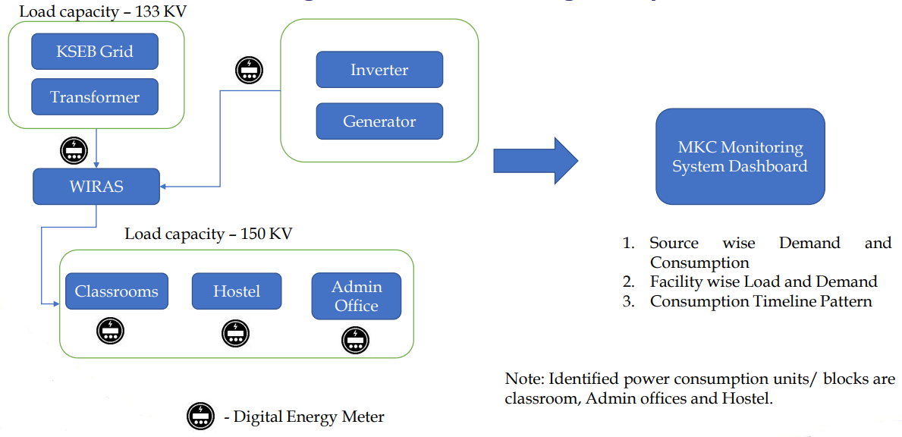

Figure 6.1.2

## Feature Summary

For the responsive web application (works in Mobile and other devices), below are the high-level details

**Web side Features:**

* Communication with Embedded Device
* Data Format of the sensor readings
* Admin Login
* Admin Dashboard
* Admin Profile Edit
* Admin user management (Add, Delete, Edit Tenants)
* Admin user management (Add, Delete, Edit Tenants Facilities)
* Manage information about Installed Sensors/ Devices (Add, Edit and Delete)
* Admin Logout
* Tenant User Login
* Tenant User Dashboard
* Tenant User Profile Edit
* Tenant User Change Password
* Power Consumption – Campus
* Power Consumption - Tenant wise
* Comparison with allocated load (% of power consumption)
* Water availability -Campus
* Water availability - Tenant wise (currently WIRAS)
* Consumption - Tenant wise (currently WIRAS)
* Availability forecast & Consumption (Drill Down Block wise)
* All Dashboard Reports with export option

**Embedded Side Features:**

* Setup the embedded board for reading data from the sensors
* Communication between sensors and Board using RS-485 interface
* Establish Communication with the server (2-way communication to receive commands to sensors and send data from sensors back to Web App)
* Above needs to be completed for WLS, FMs, STP Sensors and Energy Meters (to get Power consumption)

## Operating Environment

Sensors and their edge devices will be running on a 12V power supply and the power source should be near the sensors. Based on quality of the sensor and its power supply it may needs to be kept in closed containers. Adapters may needs to be used to convert 230V AC to 12V DC.

Web application will be hosed to AWS and connected to cloud for data storage and will be running as an independent application

## Design and Implementation Constraints

As this is an IoT based project, there are design and implementation constraints.

### Design Constraints

* Identifying the right sensors and its mode of communication
* Data conversion from sensors to web app
* Applying right formula and displaying logical data in the dashboard
* Database scalability and its entity relationships
* Application scalability based on number of tenants and their facilities

### Implementation Constraints

* Sensor and their power supply installation
* RS-485 have physical cable length of 100m to get proper data. If the internet facility is beyond above length other sources needs to be used to transmit data to web application
* Installation of Flow Meters - Diameter and position of water outlets from various sources like kitchen, rest rooms, etc.
* Identifying volume of water in Open Pond and Well
* If the facility is using Analog meters, need to have an option to get data digitally and transmit to web application (incase of not being digital power meter)

## User Documentation

* <https://xd.adobe.com/view/59ae3054-4e6b-4d41-ade6-bb9ca7069e91-0cfd/>
* All embedded (Sensor details) related documents will be added to the end of this document

## Assumptions and Dependencies

### Assumption

Naico will provide all the technical and implementation details about sensor and MKC will install the same. Naico will be completely responsible of the software end.

### Dependencies

Sensors needs to be tested once it arrives in Naico and then needs to be installed the same in MKC facility

# Interface Requirements

## User Interfaces

High Level UI/UX wireframes below

<https://xd.adobe.com/view/59ae3054-4e6b-4d41-ade6-bb9ca7069e91-0cfd/>

## Software Interfaces

Project do have a software interface to communicate to sensors from Web Application. Details of this interface is available in section 9 of this document.

## Communications Interfaces

All the sensors will be connected to edge device in respective ports and from there it will be connected via RS-485 to internet following TCP/IP protocol. On the other end, AWS IoT core receives the signals and pass the data to DB from there with Node microservices, raw data will be converted to logical data and stores in a different table, which in turn feeds the data to dashboard and reporting purposes.

# Detailed Requirements

## Project Initial Design and Architecture Setup

### Communication with Embedded Device

### Data Format of the sensor readings

## Admin User Module

### Login

### Dashboard

### Profile Page

### User Management

### Manage Tenant Users

### Manage the Tenant facility

### Assign Tenant Facility to User

### Information about Installed Sensors/ Devices

### Manage information about Installed Sensors/ Devices

## Tenant User Module

### Login

### Dashboard

### Profile Page

### Change Password

## Power Resource Management

### Dashboard & Reports

### Power Consumption – Campus

### Power Consumption - Tenant wise

### Power Consumption - Block wise (Each tenant)

### Comparison with allocated load (% of power consumption)

### Reports with Export Option

## Water Resource Management

### Dashboard & Reports

### Water availability -Campus

### Water availability - Tenant wise

### Consumption - Tenant wise

### Consumption (Drill Down Block wise)

### Availability forecast

### Reports with Export Option

## Sewage Treatment Plant Management

### Dashboard & Reports

### Treatment capacity available

### % of treatment capacity utilized

### Availability of treated water

### Water quality monitoring

## Embedded Initial Setup

### Setup the Embedded device board

### Setup the embedded board for reading data from the sensors

### Communication between sensors and Board using RS-485 interface

## Server Communication

### Server Communication

### Establish Communication with the server

### Send Data from the device to the server

## Power Resources Management

### Smart Energy Meter

### Collecting load capacity data from the sensor

### Communication with the server

## Water Resources Management

### Digital Flow Meter Sensor

### Collecting water capacity data from the sensor

### Communication with the server

### Water Level Sensor

### Collecting water capacity data from the sensor

### Communication with the server

### Ph Sensor

### Collecting Ph level data from the sensor

### Communication with the server

### Turbidity Sensor

### Collecting Turbidity level data from the sensor

### Communication with the server

### TDS Sensor

### Collecting Turbidity level data from the sensor

### Communication with the server

### COD and BOD Sensor

### Collecting COD and BOD level data from the sensor

### Communication with the server

# Architecture Requirements

A high-level architecture diagram of the web app is mentioned below

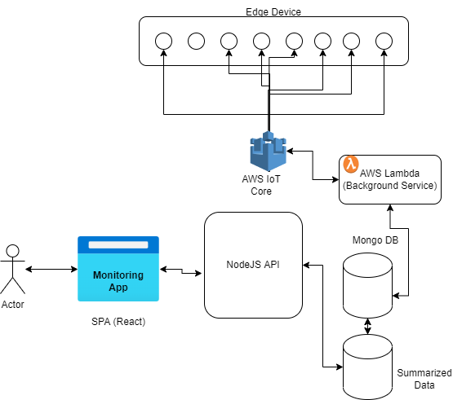

Figure 9.1

Data from the edge device will be transmitted to internet with Sensor Device ID, Edge Device ID and all other sensor data details via URL. Web application will have an AWS IoT core interface, which will monitor and control sensor data and commands who will receive the data from Sensors. This data will be stored in Mongo DB via AWS Lambda services. This data stored in the DB will be converted to meaning full data (by applying logic and formulas) by another micro service written in Node JS and stores the information in another table. This processed data will be the one used for Dashboard and Reporting purposes by Admin and Tenant users.

# CI/CD Design Requirements

CI/CD is an integral part of an application that bridges teh gap between the application development and its deployment. Here, we can make use of the AWS automated processes in our application as below.

AWS CodeBuild – A fully managed continuous integration service that compiles source code, runs tests, and produces software packages that are ready to deploy, on a dynamically created build server. This solution uses CodeBuild to build and test the code, which we deploy later.

AWS CodeDeploy – A fully managed deployment service that automates software deployments to a variety of compute services such as Amazon EC2, AWS Fargate, AWS Lambda, and your on-premises servers. This solution uses CodeDeploy to deploy the code or application onto a set of EC2 instances running CodeDeploy agents.

AWS CodePipeline – A fully managed continuous delivery service that helps you automate your release pipelines for fast and reliable application and infrastructure updates. This solution uses CodePipeline to create an end-to-end pipeline that fetches the application code from CodeCommit, builds and tests using CodeBuild, and finally deploys using CodeDeploy.

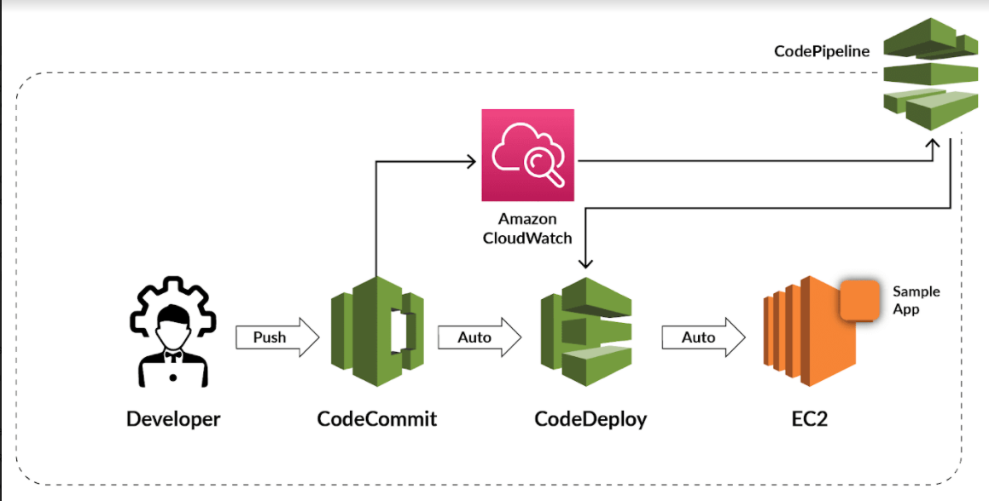

# Non-functional Requirements

## Performance Requirements

Performance testing is a testing measure that evaluates the speed, responsiveness and stability of a computer, network, software program or device under a workload. This will identify performance-related bottlenecks. For this project main performance testing will be the scalability of the application, which is adding more sensors, more tenants and more tenant facilities. Need to make sure we have proper Data Base functioning as well as AWS IoT core handles the sensor communications with no efficiency degradation.

## Security Requirements

Security Testing will be done to uncover vulnerabilities of the system and determine that its data will be protected from possible intruders. For this project, web application will make sure to have all proper validations in place and also application also make sure the data is receiving from right sensor and edge device by validating their device IDs.

# Target Environment

Once the development is completed and ready for production, planning the application to be hosted in AWS Cloud.

# Developing Environment

Developing environment will be Windows Systems with proper CI/CD pipeline established with necessary coverage on coding and unit testing

# Acceptance Criteria

User Acceptance Testing (UAT) is a type of testing performed by the end user or the client to verify/accept the software system before moving the software application to the production environment. UAT is done in the final phase of testing after functional, integration and system testing are done.

# Installation Requirements

## Various Sensors and their hardware specifications

Below details covers all sensors and their respective hardware specifications.

### PH Sensor:

The pH stands for the power of hydrogen, which is a measurement of the hydrogen ion concentration in the body. This is used in Water quality testing and Aquaculture. The total pH scale ranges from 1 to 14, with 7 considered to be neutral. A pH less than 7 is said to be acidic and solutions with a pH greater than 7 are basic or alkaline. The PH electrode has a single cylinder that allows direct connection to the input terminal of a pH meter, controller, or any pH device which has a BNC input terminal. The pH electrode probe is accurate and reliable that can give almost instantaneous readings.

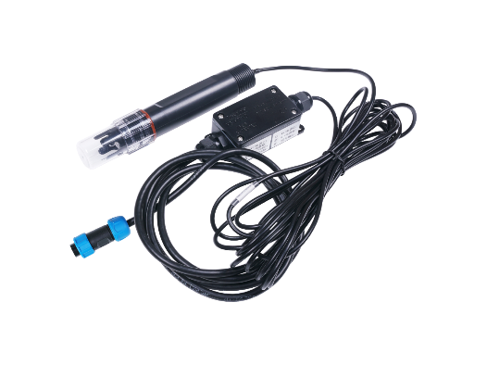

### Turbidity Sensor:

Turbidity sensors measure the amount of light that is scattered by the suspended solids in water. As the amount of total suspended solids (TSS) in water increases, the water’s turbidity level (and cloudiness or haziness) increases. Turbidity sensors are used in river and stream gaging, wastewater and effluent measurements, control instrumentation for settling ponds, sediment transport research, and laboratory measurements.

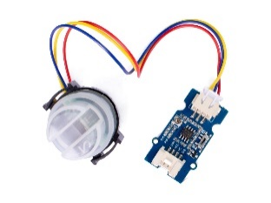

### Total Suspended Solids:

TSS is an important water quality parameter measure for wastewater treatment operations and environmental health. Wastewater contains large quantities of suspended organic and inorganic material that must be removed through screening, filtration or settling/flotation methods prior to environmental discharge.

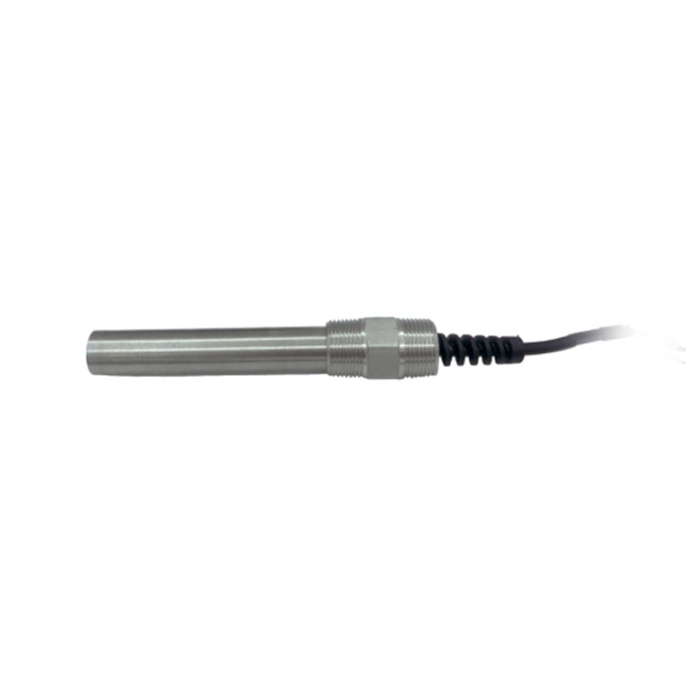

### TDS Sensor:

This item can be used for water purifiers and filters, food (vegetables, fruits) and beverage quality monitoring, swimming pools, spas, aquariums, and hydroponics.

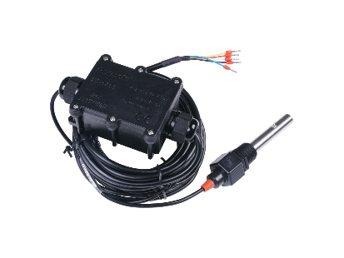

### BOD/COD Sensor:

Real Tech’s bypass BOD/COD sensor provides affordable real-time measurement of organic matter in water or wastewater. The BOD/COD sensor provides superior measurement performance across multiple wavelengths of light using UV LEDs. Designed to meet the needs of many monitoring applications, the BL series offers multiple sensor path length selections to meet the desired measurement range.

Chemical Oxygen Demand (COD) is a test that measures the amount of oxygen required to chemically oxidize the organic material and inorganic nutrients, such as Ammonia or Nitrate, present in water.

BOD (Biochemical Oxygen Demand) Determination is a simple and easy way for monitoring the microorganisms' activity in water samples with extremely reliable results. The BOD measure this change in gas pressure between the beginning to the end of the analysis and give a result expressed in mg/l.

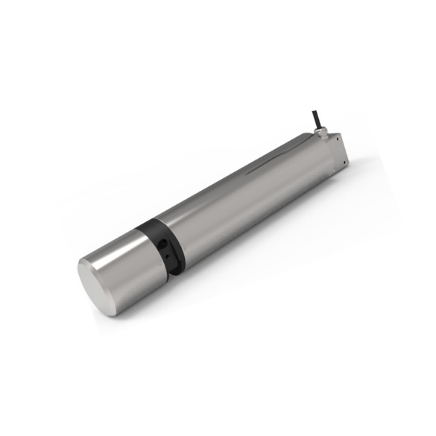

### Flow Rate Sensor:

A flow sensor (more commonly referred to as a “flow meter”) is an electronic device that measures or regulates the flow rate of liquids and gasses within pipes and tubes. Flow sensors are generally connected to gauges to render their measurements, but they can also be connected to computers and digital interfaces.

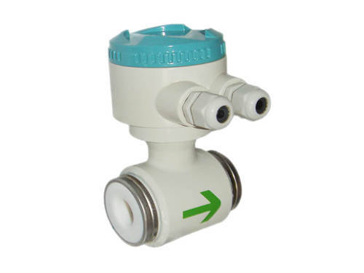

### Liquid Level Sensor:

Ultrasonic level sensors are used for non-contact level sensing of highly viscous liquids, as well as bulk solids. They are also widely used in water treatment applications for pump control and open channel flow measurement. Ultrasonic level sensors are also affected by the changing speed of sound due to moisture, temperature, and pressures. Proper mounting of the transducer is required to ensure the best response to reflected sound. The ultrasonic sensor enjoys wide popularity due to the powerful mix of low price and high functionality.

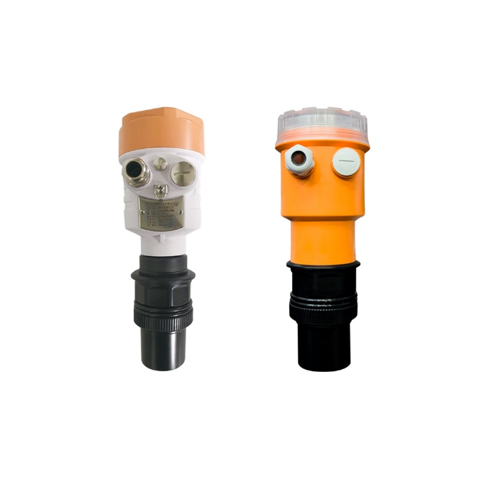

### Sensor Installations:

**STP Sensors (Ph Sensor, Turbidity Sensor, TSS, TDS, BOD and COD Sensors):**

Power source for the STP sensors will be 12V DC power supply with maximum current rating. Power cable must also have the same length of the transmitter and receiver wire. Sensors must be water proof since the sensors must be dipped in the water. Sensors must be dipped in the minimum direct distance of the plant. Depth of the sewage plant must be of maximum 1000m only the RS485 protocol can communicate.

**RS485 To Ethernet Modbus Gateway:**

Power source for the RS485 To Ethernet Modbus Gateway will be 12V DC power supply. The gateway must be placed within 1000m from the sensors. The output of the gateway is an ethernet port. Maximum distance ethernet cable for communication is 100m. Server must be within 100m from the gateway. If the server is placed beyond 100m range, the communication between the gateway and the server is done by GSM module.

When using the GSM module, the network must have full coverage in the area. There will be a microcontroller for sending the data’s through the GSM module. GSM have a 12V DC power supply.

Need another covering with IP65 box as the existing box is not corrosion free. Commands for communication between gateway and sensors. Server needs to send the command to enable the port. After enabling the port server need to send the command to communicate with the sensors using RS485 protocol. The sensors will send the reading of the inputs according to the commands which will send to the server through gateway.

**Water Level Sensor:**

Power source for the Water Level Sensor will be 12V DC power supply. Mainly 3 water sources are there to calculate the height. Natural well, Mini dam and Overhead Tank. There must be a 12V DC power supply near to the water sources. Wired water level sensors have maximum coverage distance 5m. Ultrasonic water level sensor have a maximum coverage distance of 30m. Sensors must be dipped in the plant. The output of the water level sensor is RS485. The sensor must be placed within 1000m from the gateway.

**Flow Meter Sensor:**

Power source for the Flow Meter Sensor will be 12V DC power supply. Flow meter is used in overhead tank for getting the total volume of the water consumption. Flow meter is used in the kitchen, washroom and toilets for getting the respective usages. In sewage treatment plant flow meter is used in the inlet pipe and outlet pipe for getting the volume of the treated water and its usage. For each flow meter sensor there must be power supply. The diameter of the flow meter depends on the diameter of the pipe. The output of the water level sensor is RS485. The sensor must be placed within 1000m from the gateway.

**Energy Meter**

230v Ac power supply. Serial output RS485 or USB output. The meter must be placed within 1000m from the gateway.

### Sensor Hardware Specifications:

Hardware specifications can be referenced in below document



# Others

Below are some clarifications required from customer end.

1. Volume of the water source must be calculated (Mini dam and well).
2. Checking the lower bed of the mini dam and well will be difficult.
3. Position of flow meter sensors (Diameter and number of pipes effect the sensor specifications).
4. Giving power to the flow meters will be difficult, depending upon the position of the flow meters.
5. Size of the flow meters will depend on the diameter of the pipe.
6. Position of water level sensors (Specially the terrain of the water source).
7. Want to check the power backup in the MKC.
8. Do the sensors need to check water quality in the sewage treatment plant before and after treating the water.
9. Check whether we want to check the water quality parameters of water sources like well, dam and pond.
10. Whether the distribution of power within the WIRAS facility across Class room, hostel and admin block is tracked separately? If yes, required the details
11. Breakup/ Split up of power consumption between hostel, classroom, and Admin office is needed.
12. Pipeline diagram from open well and Mini Dam to OH Tank
13. Are there separate valves used for Kitchen, Bathroom and Septic Tank?
14. Need to clarify and confirm whether there is a tracking of distribution for these separate categories (Kitchen, Bathrooms, etc.) or not?
15. Whether the fresh water for toilet and washroom is allocated from the OH tank or from the STP?
16. Qualitative parameters for chemical application – Daily, weekly or on Demand application is now a manual process)