**PH Sensor:**

The pH stands for the power of hydrogen, which is a measurement of the hydrogen ion concentration in the body. This is used in Water quality testing and Aquaculture. The total pH scale ranges from 1 to 14, with 7 considered to be neutral. A pH less than 7 is said to be acidic and solutions with a pH greater than 7 are basic or alkaline. The PH electrode has a single cylinder that allows direct connection to the input terminal of a pH meter, controller, or any pH device which has a BNC input terminal. The pH electrode probe is accurate and reliable that can give almost instantaneous readings.

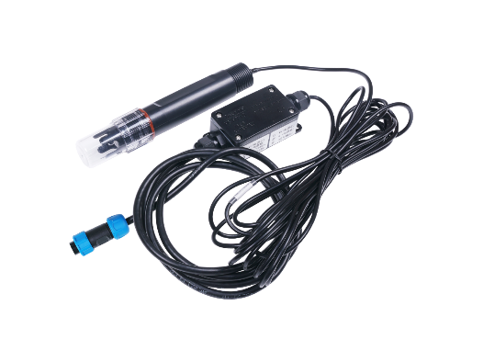

**Turbidity Sensor:**

Turbidity sensors measure the amount of light that is scattered by the suspended solids in water. As the amount of total suspended solids (TSS) in water increases, the water’s turbidity level (and cloudiness or haziness) increases. Turbidity sensors are used in river and stream gaging, wastewater and effluent measurements, control instrumentation for settling ponds, sediment transport research, and laboratory measurements.

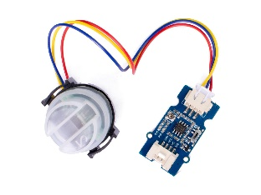

**Total Suspended Solids:**

TSS is an important water quality parameter measure for wastewater treatment operations and environmental health. Wastewater contains large quantities of suspended organic and inorganic material that must be removed through screening, filtration or settling/flotation methods prior to environmental discharge.

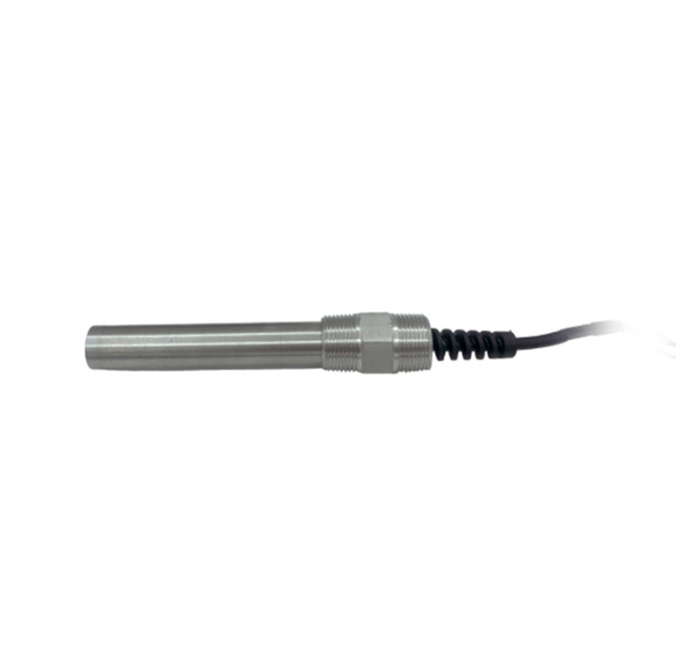

**TDS Sensor:**

This item can be used for water purifiers and filters, food (vegetables, fruits) and beverage quality monitoring, swimming pools, spas, aquariums, and hydroponics.

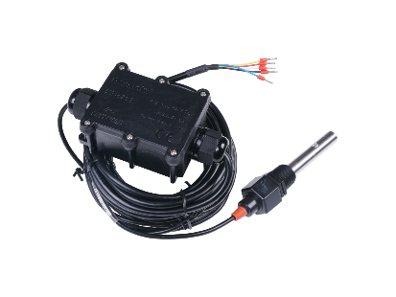

**BOD/COD Sensor:**

Real Tech’s bypass BOD/COD sensor provides affordable real-time measurement of organic matter in water or wastewater. The BOD/COD sensor provides superior measurement performance across multiple wavelengths of light using UV LEDs. Designed to meet the needs of many monitoring applications, the BL series offers multiple sensor path length selections to meet the desired measurement range.

Chemical Oxygen Demand (COD) is a test that measures the amount of oxygen required to chemically oxidize the organic material and inorganic nutrients, such as Ammonia or Nitrate, present in water.

BOD (Biochemical Oxygen Demand) Determination is a simple and easy way for monitoring the microorganisms' activity in water samples with extremely reliable results. The BOD measure this change in gas pressure between the beginning to the end of the analysis and give a result expressed in mg/l.

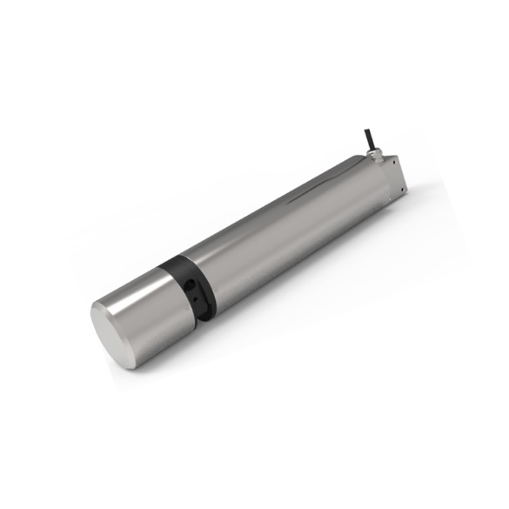

**Flow Rate Sensor:**

A flow sensor (more commonly referred to as a “flow meter”) is an electronic device that measures or regulates the flow rate of liquids and gasses within pipes and tubes. Flow sensors are generally connected to gauges to render their measurements, but they can also be connected to computers and digital interfaces.

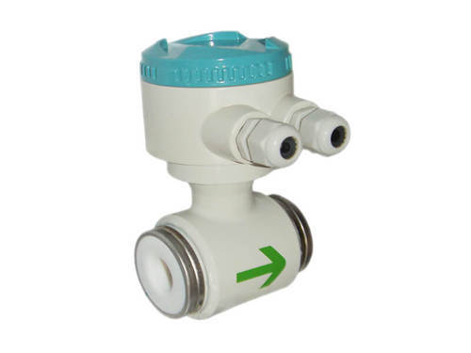

**Liquid Level Sensor:**

Ultrasonic level sensors are used for non-contact level sensing of highly viscous liquids, as well as bulk solids. They are also widely used in water treatment applications for pump control and open channel flow measurement. Ultrasonic level sensors are also affected by the changing speed of sound due to moisture, temperature, and pressures. Proper mounting of the transducer is required to ensure the best response to reflected sound. The ultrasonic sensor enjoys wide popularity due to the powerful mix of low price and high functionality.

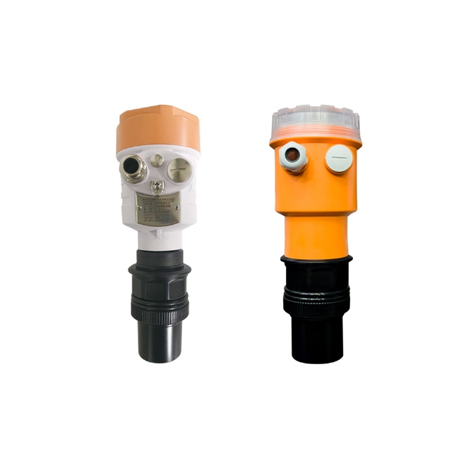

**Sensor Installations:**

**STP Sensors (Ph Sensor, Turbidity Sensor, TSS, TDS, BOD and COD Sensors):**

Power source for the STP sensors will be 12V DC power supply with maximum current rating. Power cable must also have the same length of the transmitter and receiver wire. Sensors must be water proof since the sensors must be dipped in the water. Sensors must be dipped in the minimum direct distance of the plant. Depth of the sewage plant must be of maximum 1000m only the RS485 protocol can communicate.

**RS485 To Ethernet Modbus Gateway:**

Power source for the RS485 To Ethernet Modbus Gateway will be 12V DC power supply. The gateway must be placed within 1000m from the sensors. The output of the gateway is an ethernet port. Maximum distance ethernet cable for communication is 100m. Server must be within 100m from the gateway. If the server is placed beyond 100m range, the communication between the gateway and the server is done by GSM module.

When using the GSM module, the network must have full coverage in the area. There will be a microcontroller for sending the data’s through the GSM module. GSM have a 12V DC power supply.

Need another covering with IP65 box as the existing box is not corrosion free. Commands for communication between gateway and sensors. Server needs to send the command to enable the port. After enabling the port server need to send the command to communicate with the sensors using RS485 protocol. The sensors will send the reading of the inputs according to the commands which will send to the server through gateway.

**Water Level Sensor:**

Power source for the Water Level Sensor will be 12V DC power supply. Mainly 3 water sources are there to calculate the height. Natural well, Mini dam and Overhead Tank. There must be a 12V DC power supply near to the water sources. Wired water level sensors have maximum coverage distance 5m. Ultrasonic water level sensor have a maximum coverage distance of 30m. Sensors must be dipped in the plant. The output of the water level sensor is RS485. The sensor must be placed within 1000m from the gateway.

**Flow Meter Sensor:**

Power source for the Flow Meter Sensor will be 12V DC power supply. Flow meter is used in overhead tank for getting the total volume of the water consumption. Flow meter is used in the kitchen, washroom and toilets for getting the respective usages. In sewage treatment plant flow meter is used in the inlet pipe and outlet pipe for getting the volume of the treated water and its usage. For each flow meter sensor there must be power supply. The diameter of the flow meter depends on the diameter of the pipe. The output of the water level sensor is RS485. The sensor must be placed within 1000m from the gateway.

**Energy Meter**

230v Ac power supply. Serial output RS485 or USB output. The meter must be placed within 1000m from the gateway.

**Sensor Hardware Specifications:**

**Ph Sensor:**

Power Supply : 3.6 ~ 30V DC

Communication : RS-485

Range : 0 to 14 pH

Cable Length : 5 meters

IP Rating : IP65

Operating Temperature: -40 ~ 85 degree Celsius

Interface : RS-485

Current Consumption : Max 6mA @24V DC

Cable Length : 5 meters

Installation : All buried or probe into all of the measured medium

Device Weight : 400g

Wiring : Yellow : RS485+/A/T+

White : RS485-/B/T-

Red : VCC+, power supply

Black : VCC-, power ground

Blue : Current Output

Output Mode : MODBUS RS485, pH, 0 ~ 14 pH, pH=pH register value / 100

Temperature, -40 ~ 80, pH=temperature register value/100

Installation method : Under normal circumstances, the pH value in the air is

between 6.2 and 7.8. Normal conditions Under the soil, the

soil is neutral, the pH value is about 7, the soil in different

places, the actual pH value will be different, it should be

determined according to the actual situation.

**Turbidity and TSS Sensor:**

Power Supply : 12 - 24V DC

Communication : RS485, 4 - 20Ma

Range : 0 - 4000 NTU

Cable length : 5m default

IP Rating : IP68

Operating Temperature : 0 -+ 80 C

**TDS Sensor:**

Power Supply : 3.9 - 30V/DC

Communication : RS485 Modbus-RTU

Range : 0 - 20000us/cm.

Cable Length : Power and Signal Cable：2 meters or Customize

Electrode Cable : 5 meters

IP Rating : Electrode : IP68,

Transmitter : IP65

Operating Temperature : -40 ~ 80°C

Installation : Electrode : 1/2"NPT screw threads

Transmitter : Mounting hole

**COD and BOD Sensor:**

Power supply : 12VDC

Communication : RS485 Modbus

Range : 0-200mg, 0~1000mg/l COD (2mm optical path)

Cable length : Standard 10m cable, can be extended to 100 meters

IP Rating : IP68/NEMA6P

**Digital Flow Meter Sensor:**

Power Supply : 230 VAC, 110 VAC & 24 VDC or Battery Operated

Communication : Std. 4 20 mA / RS 485 on request / Pulse output

Range : 0.5 m/sec for Minimum & 5m/sec for Maximum

Cable Length : 10 meters

IP Rating : IP 65

Diameter : 15 to 400 mm

Process Pressure : Max. 25 kg/cm2

Process Temperature : Max. 150 C

**Water Level Sensor:**

Power Supply : 11 - 30V DC

Communication : RS485 Modbus-RTU Protocol

Range : 0 ~ 5 meters

Cable Length : 5.3 meters

IP Rating : IP68

**RS485 Edge Device:**

Power Supply : 12VDC(9~48VDC)

Communication :

Ethernet :

Speed : 10/100Mbps

Distance : 100m

Connector : RJ45

RS485 :

Band rate : 300bps -115200bps

Distance : 1200m

Port Numbers : 8

Signal : D+(A), D-(B)

IP Rating : IP30 protection, metal shell

Working temperature : -40 - 85 C

Installation : Wall mounting

Configure IP address, server and client mode, data bag size etc.

Real COM driver working mode

Support cross-gateway and cross-router communication

Support WEB and Telnet configuration

Support virtual serial COM port access and Network interruption automatic recovery

**Energy Meter:**

Power Supply : 230 VAC

Displays : Active Energy (kWh),PF, Active Power(kW), Voltage(Line to

Line &Line to Neutral),Current, Frequency, Run Hour, Load

Hour

Communication : RS 485

IP Rating : IP 55

Metering Standard : IEC 62053-21/22

Old energy register back-up for re-start energy reading. Password Protected.