Hello

Hello 2

* Hello3

1. Hello 4

Using a tool "Pandoc", we need to convert the .docx file to .md format (which is plain text format) to show the changes in the text format.

Once done, we can push the docx and .md files together to master

After merging, one click on the branch and can view the changes to the file by clicking on the .md file.

Once confirmed, we can download the .docx file.

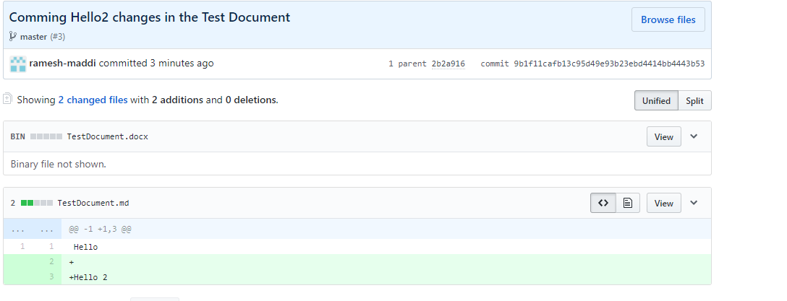

# Heading 1