HOUSING PROPERTY PRICE ESTIMATION
IN

GREATER LONDON


Project Report
Module - NCG612

GROUP Q

Authors:
Nishant Kumar (19251001),
Alok Kumar Singh (19250990),
Ramesh Suragam (19251101),
Pawan Rakesh Kumar Narayan Gowda (19250809)
Table of Contents
1. Introduction: 3
2. Understanding the Data Set: 4
3. Correlation Analysis: 6
4. Data cleaning: 8
i. Outlier Analysis: 8
5. Exploratory Analysis: 10
i. Categorical Predictors: 10
6. Predictor Significance: 15
7. Linear Regression: 16
i. Best Subsets Forward Selection approach: 17
ii. Cross Validation: 20
iii. Random Forest 22
8. Spatial Analysis: 24
9. Summary: 27

Introduction:
House price evaluation is an area in which the statistical analysis plays an important role. With the help of statistical exploratory analysis, we can create model which can help to predict the house price in an area and its neighbouring places. There is considerable public debate and concern over the affordability of house prices in London, and the potential risks of instability from the housing market. It looks at the fundamental processes that drive the market for buying and selling homes, considering the extent to which the observed changes in house prices are reasonable, and the possible long-term consequences of house price inflation for London but the sales came at the end of a decade when property prices had started to rise quickly following the deregulation of financial sector under Margaret Thatcher’s government and the passing of legislation allowing council tenants to buy their own council houses.
It presents the recent trends in the housing market, including a review of the data sources used and some of the limitations faced in producing the analysis. It then proceeds to analyse whether or not the evidence suggests house prices are in line with underlying economic ‘fundamentals’, based on a range of indicators. The data given to us is the subset of anonymised mortgage records for the area that is known as Greater London and is over 25 years old.
As a part of exploratory analyses there are different Machine Learning techniques available in R. The project will help to establish the strong relationships between the house price for greater London using the parameter such as the central heating, floor area, Garage availability in the house, location, number of bedroom available and house price of other borough as well. With this project, we aim to answer the below question.
- Is floor area an important factor for house price?
- Is central heating an important criterion when considering to buy a house in greater London? (since UK, is considered to a cold country)
- Has the deregulation in the financial sector impacted other boroughs house price hike as well apart from London?
- Is the age of the house an important criterion when considering to buy a house in London?
- Is the availability of garage an important criterion when considering to buy a house in London?
- Is the number of bedrooms in the house is considered while buying the house and if this is impacting the house price of the London.

Understanding the Data Set:
The dataset provided to us contains purchase information regarding the properties in UK. There are total 12536 records provided each representing a property having 31 attributes. The response variable we would like to predict is the purchase price represented by the variable ‘Purprice’. The exploratory variables include the below variables as described below:
Variable | Description
Easting | Easting in m
Northing | Northing in m
Purprice | Purchase price in GBP
BldIntWr | Built between 1918 and 1939
BldPostW | Built between 1945 and 1959
Bld60s | Built between 1960 and 1969
Bld70s | Built between 1970 and 1979
Bld80s | Built between 1980 and 1989
TypDetch | Detached property
TypSemiD | Semi-detached property
TypFlat | Flat or apartment
GarSingl | Single Garage
GarDoubl | Double Garage
Tenfree | Leasehold/Freehold indicator
CenHeat | Central heating
BathTwo | Two or more bathrooms
BedTwo | Two bedrooms
BedThree | Three bedrooms
BedFour | Four bedrooms
BedFive | Five bedrooms
NewPropD | New property
FlorArea | Floor area in square metres
NoCarHh | Proportion of households without a car
CarspP | Cars per person in neighbourhood
ProfPct | Proportion of Households with Professional Head
UnskPct | Proportion of Households with Unskilled Head
RetiPct | Proportion of residents retired
Saleunem | Not known
Unemploy | Unemployed workers
PopnDnsy | Local population density
Figure 1: Variables in Dataset
The variables can be analysed as:
- Geographical data – Easting, Northing
- Numerical data – BldIntWr, BldPostW, Bld60s, Bld70s, Bld80s, TypDetch, TypSemiD, TypFlat, GarSingl, GarDoubl, Tenfree, CenHeat, BathTwo, BedThree, BedFour, BedFive, NewPropD, FlorArea, NoCarHh
- Neighbourhood variables - CarspP, ProfPct, UnskPct, RetiPct, Saleunem, Unemploy, PopnDnsy.
The above table shows complete list of variables organised into several groups, and for the most part representing the levels in a categorical variable expanded into dummy (0/1) variables.
Age: Represent the time period in which the property was constructed. The omitted category is built pre-1914.
Tenure: Represents the type of building. The omitted category is bungalow.
Garage: Omitted category is NO Garage.
Bedrooms: Omitted category is One Bedroom.

Correlation Analysis:
Correlation analysis is a statistical method used to evaluate the strength of relationship between two quantitative variables. A high correlation means that two or more variables have a strong relationship with each other, while a weak correlation means that the variables are hardly related. The relationship between the predictors help us to prevent any high influence predictor to deviate the results if it is not significant. Best way is to minimize the collinearity between the variables to reduce the influence. In below graph, darker shades of blue and red conveys the high positive and negative association.
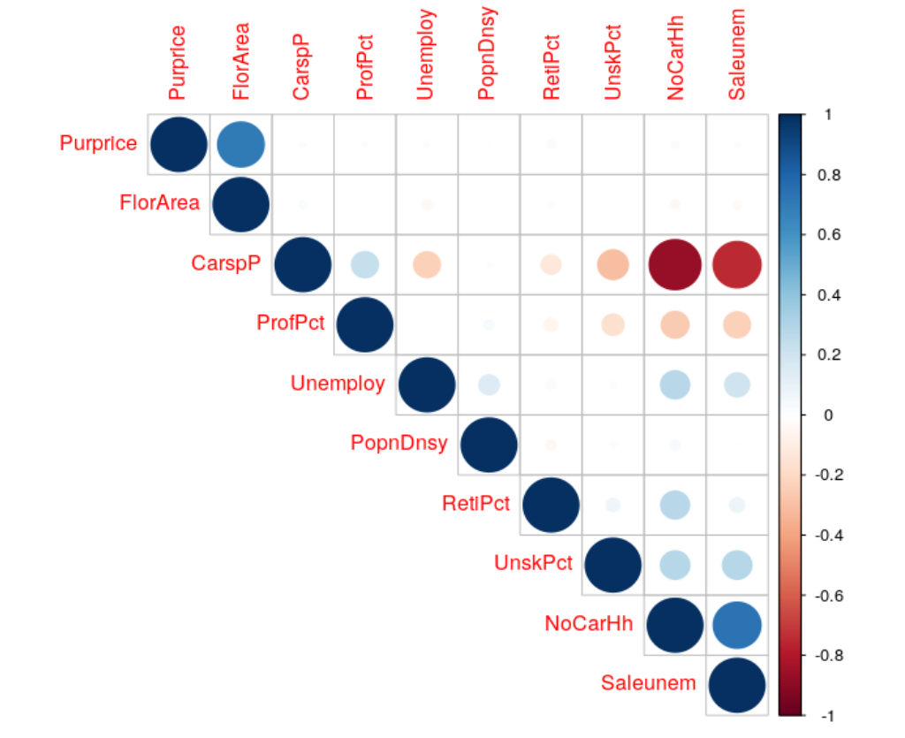
Figure 2 Correlation plot for numerical variable
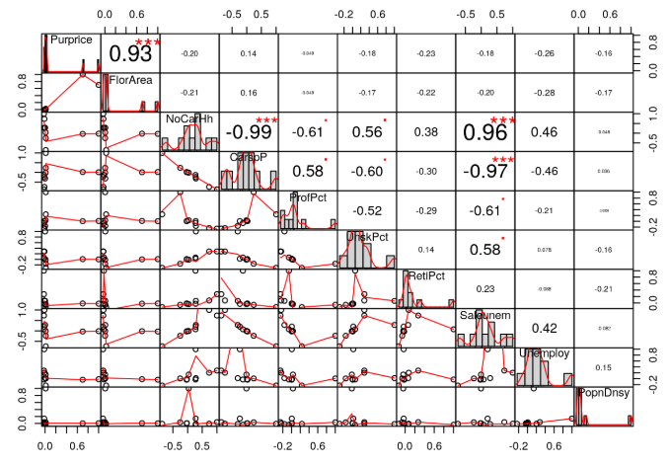
Figure 3 Correlation plot in detail
From the correlation plot we have below observation:
- Purprice and FlorArea are positively correlated with value of 0.7014.
- CarspP and NoCarHh is negatively corelated with value of -0.863.
- Saleunem and NoCarHh is positively correlated with value of 0.734.
- Saleunem and CarspP is negatively correlated with value of -0.7400.

Data cleaning:
As stated above, there were four column which have categorical variables expanded into dummy (0/1) of which few data were omitted in such as the age column has the data omitted for the house build before 1914, tenure column the category omitted was bungalow, the Garage column the data omitted was of hardstanding/no garage and bedroom column with one bed room.
Since we notice many dummy variables representing a single entity we convert the dataset by converting these dummy variables into factor variables. The following columns were constructed:
S. No. | New Variable | From Variables
 | Age | BldIntWr
 | Age | BldPostW
 | Age | Bld60s
 | Age | Bld70s
 | Age | Bld80s
 | Age | PreWW1 – missing values
 | Type | TypDetch
 | Type | TypSemiD
 | Type | TypFlat
 | Type | Others – missing values
 | Garage | GarSingl
 | Garage | GarDoubl
 | Garage | HardStnd – missing values
 | Bedrooms | BedTwo
 | Bedrooms | BedThree
 | Bedrooms | BedFour
 | Bedrooms | BedFive
 | Bedrooms | BedOne – missing values
The new dataset after the above task gives us with the below final columns:
- ‘Easting’, ‘Northing’, ‘Purprice’, ‘Tenfree’, ‘CenHeat’, ‘BathTwo’, ‘NewPropD’, ‘FlorArea’, ‘ProfPct’, ‘Age’, ‘Type’, ‘Garage’, ’Bedrooms’

Outlier Analysis:
An outlier is a data point that differs significantly from other observations. An outlier may be due to variability in the measurement or it may indicate experimental error; the latter are sometimes excluded from the data set. An outlier can cause serious problems in statistical analyses. However, it is not always necessary to remove the outliers as they may not be experimental errors all the time and it is left to the best judgement of the investigator to decide whether treating outliers is necessary and how to go about it. Boxplot is a great way to detect outliers and inspect the variables by creating visual for the given variables.
So, we draw the boxplot for the response that is the “purprice” from the given datasets. The box plot that is obtained is shown below:
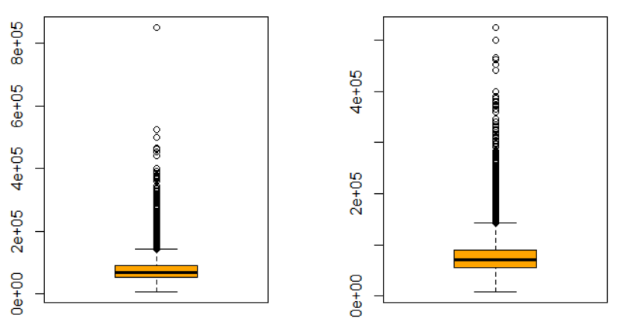
Figure 4 Boxplot of price before and after removing outlier
In the above boxplot we notice very large number of points outside the quantile regions. In a theoretical approach all these are considered outliers but since a large portion of points occur we decide to keep them. On the other hand we see a single values above 6 Million GBP which is quite abnormal and could be an error. Thus, we decide to remove only the data points above 6 Million GBP. We removed this and revisualized the plot which is displayed on the right in Figure 4.

Exploratory Analysis:
To understand the distribution of the data we perform a quick exploratory analysis on the ‘Purprice’ variable by creating a couple of histograms and density plots.
First we construct a histogram in top plot of Figure 5. We plot the mean line depicted as a ‘blue’ line on the graph. Furthermore we can visualize the density plot too. These plots suggests that there is considerable amount of right skewness in the data.
Treating the response variable with an appropriate transformation can improve the distribution of the data. Here we apply ‘log’ transformation on the response variable ‘Purprice’. The third plot of Figure 5 displays a density plot of ‘log(Purprice)’ and we clearly see that it displays normality. This can be valuable both for making patterns in the data more interpretable and for helping to meet the assumptions of inferential statistics.
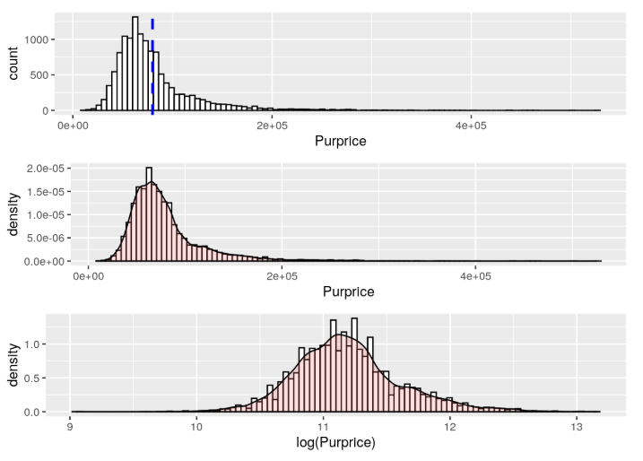
Figure 5 Density plot of Purprice before and after log transformation

Categorical Predictors:
In this dataset, we see few of the categorical variables which are directly provided as a single column like ‘CenHeat’ which specify if Central heating exists in the property or not depicted as a dummy variable and ‘NewPropD’ which specify if the property is a new property or not also depicted as a dummy variable.
On the other hand we have multiple dummy variables representing a single category like age, type, number of garages, bedrooms. We have merged multiple columns of all these categories into factor columns for each of the above.
We quickly plot a few line graphs of log(Purprice) for each of the categorical variables above.
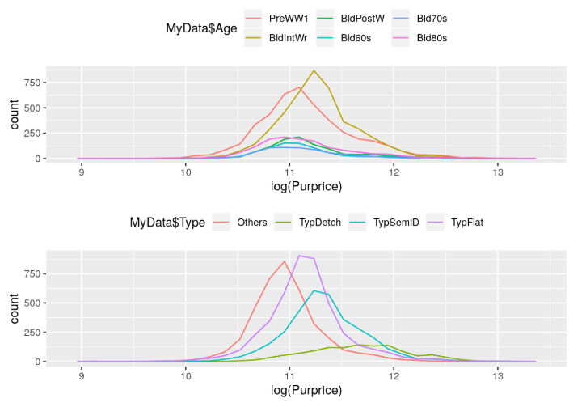
Figure 6 Line plot of log Purprice with Age and Type
In the figure 6, we observe the below findings:
- Purprice vs Age : The line plot depicts that the properties ‘Built between 1918 and 1939’(BldIntWr) has the highest purchases among all the categories followed by ‘Built before pre world war 1’(PreWW1). All the remaining categories fall very far behind with almost same ‘Purprice’ of these two categories.
- Purprice vs Type : This plot suggests that people are willing to purchase Flat properties the most followed by semi-detached properties and then at the end the detached plots.
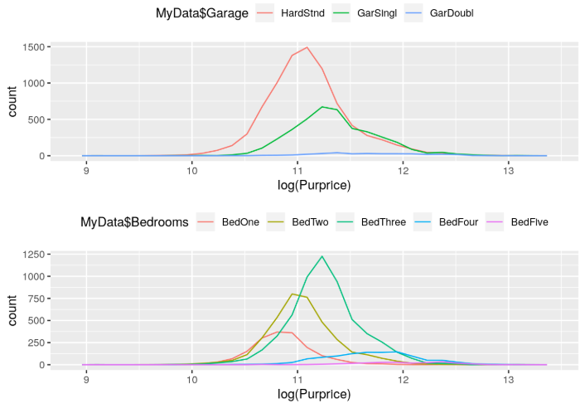
Figure 7 Line plot of log Purprice with Garage and Bedrooms
In the figure 7, we observe the below findings:
- Purprice vs Garage : The line plot depicts that the properties with hard stand are the most in the properties and then followed by a single garage and then followed by a double garage.
- Purprice vs Bedrooms : This plot suggests that people are willing to purchase properties with three bedrooms the most and then followed by a two bedroom property followed by a single bedroom property. The other two properties with four and five bedrooms are sold the least.
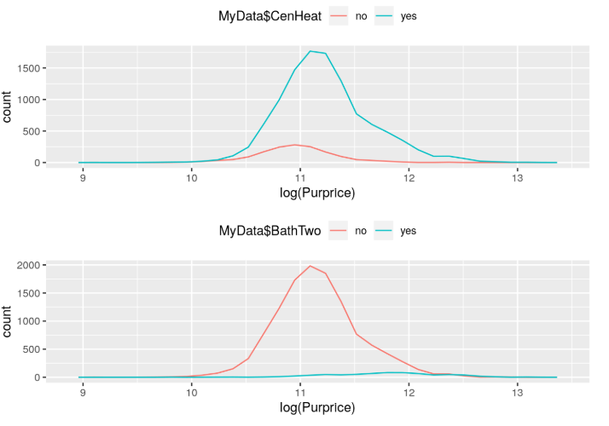
Figure 8 Line plot of log Purprice with CenHeat and BathTwo
In the figure 8, we observe the below findings:
- Purprice vs CenHeat : The line plot depicts that the properties with a central heating are more compared to the properties with no central heating.
- Purprice vs BathTwo : This plot suggests that the properties with bathrooms two are more are quite less and all of the other properties have a single bathroom option.
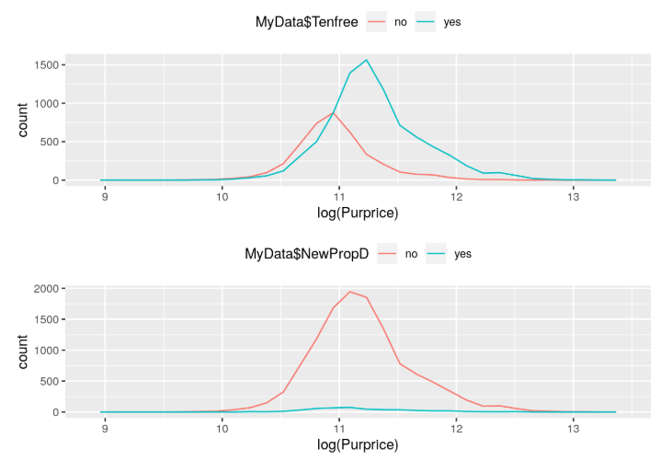
Figure 9 Lineplot of log Purprice with Tenfree and NewPropD
In the figure 9, we observe the below findings:
- Purprice vs TenFree : The line plot depicts that the properties with Leasehold are more compared to the properties without Leasehold.
- Purprice vs NewPropD : This plot suggests that the there are very few new properties compared to the old properties in the UK.

Predictor Significance:
Identification of true relation between predictors and response requires a model estimation technique. In this dataset, the response variable is continuous so regression setting is favorable for modelling. We can perform regression of ‘Purprice’ with each predictor and select appropriate model with the lowest AIC value, which will give us the closest model to the unknown actual model.
The AIC plot ‘figure 10’ shows that ‘FlorArea’ is the most significant predictor followed by ‘Bedrooms’ and other predictors add a little variation to the model. ‘NewPropD’, ‘ProfPct’ and ‘Age’ are the lease significant variables.

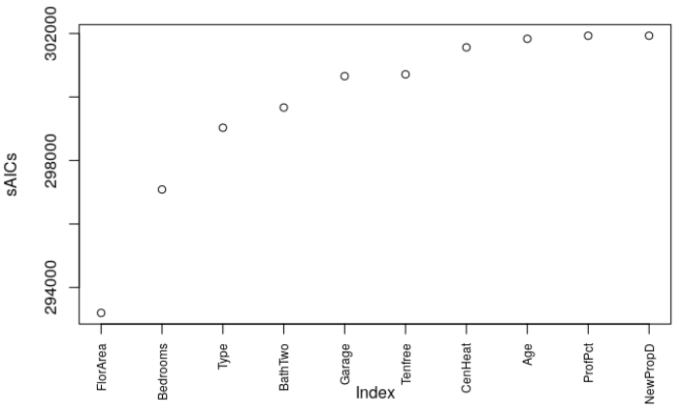
Figure 10 Index vs AIC plot

Linear Regression:
Exploratory analysis made on the predictor variables, with help of the boxplot and correlation matrix, we can conclude that there exists relationship between the predictors and the response variable “Purprice”. Among all the regression available we apply linear regression and fit the model with all predictors.
In order to explain the predictions and the variations in the response variable that can be attributed to variation in the explanatory variables we first apply linear regression on the dataset. Considering all the predictor variables except the easting and Nothing as they are spatial coordinates. The Easting and Northing are later used in spatial analysis of the dataset.
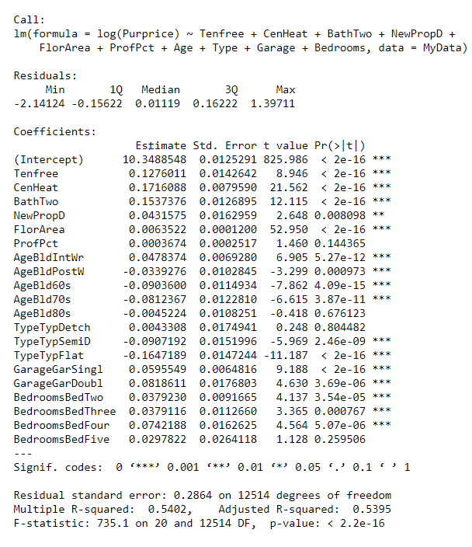
Figure 11 Coefficients from linear model
- From the summary of the multiple linear regression Intercept coefficient is 10.3488.
- Parameters with significant p-values(<0.05) and positive co-efficients are:
  - Tenfree
  - CenHeat
  - BathTwo
  - NewPropD
  - FlorArea
  - AgeBldIntWr
  - GarageGarSingl
  - GarageGarDoubl
  - BedroomsBedtwo
  - BedroomsBedthree
  - BedroomsBedFour
- ‘Purprice’ increases when the above predictors increase.
- Parameters with significant p-values(<0.05) and negative co-efficients are:
  - AgePostWr
  - AgeBld60s
  - AgeBld70s
  - TypeTypSemiD
  - TypetypFlat
- ‘Purprice’ decreases when the above predictors increase.
- Parameters which are not significant p-values(>0.05) are:
  - ProdPct
  - AgeBld80s
  - TypetypDetch
Adjusted R-squared is the proportion of variance explained by the linear model, in this case it is only 54 %.
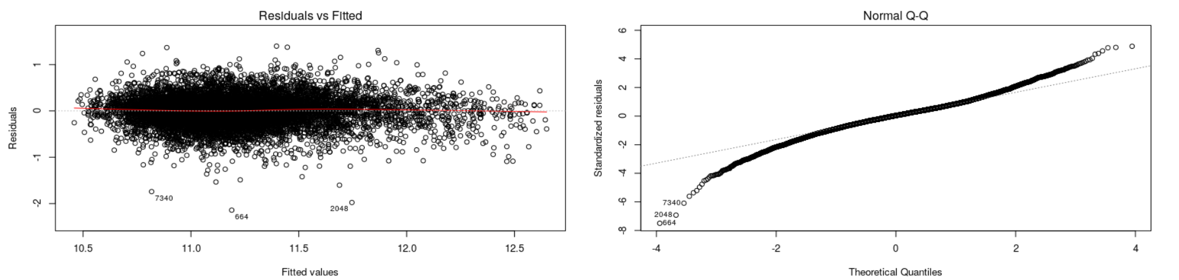
Figure 12 Residual vs Fitted and Normal Q-Q plot
From the Residual plot we see that there exists strong association between response and the predictors but there is no constant variance and from the Normal QQ plot it is clear that data is not normally distributed, it is more under dispersed. Nd also we can notice the existence of the outliers. (Case 7040, 2048, 664)
From this it is clear it violates the assumption of normality and existence of outliers which is observed earlier in the boxplot.

Best Subsets Forward Selection approach:
Best subsets is a technique that relies on stepwise regression to search, find and visualise regression models and find the best model by variable selection. But unlike stepwise regression, you have more options to see what variables were included in various shortlisted models, force-in or force-out some of the explanatory variables and also visually inspect the model’s performance w.r.t Adj R-sq.
Firstly, we use the best subsets forward selection method for ‘Purprice’ and plot the ‘adjr2’ results for all the variables in ‘figure 11’. This method basically use the forward selection method of adding the variables one by one and calculating the AIC, BIC and CP and find the best model from all the possible combinations. If there are ‘n’ variables provided then a total of 2^{n} combinations. The plot for the ‘adjr2’ is visualized as below.
Furthermore, we use the best subsets backward selection plot for ‘Purprice’ and plot the ‘adjr2’ results for all the variables as shown below in ‘figure 12’. We can notice from both the plots that ‘FlorArea’ is the most significant variable of all followed by ‘CenHeat’ and other variables. However, we can see certain differences in both the approaches.
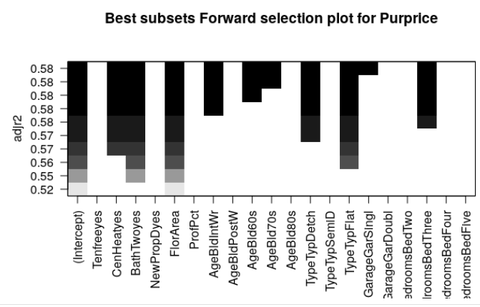
Figure 13 Best subsets forward selection plot for Purprice
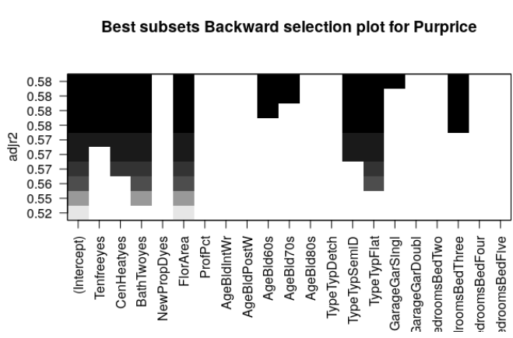
Figure 14 Best subsets backward selection plot for Purprice
Secondly, we plot the best subsets forward selection plot for ‘Log Purprice’ results for all the variables as in ‘figure 13’. Similarly, we plot the best subsets backward selection plot for ‘Log Purprice’ as in ‘figure 14’. From these plots we notice that the plots give us exactly similar significant variables unlike the forward and backward selection plots for ‘Purprice’(figures 11 & 12). The most significant variables identified are ‘FlorArea’ and ‘CenHeat’ followed by ‘Tenfree’,’TypeFlat’,’BathTwo’,’AgeBldIntWr’,’TypeSemID’,’GarSingl’,’AgeBld60s’,’AgeBld70s’.
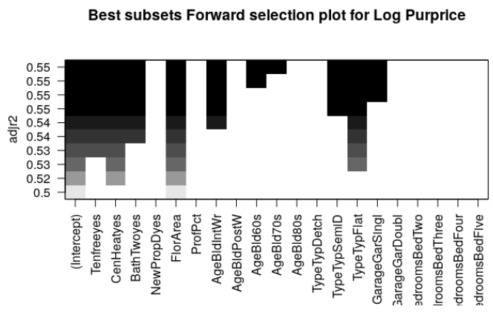
Figure 15 Best subsets forward selection plot for Log Purprice
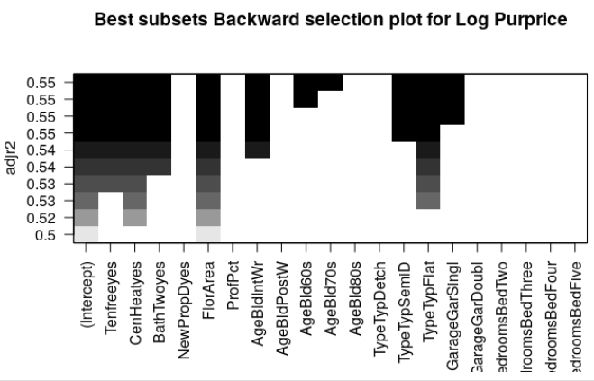
Figure 16 Best subsets backward selection plot for Log Purprice
After this we shall now plot the ‘BIC’ and ‘Cp’ graphs for ‘Purprice’ as in ‘figure 15’. From this we can identify that the ‘adjR2’ value is maximum at 10 and the values of ‘BIC’ and ‘Cp’ are minimum at 10 which implies that we can take up to 10 variables into consideration to create our model.
We even plot the ‘BIC’ and ‘Cp’ graphs for ‘Log Purprice’ as in ‘figure 16’. Even this plot suggeets that the ‘adjR2’ value is maxumum at 10 and the values of ‘BIC’ and ‘Cp’ are minimum at 10 which implies that we can take up to 10 variables into consideration to create our model. The only difference between ‘figure 15’ and ‘figure16’ is a slight change in the curvature.
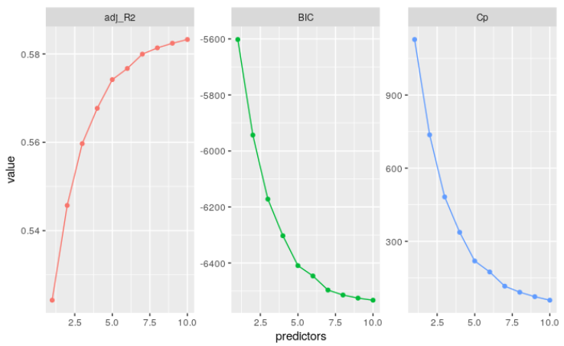
Figure 17 Plotting BIC cp for Purprice
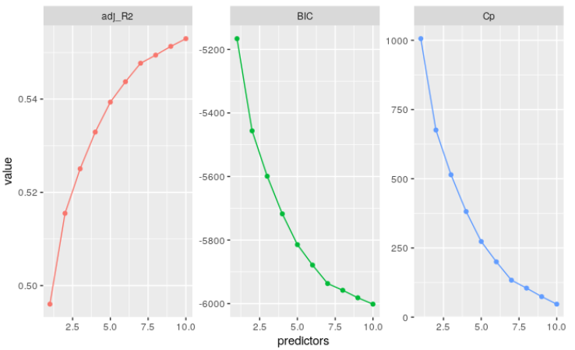
Figure 18 Plotting BIC cp for Log Purprice

Cross Validation:
We now use the models created above from the ‘train’ model and apply it to the ‘test’ model and check for the cross validation errors. We see from the plots ‘figure 17’ and ‘figure18’ that the lowest value is for 10 which suggests that we pick 10 variables to plot the graph. There is not much a difference between these two figures though.
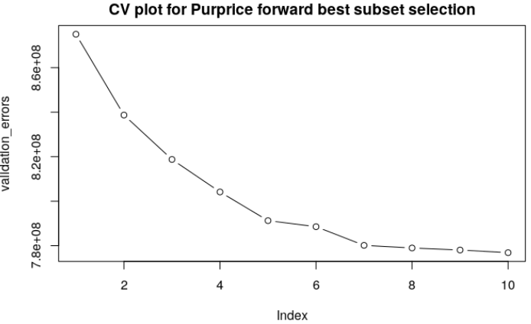
Figure 19 CV plot for Purprice using forward best subset selection
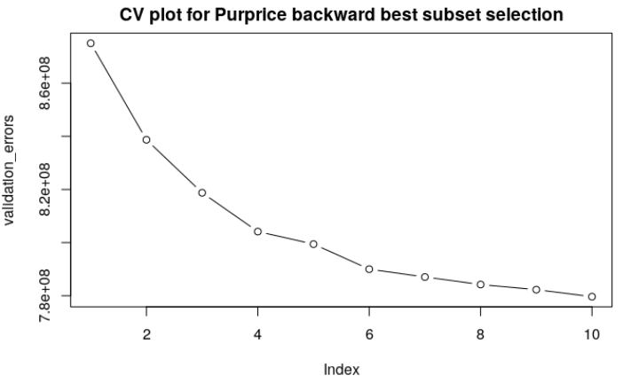
Figure 20 CV plot for Purprice using backward best subset selection
On the other hand, when we plot the cross validation errors as in ‘figure 19’ and ‘figure 20’ the curvature varies from the above two plots where log is not applied to ‘Purprice’. However, this still depicts us that 10 is the lowest value or the number of variables that we can pick and will be still significant.
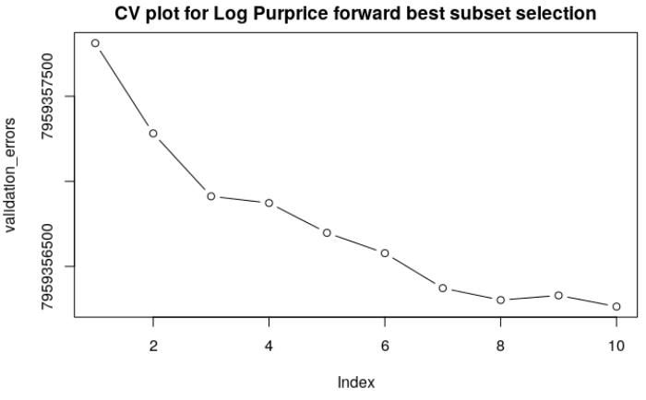
Figure 21 CV plot for Log Purprice using forward best subset selection
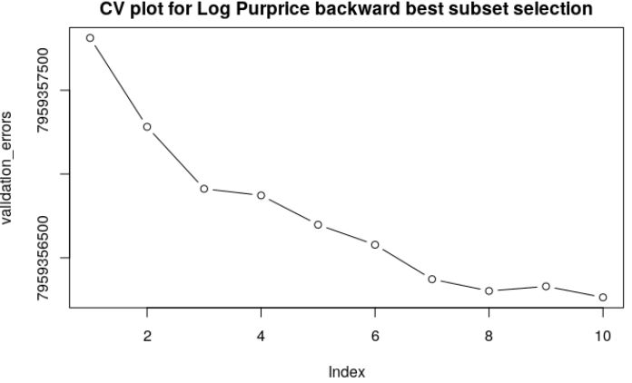
Figure 22 CV plot for Log Purprice using backward best subset selection

Random Forest
Random forests or random decision forests are an ensemble learning method for classification, regression and other tasks that operate by constructing a multitude of decision trees at training time and outputting the class that is the mode of the classes (classification) or mean prediction (regression) of the individual trees. Random decision forests correct for decision trees habit of overfitting to their training set.
The Random forest algorithm works by aggregating the predictions made by multiple decision trees of varying depth. Every decision tree in the forest is trained on different subsets of the dataset called bootstrapped dataset. The model will automatically evaluate its own accuracy by running each subset of the reaming datasets through the forest. Random forest is used for classification and is presented with a new sample the final prediction is made by taking the majority of the predictions made by each individual decision tree in the forest. The final prediction is made by taking average of the predictions made by each individual decision tree in the forest.
In R we can use Random Forest classifier by the ‘randomforest’ package. Syntax for finding the best predictor is:-
Rf <- randomforest (response~. Data = dataset)
By default the number of decision trees is 500 and number of features used as potential candidates for each split is 3. The model will automatically attempt to classify each of the samples in the subset of datasets and display confusion matrix with the result.
fit <- randomforest(log(Purprice) ~Tenfree + CenHeat + BathTwo + NewPropD + FlorArea + ProfPct + Age + Type + Garage + Bedrooms, data = train, importance=TRUE, ntree=60)
importance.features <- tibble::rownames_to_column(data.frame(fit$importance[,c(1)]))
colnames(importance.features) <- c("rowname", "value")
ggplot(importance.features, aes(x = reorder(rowname, -value), y = value)) +
geom_bar(stat = "identity", position = "dodge", fill="#E69F00", colour="black") +
xlab("Feature") + ylab("Count") + ggtitle("Importance of a feature: Simple Random Forest classifier") +
coord_flip()
In the above code fit will create 60 decision trees as we have explicitly provided ntree = 60 and do all the performance testing by predicting from all the other remaining subsets of the datasets. Importance. Features will help in finding the important feature among all the features that we have used for model creation and then ggplot will plot all the features based on their importance in the model that random forest has created.
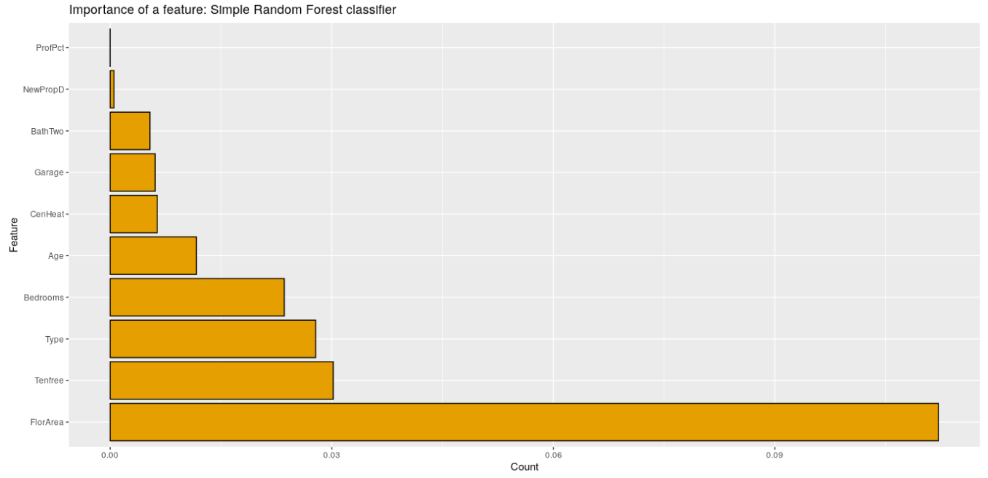
Figure 23 Density plots for significant variables
From the above plot we can clearly see that ‘FlorArea’ is playing the major role in predicting the house price among the other predictors in the model. In this we have used only 60 decision trees because of the big dataset, if we would have used more decision trees it would take more time as it will create that combinations of decision trees with 3 classifiers.
From the various approaches used above we can conclude the final model as:
lm(Purprice~FlorArea+Bedrooms+Type+BathTwo+Garage+Tenfree+CenHeat+Age+ProfPct).

Spatial Analysis:
Spatial analysis is a research paradigm that provides a unique set of techniques and methods for analysing events—events in a very general sense—that are located in geographical space.
The Variables chosen for this analysis are Borough , Purprice, Standardised residuals, Floor Area
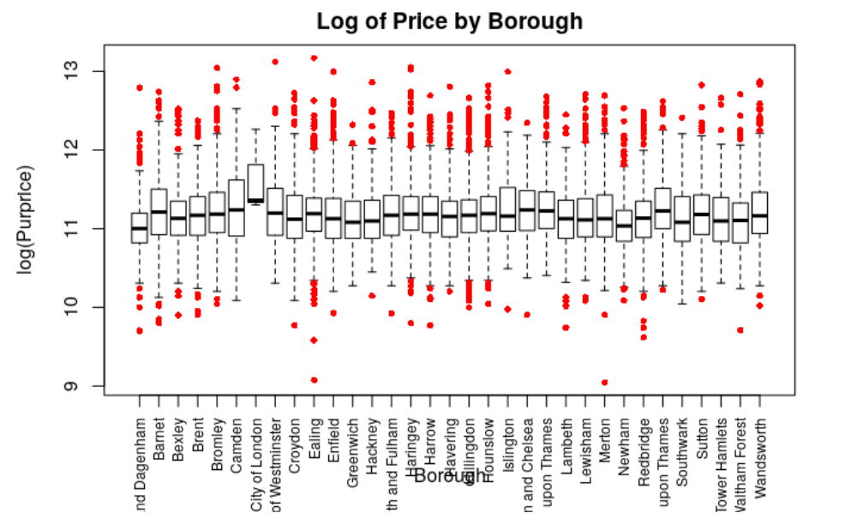
In order to understand if location factor influences the median house prices, we created the boxplots. From the boxplots, we can say that median house price falls approximately in the same range. Except for the City of London as the median price higher when compared to median price of other locations. The Choropleth map for borough shows that there is an even spread of house prices across London with the prices apparently increasing in London’s Centre neighbourhood.
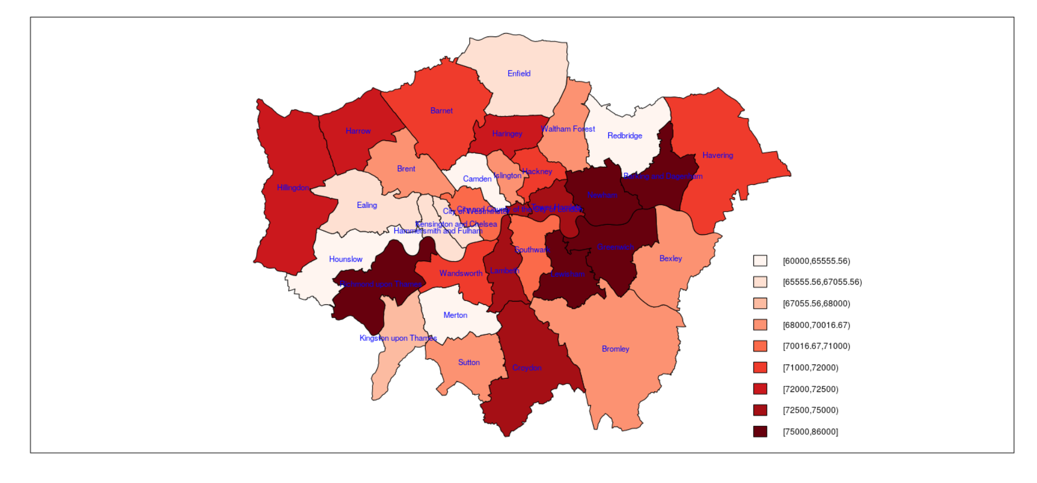
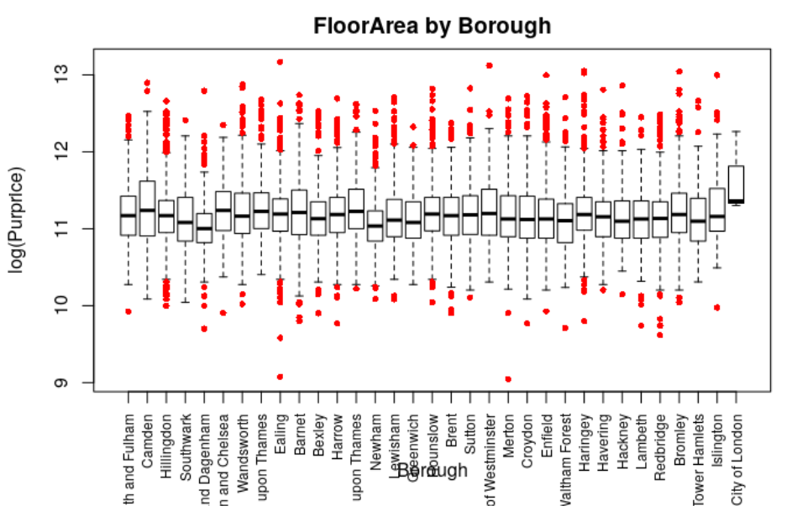
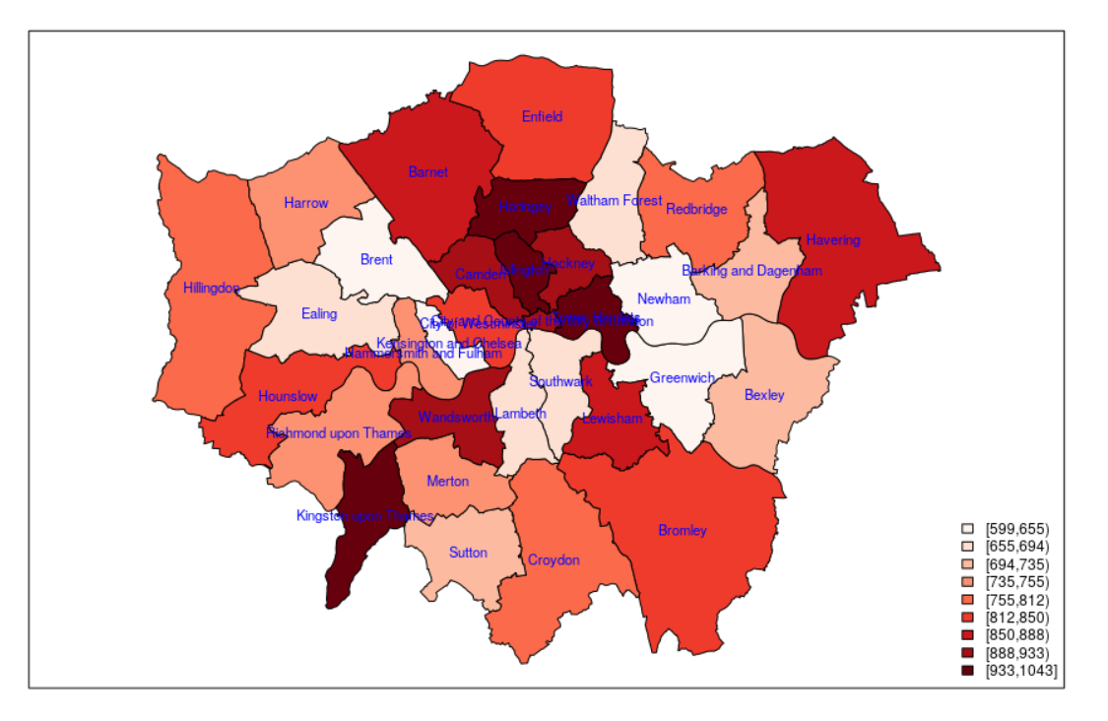
We created boxplot to observe median variable distributions with respective borough’s, shows that the median floor area has minimal changes across the different boroughs. We can also notice that median value for the city of London is slightly higher when compared to the median values of other boroughs. From Choropleth Map we can analyze that median floor area gets lower as we move closer to London Centre.
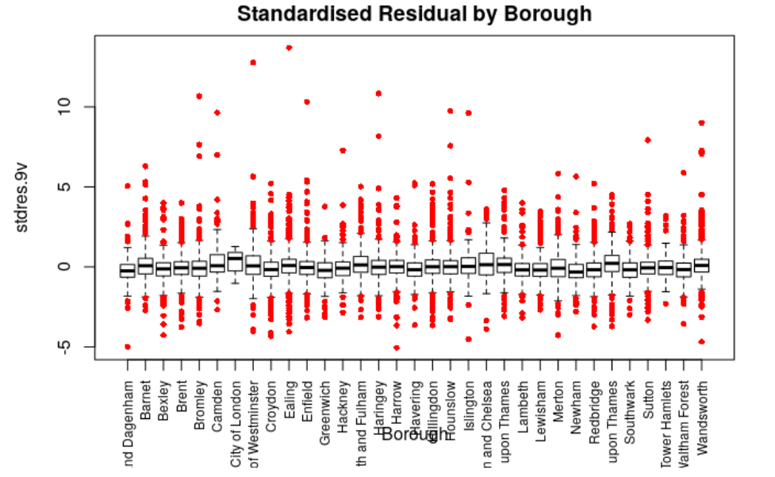
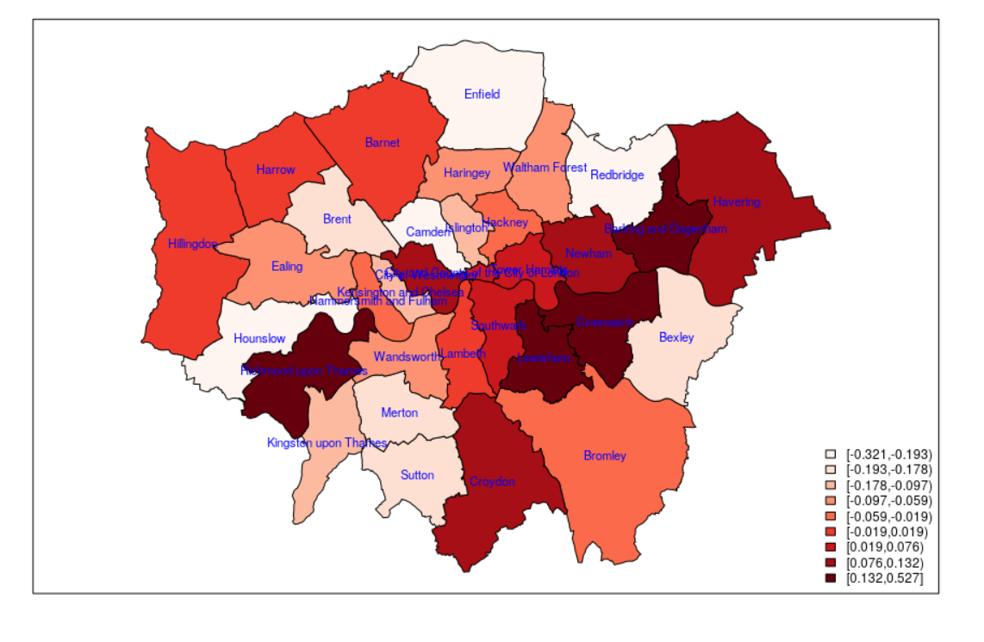
The median residuals by borough boxplot shows there is not severe changes in the median residual values across the different boroughs. And from the choropleth map the median residual are little larger on the North-east side of the map when compared to the other directions.

Summary:
For many people, buying a property is one of the most important decision in their life. Besides the affordability of a house, other factors such as the desirability of the location, long-term investment prospects and carpet area of the house also affect the decision-making process. The housing market in the UK has always been a topic of national attention, with news sites dedicating sections that report on key news that can potentially affect housing prices and the trends in recent months.
House price evaluation is an area in which the statistical analysis plays an important role. With the help of statistical exploratory analysis, we can create model which can help to predict the house price in an area and its neighbouring places. For this we can use multiple algorithms to create a model in this we have used linear regression and random forest for predicting the house price data. We have also used spatial methods to visualize the difference in price based on the floor area i.e. how the price of the house changes with change in the floor area with the change in the location.
The dataset is a subset of anonymised mortgage records for the area that is known as Greater London. The purchase price (which is different from the asking price) is available, as a series of the characteristics of the property. Boxplots, Correlation plots, Linear regression and Random Forest were used to analyse and visualize the spatial data.
Initially the collinearity of the predictors were analysed with the help of correlation plot and found that there are few correlations among the predictors but its moderate only. After collinearity we checked for the normality of our data with respect to our response variable which is ‘Purprice’ (Purchase Price) in our case, to check for the normality we have created density plot and found that it is not normally distributed and left skewed. To make it normal we transformed our response variable by using log transformation and used this log transformed response in our further analysis and model creation.
After checking for the normality of the data we checked for the possible outliers in the data set for various predictors. To check for the outliers, we have used Boxplots and interpreted its impact on the predictions. We found few outliers that we removed from the dataset and also found that we can merge few columns and make one categorical predictor for making the model.
After removing the outliers, we have created the linear models using forward and backward regression the best model will only include ‘FlorArea’ as a predictor for predicting the house price and if we go for more predictors then we can include ‘CenHeat’ and Type into our model for prediction. Based on the p values and significance level from model generated by forward and backward regression we can say ‘FlorArea’ as the most important predictor and also in our collinearity test we found that ‘FlorArea’ and ‘Purprice’ are positively correlated so we can say that they are directly proportional.
The above conclusion is also supported when we used random forest method for model creation. In the plot of random forest we can clearly spot that ‘FlorArea’ is most important predictor. But random forest contradicts few of our findings in linear model i.e. ‘CenHeat’ is least significant predictor according to the random forest and if we create a model with 5 predictors then we won’t be using ‘CenHeat’ as a predictor for predicting the price.

