# **Assignment: -**

Create 20 files with .txt extensions and rename the first 5 files to. yml extension Print the latest created top 5 files among the total no of files

# **Step-1:** create a 20 **.txt** files [ command: **touch testfile{1..20}.txt** ]

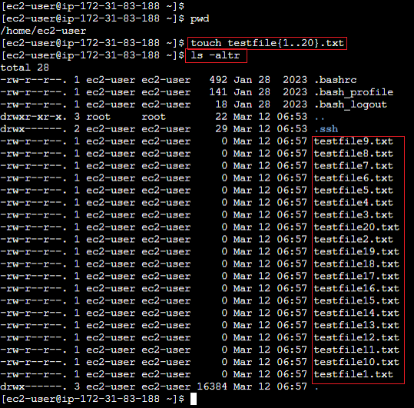

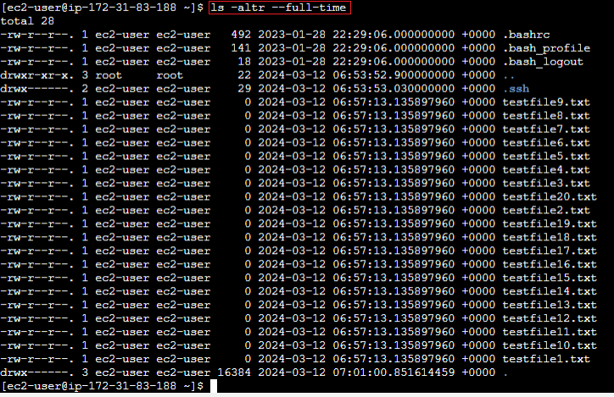

Note: **- ls -altr – full-time**

--full-time 🡺 display full time stamp.

-a -> display hidden folder or file (which started with **dot (.)**)

-t -> sort by file creation time.

-r -> --reverse: reverse order wh ile sorting.

# **Step-2:** display files creation in normal sorting order without reverse.

Command: **ls -lt –full-time**

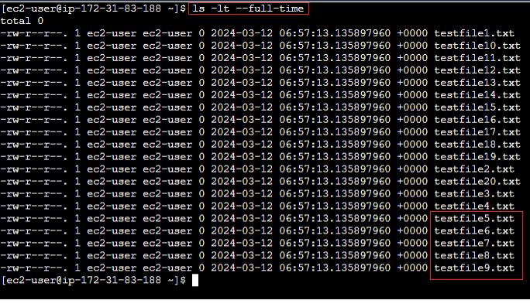

From above result output is, **the first created 5 files are:**

testfile9.txt

testfile8.txt

testfile7.txt

testfile6.txt

testfile5.txt

# **Step-3:** rename the first 5 files to**. yml** extension.

Rename file command is: **mv** **existing_filename** **new_filename**

mv testfile9.txt testfile9.yml

mv testfile8.txt testfile8.yml

mv testfile7.txt testfile7.yml

mv testfile6.txt testfile6.yml

mv testfile5.txt testfile5.yml

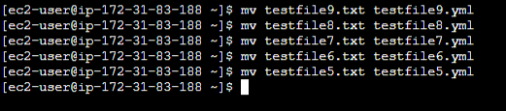

Note: - **mv** command will not change file creation time. File creation time is only change when content inside file got updated.

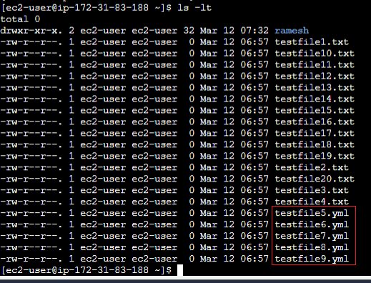

# **Step-4:** Print the latest created top 5 files among the total no of files.

Command: **ls -lt | head -n 6**

