# **Assignment#1:**



# **Jenkin Setup using docker container:**

## **Pre-requestees:**

1. EC2 instance has been created.
2. Docker has been installed.

## **Jenkins Installation:**

1. Pull Jenkins docker image from hub.docker.com.

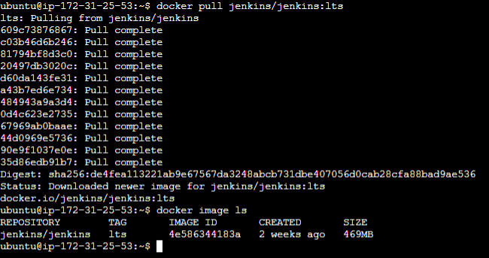

1. Create a container to start Jenkins service.





1. Access Jenkins web-portal using <http://IP-Address:8080/>

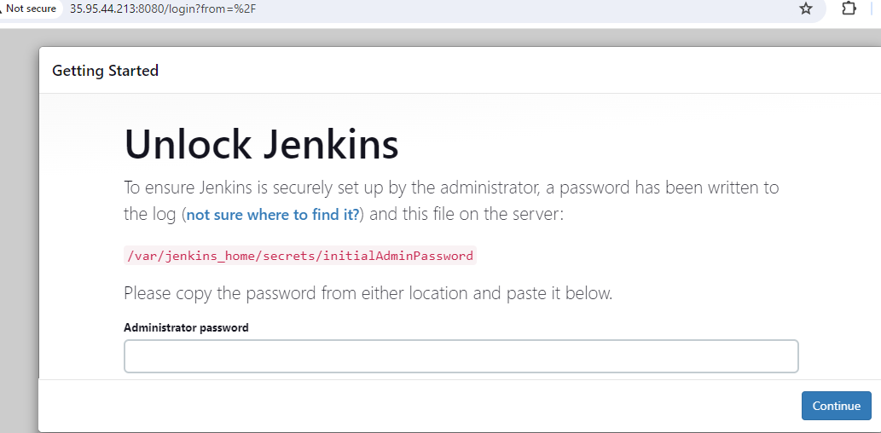

1. Get default admin password from above mentioned jenkin path and enter a password in text box and click on **“Continue”**.

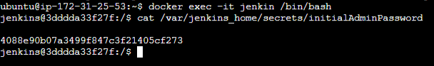

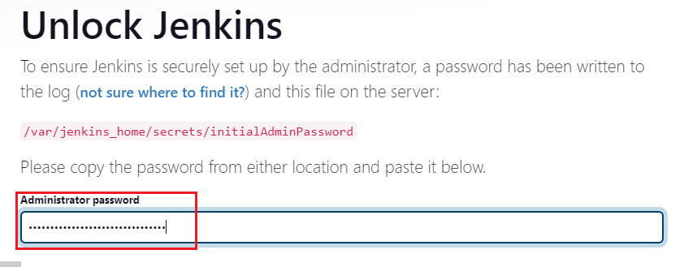

1. Select “install suggested plugins” and continue.

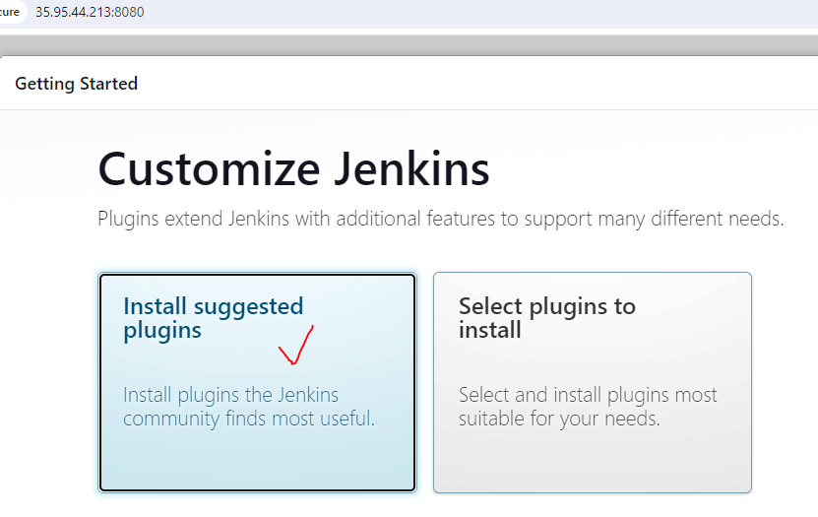

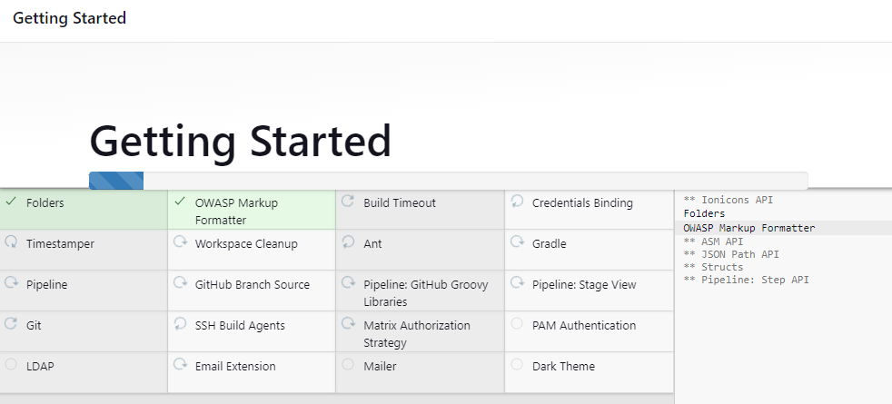

1. Create an admin user.

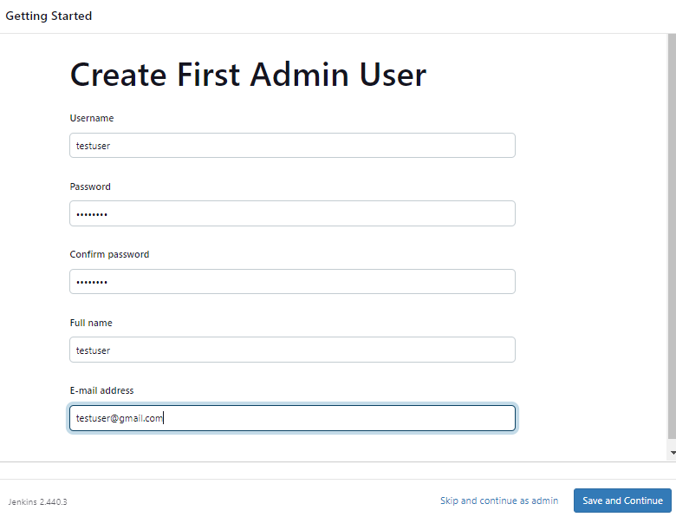

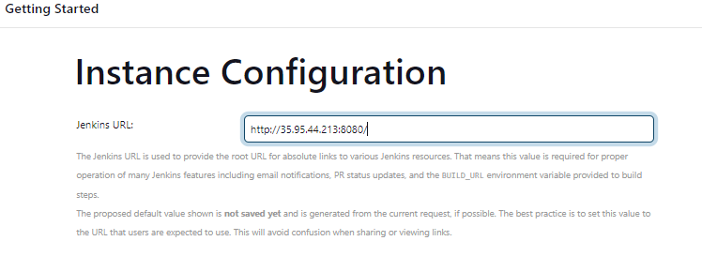

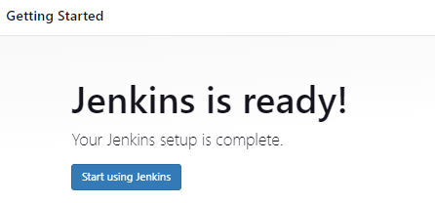

## **Explore project:**

1. Enter **project name** and select project type as “**Freestyle project**” and click on “**OK**”.

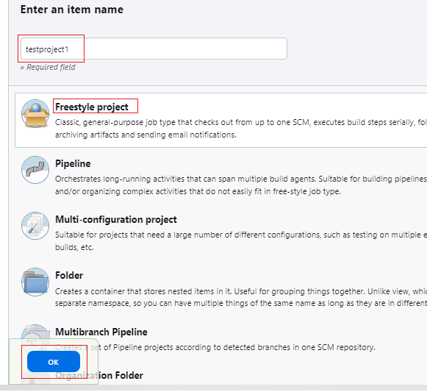

1. **testproject1** has been created.

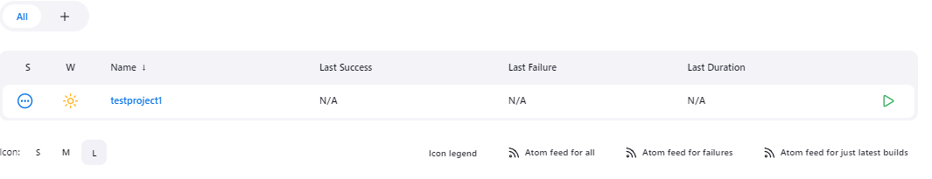

1. Follow below step to **configure** the project.

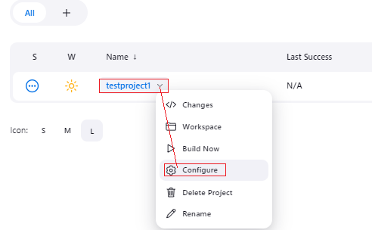

1. **Description**: used to describe about project.

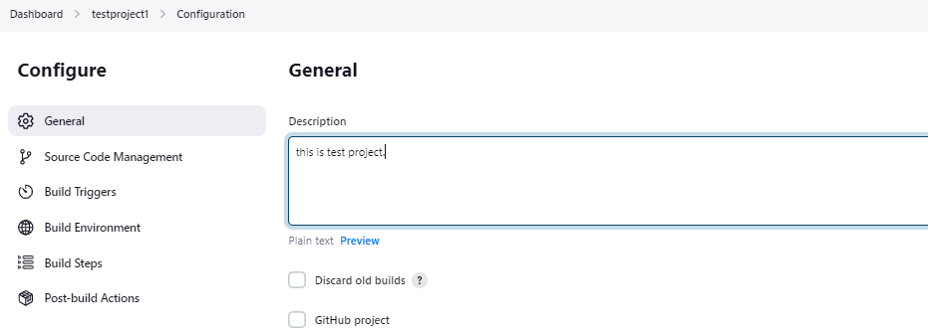

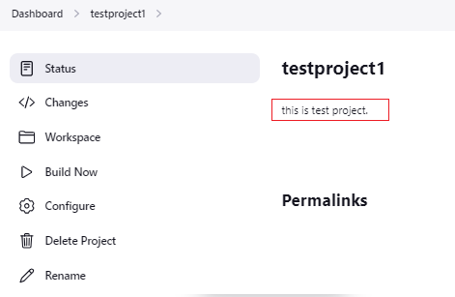

**Build periodically:** If we want to trigger a job automatically **every 1 minute**, then set **“Build periodically”** to **“1 * * * *”**. [ can refer - <https://crontab.guru/> for different time settings]

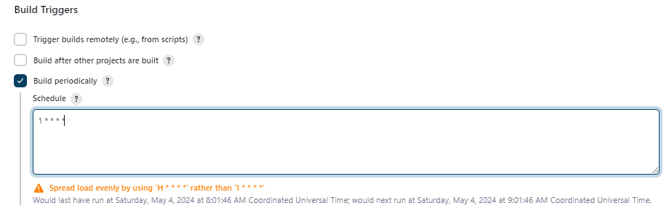

|  |  |
| --- | --- |
| **Build periodically** | **Poll SCM** |
| Irrespective of changes made, Jenkins  triggers a job automatically based on schedule period. | It triggers a job based on schedule period only if when changes are made. |

**Configure SCM (Source Code Management):**

**Note: If repository type is public, then no need credentials.**

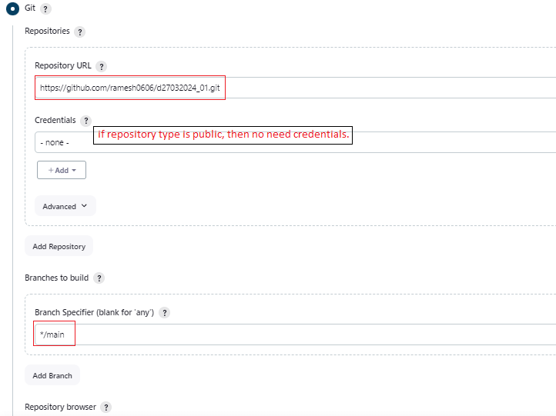

**If repository type is private, then need credentials.**

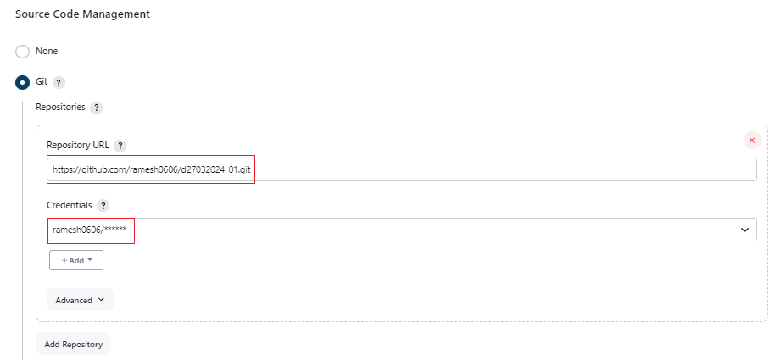

**Discard old builds:** Based on business requirement, we can set values for Discard old builds. For example, I set “Max # of builds to keep” = 3, Jenkins always keeps only 3 builds for this specific project and automatically deletes oldest.

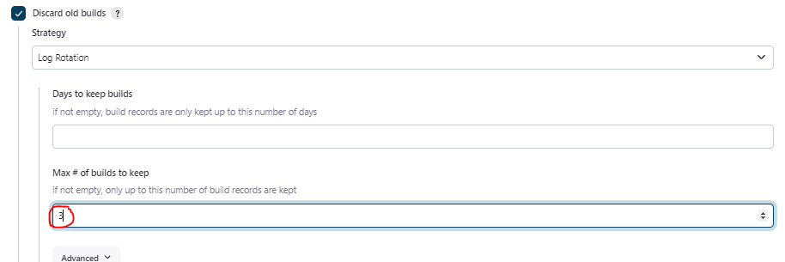

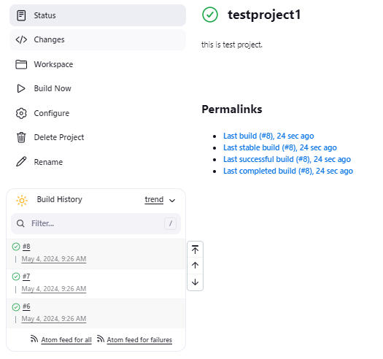

## **Explore users:**

## List all available Jenkins users.

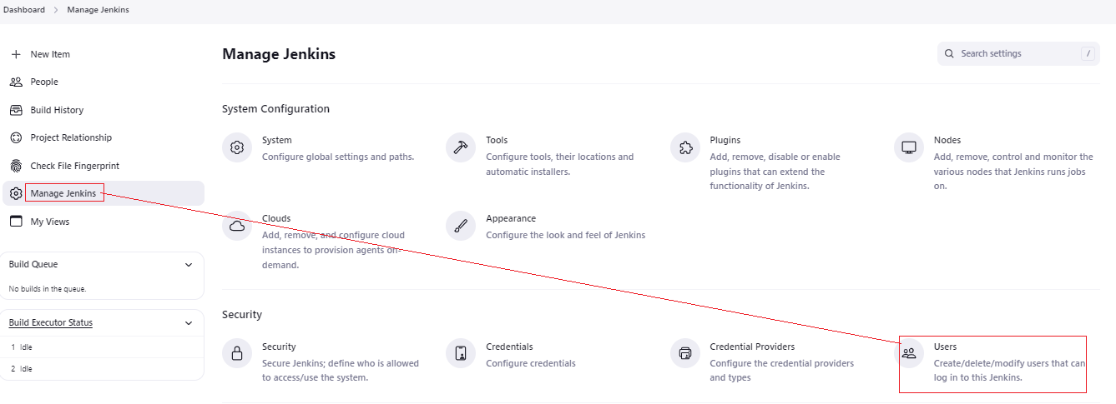

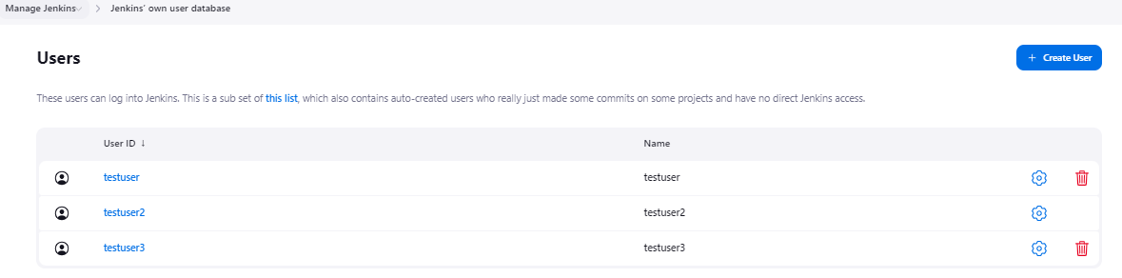

## Create a new another Jenkin user.

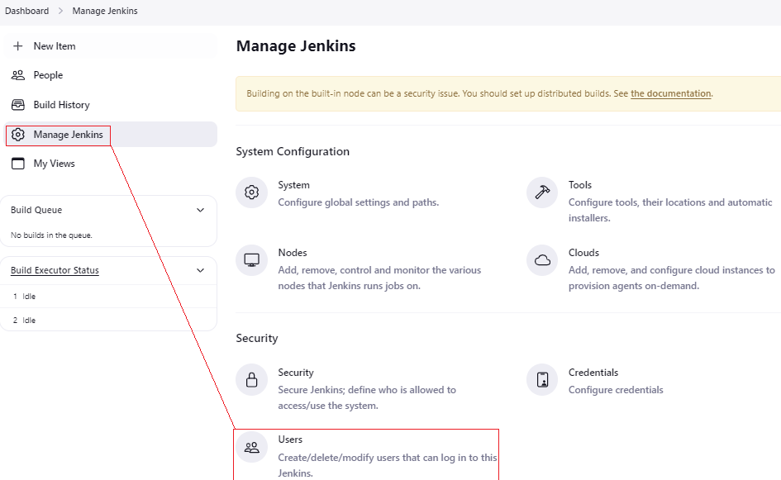

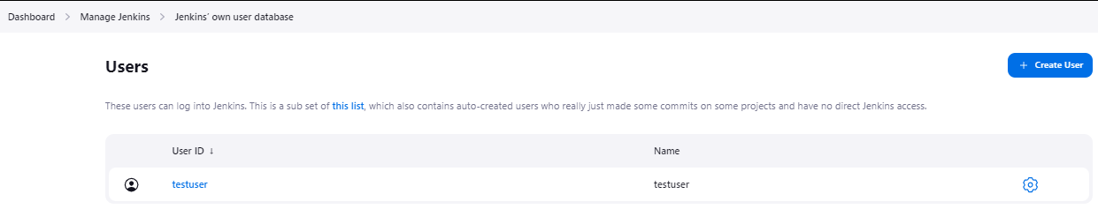

Click on “**create user**” and provide all required details and submit.

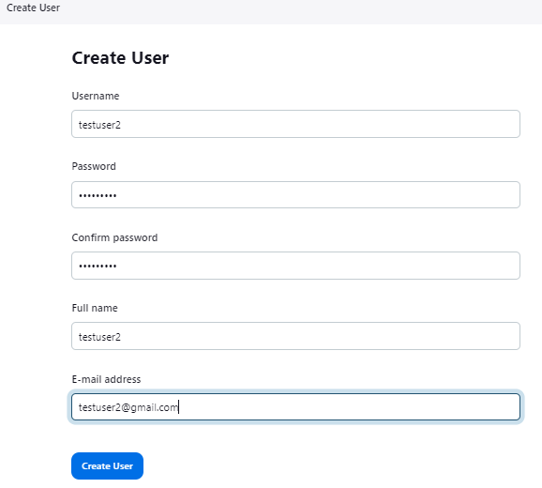

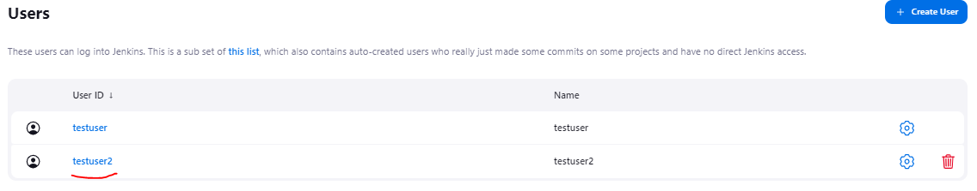

Now, login with new user **“testuser2”** and verify.

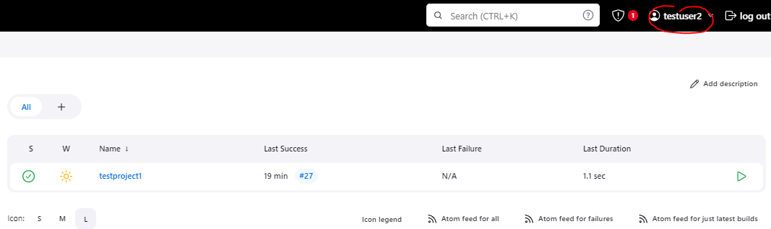

## Matrix based security

If want to allow specific Jenkin user only read the jobs, then we can set as below for example.

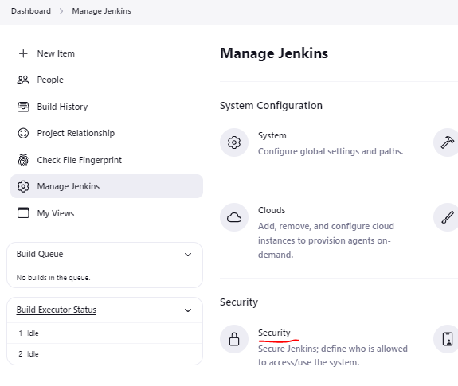

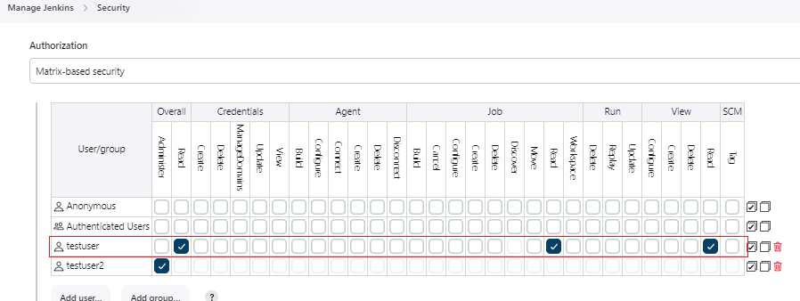

As shown below, user can only see the jobs but can’t perform other operations such as modify build or trigger build.

