# **Assignment#1:**



# **Jenkin Setup using docker container:**

## **Pre-requestees:**

1. EC2 instance has been created.
2. Docker has been installed.

## **Jenkins Installation:**

1. Pull Jenkins docker image from hub.docker.com.

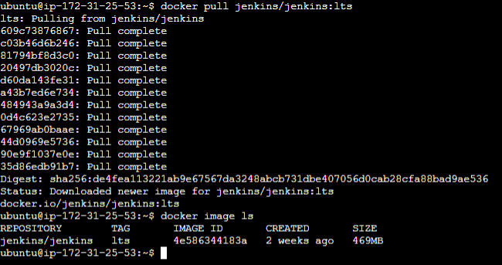

1. Create a container to start Jenkins service.





1. Access Jenkins web-portal using <http://IP-Address:8080/>

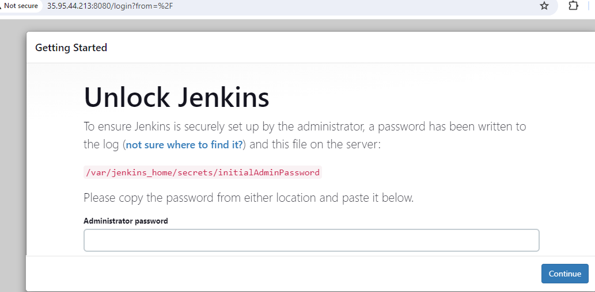

1. Get default admin password from above mentioned jenkin path and enter a password in text box and click on **“Continue”**.

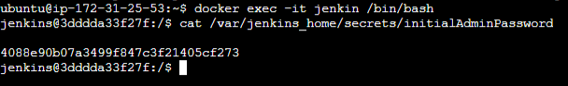

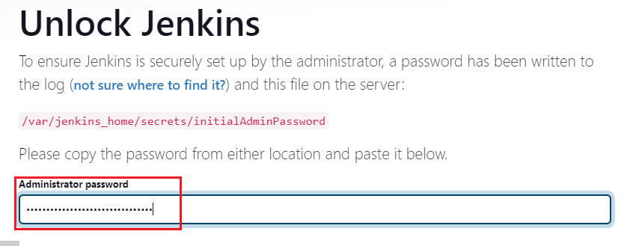

1. Select “install suggested plugins” and continue.

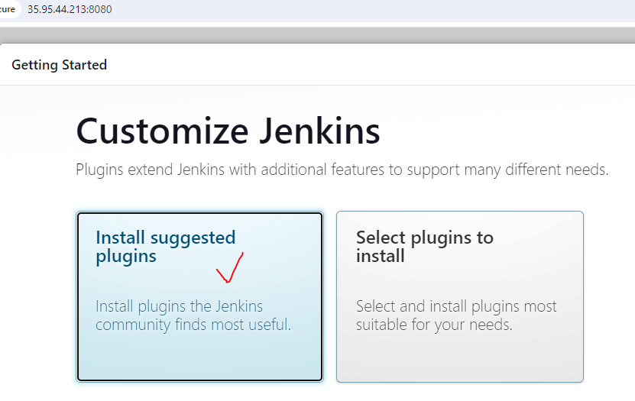

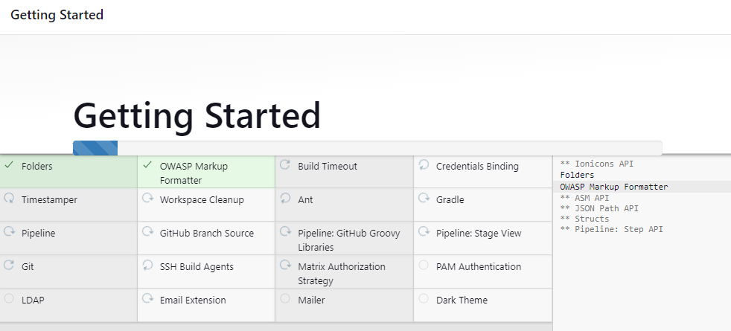

1. Create an admin user.

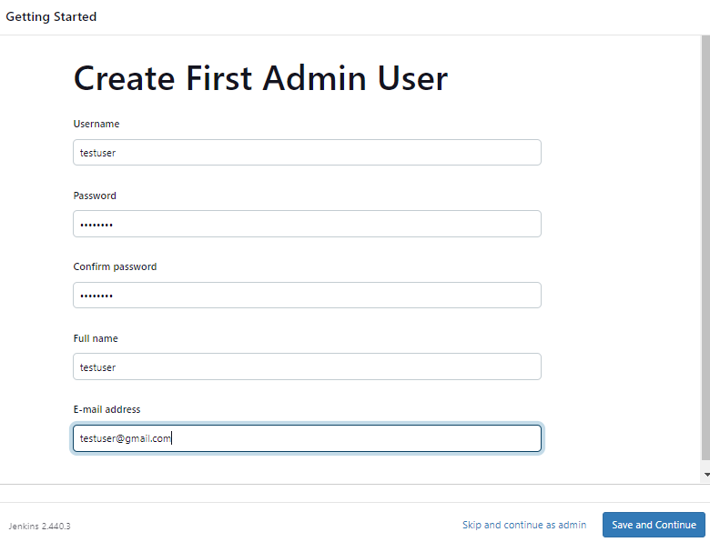

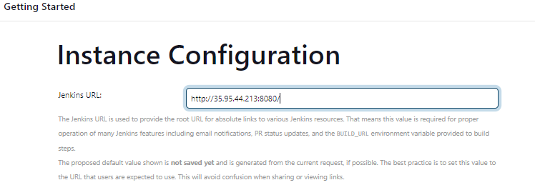

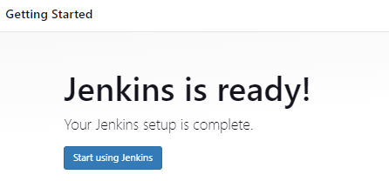

## **Explore project:**

1. Enter **project name** and select project type as “**Freestyle project**” and click on “**OK**”.

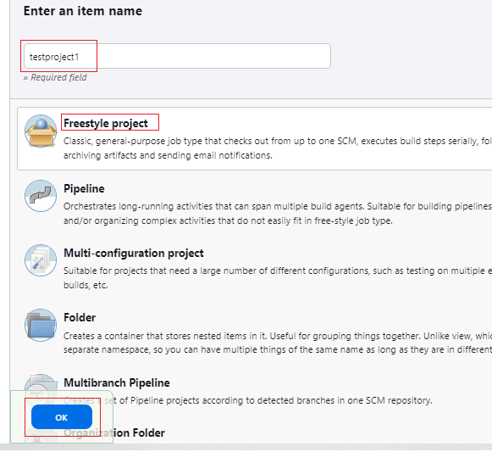

1. **testproject1** has been created.

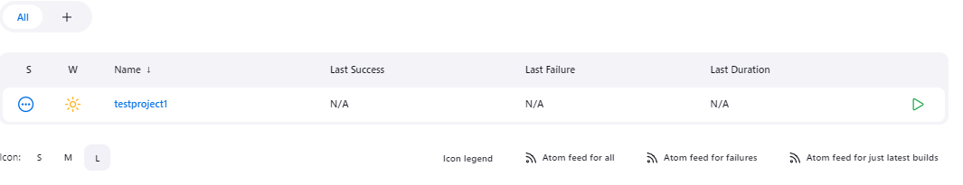

1. Follow below step to **configure** the project.

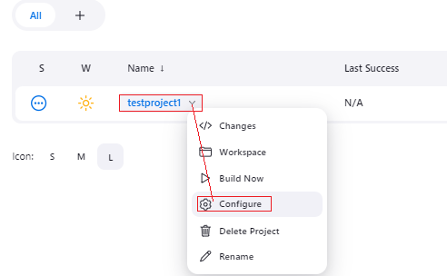

1. **Description**: used to describe about project.

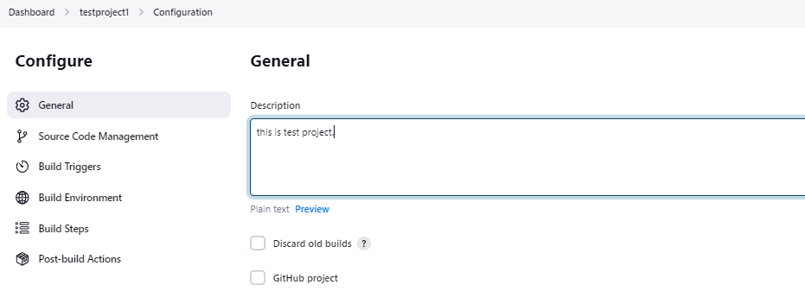

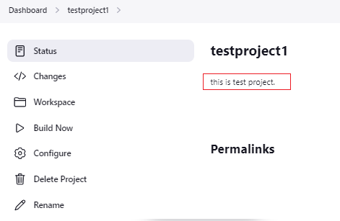

**Build periodically:** If we want to trigger a job automatically **every 1 minute**, then set **“Build periodically”** to **“1 * * * *”**. [ can refer - <https://crontab.guru/> for different time settings]

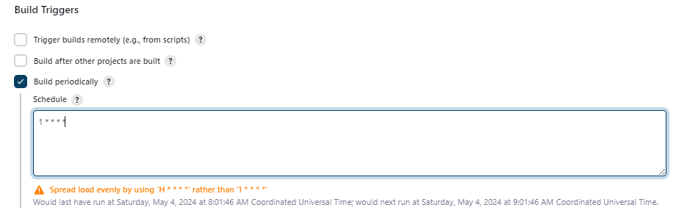

|  |  |
| --- | --- |
| **Build periodically** | **Poll SCM** |
| Irrespective of changes made, Jenkins  triggers a job automatically based on schedule period. | It triggers a job based on schedule period only if when changes are made. |

**Configure SCM (Source Code Management):**

**Note: If repository type is public, then no need credentials.**

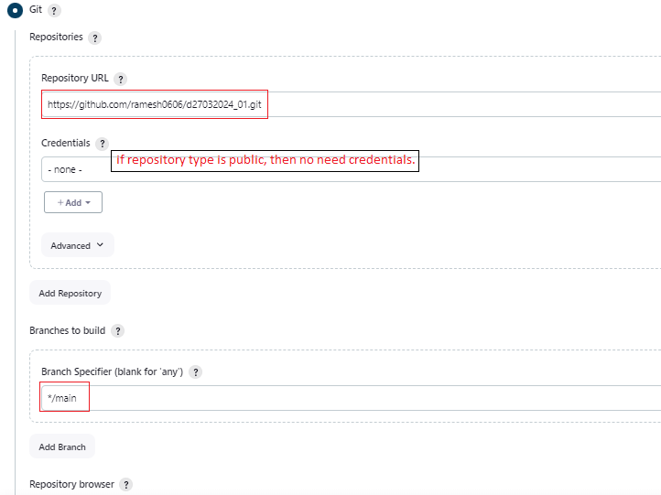

**If repository type is private, then need credentials.**

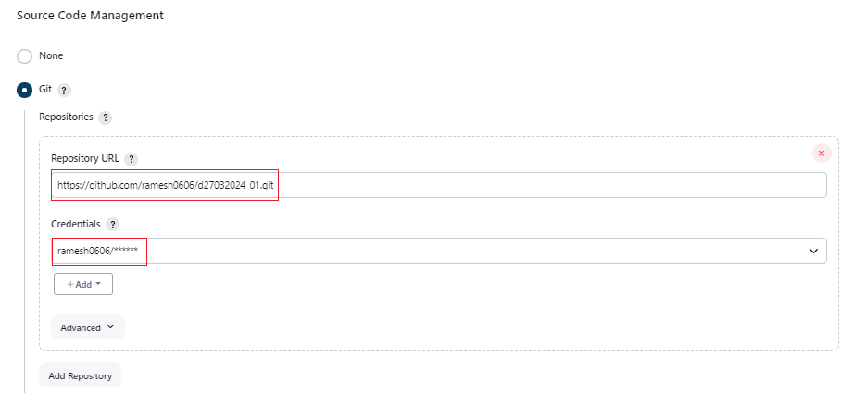

**Discard old builds:** Based on business requirement, we can set values for Discard old builds. For example, I set “Max # of builds to keep” = 3, Jenkins always keeps only 3 builds for this specific project and automatically deletes oldest.

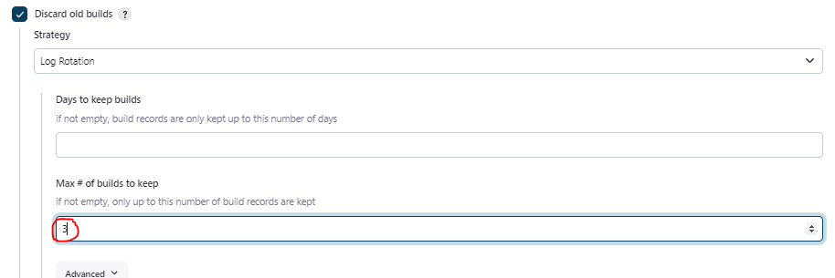

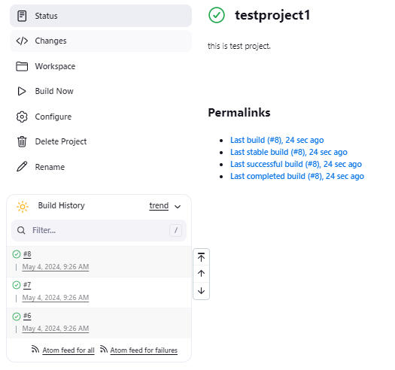

## **Explore users:**

## Create a new another Jenkin user.

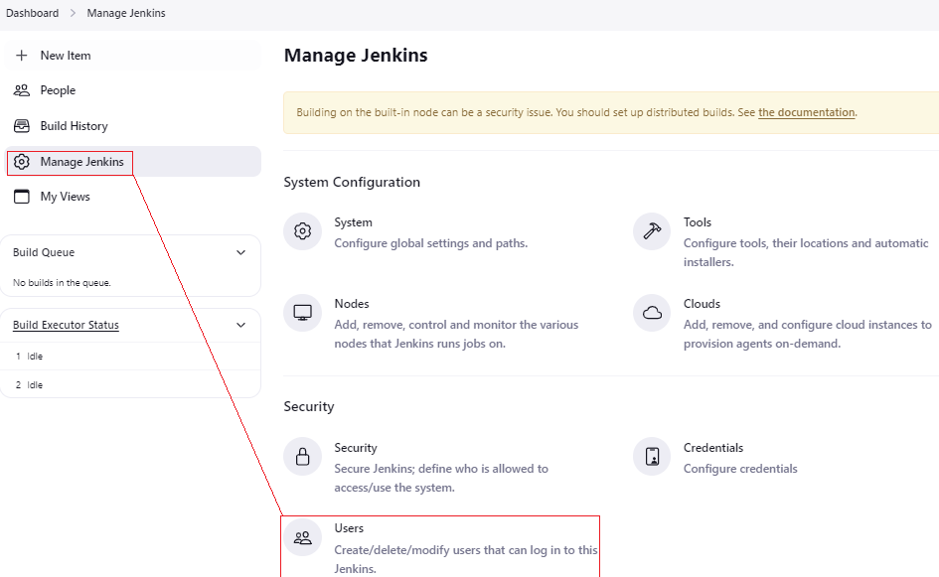

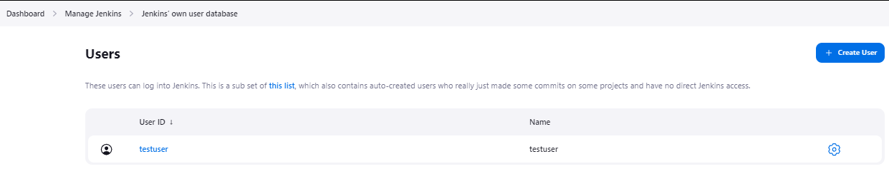

Click on “**create user**” and provide all required details and submit.

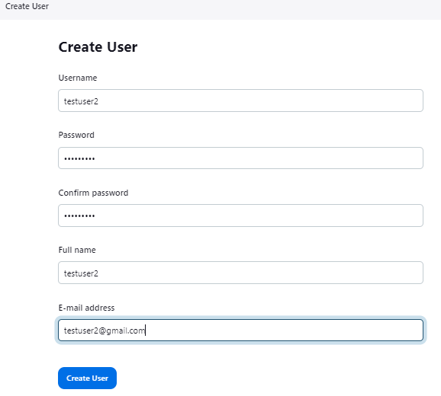

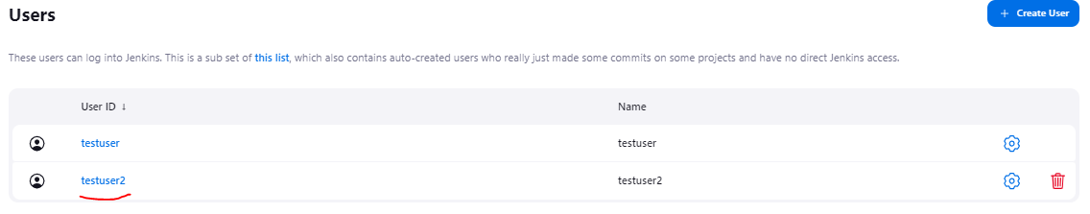

Now, login with new user **“testuser2”** and verify.

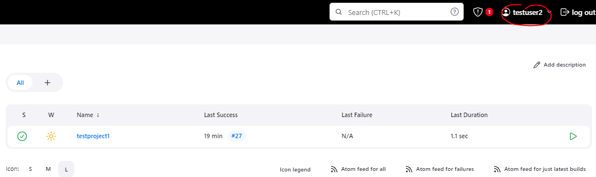

## Role-based authorization strategy:

