# Day-2 Assignment Task:

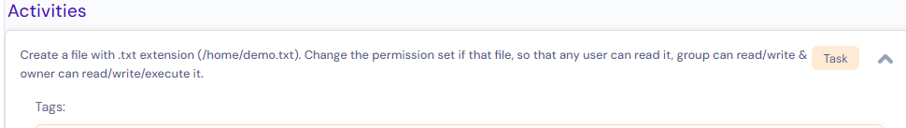

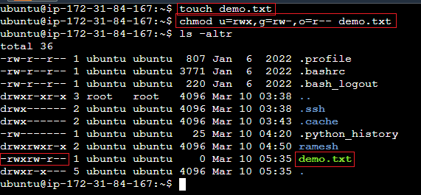

# **Session Practice:**

## How to **create** a single text file. **[ command: touch filename]**

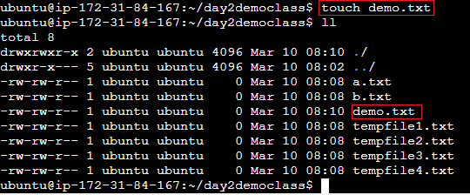

## How to **delete/remove** a single text file. **[ command: rm filename]**

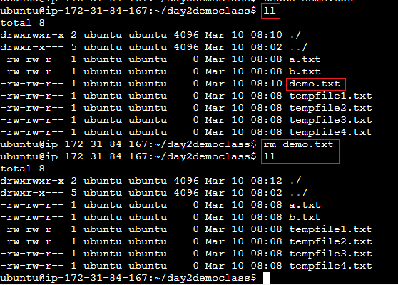

## How to **delete/remove** multiple text file in single line command. **[ command: rm *.txt]**

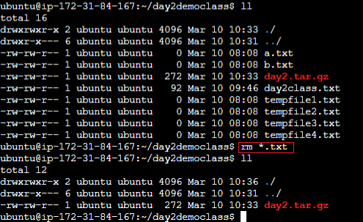

## How to **Append a content** to text file.

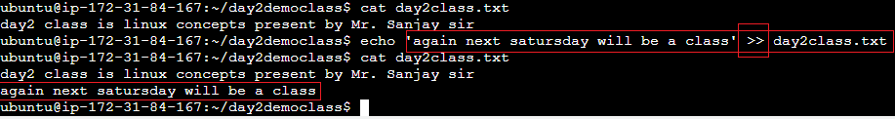

## How to **Overwrite a text file** content with new content.

‘single Arrow’ **>** will overwrite existing content with new content.

“double arrow” >> will append new content at new line after existing content.

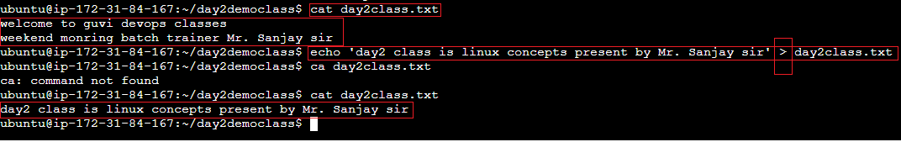

## How to **create multiple files** in single line command [ command: **touch** **tempfile{1..4}.txt**]

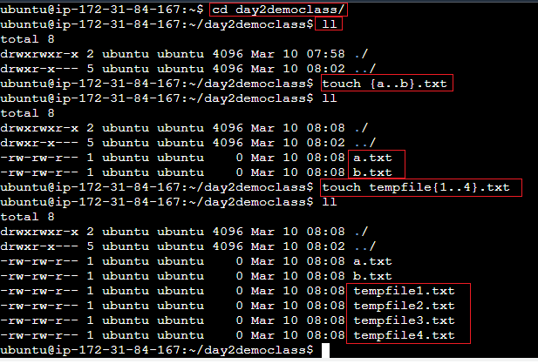

## How to **create single directory**. [ command: **mkdir directory_name**]

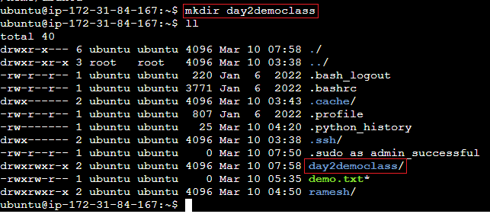

## How to **Create a folder recursively** in single line command

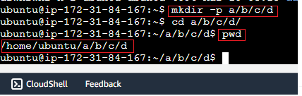

## How to **Compress multiple** files

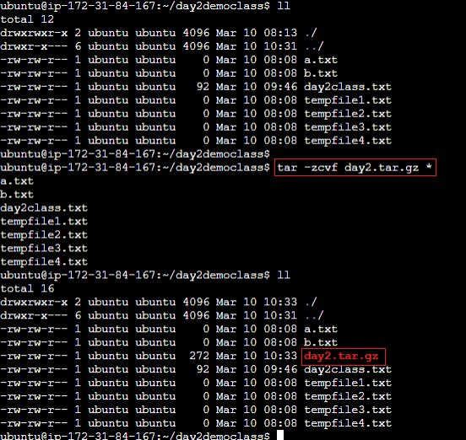

1. How to **view** **files inside tar.gz file without uncompress**.

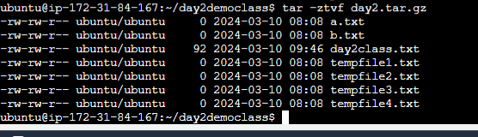

## How to **uncompressed** the tar file.

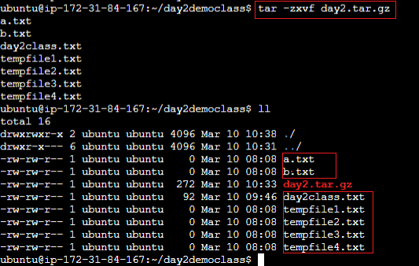

## How to **check disk usage**.

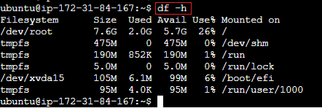

## How to **display total memory**.

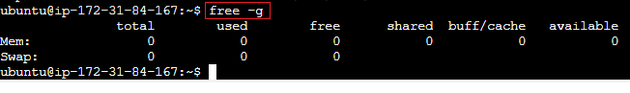

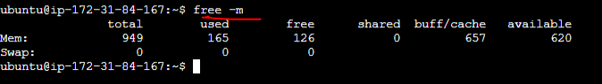

## How to **display the process wise memory utilization**. [ command: top, htop]

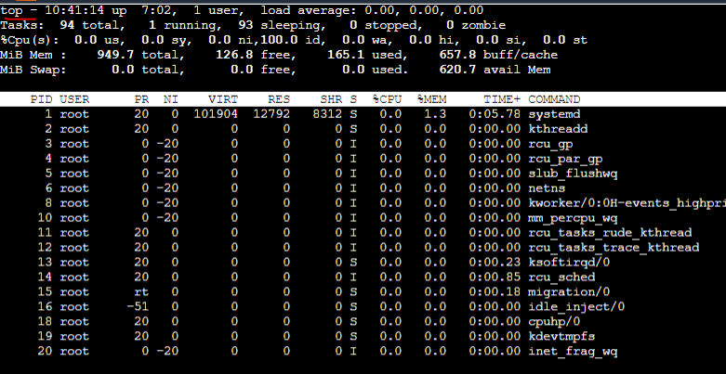

## How to **rename file**.

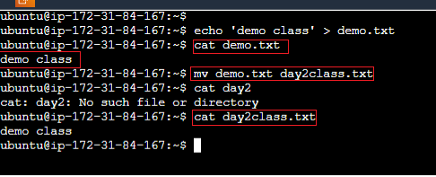

## How to **rename folder name**.

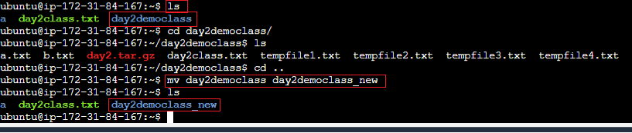

## **moving file** from one directory to another directory.

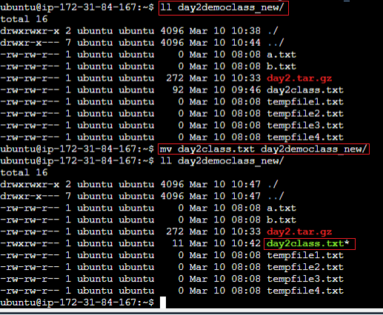

## How to Copying a file.

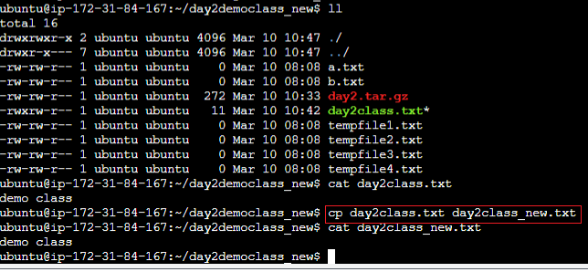

## How to Check the **present working directory**.

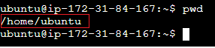

## How to go to back to previous directory.

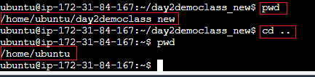

## How to go to **user home directory** directly in single line command.

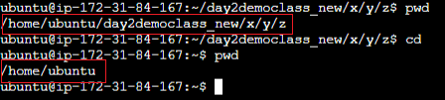

## How to **clear** the terminal.

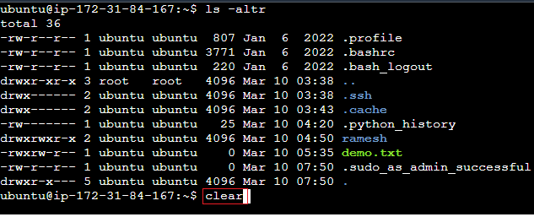

## How to **display** command line history.

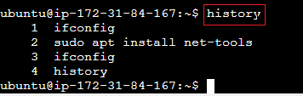

## How to **delete** a command line history.

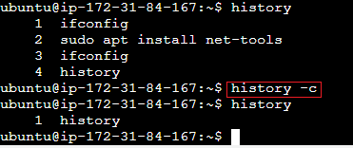

## What is difference between **rmdir** and **rm -rf**

Ans: **rmdir** -> only delete empty directory or folder

‘**rm -rf**’ -> will delete folder forcibly and recursively of that directory.

## How to **change the directory**.

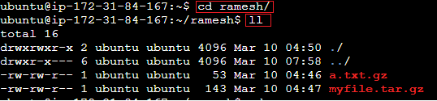

## How to check my compute instance IP address.

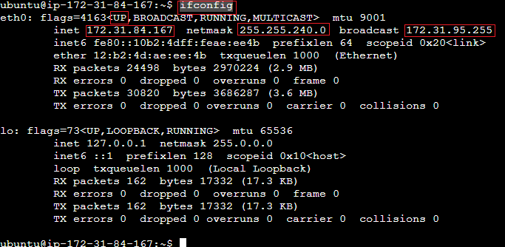

## How to check all created/available users in **compute instance**. [**command: cat /etc/passwd**]

## How to find a file. [**find . -iname *.txt**]

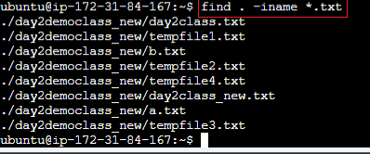

## **Search and replace a specific word** in a specific file.

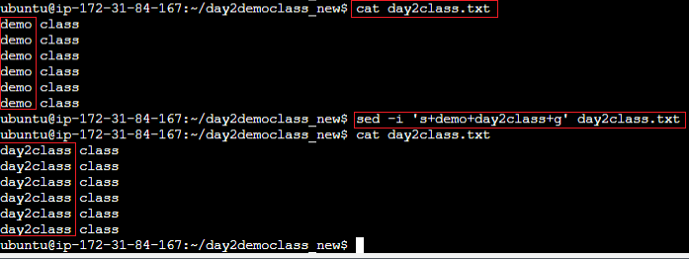

## **search a specific word in all text files** in particular directory. [command: grep -i “**class**” *.txt]

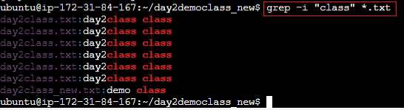

1. **search a specific word in all text files in all files under specific user.**

