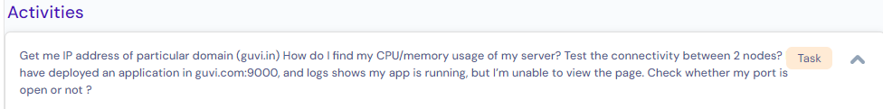

# Get me IP address of particular domain (**guvi.in**)

[command]: **nslookup guvi.in**

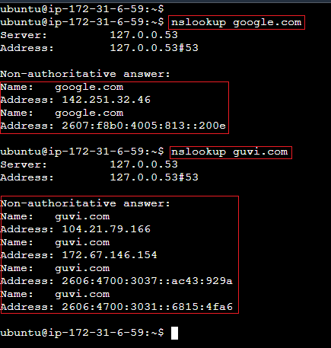

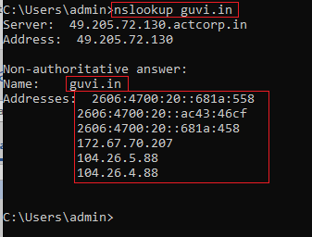

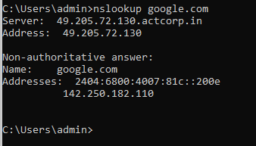

# How do I find my CPU/memory usage of my server?

**[command]:** top or htop.

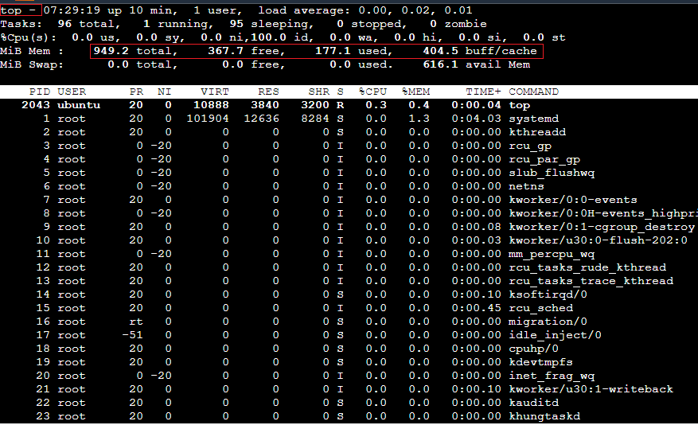

To know server’s total memory: command is **“free -g”**

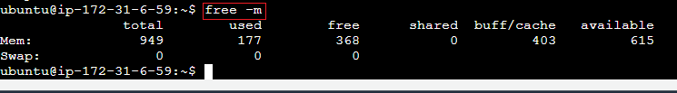



# Test the connectivity between 2 nodes?

[command]: **ping** is command which is used to test connectivity between 2 nodes.

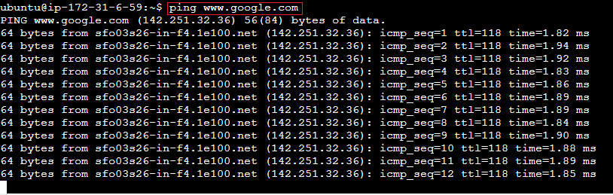

# have deployed an application in **guvi.com:9000**, and logs shows my app is running, but I’m unable to view the page. Check whether my port is open or not?

[command]: use “**telnet**” command to check whether specific is opened/allowed or not.

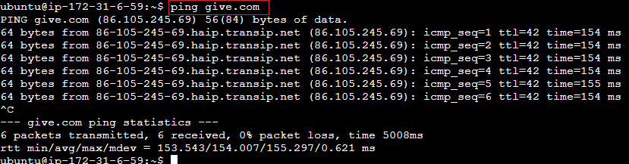

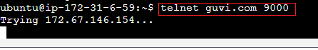

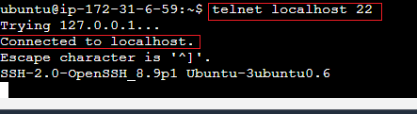

# How to install a package.

**[Command]: -** **sudo apt install net-tools**

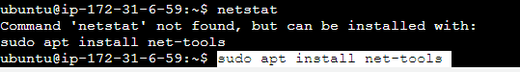

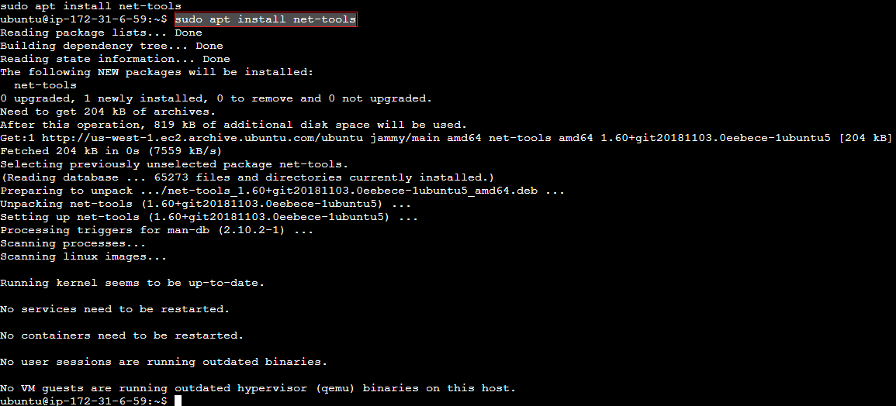

# netstat – will show all network connections.

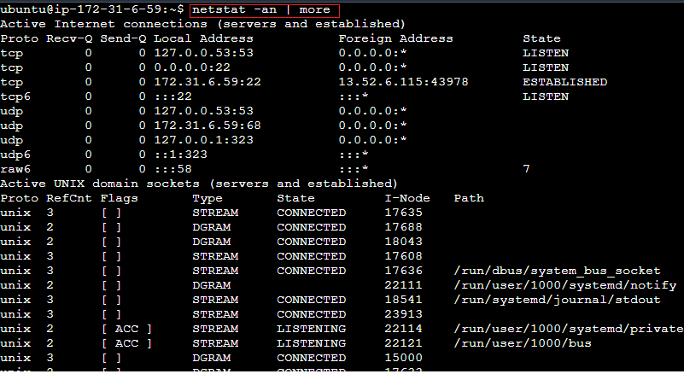

# Check the running process.

**[command]: ps -aux**

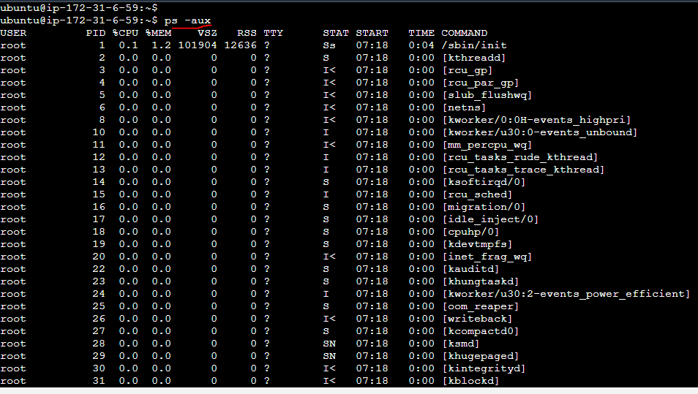

# How to know server IP address.

**[command]: ifconfig**

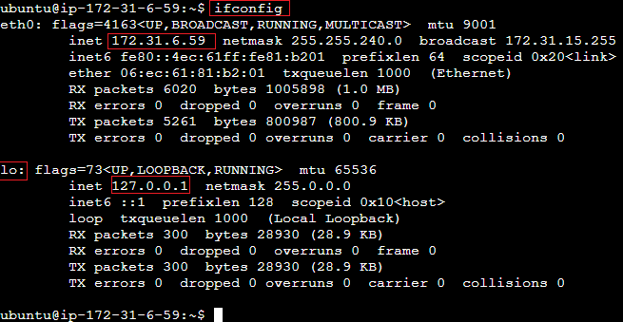

# How to know the path of connectivity with target server.

**[command]: tracepath or traceroute**

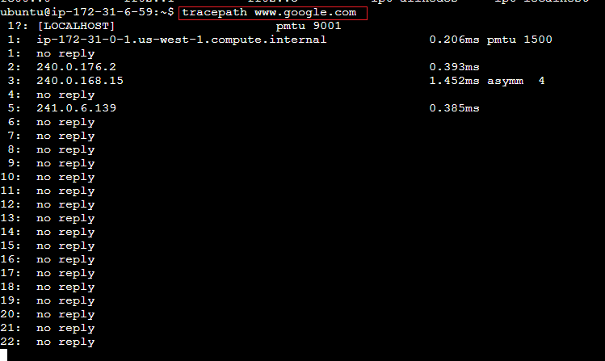

# How to know any Linux command usage.

**command: curl --help**

format: - **command_name --help**

