## **Assignment**

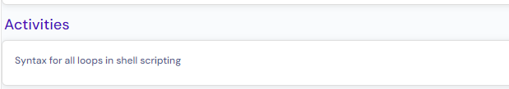

## Theory:

In shell scripting, we have two loops concepts such as

1. For loop
2. While loop

## For loop:

In advance, if we know how many times we have to repeat the loop, in other words, if we know number of iterations in advance, then we need to go for “**for loop**”.

#### **For loop syntax:**

**Example#1:**

**for x in ${list[@]}**

**do**

**# code logic**

**done**

**Example#2:**

**for ((i=1; i<=5; i++))**

**do**

**# code logic**

**done**

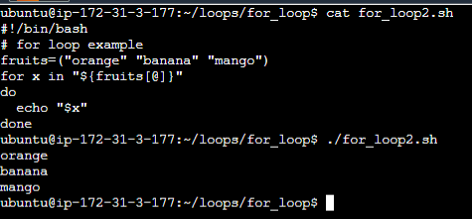

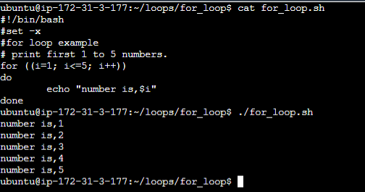

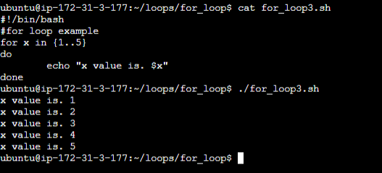

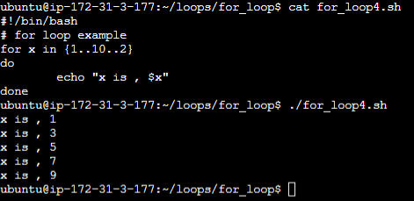

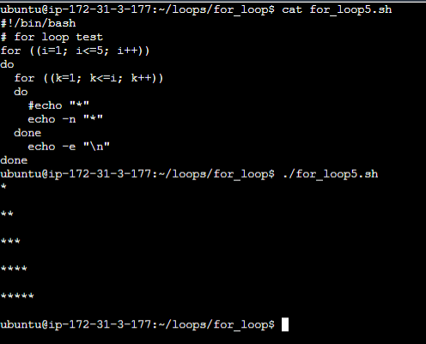

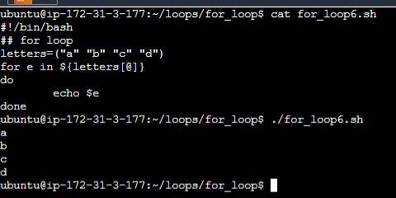

#### **While loop:**

In advance, if we don’t know how many times we have to repeat the loop and have to break the loop based on some condition, then we should go for “**while loop**”.

Syntax:

while [ **condition** ]

do

done

**Example: -**

##### Write a program to print the numbers until number reaches to 5.

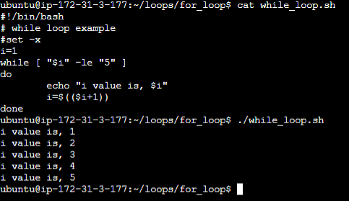

##### Write a program to calculate factorial for given number.

