**Assignment:**



# Task-1 Establish a new directory

**[comment]:** using **mkdir** command, created a new directory.

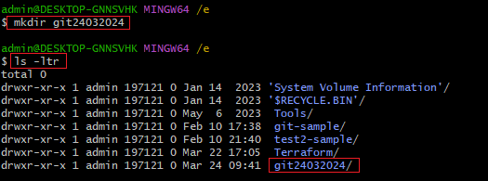

# Task-2 populate it with script files

**[comment]:** using touch command, created 5 sample .sh files.

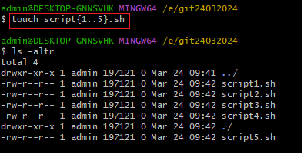

**[comment]:** write some content to each individual sample scrip files.

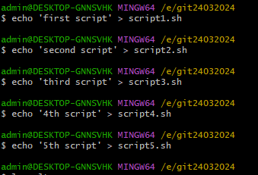

[comment]: view content in each file

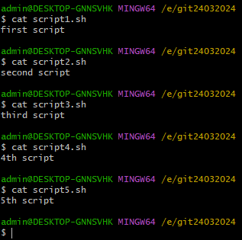

# Task-3 initiate an empty repository on **GitHub**

Go to “**your repositories**”

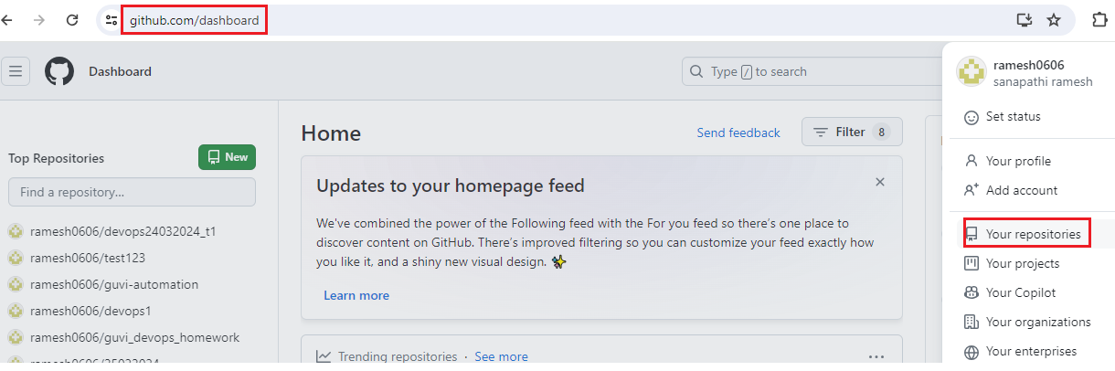

Click on “**New**”

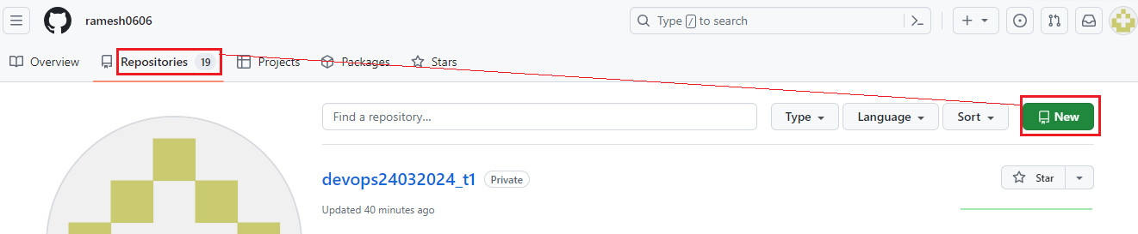

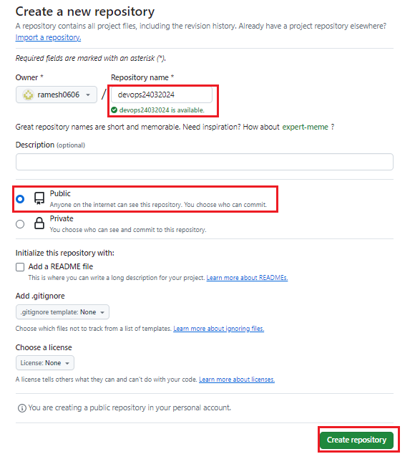

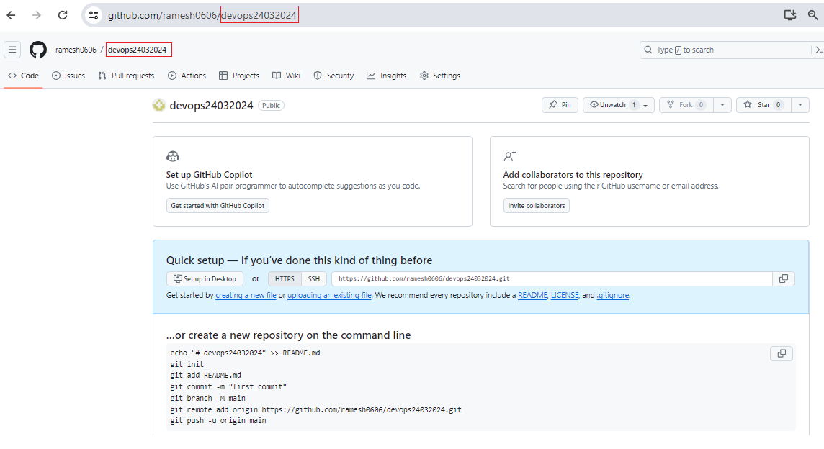

# Task-4 convert the **local directory** into a **Git repository**

[comment]: we need to run “**git init**” command to convert local directory as **git repository**.

Before run **“git init”**

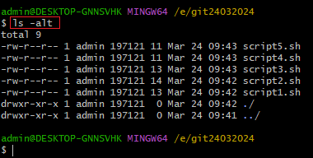

After run “**git init**” command, ‘**.git’** folder gets created.

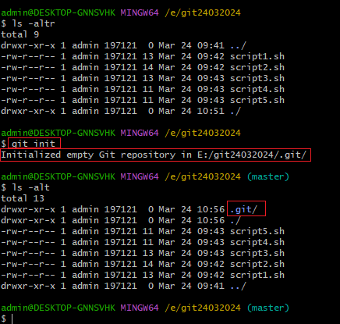

Go to **“. git”** directory and look what are various files are available inside it.

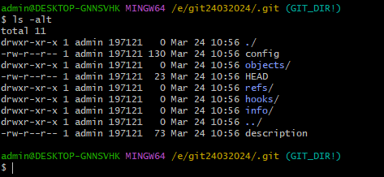

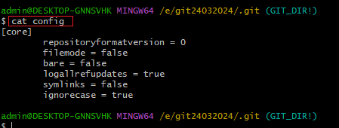

# Task-5 link it to GitHub for pushing the code into the repository.

Run the below command on local directory to establish a connection between **local git repository with GitHub**

git remote add origin https://github.com/ramesh0606/devops24032024.git

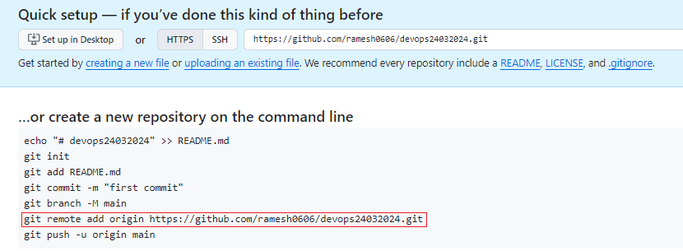

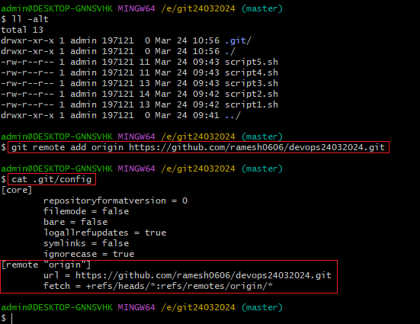

# Task-6:  pushing the code into the repository [**devops24032024**]

## Check the content on GitHub repository before pushing the code:

As shown below, it is empty GitHub repository and no files exists.

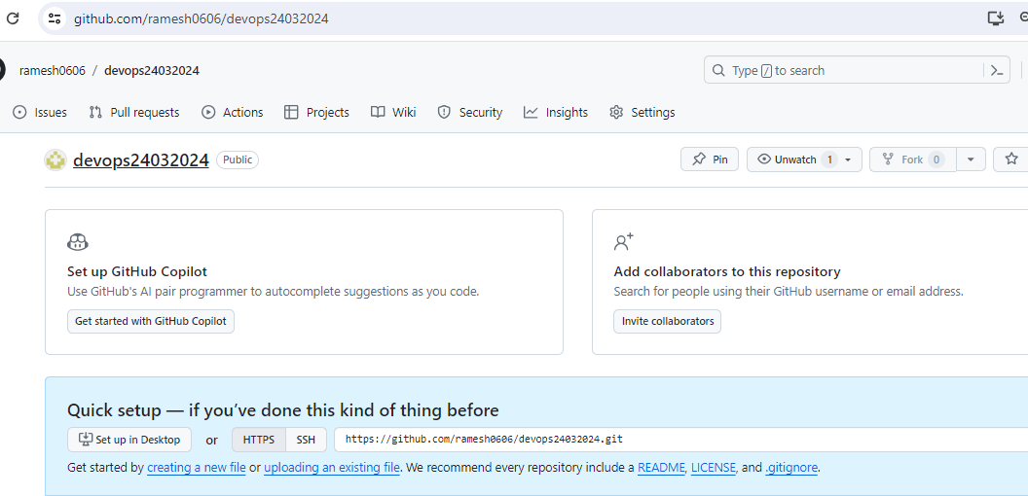

## Check the content on GitHub repository after pushing the code:

