# **Assignment :**

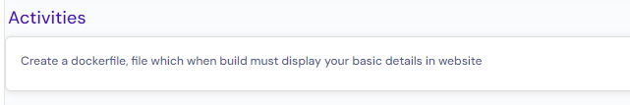

# Dockerfile Definition:

Dockerfile is a text file in which a set of instructions defined to build an image.

Using image, container is created.

Using Dockerfile, image is created.

# “Ways to create an image using dockerfile”:

## **Scenario-1 (If dockerfile name is “Dockerfile”):**

Run below command in same path where Dockerfile exists to create an image.

“docker build -t image_name: tag_name .”

Note: - By default, dockerfile name should be “Dockerfile” (Capital “D”, small “f”). But, we can have any other different name. in case, if we have different dockerfile name instead of default name “Dockerfile”, then we should use below command.

## **Scenario-2 (If dockerfile name is not “Dockerfile”):**

“docker build -t image_name: tag_name -f **filename**”

# **Dockerfile Description:**

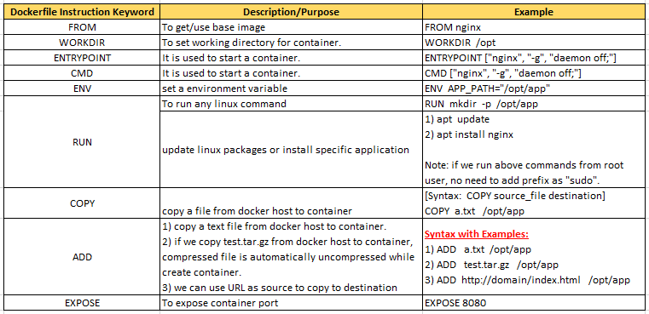

# **Scenario: Write a sample Dockerfile with set of instructions to create nginx image on Ubuntu OS.**

## **Implementation:**

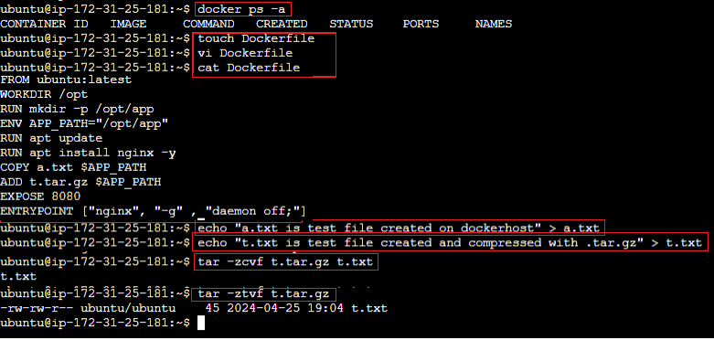

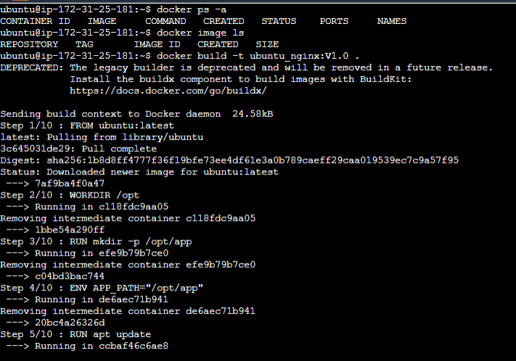



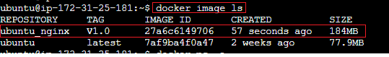



## **Verification:**

When we tried to access as <http://pubic_ip:8080>, if nginx default page not displayed, then add port “8080” in inbound security rule of that security group of that EC2 instance.

