**Task 1**

Given a list of strings - List[String] (“alpha”, “gamma”, “omega”, “zeta”, “beta”)

- Find count of all strings with length 4.

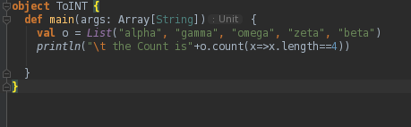

Output

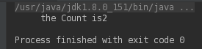

**- Convert the list of string to a list of integers, where each string is mapped to its**

**corresponding length.**

**Code**

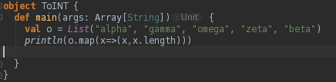

Output

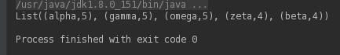

**Find count of all strings which contain alphabet ‘m’.**

**Code:**

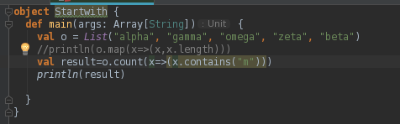

Output:



**Find the count of all strings which start with the alphabet ‘a’.**

**Code**

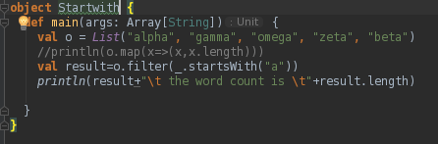

Output:

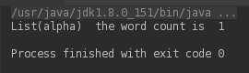

**TASK-2**

**Create a list of tuples, where the 1st element of the tuple is an int and the second**

**Element is a string.**

**- For the above list, print the numbers where the corresponding string length is 4.**

**CODE:**

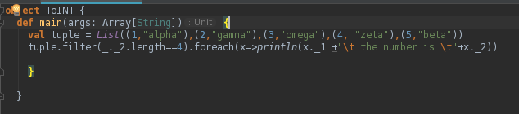

**Output:**

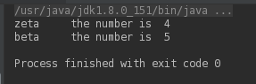

**- find the average of all numbers, where the corresponding string contains alphabet ‘m’**

**or alphabet ‘z’.**

**CODE:**

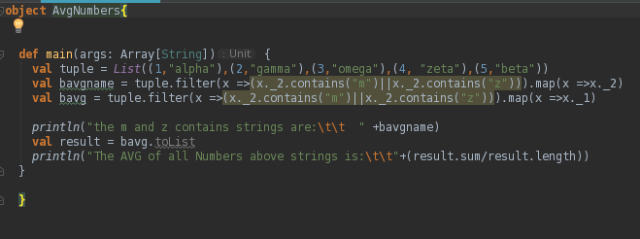

**OUTPUT:**

