Details of the Data Set:
The MSD challenge tests the generalisability of machine learning algorithms when applied to 10 different semantic segmentation tasks. The aim is to develop an algorithm or learning system that can solve each task, separateley, without human interaction.
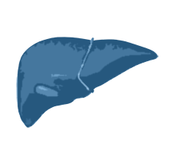

1) Liver Tumours
Target: Liver and tumour
Modality: Portal venous phase CT
Size: 402 3D volumes (262 Training + 140 Testing)
Source: IRCAD Hôpitaux Universitaires
Challenge: Label unbalance with a large (liver) and small (tumour) target
Image Size : (512, 512, 565)
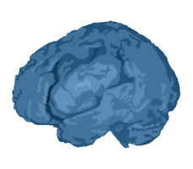

2) Brain Tumours
Target: Gliomas segmentation necrotic/active tumour and oedema
Modality: Multimodal multisite MRI data (FLAIR, T1w, T1gd,T2w)
Size: 750 4D volumes (484 Training + 266 Testing)
Source: BRATS 2016 and 2017 datasets.
Challenge: Complex and heterogeneously-located targets
Image Size: ( 240, 240, 155, 4)



3) Hippocampus
Target: Hippocampus head and body
Modality: Mono-modal MRI
Size: 394 3D volumes (263 Training + 131 Testing)
Source: Vanderbilt University Medical Center
Challenge: Segmenting two neighbouring small structures with high precision
Image Resolution: (39, 47, 36)



4) Lung Tumours
Target: Lung and tumours
Modality: CT
Size: 96 3D volumes (64 Training + 32 Testing)
Source: The Cancer Imaging Archive
Challenge: Segmentation of a small target (cancer) in a large image
Image Size :(512, 512, 373)

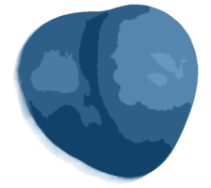

5) Prostate
Target: Prostate central gland and peripheral zone
Modality: Multimodal MR (T2, ADC)
Size: 48 4D volumes (32 Training + 16 Testing)
Source: Radboud University, Nijmegen Medical Centre
Challenge: Segmenting two adjoint regions with large inter-subject variations
Image Size :(320, 320, 20, 2)

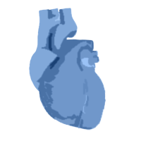

6) Cardiac/ Heart
Target: Left Atrium
Modality: Mono-modal MRI
Size: 30 3D volumes (20 Training + 10 Testing)
Source: King’s College London
Challenge: Small training dataset with large variability
Image Size : (320, 320, 140)

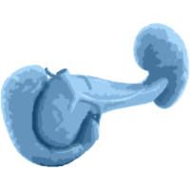

7) Pancreas Tumour
Target: Liver and tumour
Modality: Portal venous phase CT
Size: 420 3D volumes (282 Training +139 Testing)
Source: Memorial Sloan Kettering Cancer Center
Challenge: Label unbalance with large (background), medium (pancreas) and small (tumour) structures.
Image Size : (512, 512, 103)

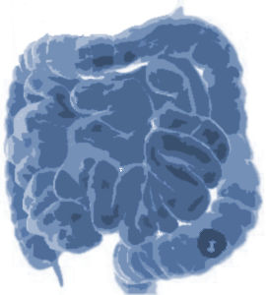

8) Colon Cancer
Target: Colon Cancer Primaries
Modality: CT
Size: 190 3D volumes (126 Training + 64 Testing)
Source: Memorial Sloan Kettering Cancer Center
Challenge: Heterogeneous appearance
Image Size :(512, 512, 81)

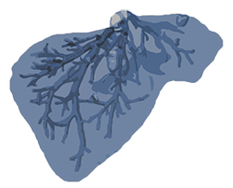

9) Hepatic Vessels
Target: Hepatic vessels and tumour
Modality: CT
Size: 443 3D volumes (303 Training + 140 Testing)
Source: Memorial Sloan Kettering Cancer Center
Challenge: Tubular small structures next to heterogeneous tumour.
Image Size : (512, 512, 55)

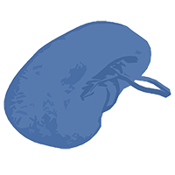

10) Spleen
Target: Spleen
Modality: CT
Size: 61 3D volumes (41 Training + 20 Testing)
Source: Memorial Sloan Kettering Cancer Center
Challenge: Large ranging foreground size
Image Size :(512, 512, 36)

Results of Basic U Net Example

