Release Notes
- This is the first version of the release of the XYZ.EntLib.Dll solution. Its main requirements are to use Microsoft Ent Lib 3.1 and establish a common or public interface of logging, exception handling, validation, data access etc. relevant to the organization. XYZ here stands for the name of an organization. In this case a simple organization that is building an app called CVWiz.
- Detailed logging of assembly, process, startup, environment, host, exception app blocks etc. apart from standard logging.
- Logging integrated with Ent Lib. Formatters of type XML, HTML and Text app blocks are developed for all the types of log information.
- Database, FlatFile and Email listeners or app blocks developed, that will log messages selectively to the database. The DB model is comprehensive to store exception, diagnostic information.
- A unified a data layer that uses XSD Dataset adapter to accomplish tasks of persisting data in targets like files or database and at the same time used for browsing the errors or log messages from the log message center site.
- A log message center site that shows messages logged by all the applications in an organization along with the ability to view details of each message.
- A sample config. file that specifies a way of using the XYZ.EntLib.Dll in a standard way.
- 2 test programs, one a test web site and the other a winforms test app, to test the functions of the XYZ.EntLib.Dll.

Setup of XYZ.EntLib.Dll Solution
- Unzip the given file XYZ_EntLib_V10.zip to a root folder (XYZ.EntLib) (need not be under inetup).
- Create the XYZ.EntLib.Site which is the message center using IIS by creating a virtual directory for Unzipped Folder\XYZ_EntLib_V10\XYZ.EntLib.Site
- Create the XYZ.EntLib.Test.Site which is the test site using the IIS by creating a virtual directory for Unzipped Folder\XYZ_EntLib_V10\XYZ.EntLib.Test.Site
- For both the web sites, set default.aspx as the default document.
- Download and Install Microsoft Enterprise Library V 3.1.
- Open the Unzipped Folder\XYZ_EntLib_V10\XYZ.EntLib_V10.sln file in MS VS 2005.
- The solution should load four projects,
  - The 2 web sites mentioned above.
  - The main project XYZ.EntLib.Dll
  - The XYZ.Test application.
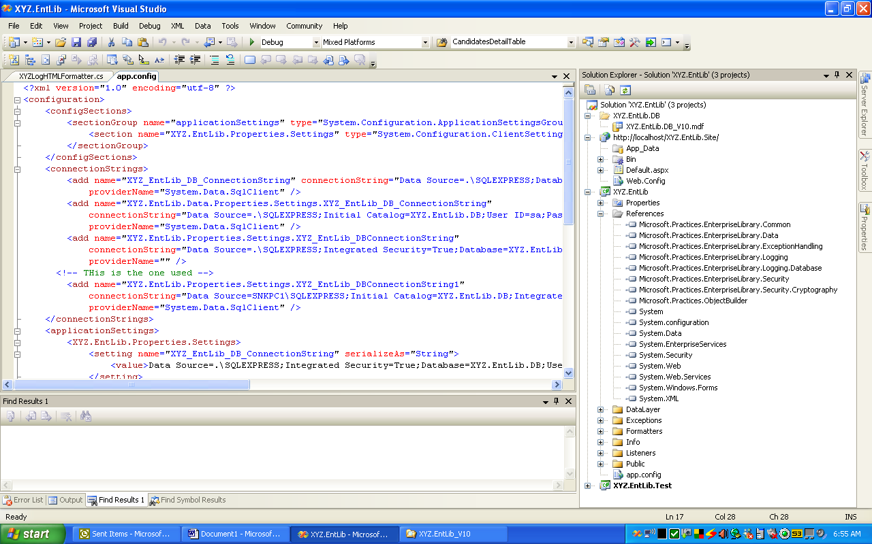
- Make sure the references are correct.
- Set the references for XYZ.EntLib.Dll
  - This uses the Logging, Exception Handling, Security, Cryptography, common and object builder dlls and few more.
  - IMPORTANT. Browse only to the “weak signed dlls”. That is not use the dlls with the strong name in the MS Ent Lib Install Folder/bin directory. Instead browse to MS Ent Lib Install dir/App Blocks/Src/Logging, validation etc.. bin/debug/ folder.
- Set XYZ.EntLib as the “Project” reference to other projects. Showld already be set actually.
- Build the solution. All the 4 projects should build successfully. Correct any incorrect/missing references to MS EntLib dlls.
- Setup the XYZ.EntLib Dalabase. Attach the database permanently to SQL Server Express 2005. Use Integrated Security for connection always in the connection string. Check app.config for connection string. Make sure it is correct.
- Run the Test site and the test app.
- Open the Log Message center website and check for tested messages.

