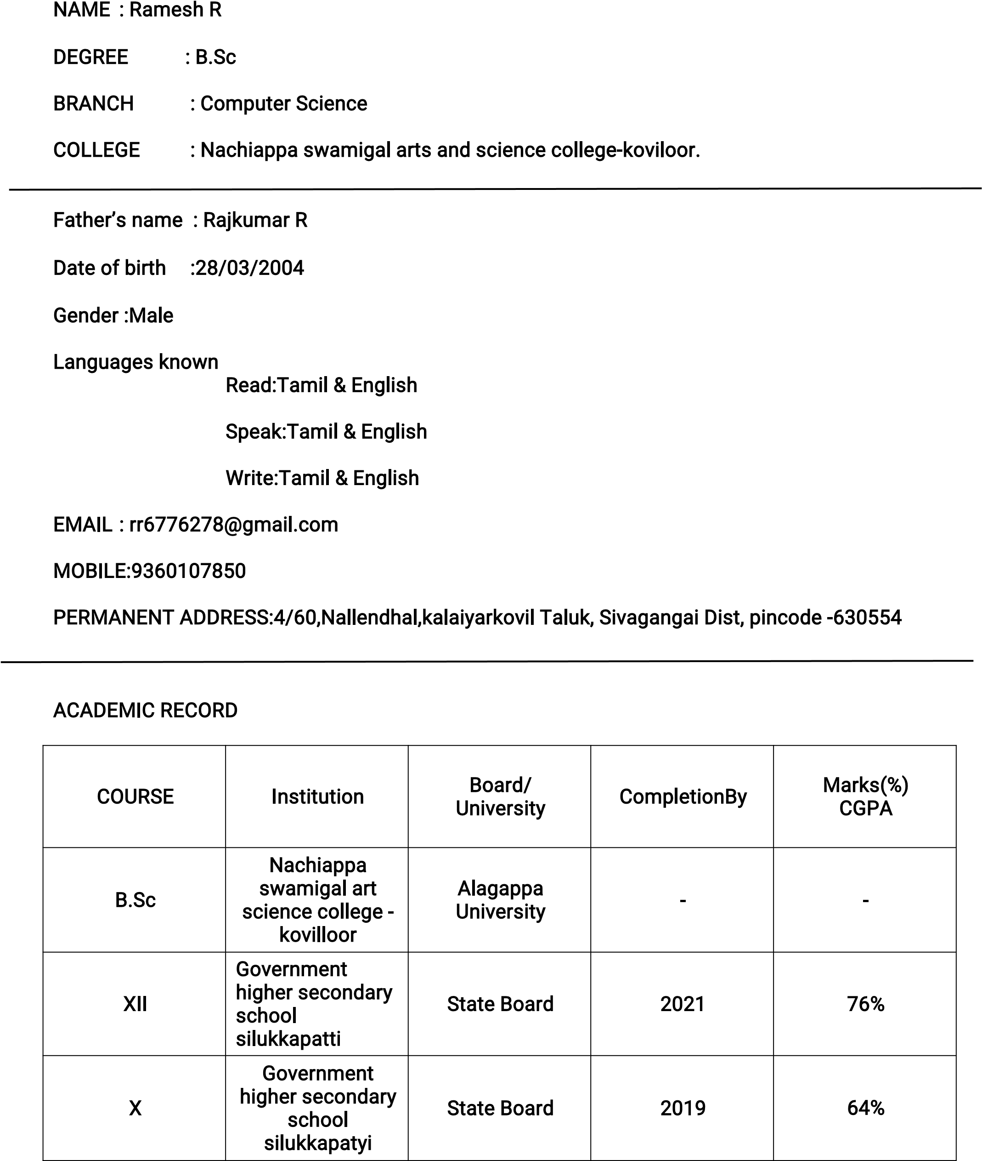

SKILL SET

* Proficient in Python Programming
* Expertise in Ambiance and Design Strategies
* Strong Event Management Capabilities - Demonstrated Leadership Skills

HOBBIES

* Art and Painting Enthusiast
* Avid Reader
* Freelance Interior Designer

EXTRACURRICULAR ACTIVITIES

* Fine Arts Club: Served as a dedicated member
* CAP and Nature: Active participation in environmental initiatives
* Hostel Floor Representative: Provided exceptional service and support
* Engaged in various Drawing and Painting Competitions showcasing talent

DECLARATION

I Ramesh R,do here by confirm that the information given above is true to the best of my knowledge.

Place ~~:~~ Koviloor R. Ramesh

Date ~~:~~ 26/10/2023

