OCI Cloud Adoption Framework (CAF)

Contents

1. Introduction 2
Technology Implementation 2
Deciding on Which Landing Zone to Use? 3
1. Enterprise scale baseline landing zone 3
2. Start small and scale landing zone 3
3. Self-service landing zone 3
Extreme Reliability, High Availability, and Disaster Recovery 3
2. CAF Landing Zone 4
a. Deploying the CAF landing zone 4
b. Primary Objectives of CAF Landing Zone 5
c. Key Design Principles 5
d. Architecture Overview 5
3. Domains 6
4. Tenancy Management 7
5. Compartments 7
6. Tags 8
7. Budgets and Alerts 9
8. IAM 9
9. Security 14
10. Cloud Guard 15
11. Bastion 17
12. Cloud Guard 19

Introduction

Technology Implementation

The technology implementation pillar focuses on transforming your governance and security model into a cloud environment that is deployed to meet any organization's needs. Organizational goals are technically implemented by deploying a landing zone.

A landing zone is a cloud environment that is built from an automated template. The landing zone serves as the foundation for cloud deployment. After creating the landing zone, migration of existing on-premises data-center solutions or creating new cloud native solutions that address the business goals conveniently.

Deciding on Which Landing Zone to Use?

OCI provides multiple landing zones implementations to choose from:

- Enterprise scale baseline landing zone
- Start small and scale landing zone
- Self-service landing zone

Enterprise scale baseline landing zone

- The comprehensive version of the Cloud Adoption Framework (CAF) landing zone.
- This reference architecture provides an enterprise-scale architecture and deployment that includes designs for governance, security segmentation, and separation of duties.
- Deploy multiple workloads with separate networks for isolation and access, add private connectivity to the environment from on-premise locations by using Fast-Connect or Site-to-Site VPN, and optionally federate with Microsoft Active Directory.

Start small and scale landing zone

- The quick-start version of the CAF landing zone.
- This reference architecture provides a basic template for deployment that lets specify preconfigured security settings for Audit logs and protocols for the Bastion service.

Self-service landing zone

- This reference architecture provides a Terraform-based landing zone template that meets the security guidance prescribed in Deploy a secure landing zone that meets the CIS Foundations Benchmark for Oracle Cloud.

Extreme Reliability, High Availability, and Disaster Recovery

A well-architected disaster recovery (DR) plan enables you to recover quickly from disasters and continue to provide services to your users. High availability (HA) systems are designed to ensure that they have the maximum potential for uptime and accessibility. Use the principles of high availability and disaster recovery to design cloud architecture for extreme reliability.

This pillar includes the following capabilities:
- Extreme Reliability
- High Availability
- Disaster Recovery

CAF Landing Zone

The Cloud Adoption Framework (CAF), landing zone provides the baseline architectural framework for organizations to deploy new projects and workloads on OCI. The landing zone consists of Terraform modules, the architectural documentation in this section, and an implementation guide. The landing zone helps quickly and securely to create a foundation for cloud deployment based on Oracle recommendations, customer experience, and industry-standard best practices.

- The CAF landing zone creates infrastructure that consists of compartments, networking resources, and security at the infrastructure layer.
- Migrating or developing workloads is not in scope for the CAF landing zone. However, setting up the right infrastructure is often the first step to migrating workloads to the cloud or developing cloud-native workloads successfully.

Deploying the CAF landing zone

CAF landing zone is deployed as either
- a comprehensive version (the enterprise scale baseline landing zone) or
- a start small and scale version.

- Comprehensive version: The enterprise scale baseline landing zone includes an implementation guide and architectural guidance. Deploy multiple workloads with separate networks for isolation and access, add private connectivity to your environment from on-premise locations by using Fast-Connect or Site-to-Site VPN, and optionally federate with Microsoft Active Directory. Install the enterprise scale baseline landing zone using the Console, Resource Manager, or the Oracle Cloud Infrastructure Terraform provider.

https://github.com/oracle-quickstart/oci-enterprise-scale-baseline-landing-zone

- Start small and scale version: The start small and scale landing zone includes a limited set of functionality that gets started with the CAF landing zone. Install the start small and scale landing zone from the Deploy a baseline landing zone Quick-starts card on the Console home page.

Primary Objectives of CAF Landing Zone

The primary objectives of the CAF landing zone include the following items:
- Reduce time-to-start and deploy
- Provide an architecturally strong foundation
- Maintain the flexibility to customize and evolve the implementation to your organization's needs

Key Design Principles

Key design principles for resiliency and security ensure that the CAF landing zone deploys a strong foundation for cloud environment.

- Resiliency
A resilient cloud architecture helps you to avoid single points of failure for your cloud-based workloads.
At the infrastructure level, OCI provides physical and logical resources to help you design for resiliency, such as regions, availability domains, and fault domains.
Resiliency depends on the nature, architecture, and implementation of the workloads that you plan to deploy on OCI.

- Security
The CAF landing zone follows best practices for security design principles.
  - Design for attackers
    - Limit permissions based on requirements
    - Enforce network segmentation
  - Leverage native controls
  - Use identity as primary access control
  - Accountability
  - Embrace automation
  - Focus on information protection
  - Design for resilience
    - Ongoing vigilance
    - Defense in depth
    - Defense at edge
    - Least privilege
  - Assume zero trust

Architecture Overview
The CAF landing zone creates an architectural framework that's ready for you to launch new projects and workloads on OCI.

Compartments: Use compartments to organize and isolate your resources to make it easier to manage and secure access to them.

Tags: Use tags to organize and list resources based on your business needs.

Budgets and Alerts: Use budgets to set soft limits on your OCI spending, and use alerts to let you know when you might exceed your budget.

Oracle Cloud Infrastructure Identity and Access Management (IAM): Use IAM to control access to manage cloud resources on OCI.

Networking and connectivity: Create a virtual cloud network (VCN), subnets, and other networking and connectivity resources that are required to run workloads and connect to the internet or on-premises network.

Security: Enable a strong security posture by enabling OCI security services such as Oracle Cloud Guard, Oracle Vulnerability Scanning Service, and Oracle Cloud Infrastructure Bastion

Domains

New tenancies are now shipped with merged IDCS capabilities.
Please follow the Tenancy setup and organization design document to 'Create secondary domain' i.e. secondary. This activity is a predecessor to onboard Terraform to launch the scripts that creates resources going forward.

Attribute | Value
Domain name | Default.  Updating the Identity domains: default - Out of the box. This will have terraform account initially. Secondary - Custom as Oracle Apps premium. This domain can have federated and local users.
Description | Created using. Last modified MM-DD-YYYY. Related Confluence page number or user story etc. TBD?
Domain Type | : Free (Other domain types come at a cost - TBD). Can be changed later, a few restrictions apply - Refer to above link
Domain administrator | No (Don't create additional. To centrally manage all domains by Tenancy / Default domain administrator)
Compartment | Root
Tags | TBD

Tenancy Management

Refer OCI_Tenancy_management document enclosed.
OCI Domain, Organization setup for oftprism

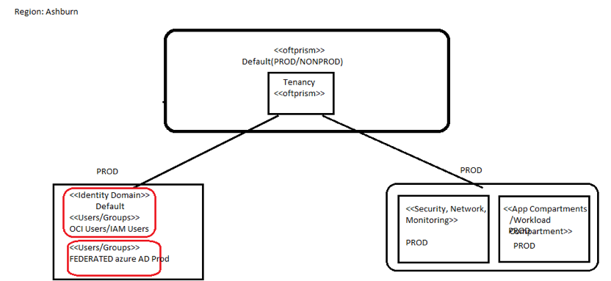

Securing the Tenancy:
- Identity Domains
  - Will exist when the tenancy is originally created, and will host people (users) temporarily until we have Azure AD Federation setup and possibly a few break-grass accts once Azure AD is done
  - Will exist on-going for the tenancy as well for local resource service-accts (and possibly break-glass)
  - This means we need OCI IAM group / role structures to support these localized service-acct (and temporary) groups
- Azure AD/SSO PROD
  - All our tenancies will leverage PROD AD for SSO, for any people (customer’s users) who need access to OCI (administration, developers, etc)
  - This means we need groups defined and synced between AD and OCI in the AD federation and OCI IAM Groups (mapped)
    - And as such, and these groups will need to co-exist with the IAM group structure to support the above co-existed Default Domain identities)
  - It will be important to note that we will not federated AD groups across tenancies
  - At this time we will not leverage AD for the ‘service-accts’ for OCI itself, as these will be local groups

Compartments

Compartments can be used to organize and isolate your resources to make it easier to manage and secure access to them. The CAF landing zone creates a compartment structure for your organization. Controlling access to compartment is obtained by creating policies that specify what actions groups of users can take on the resources in those compartments. The following diagram shows the compartments that are created by the CAF landing zone.

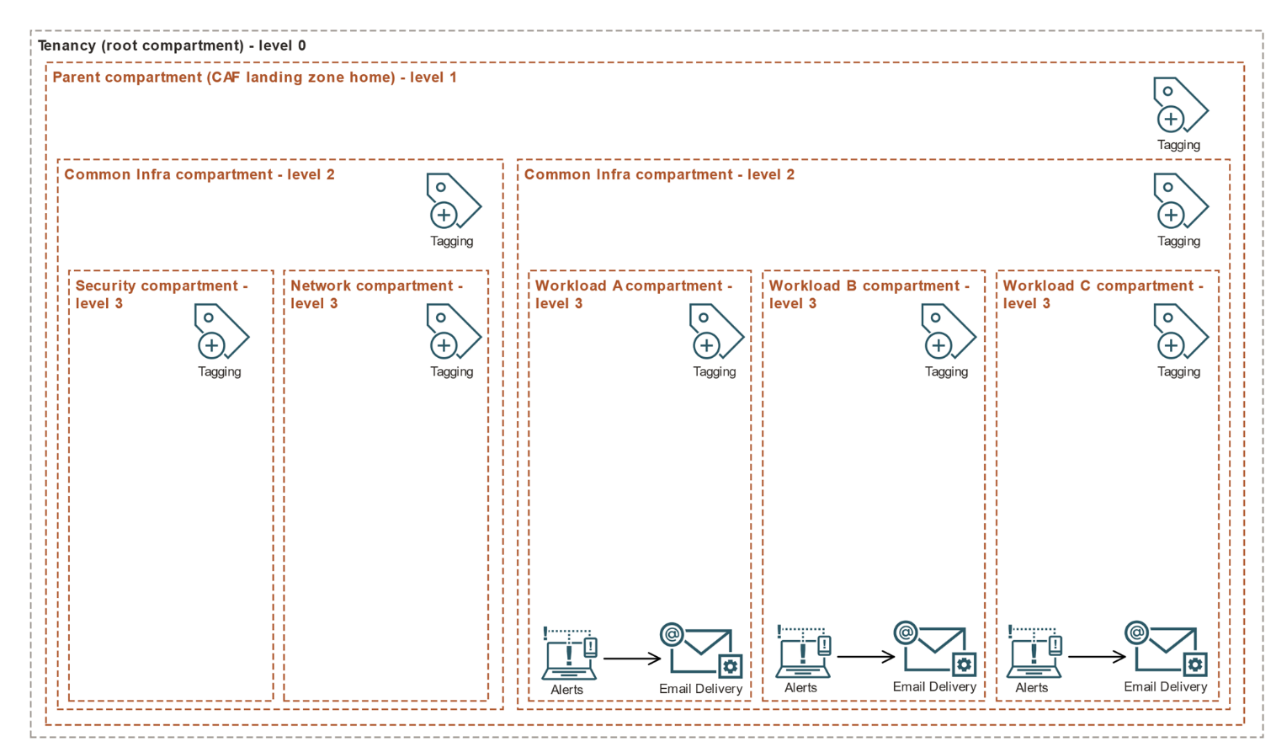

Tags

The CAF landing zone creates a basic tagging structure to help manage resources.

- Tagging allows defining keys and values and associating them with resources. Tags also help you organize and list resources based on your business needs.
- As part of the CAF landing zone deployment, the resources that are created by the landing zone are assigned tags for cost center and geographic location.
- Defining values for these tags that will help identify and separate resources based on organization's workloads. It’s recommended to map the cost center tag to a project or line of business that a workload supports.
- The geographic location should be defaulted to the OCI region is where workload runs.

Budgets and Alerts

The CAF landing zone configures basic budgets and alerts to help you manage your resources.
- A budget can be used to set soft limits on your OCI spending.
- Set alerts on budget intimate if exceeded budget, and track and view all of the budgets and spending from one single place in the Console.
- The CAF landing zone creates the necessary resources to use budgets and alerts, including a threshold metric for alerts and an email recipient to receive the alerts.

IAM

- Use Oracle Cloud Infrastructure Identity and Access Management (IAM) to control access to cloud resources on OCI.
- The CAF landing zone creates IAM groups and policies that control access to the resources created by the landing zone. Optionally, with the enterprise scale baseline landing zone, federation with Microsoft Active Directory can be obtained.
- It is highly recommended to create one or more break-glass users during deployment, especially while using federation. Break-glass users are administrators who have emergency access to all Oracle Cloud Infrastructure services and resources in the tenancy.

Non-Federated Setup
For non-federated users, the CAF landing zone creates IAM groups and policies.

Federating with Microsoft Active Directory
- Microsoft Active Directory can optionally federate with the enterprise scale baseline landing zone.
- Use the same group names in Oracle Cloud Infrastructure as used for Active Directory.
- To do this, pass the Active Directory group names as variables to the enterprise scale baseline landing zone Terraform module. The groups will be created by the landing zone and mapped to your Active Directory groups.
- The following diagram shows the Microsoft Active Directory federation supported by the enterprise scale baseline landing zone.

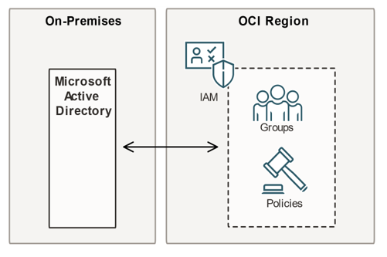

IAM Policies and Groups
- Oracle Cloud Infrastructure Identity and Access Management (IAM) lets control who has access to specific cloud resources and what type of access a group of users has.
- The enterprise scale baseline landing zone provisions IAM groups with established roles and access levels. Each IAM group is referenced in IAM policies that grant access to the associated resources.
- All groups belong to the parent compartment. Each policy belongs to the compartment that is closest to the resource that it controls access to.
- The enterprise scale baseline landing zone stack provisions the groups and IAM policies listed in the following table.
- To override the default group names, update the Terraform variables when you create the stack. For example, groups can be renamed to fit the organizational structure or to map with a federated identity service.

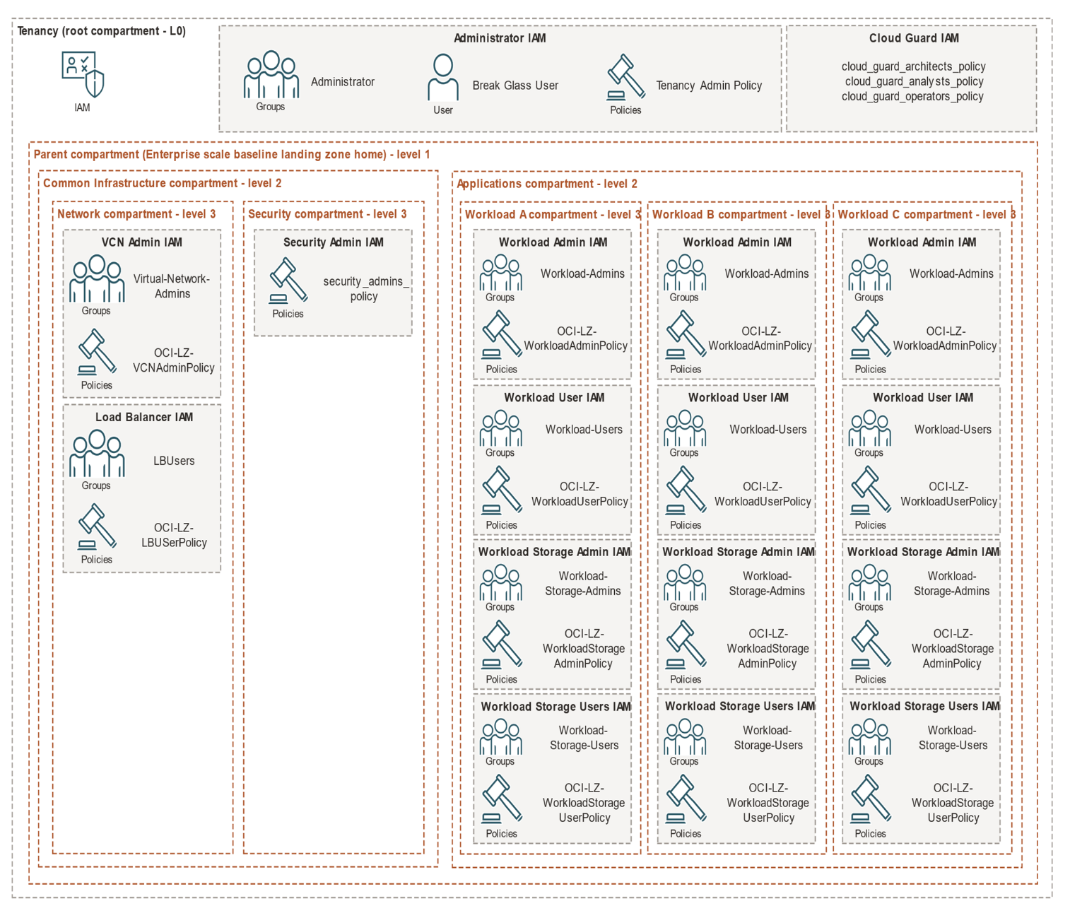

Networking and Connectivity
- The CAF landing zone helps you configure the network architecture for your organization's cloud deployment.
- The CAF landing zone creates a virtual cloud network (VCN) in the Network compartment.
- The name and the IPv4 CIDR blocks are chosen for the VCN. It’s recommended to use a single VCN with multiple subnets, and deploy each workload on its own subnet.
- This will lead to better network isolation for your workloads. Because of this, ensure that you create the VCN with a large enough CIDR range for your workloads.

The following diagram shows the VCN that is created by the CAF landing zone.

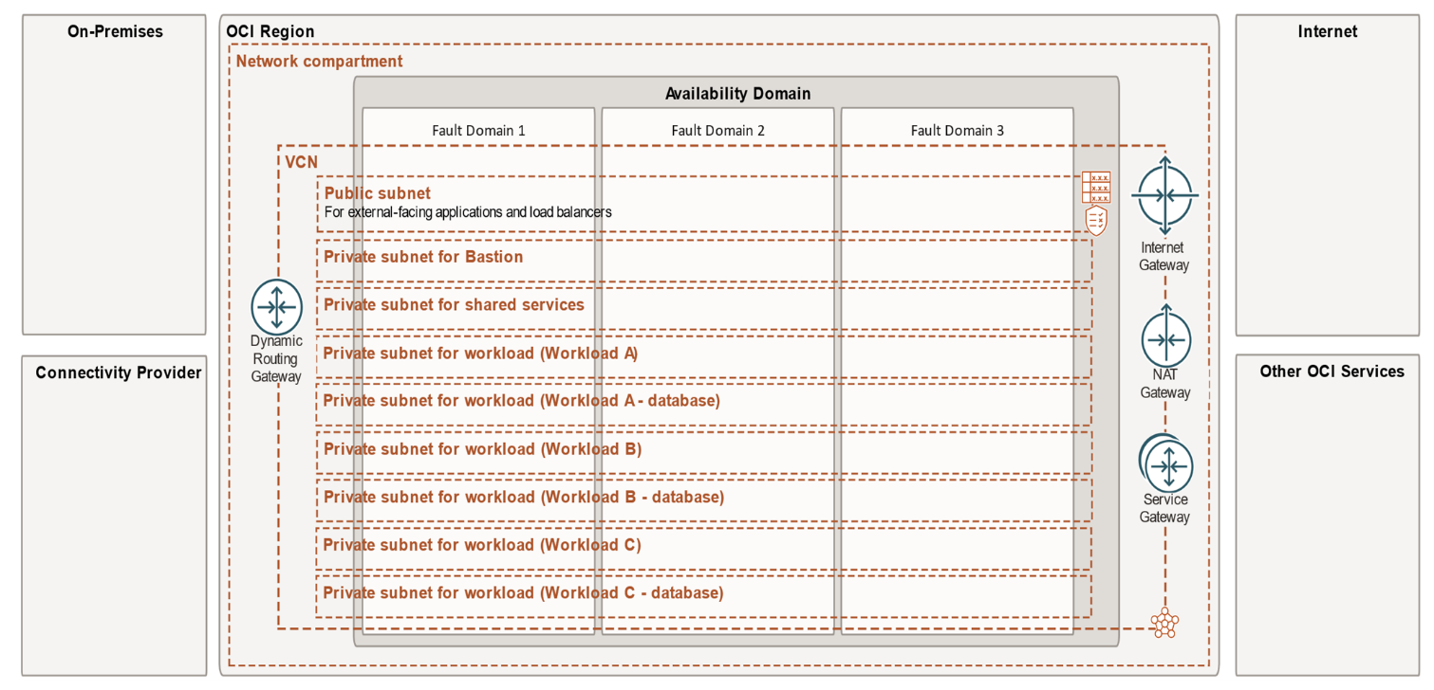

Subnets

The CAF landing zone creates public and private subnets within the VCN.

Subnet-Public: A public subnet to host all internet-facing servers and resources, including load balancers. This subnet must be secured with the correct Cloud Guard recipes and other security features, as described in Security.

Subnet-Shared Services: A private subnet to host all common or shared services that organization uses. Depending on your applications, you must create security lists to allow the network traffic between servers in cloud tenancy (east/west traffic) to enter and exit this subnet. Create security lists during the deployment of workloads.

Subnet Bastion Service: A private subnet to host the Bastion service. Bastion provides restricted and time-limited access to target resources that don't have public endpoints. Configuring bastions is important to ensure that organization's cloud administrators can access resources that reside in private subnets.

Subnet - <Workload>: A private subnet that you should use to host all resources that are needed by a specific workload, with the exception of databases. Multiple subnets can be created, one for each workload.

Subnet - <Workload> - Database Services: A private subnet to host database resources for your applications. You can create multiple subnets, one for each workload's database resources.

Gateways

The CAF landing zone creates the gateways that your applications might need to connect with Oracle Cloud Infrastructure services and the internet, plus the basic components to control access.

Internet gateway: A virtual router that connects the edge of the VCN with the internet to allow direct connectivity to the internet. The CAF landing zone creates an internet gateway, and the following components along with the internet gateway:

- Security lists: Security lists are virtual firewalls that let you control ingress and egress traffic. The CAF landing zone creates a security list associated with the internet gateway. The actual ingress and egress rules will depend on workloads and the traffic that is only allowed. Configure the ingress and egress rules when you move your workloads to OCI.

Note: The CAF landing zone creates stateful security lists. If you have a public-facing application or load balancer that requires you to support a very large number of connections, we recommend that you create stateless security lists. For more information, see Stateful Versus Stateless Rules.

- Route table: Route tables are used to map the traffic of a VCN from subnets through gateways to external destinations. The CAF landing zone creates a route table that is associated with the internet gateway. You must create rules in the route table to allow necessary traffic to go to the internet gateway. The rules will depend on your workloads.

Network Address Translation (NAT) gateway: A NAT gateway gives cloud resources without public IP addresses access to the internet without exposing those resources to incoming internet connections. The CAF landing zone creates a NAT gateway for the landing zone deployment. It also creates a route table and route rule to route traffic from each of your workload compartments. The actual route rules will depend on your workloads. Create the rules when you move your workloads to OCI.

Private endpoints: A private endpoint is a private IP address within your VCN that you can use to access a given service within OCI. The CAF landing zone creates private endpoints to access the following Oracle Cloud Infrastructure services: Autonomous Database, Streaming, Data Safe, Data Catalog, Analytics Cloud, and Data Flow. We recommend that you use private endpoints if your workloads need to connect with any of these services.

Service gateway: A service gateway enables cloud resources without public IP addresses to privately access Oracle services without the traffic going over the internet. The CAF landing zone creates a service gateway. You must create service CIDR labels, route rules, and security rules for the service gateway when you move your workloads to OCI. The configuration will depend on your workloads.

Connectivity
The enterprise scale baseline landing zone can optionally configure dynamic routing gateways (DRGs) using Site-to-Site VPN or FastConnect.

- Site-to-Site VPN: A site-to-site IPSec connection between your on-premises network and your VCN. Provide the IP address of your customer-premises equipment (CPE) to the landing zone Terraform module. Also provide the static routes for the IPSec connection.
- FastConnect: A dedicated, private connection between your data center and Oracle Cloud Infrastructure, using your choice of Oracle partners. In addition to selecting an Oracle partner, also provide the following information:
o FastConnect routing policy
o Virtual circuit bandwidth shape
o Virtual circuit cross connect mapping - customer Border Gateway Protocol (BGP) peering
o Virtual circuit cross connect mapping - Oracle BGP peering
o Virtual circuit customer autonomous system number (ASN)

Security

The CAF landing zone helps you configure security architecture for your organization's cloud deployment.
  - Security features are deployed in the Security compartment.
  - Depending on an organization's structure, a cyber security or cloud platform team typically manages the security functions for tenancy.
  - The following diagram shows the reference architecture for security features in the CAF landing zone.

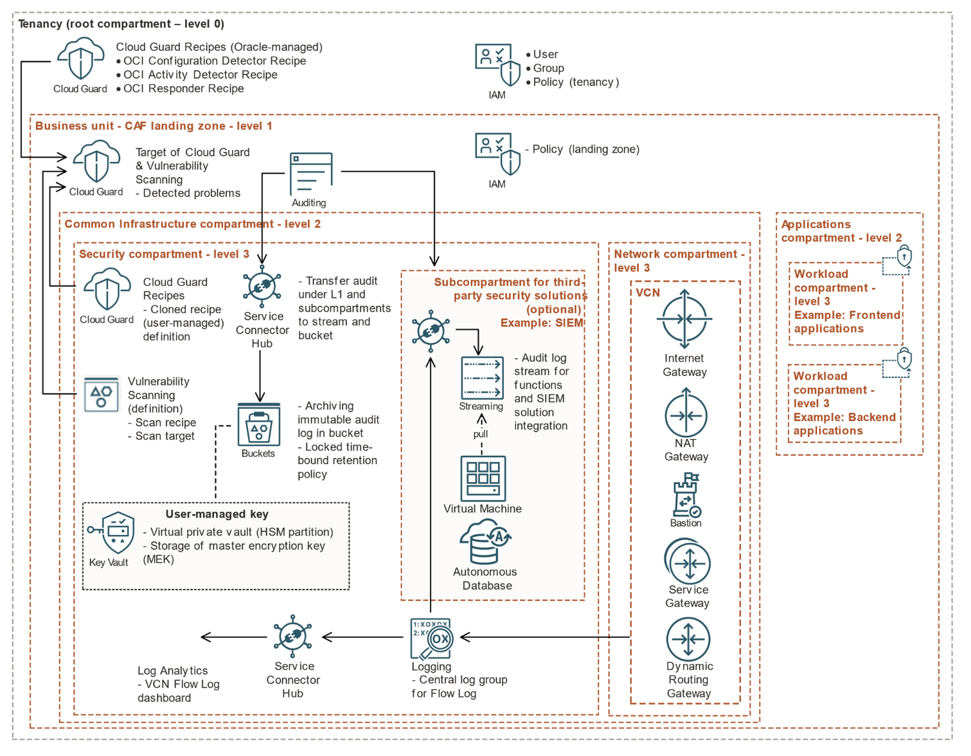

Cloud Guard

Use Cloud Guard to manage the security of cloud resources in alignment with Oracle best practices.

Cloud Guard is a cloud-native service that helps customers monitor, identify, achieve, and maintain a strong security posture on Oracle Cloud. Use the service to examine Oracle Cloud Infrastructure resources for security weakness related to configuration, and Oracle Cloud Infrastructure operators and users for risky activities. Upon detection, Cloud Guard can suggest, assist, or take corrective actions, based on configuration.

Use Oracle-managed recipes as the baseline starting point. Available recipes include:
- OCI Configuration Detector recipe: Set of rules designed specifically to detect resource configuration settings that could pose a security problem.
- OCI Activity Detector recipe: Set of rules designed specifically to detect actions on resources that could pose a security problem.
- Responder recipe: Defines the action or set of actions to take in response to a problem that a detector has identified.

The CAF landing zone implements security best practices monitoring by enabling Cloud Guard at the tenancy level. It also enables security posture monitoring of the parent compartment by using Oracle-managed configuration detector recipes and activity detector recipes.

Note: To avoid potential application outages due to unexpected platform modification, responder recipes are not enabled. It is recommended to apply responder recipes after reviewing and testing for the organization.

Be aware of the following considerations:
- Cloud Guard administrator should review the detector recipes and customize the scope with conditional groups as needed.
- Before enabling the responder recipes and related policies, Cloud Guard administrator should review them with the stakeholders of any existing applications.
- Create customer-managed responder recipes and detector recipes by cloning Oracle-managed recipes as needed.

Vulnerability Scanning
- Vulnerability and port scanning is enabled for the parent compartment of the CAF landing zone.
- Vulnerability Scanning helps improve your security posture by routinely checking your cloud resources for potential vulnerabilities.
- The Scanning service also scans for ports in your compute instances that are unintentionally left open and might be a potential attack vector to your cloud resources, or enable hackers to exploit other vulnerabilities.
- A network mapper searches your public IP addresses for open ports.
- Agent-based scanning checks for open ports that are not accessible from public IP addresses.
- Administrator can extend the Scanning service to the tenancy level by defining a scan target at the root compartment with a standard recipe.

Important: Because Windows scanning does not include Open Vulnerability and Assessment Language (OVAL) data, we recommend that you do not rely solely on the Scanning service to ensure that your Windows instances are up to date and secure.

Prolonged Archiving of Audit Logs

Use retention rules to preserve Oracle Cloud Infrastructure Audit logs for long-term data governance, regulatory compliance, and legal hold requirements.

Be aware of the following considerations:
- By default, Audit logs are retained for 365 days. If your organization needs to meet compliance or other requirements, you can optionally archive Audit logs for a longer length of time by saving them in immutable storage written to Oracle Cloud Infrastructure Object Storage and Archive Storage buckets with locked, time-bound retention rules.
- You should deploy immutable Audit log archiving only when there is a strong business need to keep Audit logs for longer than the retention period.
- Review (or unlock) the retention rule within 14 days before it is locked.
o Locking a retention rule is an irreversible operation. Not even a tenancy administrator can delete a locked rule.
o There is a mandatory 14-day delay before a rule is locked. This delay lets you thoroughly test, modify, or delete the rule or the rule lock before the rule is permanently locked.
o A rule is active at the time of creation. The lock only controls whether the rule itself can be modified. After a rule is locked, only increases in the duration are allowed.
o Object modification is prevented and the rule can only be deleted by deleting the bucket. A bucket must be empty before it can be deleted.
o To avoid difficulties in cleaning up your testing environment, consider using a short retention period in non-production environments, such as one day.
  - By default, Oracle manages the keys that encrypt the Object Storage or Archive Storage buckets. If you want greater control over the lifecycle and use of your encryption keys, choose a key from a vault that you have access to.
  - After the audit log bucket is created, you can manually enable the write access logs to meet the Center for Internet Security (CIS) Oracle Cloud Infrastructure Benchmark.

Integrate logs with third-party security information and event management (SIEM) solutions using the Service Connector Hub and Streaming services

Bastion

- Bastion provides secured, session-based access to resources without public endpoints.
- Bastions let authorized users connect from specific IP addresses to target resources using Secure Shell (SSH) sessions. When connected, users can interact with the target Oracle Cloud Infrastructure resource by using any software or protocol supported by SSH. For example, using the Remote Desktop Protocol (RDP) to connect to a Windows host, or using Oracle Net Services to connect to a database.

Be aware of the following considerations:

A bastion is associated with a single virtual cloud network (VCN). You cannot create a bastion in one VCN and then use it to access target resources in a different VCN.
Bastions, like most Oracle Cloud Infrastructure resources, are subject to service limits. Request a service limit increase if needed, and consider sub compartments for your bastions as an alternative.

VCN Flow Logs

- Use VCN flow logs to view details about traffic that passes through your VCN.
- VCN flow logs help you to audit traffic and troubleshoot your network controls. After you enable VCN flow logs, they record traffic for the virtual network interface cards (VNICs) attached to compute instances in the subnet.
- Your operational teams can use the predefined VCN Flow Logs dashboard in Oracle Cloud Infrastructure Logging Analytics, or create custom dashboards to meet your organization's specific needs.

Managing Terraform State

    - The enterprise scale baseline landing zone in Resource Manager and the start small and scale landing zone in the Console Quick-starts manage Terraform state inherently as part of each landing zone deployment.
    - Store Terraform state within Oracle Cloud Infrastructure Object Storage if needed.

The following diagram shows the IAM groups and policies that are created by the enterprise scale baseline landing zone.

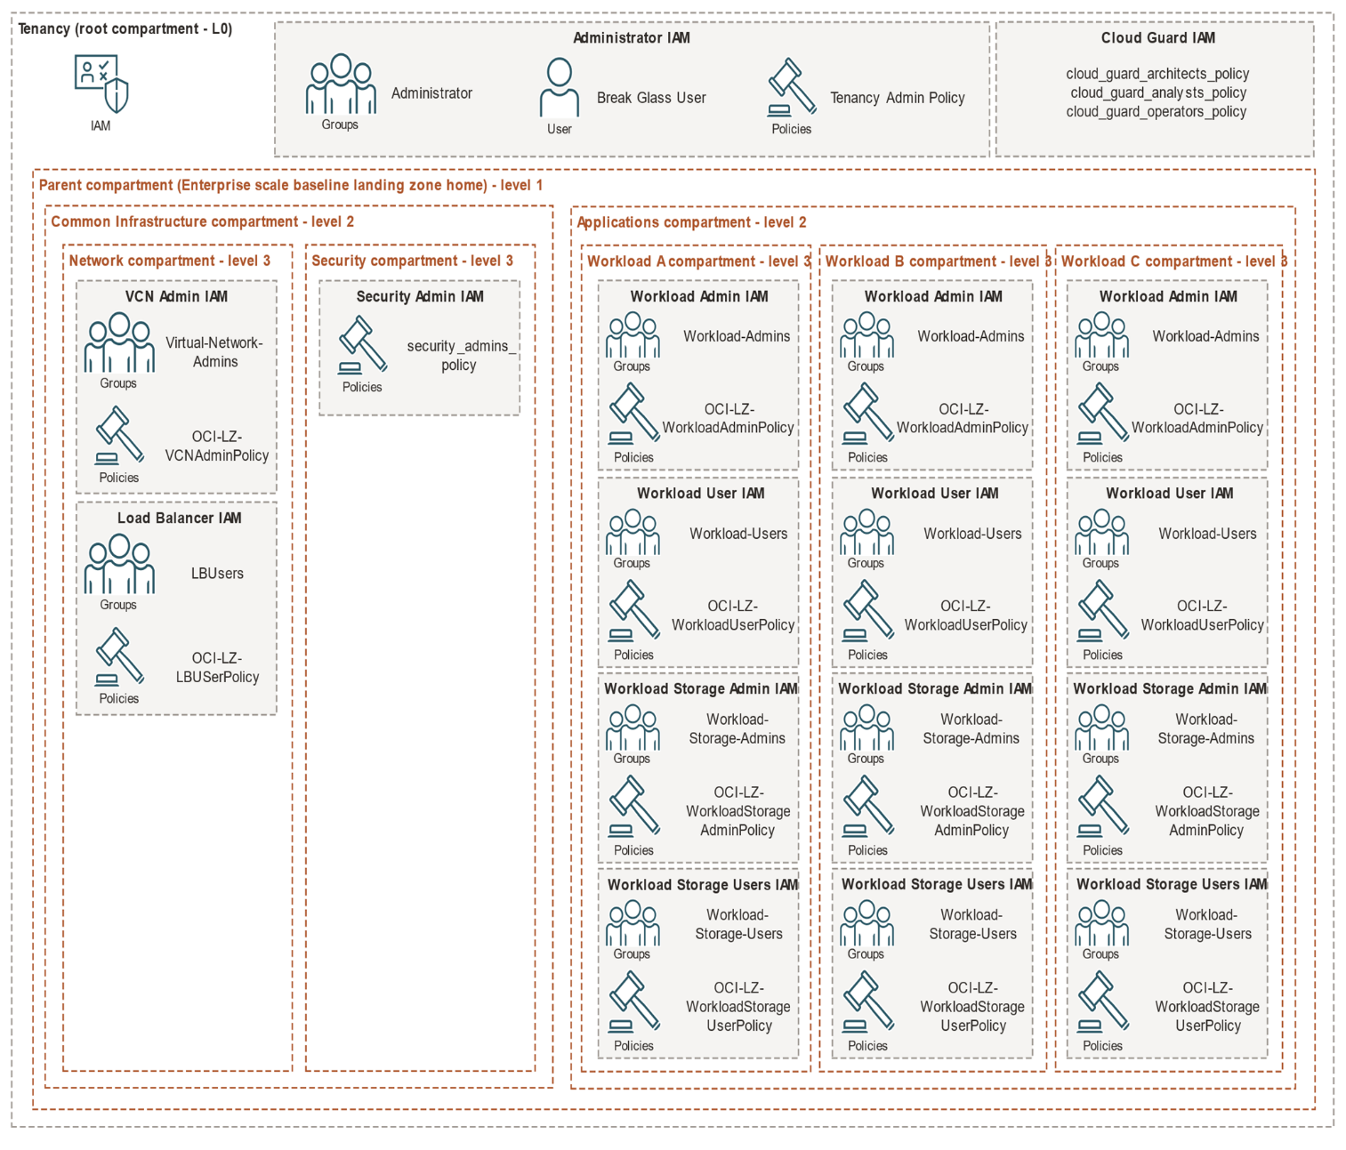

Optionally, additional users can be added to the groups that are created.

To add users to groups:
- Open the navigation menu and click Identity & Security. Under Identity, click Users.
- A list of the users in your tenancy is displayed.
- Locate the user in the list.
- Click the user. The user's details are displayed.
- Click Groups.
- Click Add User to Group.
- Select the group from the drop-down list, and then click Add.
User membership can also be managed in groups through the API, SDKs, CLI, or Terraform

Cloud Guard

Use Cloud Guard to monitor and manage the security of your cloud resources.

Usage and Best Practices
Cloud Guard is a cloud-native service that helps customers monitor, identify, achieve, and maintain a strong security posture on Oracle Cloud. Use the service to examine your Oracle Cloud Infrastructure resources for security weakness related to configuration, and your Oracle Cloud Infrastructure operators and users for risky activities. Upon detection, Cloud Guard can suggest, assist, or take corrective actions, based on your configuration.

To use Cloud Guard, define target resources that are wanted Cloud Guard to monitor. Then, use either Oracle-managed or user-managed detector recipes, or sets of rules, to examine the resources and activities in the target and identify problems.

The reporting region for Cloud Guard is set to tenancy's home region by default. This is because if Cloud Guard is already enabled in tenancy and the reporting region is not the home region, Cloud Guard would need to be disabled and then re-enabled, which adds unnecessary complexity. Cloud Guard can detect events in the region where the enterprise scale baseline landing zone is deployed, even if the reporting region is different. If necessary, the reporting region can manually be change.

While provisioning Cloud Guard resources using the enterprise scale baseline landing zone stack, the target is all resources within the parent compartment. The enterprise scale baseline landing zone includes two Oracle-managed recipes, OCI Configuration Detector Recipe and OCI Activity Detector Recipe. These detector recipes perform checks and identify potential security problems on your resources.

Optionally, create responder recipes and rules of own requirement. Responders are structured in a similar way to detectors. A responder is an action that Cloud Guard can take when a detector has identified a problem. Each responder uses a responder recipe with rules that define the action or set of actions to take in response to a problem that a detector has identified. The available actions are resource-specific.

Enabling or Disabling Cloud Guard
To enable Cloud Guard at the tenancy level, in the enterprise scale baseline landing zone stack, set the variable cloud_guard_configuration_status to ENABLE. To disable the service, set the variable to DISABLE.

Cloning Cloud Guard Recipes
You can clone detector recipes to fine-tune the set of detector recipes available to use in your environment. Only a member of the CloudGuardArchitect group can clone recipes.

Cloud Guard IAM Policies
The IAM policies in the following table are provisioned with Cloud Guard. You might need to add users to specific IAM groups to allow them to access and manage Cloud Guard resources.

Policy Name | Description
OCI-LZ-Cloud-Guard-Policy | Configures permissions for Cloud Guard to access tenancy resources:  Read-only access to tenancy keys  Read-only access to compartments  Read-only access to compute management family  Read-only access to virtual network family  Read-only access to volume family  Read-only access to audit events  Read-only access to vaults  Read-only access to object family  Read-only access to load balancers  Read-only access to groups  Read-only access to dynamic groups  Read-only access to users  Read-only access to database family  Read-only access to authentication policies  Read-only access to policies
OCI-LZ-Scanning-Service-Policy | Configures permissions for the Vulnerability Scanning service to access resources in the parent compartment:  Manage access to instances  Read-only access to compartments  Read-only access to VNICs  Read-only access to VNIC attachments

Cloud Guard Target
Target name: OCI-LZ-Cloud-Guard-Target
In the enterprise scale baseline landing zone stack, a user-managed Cloud Guard target is deployed. The target resource ID is the parent compartment and all resources within it. The target uses two Oracle-managed detector recipes.

Vulnerability Scanning Host Scan Recipe
Host scan recipe name: OCI-LZ-Scanning-Service-Recipe
In the enterprise scale baseline landing zone stack, a user-managed host scan recipe for Vulnerability Scanning is deployed into the security compartment. The agent, the port scanning level, and the scan schedule are configured in Terraform.

Vulnerability Scanning Host Scan Target
Host scan target name: OCI-LZ-Scanning-Service-Target
In the enterprise scale baseline landing zone stack, a user-managed host scan target for Vulnerability Scanning is deployed into the security compartment. This resource uses the Vulnerability Scanning host scan recipe that is created by the stack. The target resource ID is the parent compartment and all resources within it.

Emergency Break Glass Users
Users in the break-glass user group are administrators who have emergency access to all Oracle Cloud Infrastructure services and resources in the tenancy. The users in this group must enable multi-factor authentication.

Resources
The landing zone stack provisions the following IAM resources for break-glass users:
  - Default username: break_glass_user_<number>
  - Default group name: Administrators
  - Default policy: OCI-LZ-Admin-TenantAdminPolicy
The break-glass IAM policy contains the following statement:

Allow group <administrator_group_name> to manage all-resources in tenancy where request.user.mfaTotpVerified='true'.

Usage
- The enterprise scale baseline landing zone stack provisions users in the break-glass group using the break_glass_user_email_list variable.
- To create multiple break-glass users, provide multiple valid email addresses for this list variable.
- After break-glass users are provisioned, the system sends a password reset email to each user to grant access to their account.
- When a break-glass user signs in to the Console, they can view their membership in groups by reviewing their user settings.
- Each break-glass user must enable multi-factor authentication (MFA).

To enable MFA for your user account:

Prerequisite:
Install a supported authenticator app on the mobile device you intend to register for MFA.
1. In the upper-right corner of the Console, open the Profile menu and then select User Settings. Your user details are displayed.
2. Click Enable Multi-Factor Authentication.
3. Scan the QR code displayed in the dialog with your mobile device's authenticator app.
Note: If you close the browser, or if the browser crashes before you can enter the verification code, you must generate a new QR code and scan it again with your app. To generate a new QR code, click the Enable Multi-Factor Authentication button again.
4. In the Verification Code field, enter the code displayed on your authenticator app.
5. Click Enable.
Mobile device is now registered with the IAM service and account is enabled for MFA. Every time you sign in, you are prompted for your username and password first. After you provide the correct credentials, you will be prompted for a TOTP code generated by the authenticator app on your registered mobile device. You must have your registered mobile device available every time you sign in to Oracle Cloud Infrastructure.
After MFA is enabled for a break-glass account, the account can be used to manage the tenancy through the API, SDKs, CLI, or Console.

Bastion

The Bastion service provides restricted and time-limited access to cloud resources without public-facing endpoints.
There are two types of bastion sessions:
- managed SSH and
- port forwarding.

The type of bastion session depends on the target resource:
- Managed SSH sessions simplify SSH access to native Oracle Linux images running the Oracle Cloud Agent software.
- Port forwarding creates a secure connection between a specific port on the client machine and a specific port on the target resource.

Resources
The enterprise scale baseline landing zone stack creates a bastion named LZBastion and a subnet named OCI-LZ-Bastion-<region_key>-subnet. The subnet and bastion are attached to the default VCN residing in the network compartment.
The stack does not provision bastion sessions. You can create bastion sessions after the bastion has been provisioned.

Usage
To deploy or update the bastion module using Resource Manager, provide the required values listed in the following table.

Field | Variable Name | Description
Bastion Subnet CIDR Block | bastion_subnet_cidr_block | CIDR block for the bastion subnet.
Bastion Client CIDR Block Allowlist | bastion_client_cidr_block_allow_list | A list of address ranges in CIDR notation that the bastion is allowed to connect to.

After the bastion has been provisioned, you can create bastion sessions using the API, SDKs, CLI, or Console.
For more information about bastions

Budgets
The enterprise scale baseline landing zone includes an optional budget module.
To enable the budgets feature when deploying or updating the stack using Resource Manager, select the option for Budget Alerting, and then provide the required values listed in the following table.

Field | Variable Name | Description
Budget Amount | budget_amount | Monthly budget.
Budget Alert Rule Threshold | budget_alert_rule_threshold | Alerting threshold for spend.
Budget Alert Rule Recipient | budget_alert_rule_recipients | Email address to receive budget alerts.

The budget that is created applies to the parent compartment

# END #

