Deploying the Enterprise Scale Baseline Landing Zone

Contents

1. Introduction 2
2. How to Deploy 3
a. Terraform Modules 3
b. Tags 4
c. IAM Policies and Groups 4
d. Cloud Guard 8
e. Bastion 12
f. Budgets 13

Introduction

Enterprise scale baseline landing zone is used to deploy a secure cloud environment that's ready for you to launch new projects and workloads in Oracle Cloud Infrastructure.
Important: This reference architecture provides an enterprise-scale architecture and deployment that includes designs for governance, security segmentation, and separation of duties.
Prerequisites
Before launching the enterprise scale baseline landing zone, prepare the following information.
- Tag values for the Cost-Center and Geo-Location tags. Every resource that is created by the landing zone stack will be tagged with the values that you provide.
- A name for the parent compartment. The parent compartment is the top-level organizational compartment that is created by the landing zone.
- Names for one or more workload compartments under the parent compartment.
- Email addresses for one or more break-glass users. Break-glass users have emergency access to all Oracle Cloud Infrastructure resources.
- CIDR block for the allow list on the bastion.
- CIDR blocks for the following subnets created within the virtual cloud network (VCN):

- Public
- Private - one for each workload
- Database - one for each workload
- Shared
- Bastion

How to Deploy

Install the enterprise scale baseline landing zone using the Console, Resource Manager, or the Oracle Cloud Infrastructure Terraform provider.
The Terraform template is available on GitHub:
https://github.com/oracle-quickstart/oci-enterprise-scale-baseline-landing-zone

Terraform Modules
The enterprise scale baseline landing zone is composed of multiple Terraform modules. Each module is written to work together in a stack. The following table lists the modules in the enterprise scale baseline landing zone.
Module | Description
Compartments | Contains sub modules for creating the compartment structure for the enterprise scale baseline landing zone. These compartments include the parent compartment and compartments for security, networking, and workloads.
Budget | Builds a compartment-level budget alarm based on a threshold that you define. The budget is valid for everything that resides under the parent compartment. This module is optional.
Virtual Cloud Network (VCN) | Builds and configures all network-related resources, including a VCN, subnets, gateways, security lists, and routing rules. This module also configures optional dynamic routing gateways (DRGs), using either Site-to-Site VPN or FastConnect.
Identity and Access Management (IAM) | Creates nearly all required policies and groups. A sub module creates accounts for emergency access, called break-glass users.  In some cases, if permissions are related to a specific feature, an IAM policy might be created in a different module. For example, if Cloud Guard is used, the related IAM policies are created in the Cloud Guard sub module.
Security | Implements VCN flow logs, Cloud Guard, Audit logs, and the Bastion service.

Knowing the contents of each module can help you understand how to scale and operate the stack. In the top-level directory, each module has a module-variables.tf file that defines the module's variables, a module.tf file that creates the module's resources, and a subdirectory that is named after the module and contains the sub modules. For example, the compartments module includes a compartments-variables.tf file, a compartments.tf file, and a subdirectory named compartments.

Tags
The enterprise scale baseline landing zone includes a set of free-form tags that are applied to resources created within the template. Each resource is given a default assigned value for the Description tag. The values that are defined while creating the enterprise scale baseline landing zone stack propagate to the Cost-Center and Geo-Location tags.

IAM Policies and Groups
Oracle Cloud Infrastructure Identity and Access Management (IAM) lets you control who has access to specific cloud resources and what type of access a group of users has.
The enterprise scale baseline landing zone provisions IAM groups with established roles and access levels. Each IAM group is referenced in IAM policies that grant access to the associated resources. All groups belong to the parent compartment. Each policy belongs to the compartment that is closest to the resource that it controls access to.
The enterprise scale baseline landing zone stack provisions the groups and IAM policies listed in the following table. To override the default group names, update the Terraform variables when you create the stack. For example, Groups can be renamed to fit organizational structure or to map with a federated identity service.
Group | Policy name | Description
Virtual-Network-Admins | OCI-LZ-VCNAdminPolicy | Network administrators are allowed to manage all network resources in the network compartment.
LBUsers | OCI-LZ-<WorkloadName>-LBUserPolicy | Each workload has its own policy to grant management access to the load balancer user. There is only one load balancer user for all the workloads with access to only the created workload load balancers. The user can create and modify load balancers in each of these workload compartments.
Workload-Admins | OCI-LZ-<WorkloadName>-WorkloadAdminPolicy | Compute or workload administrators are allowed to manage all compute resources that host workloads. This includes the ability to manage all things related to creating instances, instance pools, auto-scaling configurations, cluster networks, custom images, and images in the Partner Image catalog.
Workload-Users | OCI-LZ-<WorkloadName>-WorkloadUserPolicy | Compute or workload users are allowed to use all compute instances for the workload. Workload users can also create console connections, launch instances on dedicated virtual machine hosts, and create images in the Partner Image catalog. Workload users cannot create custom images, and cannot use instance pools, auto-scaling, or cluster networks.
Workload-Storage-Admins | OCI-LZ-<WorkloadName>-StorageAdminPolicy | Storage administrators are allowed to manage all types of storage requirements for the workload, including Object Storage buckets and objects, File Storage resources, and Block Volume volumes and backups.
Workload-Storage-Users | OCI-LZ-<WorkloadName>-StorageUserPolicy | Storage users are allowed to write and read from any Object Storage bucket in the associated workload compartment.
Security-Admins | OCI-LZ-SecurityAdmins | Security administrators are allowed to manage and use encryption keys to encrypt resources. They can view resources in the Vault service, which manages user keys and secrets. Security administrators can also manage Bastion resources, which allow users to connect to hosts and subnets in the VCN. Access for security administrators is scoped to the security compartment.
CloudGuard-Architect | OCI-LZ-CGAdmins | Cloud Guard administrators are allowed to manage Cloud Guard resources in general, including all resources in the Cloud Guard resource family. This includes scores, problems, detector recipes, responders, and targets.
CloudGuard-Analyst | OCI-LZ-CGOps | Cloud Guard analysts are allowed to use Cloud Guard resources and workflows. They can review problems and recommendations, execute responders, and add new targets with existing recipes and responders.
CloudGuard-Operator | OCI-LZ-CGUsers | Cloud Guard operators are allowed to access Cloud Guard problems and detector recipes. They have read-only access to issues and problems that are detected by Cloud Guard, but do not have permission to take corrective action on the security issues, nor can they manage targets.

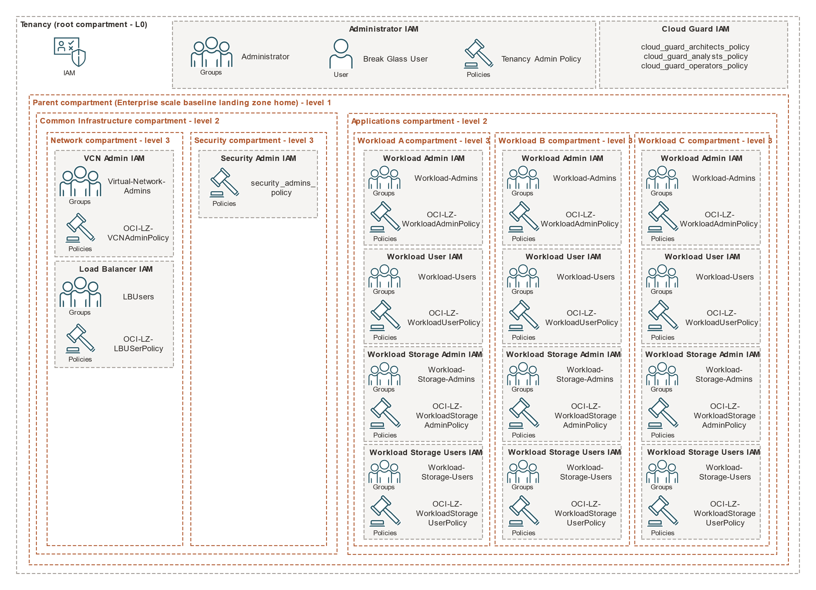
The following diagram shows the IAM groups and policies that are created by the enterprise scale baseline landing zone.

Optionally, additional users can be added to the groups that are created.
To add users to groups:
- Open the navigation menu and click Identity & Security. Under Identity, click Users.
- A list of the users in your tenancy is displayed.
- Locate the user in the list.
- Click the user. The user's details are displayed.
- Click Groups.
- Click Add User to Group.
- Select the group from the drop-down list, and then click Add.
User membership can also be managed in groups through the API, SDKs, CLI, or Terraform

Cloud Guard
Use Cloud Guard to monitor and manage the security of your cloud resources.
Usage and Best Practices
Cloud Guard is a cloud-native service that helps customers monitor, identify, achieve, and maintain a strong security posture on Oracle Cloud. Use the service to examine your Oracle Cloud Infrastructure resources for security weakness related to configuration, and your Oracle Cloud Infrastructure operators and users for risky activities. Upon detection, Cloud Guard can suggest, assist, or take corrective actions, based on your configuration.
To use Cloud Guard, define target resources that are wanted Cloud Guard to monitor. Then, use either Oracle-managed or user-managed detector recipes, or sets of rules, to examine the resources and activities in the target and identify problems.
The reporting region for Cloud Guard is set to tenancy's home region by default. This is because if Cloud Guard is already enabled in tenancy and the reporting region is not the home region, Cloud Guard would need to be disabled and then re-enabled, which adds unnecessary complexity. Cloud Guard can detect events in the region where the enterprise scale baseline landing zone is deployed, even if the reporting region is different. If necessary, the reporting region can manually be change.
While provisioning Cloud Guard resources using the enterprise scale baseline landing zone stack, the target is all resources within the parent compartment. The enterprise scale baseline landing zone includes two Oracle-managed recipes, OCI Configuration Detector Recipe and OCI Activity Detector Recipe. These detector recipes perform checks and identify potential security problems on your resources.
Optionally, create responder recipes and rules of own requirement. Responders are structured in a similar way to detectors. A responder is an action that Cloud Guard can take when a detector has identified a problem. Each responder uses a responder recipe with rules that define the action or set of actions to take in response to a problem that a detector has identified. The available actions are resource-specific.
Enabling or Disabling Cloud Guard
To enable Cloud Guard at the tenancy level, in the enterprise scale baseline landing zone stack, set the variable cloud_guard_configuration_status to ENABLE. To disable the service, set the variable to DISABLE.
Cloning Cloud Guard Recipes
You can clone detector recipes to fine-tune the set of detector recipes available to use in your environment. Only a member of the CloudGuardArchitect group can clone recipes.
Cloud Guard IAM Policies
The IAM policies in the following table are provisioned with Cloud Guard. You might need to add users to specific IAM groups to allow them to access and manage Cloud Guard resources.
Policy Name | Description
OCI-LZ-Cloud-Guard-Policy | Configures permissions for Cloud Guard to access tenancy resources:  Read-only access to tenancy keys  Read-only access to compartments  Read-only access to compute management family  Read-only access to virtual network family  Read-only access to volume family  Read-only access to audit events  Read-only access to vaults  Read-only access to object family  Read-only access to load balancers  Read-only access to groups  Read-only access to dynamic groups  Read-only access to users  Read-only access to database family  Read-only access to authentication policies  Read-only access to policies
OCI-LZ-Scanning-Service-Policy | Configures permissions for the Vulnerability Scanning service to access resources in the parent compartment:  Manage access to instances  Read-only access to compartments  Read-only access to VNICs  Read-only access to VNIC attachments

Cloud Guard Target
Target name: OCI-LZ-Cloud-Guard-Target
In the enterprise scale baseline landing zone stack, a user-managed Cloud Guard target is deployed. The target resource ID is the parent compartment and all resources within it. The target uses two Oracle-managed detector recipes.
Vulnerability Scanning Host Scan Recipe
Host scan recipe name: OCI-LZ-Scanning-Service-Recipe
In the enterprise scale baseline landing zone stack, a user-managed host scan recipe for Vulnerability Scanning is deployed into the security compartment. The agent, the port scanning level, and the scan schedule are configured in Terraform.
Vulnerability Scanning Host Scan Target
Host scan target name: OCI-LZ-Scanning-Service-Target
In the enterprise scale baseline landing zone stack, a user-managed host scan target for Vulnerability Scanning is deployed into the security compartment. This resource uses the Vulnerability Scanning host scan recipe that is created by the stack. The target resource ID is the parent compartment and all resources within it.
Emergency Break Glass Users
Users in the break-glass user group are administrators who have emergency access to all Oracle Cloud Infrastructure services and resources in the tenancy. The users in this group must enable multi-factor authentication.
Resources
The landing zone stack provisions the following IAM resources for break-glass users:
- Default username: break_glass_user_<number>
- Default group name: Administrators
- Default policy: OCI-LZ-Admin-TenantAdminPolicy
The break-glass IAM policy contains the following statement:
Allow group <administrator_group_name> to manage all-resources in tenancy where request.user.mfaTotpVerified='true'.
Usage
- The enterprise scale baseline landing zone stack provisions users in the break-glass group using the break_glass_user_email_list variable.
- To create multiple break-glass users, provide multiple valid email addresses for this list variable.
- After break-glass users are provisioned, the system sends a password reset email to each user to grant access to their account.
- When a break-glass user signs in to the Console, they can view their membership in groups by reviewing their user settings.
- Each break-glass user must enable multi-factor authentication (MFA).

To enable MFA for your user account:
Prerequisite:
- Install a supported authenticator app on the mobile device you intend to register for MFA.
- In the upper-right corner of the Console, open the Profile menu and then select User Settings. Your user details are displayed.
- Click Enable Multi-Factor Authentication.
- Scan the QR code displayed in the dialog with your mobile device's authenticator app.
Note: If you close the browser, or if the browser crashes before you can enter the verification code, you must generate a new QR code and scan it again with your app. To generate a new QR code, click the Enable Multi-Factor Authentication button again.
- In the Verification Code field, enter the code displayed on your authenticator app.
- Click Enable.
Mobile device is now registered with the IAM service and account is enabled for MFA. Every time you sign in, you are prompted for your username and password first. After you provide the correct credentials, you will be prompted for a TOTP code generated by the authenticator app on your registered mobile device. You must have your registered mobile device available every time you sign in to Oracle Cloud Infrastructure.
After MFA is enabled for a break-glass account, the account can be used to manage the tenancy through the API, SDKs, CLI, or Console.

Bastion
The Bastion service provides restricted and time-limited access to cloud resources without public-facing endpoints.
There are two types of bastion sessions:
- managed SSH and
- port forwarding.
The type of bastion session depends on the target resource:
- Managed SSH sessions simplify SSH access to native Oracle Linux images running the Oracle Cloud Agent software.
- Port forwarding creates a secure connection between a specific port on the client machine and a specific port on the target resource.
Resources
The enterprise scale baseline landing zone stack creates a bastion named LZBastion and a subnet named OCI-LZ-Bastion-<region_key>-subnet. The subnet and bastion are attached to the default VCN residing in the network compartment.
The stack does not provision bastion sessions. You can create bastion sessions after the bastion has been provisioned.
Usage
To deploy or update the bastion module using Resource Manager, provide the required values listed in the following table.
Field | Variable name | Description
Bastion Subnet CIDR Block | bastion_subnet_cidr_block | CIDR block for the bastion subnet.
Bastion Client CIDR Block Allowlist | bastion_client_cidr_block_allow_list | A list of address ranges in CIDR notation that the bastion is allowed to connect to.

After the bastion has been provisioned, you can create bastion sessions using the API, SDKs, CLI, or Console.

Budgets
The enterprise scale baseline landing zone includes an optional budget module.
To enable the budgets feature when deploying or updating the stack using Resource Manager, select the option for Budget Alerting, and then provide the required values listed in the following table.
Field | Variable name | Description
Budget Amount | budget_amount | Monthly budget.
Budget Alert Rule Threshold | budget_alert_rule_threshold | Alerting threshold for spend.
Budget Alert Rule Recipient | budget_alert_rule_recipients | Email address to receive budget alerts.

The budget that is created applies to the parent compartment.

# END #

