Extreme Reliability

Contents

1. Overview 3
Architecture Recommendations for Extreme Reliability 3
2. Phase 1: Distribute Instances Across Fault Domains 3
Scenario A: Highly Available Application Architecture 4
Scenario B: Single Web Server and Database Instance Architecture 4
Composite SLAs 5
3. Phase 2: Deploy Resources in Multiple Regions 5
Scenario C: Multiple Region Architecture 5

Overview

Use the principles of high availability and disaster recovery to design a cloud architecture for extreme reliability.

High availability (HA) systems are designed to ensure that they have the maximum potential for uptime and accessibility. To ensure HA, eliminate single points of failure, so that even if components fail the application remains running and available.

A well-architected disaster recovery (DR) plan enables recover quickly from disasters and continue to provide services to users. DR is the process of preparing for and recovering from a disaster. A disaster can be any event that puts applications at risk, from network outages to equipment and application failures to natural disasters. To design for DR, deploy the mission-critical applications to multiple regions and use asynchronous replication across regions. Plan for DR at all layers of the stack, including Networking, Compute, Object Storage, Database, and Monitoring.

Architecture Recommendations for Extreme Reliability

Recommend a phased approach for extreme reliability. In the first phase, deploy an architecture that provides HA capabilities by leveraging the fault domains within an availability domain. If more resiliency is needed, in the second phase, deploy an architecture that spans multiple regions.

Phase 1: Distribute Instances Across Fault Domains

High availability systems are designed to avoid single points of failure. One of the key principles for designing a high availability system is to distribute instances across multiple fault domains. By properly leveraging fault domains, can increase the availability of applications running on Oracle Cloud Infrastructure.
Application's architecture determines whether you separate or group instances by using fault domains.

Scenario A: Highly Available Application Architecture

In this scenario, have a highly available application, for example two web servers and a clustered database. In this scenario, you should group one web server and one database node in one fault domain and the other half of each pair in another fault domain. This placement ensures that a failure of any one fault domain does not result in an outage for application
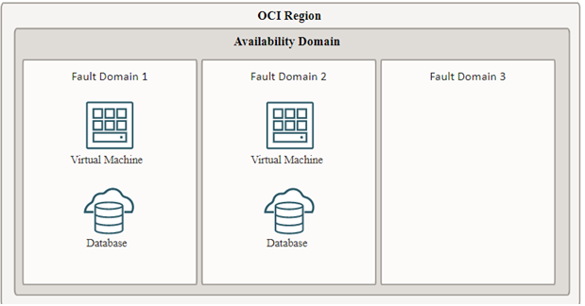

Scenario B: Single Web Server and Database Instance Architecture

In this scenario, application architecture is not highly available, for example one web server and one database instance. In this scenario, both the web server and the database instance should be placed in the same fault domain to minimize customer outages. This placement ensures that application is only impacted by the failure of that single fault domain, providing greater application availability overall.
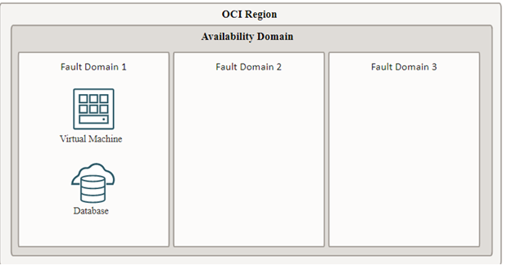

Composite SLAs

When services are used in combination, the overall system availability depends on the availability of each of the subsystems. To maximize the availability of a system with multiple subcomponents, should minimize the dependencies that the subcomponents have on each other. This means that, depending on application architecture, achieve the greatest reliability for a given amount of engineering effort by leveraging the fault domains within an availability domain, rather than spanning resources across availability domains.

Phase 2: Deploy Resources in Multiple Regions

To maximize the resiliency of workloads, deploy cloud workloads across multiple regions, rather than multiple availability domains.
Deploying to multiple regions lets minimize the risks associated with a regional outage, because a regional outage can affect all availability domains in the region. Deploying to multiple regions also maximizes the value of the engineering effort that invest into porting your workloads across multiple data centers.

Scenario C: Multiple Region Architecture

In this scenario, architecture replicates the same stack across two regions.
To provide a consistent data source in both regions, use replication capabilities such as Golden Gate for the data layer, Autonomous Data Guard for the database layer, and Object Storage replication policies on the source bucket that identify the region and the bucket to replicate to.
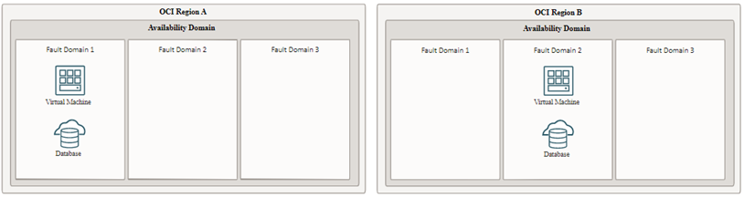
For the front-end and application layer, create a load balancer and configure health check capabilities on the backend resources that are deployed across fault domains in both regions. Every time deploy a new application to production, deploy the application to instances in both regions.

### END ###

