High Availability

Contents

1. Overview 1
HA Concepts 2
Choosing an HA Approach 3
Measuring HA 3
HA Design Considerations 4

Overview

High availability (HA) systems are designed to ensure that they have the maximum potential for uptime and accessibility.

Enterprise applications are critical to everyday business operations and need to be available. There is an expectation that these systems are always working and there will never be any downtime. Although it's impossible to rule out downtime entirely, you can minimize the negative impacts of downtime by ensuring that your applications have HA. To ensure HA, eliminate single points of failure, so that even if components fail the application remains running and available. Oracle Cloud Infrastructure (OCI) provides HA capabilities and reliable and resilient cloud topology best practices that let you create enterprise applications that are HA.

Because multi-tier or three-tier architectures are common in traditional on-premises enterprise applications, let's use an example three-tier enterprise application to show how you can use OCI HA capabilities and the reliable and resilient cloud topology best practices to make that application HA. The following diagram shows an example enterprise application in a single region HA configuration.

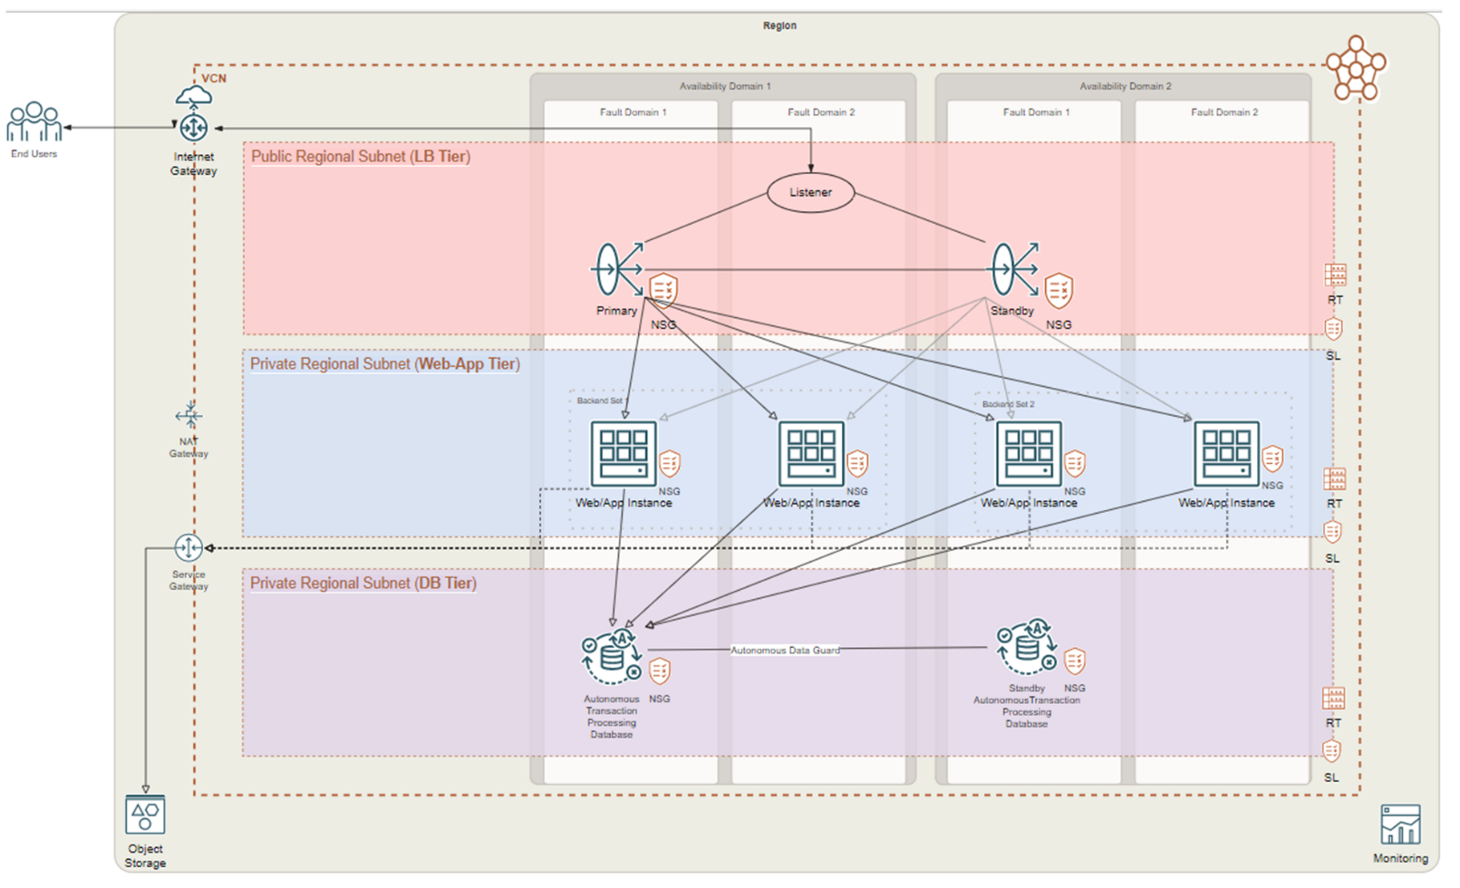

This document does not cover connectivity from on-premises to OCI or disaster recovery (DR) aspects of the infrastructure.

HA Concepts
When your infrastructure is configured to provide nearly full-time availability, it's an HA system.

To design a high availability architecture, consider the following key elements:
Redundancy: Does each resource have at least one similar resource ready to step in and take over? Notice that in each tier shown in the diagram, the resources always have a primary and a standby, and resources are in different availability domains and fault domains to avoid single points of failure (SPOF).

Monitoring: Are primary resources functioning as expected? If not, at what point does the backup resource take over for the primary?

Failover: When the criteria is met to trigger a switch from primary to standby, is the standby ready?

Achieving HA requires that a system accounts for all of these elements. Although high availability can be achieved at many different levels (including the application level and the cloud infrastructure level), this section focuses on the cloud infrastructure level.

Choosing an HA Approach
Some applications are more critical than others. Use the following decision tree to decide which OCI HA capabilities to use when deploying multi-tier enterprise applications on OCI.

For our example enterprise application, we need HA and to be able to survive an availability domain outage. In addition, we need to be able to survive a regional outage but can handle some downtime if a region is affected. For these reasons we chose an active/passive deployment in multiple regions.

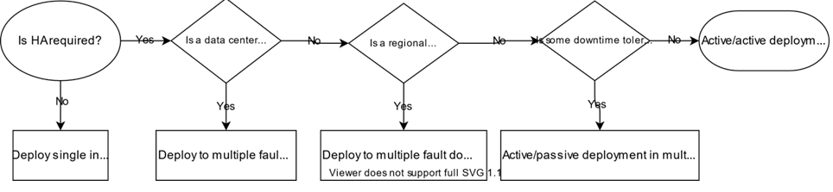

Measuring HA
High availability is the ability of a system to meet a continuous level of operational performance, or uptime, for a given period of time.

Availability is usually expressed as a percentage of uptime in a year, often described in terms of "nines." The following table shows availability levels and the associated downtime of each level.

Availability % | Availability (Nines) | Downtime per Year | Downtime per Month | Downtime per Week | Downtime per Day
90% | One nine | 36.53 days | 73.05 hours | 16.80 hours | 2.40 hours
99% | Two nines | 3.65 days | 7.31 hours | 1.68 hours | 14.40 minutes
99.9% | Three nines | 8.77 hours | 43.83 minutes | 10.08 minutes | 1.44 minutes
99.99% | Four nines | 52.60 minutes | 4.38 minutes | 1.01 minutes | 8.64 seconds
99.999% | Five nines | 5.26 minutes | 26.30 seconds | 6.05 seconds | 864.00 milliseconds
99.9999% | Six nines | 31.56 seconds | 2.63 seconds | 604.80 milliseconds | 86.40 milliseconds
99.99999% | Seven nines | 3.16 seconds | 262.98 milliseconds | 60.48 milliseconds | 8.64 milliseconds
99.999999% | Eight nines | 315.58 milliseconds | 26.30 milliseconds | 6.05 milliseconds | 864.00 microseconds
99.9999999% | Nine nines | 31.56 milliseconds | 2.63 milliseconds | 604.80 microseconds | 86.40 microseconds

Each Oracle Cloud Infrastructure service usually has a service-level agreement (SLA) that defines the expected availability of that service. Most cloud solutions require that you use a combination of services to achieve the desired architecture for your cloud deployment. When services are used in combination, the overall system availability is dependent on the availability of each of the subsystems. The overall SLA for a system with multiple components is called a composite SLA.

To calculate the composite SLA of a system or application, consider all the subsystems and how those systems are configured. For example, consider a scenario where an application is dependent on two systems, System A and System B. Each system has a 99.9% availability. The systems are serially dependent, as shown in the following image.

If either System A or System B is unavailable, then the whole system is unavailable. For this type of system configuration, you can calculate the composite SLA by multiplying the availability of the two systems: 99.9% × 99.9% = 99.8%. Because of the serial dependency between the two systems, the resulting composite SLA of 99.8% is lower than the individual SLAs for each system.

HA Design Considerations
Oracle Cloud Infrastructure provides the building blocks that let you enable HA for your infrastructure.

The example enterprise application uses services within the OCI concepts of regions, availability domains, and fault domains. The use of multiple availability domains, and multiple fault domains within each of those availability domains, increases redundancy and eliminates SPOF. For background information about regions and a list of resources that are available across regions, within a single region, or within a single availability domain.

Networking
After creating the network foundation of virtual cloud networks (VCNs) and subnets, to provide highly availability you need to use the Load Balancing service to distribute traffic. When a load balancer is deployed, it uses an HA configuration as shown in the example architecture diagram.

Compute
To eliminate SPOF, create multiple compute instances that are distributed across fault domains in each of the availability domains. Place compute instances behind a load balancer to distribute the traffic and achieve HA as shown in the example architecture.

Storage
OCI provides a set of storage services (Block Volume, File Storage, and Object Storage) that you can configure to meet the requirements of a high availability architecture. Object Storage is an internet-scale, high-performance storage platform that offers reliable and cost-efficient data durability. Object Storage is a regional service and is available across all availability domains within a region. Data is stored redundantly across multiple storage servers and across multiple availability domains. For steps to create storage resources, see Creating a Volume, Creating File Systems, and Managing Buckets.

Database
Autonomous Database is a self-driving, self-securing, self-repairing database service. You do not need to configure or manage any hardware or install any software. Autonomous Database handles creating the database, as well as backing up, patching, upgrading, and tuning the database. To eliminate SPOF with the database, use Autonomous Data Guard with a standby database.

Monitoring
Monitoring enables you to actively and passively monitor your cloud resources for improved availability and consistent service levels

# END #

