Security checklist for Oracle Cloud Infrastructure

Contents

1. Learn About Security in Oracle Cloud Infrastructure 3
Security Pillars 3
Design Principles 4
Shared Security Model 5
2. Use Security Controls 7
About Security Controls 7
Authentication 8
Authorization 9
Identity Federation 11
Resource Isolation 12
Network Security 13
Compute Instance Security 15
Service-Level Security 17
Data Protection 17
Governance, Audit, and Monitoring 18
Incident Management and Response 18
Compliance and Application Security 19
Operational Resilience and Business Continuity 19

Learn About Security in Oracle Cloud Infrastructure
Applications need reliable, high-performance, and cost-effective cloud solutions that meet all security, data protection, and compliance requirements. Oracle Cloud is built on a foundation of state-of-the-art security technologies and operational processes that allow to exercise complete control with unmatched security.
Use this document to learn about the security design principles of Oracle Cloud Infrastructure and understand the shared security model. Review the wide range of security controls that can use to build the most secure cloud topology for your mission-critical enterprise applications and modern cloud-native workloads.
The checklists included in this document align with the best practices for security and compliance, as described in Best practices framework for Oracle Cloud Infrastructure.

Security Pillars
Security in Oracle Cloud Infrastructure is based on seven core pillars. Each pillar includes multiple solutions designed to maximize the security and compliance of the platform.
- Customer isolation: Isolate application, data, and resources in the cloud from other tenants and Oracle.
- Data encryption: Protect data by using security controls, and fulfill your security and compliance requirements.
- Security controls: Reduce the risks associated with malicious and accidental user actions by managing access to services and segregating operational responsibilities.
- Visibility: Minimize security and operational risk by auditing and monitoring actions on resources through comprehensive logs and security monitoring solutions.
- Secure hybrid cloud: Use your existing security assets—such as user accounts, policies, and third-party security solutions—when accessing cloud resources and securing data and application assets.
- High availability: Ensure consistent up time for workloads, by taking advantage of fault-tolerant data centers that are resilient against network attacks.
- Verifiably secure infrastructure: Run business-critical workloads on a verifiably secure infrastructure that implements rigorous processes and security controls in all the phases of development and operation.
Oracle Cloud Infrastructure services are compliant with a wide range of standards and requirements, including FedRAMP, FIPS 140-2, GDPR, HIPAA, PCI DSS, and SOC 1/2/3.
The following figure shows the key Oracle Cloud Infrastructure services and features that constitute the seven core security pillars:

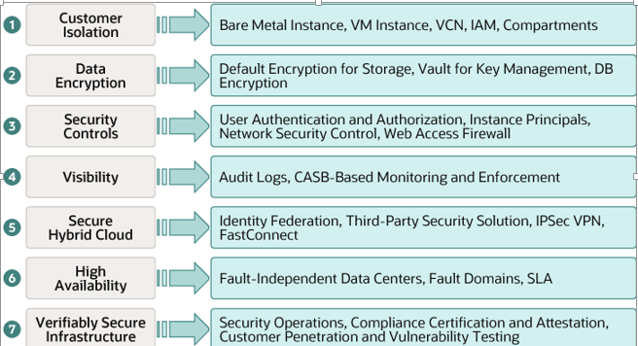

Design Principles
Apply the following design principles to deploy, operate, and use applications securely in Oracle Cloud Infrastructure:
- Understand and implement the security services and features of Oracle Cloud Infrastructure.
- Understand the shared security responsibility model. See the next section.
- Implement the principles of least privilege and separation of duties.
Limit privileges as much as possible. Users should be given only the access that's essential to perform their work. Review user privileges periodically to determine relevance to the current work requirements.
- Implement multilayer security mechanisms.
- Protect data at rest and in transit.
- Monitor and respond to security events.
Monitor system activity. Establish who should access which system components, and how often; and monitor those components.
- Stay up to date on security alerts, patches, and software updates.
Oracle regularly issues security-related patch updates and security alerts. Install all security patches as soon as possible.
- Implement security-related best practices.

Shared Security Model
Oracle employs best-in-class, enterprise-grade security technology and operational processes to secure the cloud services. To deploy and operate your workloads securely in Oracle Cloud, you must be aware of your security and compliance responsibilities.
Oracle ensures security of cloud infrastructure and operations, such as cloud operator access controls and infrastructure security patching. Configuring cloud resources securely is the responsibility of the user. The following graphic illustrates the shared security responsibility model:
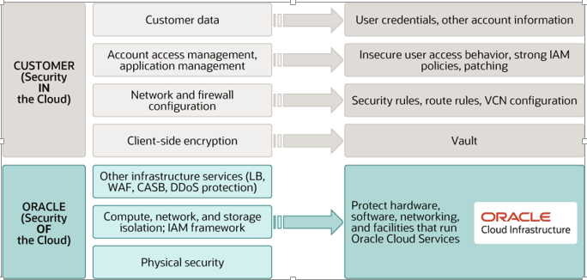
Oracle is solely responsible for all aspects of the physical security of the availability domains and fault domains in each region. Both Oracle and you are responsible for the infrastructure security of hardware, software, and the associated logical configurations and controls.
As a customer, your security responsibilities encompass the following:
- The platform you create on top of Oracle Cloud.
- The applications that you deploy.
- The data that you store and use.
- The overall governance, risk, and security of your workloads.
The shared responsibility extends across different domains including identity management, access control, workload security, data classification and compliance, infrastructure security, and network security.
- Identity and access management (IAM)
Protect cloud access credentials, and set up individual user accounts. Manage and review access permissions for own employee accounts and for all the activities in your tenancy.
Oracle provides the required IAM services, such as identity management, authentication, authorization, and auditing.
- Workload security
Oracle provides secure images that are hardened and include the latest patches. Oracle makes it simple for to bring the same third-party security solutions that you use today.
After provision compute instances, protect and secure the operating system and application layers from attacks and compromises. This includes patching the applications and operating systems, ensuring that the operating system configuration is secure, and protecting applications against malware and network attacks. Use the OS management service to manage updates and patches for the operating system environment of compute instances.
- Data classification and compliance
Classify and label data appropriately to fulfill security and compliance requirements. Audit and monitor deployments to ensure that they continue to meet data-compliance obligations.
- Host infrastructure security
Securely configure and manage compute resources (virtual machines, bare metal instances, and containers), storage resources (object storage, local storage, and block volumes), and database services.
Oracle shares the responsibility to ensure that the services are configured optimally and secured. This responsibility includes security of the hypervisor. It extends to configuring the permissions and network access controls necessary for hosts to communicate correctly and for storage devices to be attached and mounted securely.
- Network security
Securely configure network elements, such as virtual networking, load balancing, DNS, and gateways.
Oracle ensures security of the networking infrastructure.
- Client and endpoint protection
Users might use various hardware and software systems, such as mobile devices and browsers, to access cloud resources. Ensure the security of all the clients and endpoints that allow to access Oracle Cloud Infrastructure services.
- Physical security
Oracle protects the global physical infrastructure (hardware, software, networking, and facilities) that are used to run the Oracle Cloud Infrastructure services.

Use Security Controls

About Security Controls
For any cloud project—whether migrating an application to Oracle Cloud, using an application from Oracle Cloud Marketplace, or building enterprise and cloud-native applications—it’s important for development and security teams to work together in a DevSecOps model. Security controls enable development team and security administrators to collaboratively manage the security of cloud resources.
Use these controls to manage access to services and segregate operational responsibilities to reduce the risk associated with potentially malicious and accidental user actions.
The remainder of this document presents all the security controls available in Oracle Cloud Infrastructure, as checklists that can use when designing, deploying, and managing workloads in Oracle Cloud.
A separate checklist is provided for each of the following security areas:
- Authentication
- Authorization
- Resource isolation
- Network security
- Compute instance security
- Service-level security
- Data protection
- Governance, audit, and monitoring
- Incident management and response
- Compliance and application security
- Operational resilience and business continuity

Authentication
Users require credentials to authenticate themselves to Oracle Cloud. Users can generate and rotate their own credentials. In addition, a tenancy security administrator can reset the credentials for any user within a tenancy.
A user can have the following credentials:
- A console password to sign in to the web console of Oracle Cloud Infrastructure.
- API signing keys (in PEM format) for sending API requests.
- Auth tokens to authenticate with third-party APIs.
For example, users need an auth token to authenticate a Swift client when using Recovery Manager (RMAN) to back up a DB system database to Oracle Cloud Infrastructure Object Storage.
- Customer secret keys for using the Amazon S3 Compatibility API with the Oracle Cloud Infrastructure Object Storage.
- SMTP credentials for using the Email Delivery service.
Use the following controls to securely set up and manage user accounts in your tenancy:
Done? | Security Controls and Recommendations
 | Identify users who need access to Oracle Cloud Infrastructure.
 | Use unique and complex passwords.
 | Enforce password rotation and API key rotation every 90 days or less.
 | Ensure that credentials are not hard-coded in any software or listed in any documentation.
 | Do not share user accounts across multiple users.
 | Implement mechanisms to disable tenancy access immediately when an employee leaves the organization.
 | Periodically review membership of users in IAM groups, and remove users from groups that they don’t need access to anymore.
 | Use tenancy administrator credentials only in emergencies, not for day-to-day work.
 | Periodically review the audit logs for administrator activities.
 | Use multifactor authentication (MFA).
 | Monitor audit logs for accesses by the default tenancy administrator and changes to the administrator group to alert on any unauthorized actions.

Authorization
All requests to access Oracle Cloud Infrastructure resources are authenticated based on the provided credentials and authorized based on IAM policies that you define, as shown in the following graphic:
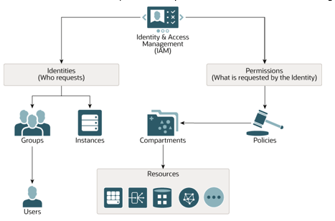

Use the following checklist to manage authorization:
Done? | Security Controls and Recommendations
 | Map IAM groups to your organization’s functional roles.
 | Create IAM groups based on the permissions required.
 | Write appropriate IAM policies for IAM groups.
 | Add users to relevant IAM groups.
 | When assigning IAM permissions for users and instances, follow the principles of least privilege and separation of duties.
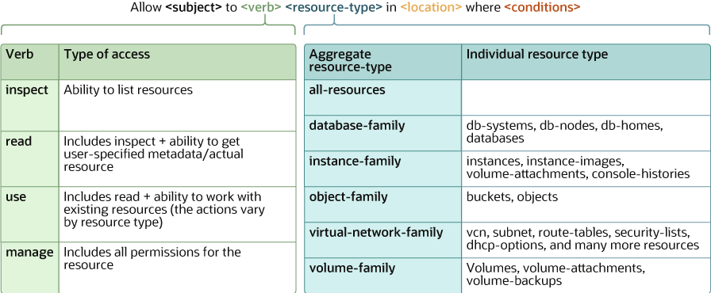
The following graphic shows the syntax of a policy statement, the supported policy verbs, and a few examples of the resource types. For a full list of the supported resource types, see Policy Reference.

Identity Federation
Oracle Cloud Infrastructure supports federation with Oracle Identity Cloud Service, Microsoft Active Directory through Active Directory Federation Services (AD FS), Microsoft Azure Active Directory, Okta, and other identity providers that support the Security Assertion Markup Language (SAML) 2.0 protocol.
Use the following controls to manage identity federation for your tenancy:

Done? | Security Controls and Recommendations
 | Create a federation administrators group that maps to the federated IdP administrator group and is governed by the same security policies as the federated IdP administrator group.
 | Implement an IAM security policy to prevent the federated administrators IAM group from adding or modifying the membership of the default tenancy administrator group, to prevent security bypasses.
 | Coordinate and align information security roles and responsibilities for Oracle Cloud environments with your existing roles and requirements.

On the Oracle Cloud Infrastructure sign-in page, federated users can sign in by using the federated identity provider's authentication workflow, as shown in the following screenshot.
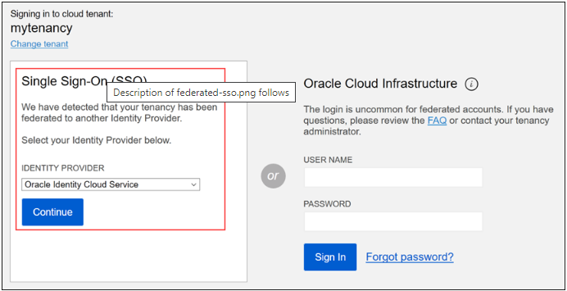

Resource Isolation
Compartments are a fundamental component of Oracle Cloud Infrastructure that allow to create a heterogeneous collection of resources for organization, security isolation, and access control.
To learn more about compartments, see Managing Compartments.
Organize cloud resources in logically separate compartments, for the purposes of measuring usage and billing, controlling access, and isolating resources. A common approach is to create a compartment for each major part of your organization.
Done? | Security Controls and Recommendations
 | Isolate departmental resources in compartments.
 | Use compartments and IAM policies to allow access to only users who need permission to access specific resources.
 | Create child compartments and write IAM policies for each compartment if more organizational layers are required.
 | Use compartment quotas to limit the number of resources that can be created.
 | Avoid writing IAM policies at the level of the root compartment.
 | Limit the resources that an instance principal can manage by specifying a compartment in the IAM policy.
 | Write IAM policies to ensure that only authorized users can move child compartments to a different parent compartment and move resources from one compartment to another.
Use the following checklist:

The following graphic shows how can use policies and compartments to control access by users and instances to resources in specific compartments.
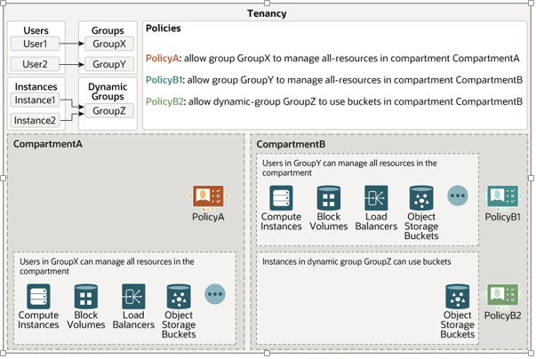

Network Security
The Oracle Cloud Infrastructure Networking service supports provisioning virtual cloud networks (VCNs) and subnets, which can use to isolate resources in the cloud at the network level.
The VCNs can be configured for internet connectivity or connected to your on-premises data centers by using Oracle Cloud Infrastructure FastConnect circuits or IPSec VPN connections.can use bidirectional stateful and stateless firewall rules, communication gateways, and route tables to control the flow of traffic to and from the networks that create. Firewalls and access control lists (ACLs) specified for a VCN are propagated throughout the network topology and control plane, ensuring a multitiered and defense-in-depth implementation. For more information about networking in Oracle Cloud Infrastructure, see Overview of Networking.
The following architecture illustrates how can use subnets, route tables, and security lists to secure your network boundaries.
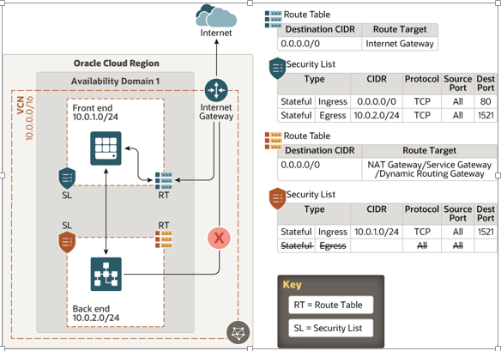

This architecture shows a virtual firewall implementation using security lists. The rules that you specify in a security list apply to all the VNICs in the subnet to which attach the security list. If you need firewalls at a more granular level, use network security groups (NSGs). The rules in an NSG apply to only the VNICs that you specify. Oracle recommends that you use NSGs, because they enable you to separate the subnet architecture from your workload's security requirements.
The following example compares security lists and NSGs:
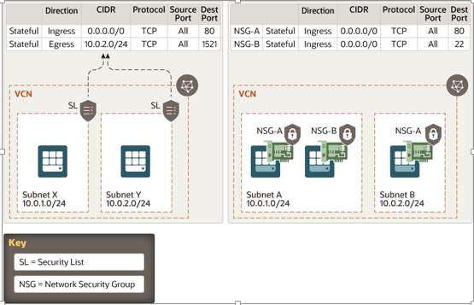
Use the following checklist to protect your network boundaries:
Done? | Security Controls and Recommendations
 | Partition VCN into private and public subnets.
 | Define firewall rules to control access to instances.
 | Create and configure virtual routers for network connectivity.
 | Use IAM policies to restrict access to network resources to only groups allowed to manage network resources.
 | To control network access, use a tiered subnet strategy for the VCN. Use a demilitarized zone (DMZ) subnet for load balancers; a public subnet for externally accessible hosts, such as web servers; and a private subnet for internal hosts, such as databases.
 | Use a NAT gateway for connectivity to the internet from private compute instances.
 | Use a service gateway for connectivity to the Oracle Services Network.
 | Use granular security rules for access within a VCN, communication with the internet, access with other VCNs through peering gateways, and access to on-premises networks through IPSec VPN and FastConnect.
 | Set up an intrusion detection and protection system (IDS/IPS).
 | Create and configure load balancers for high availability and transport layer security (TLS).
 | Use a web application firewall (WAF).
 | Create DNS zones and mappings. An important security consideration in load balancers is using customer TLS certificates to configure TLS connections to the customer’s VCN.
 | Follow security best practices for external cloud connections.

The following graphic shows network connectivity options with Oracle Cloud Infrastructure.
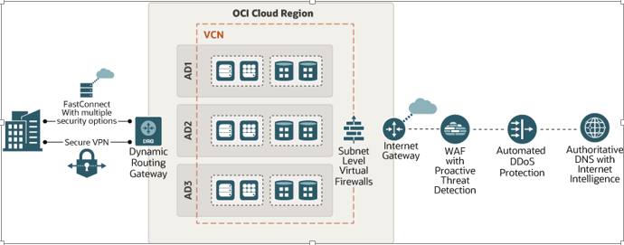

Compute Instance Security
Make sure that compute instances are secure, and control access to them. We recommend using key-based SSH to access compute instances. Password-based SSH could be susceptible to brute-forcing attacks, and is not recommended.
Use the following checklist to protect compute instances.
Done? | Security Controls and Recommendations
Apply the latest operating system patches.
Use the OS management service to manage updates and patches for the operating system environment of your compute instances. See OS Management.
 | Manage SSH keys and their rotation.
 | Disable password login.
 | Disable root login.
 | Change the SSH port to a nonstandard port.
 | Harden the operating system of compute instances.
 | Use host-based intrusion detection and prevention systems (IDS and IPS).
 | Use host-based firewalls, such as iptables, to restrict network access to instances including ports, protocols, and packet types.
 | Apply the latest security patches for applications.
 | Limit instance metadata access to only privileged users on the instance. For example, iptables can be used to restrict instance metadata access to only privileged users, such as root.
 | Use instance principals and dynamic groups.

The following graphic illustrates how can designate compute instances as instance principals, to enable the instances to make API calls to Oracle Cloud Infrastructure services. This example shows a dynamic group consisting of three compute instances. An IAM policy is defined to authorize the dynamic group to send Oracle Cloud Infrastructure API requests.
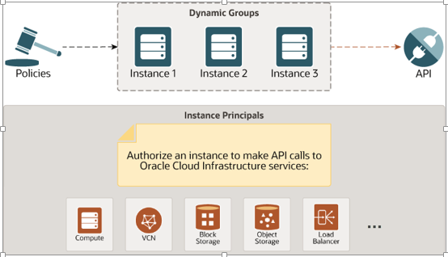

Service-Level Security
Implement security controls, guidelines, and best practices for the individual Oracle Cloud Infrastructure services.
Use the following checklist:
Done? | Security Controls and Recommendations
 | Securing Block Volumes
 | Securing Compute
 | Securing Container Engine for Kubernetes
 | Securing Data Catalog
 | Securing Data Integration
 | Securing Data Transfer
 | Securing Database
 | Securing Email Delivery
 | Securing File Storage
 | Securing IAM
 | Securing Networking: VCN, Load Balancers, and DNS
 | Securing Object Storage
 | Securing Resource Manager

Data Protection
Use the following checklist:
Done? | Security Controls and Recommendations
Manage your keys by using the Vault service.
See Overview of Vault.
 | Implement secure access to secrets.
 | Implement a process for rotating keys.
 | Classify data based on type, value, sensitivity, confidentiality, and criticality to the organization.
Encrypt data at rest.
Oracle encrypts all data by default in the Block Volumes, Object Storage, and File Storage services by using Oracle-managed keys. You can also encrypt all your data by using the keys that you own and manage, using the Vault service.
 | Encrypt all data in transit.
 | Implement data backup and recovery based on your requirements and SLAs.
 | Implement data lifecycle management.

Governance, Audit, and Monitoring
Oracle Cloud Infrastructure offers a rich portfolio of services that can use to monitor and govern cloud resources efficiently and effectively.
Done? | Security Controls and Recommendations
 | Create an inventory of Oracle Cloud resources.
 | Define and use a naming convention for resources.
 | Use a system of tags to classify resources.
 | Implement systems for aggregating and analyzing monitoring and logging data.
 | Set up alerts and notifications.
Set soft limits on spending.
See Budgets Overview.
Set compartment-level quotas.
See Compartment Quotas.
 | Establish cloud auditing procedures.
 | Process threat intelligence.
 | Establish procedures for inspecting and analyzing logs

Incident Management and Response
Use the following checklist to monitor, prevent, and manage incidents.
Done? | Security Controls and Recommendations
 | Use a system such as Oracle CASB to determine risks, threats vulnerabilities, likelihoods, and impacts related to security of your Oracle Cloud Infrastructure environments.
 | Set up a security information and event management (SIEM) system.
 | Set up a security operations center (SOC) and an incident response team.
 | Implement incident detection.
 | Implement incident response.
 | Implement incident reporting.
 | Define an escalation path.
 | Build a standard post-mortem and learning mechanism.

Compliance and Application Security
Use the following checklist:
Done? | Security Controls and Recommendations
 | Classify data used by each of applications.
 | Configure data controls to meet classification requirements.
 | Configure application-level network controls.
 | Configure application-level authentication, authorization, and access control for users.
 | Configure a WAF for web applications.
 | Configure application-level monitoring, logging, and auditing.
 | Follow all the security best practices for applications.
 | Identify and configure all the compliance controls and regulatory requirements.

Operational Resilience and Business Continuity
Use the following checklist:
Done? | Security Controls and Recommendations
 | Implement API management and protection.
 | Establish business continuity planning.
 | Establish security policies and procedures related to external partner and vendor management.
 | Establish security policies and procedures related to production changes.
 | Establish integrity checking to verify software, files, and information integrity by using tools such as Tripwire.
 | Establish and monitor a baseline of expected data flows for users and systems.
 | Establish policies and procedures for managing the risks associated with applying changes to applications, system-system interface (API) designs and configurations, and infrastructure components.
 | Test plans regularly by simulating failures, exceptions, and recovery using game days.

# END #

