Establish a Foundational OCI Governance Model

Contents

1. About Governance 2
Governance Model 3
Governance Model Values 5
2. OCI Resources and Services 7
Resources 7
Tenancy 9
Compartments 9
Logging 10
Cloud Guard 11
Tagging 12
3. Design and Implement Your Governance Model 13
Use the Secure Landing Zone 15
4. Baseline Governance Lifecycle 15
Organize Resources 15
Govern Resource Identity 17
Govern Resource Access 19
Govern Resource Cost 22
Observe and Monitor Resources 23
Implement Baseline Governance 25
Deploy 29
5. Workload Governance Lifecycle 29
Scope and Assess Workload 30
Design Your Workload Governance 30
Monitor, Support, and Offboard Workloads 35

About Governance

Governance is a set of well-planned rules and processes that you create, monitor, and amend as necessary. It enables organizations to control costs, improve efficiency, and eliminate security risks.
As organizations move to the cloud and support multi-cloud environments, the network is no longer the perimeter. Organizations need a comprehensive plan to onboard and implement security controls including protective and detective controls. The governance model provides a structure to design and improve cloud security, ensure compliance, and reduce costs.
This solution playbook helps you get started with the foundational concepts, the thought process, and the kind of decisions you must make to design a governance model specific to your organizational goals. It uses specific examples to explain how to set up your governance model. Your organization's goals will drive the design of your governance model.

Governance Model

Using a governance model enables organizations to define a structured process for enforcing security and compliance that can be mirrored, modified, or changed based on your organizational requirements.
Creating an effective governance model includes decisions around the provisioning, administration, stewardship, and offboarding of cloud resources. You can use a manual process to configure the workflow. As the governance model matures, you can configure automated workflows and infrastructure-as-code Terraform stack to deploy the governance model.

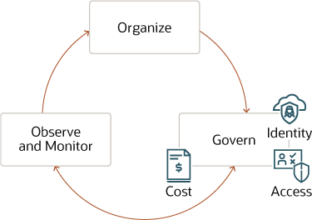

The process to implement a governance model is cyclic and iterative. You begin with organizing resources followed by implementing governance that includes identity, access, and cost governance. Finally, you set up processes to observe and monitor security controls. As you detect issues with the model, you feed the data back into the model to improve it.

Organize
You organize your resources and workloads to set up the foundation of an effective governance model.
Govern
You govern your resources and workloads by managing who gets access to which resources. You can manage access to resources using an identity and access provisioning system.
Observe and Monitor
You continuously observe and monitor your resources to ensure the governance model is working to meet your organizational goals. You will require certain essential services such as Cloud Guard, and OCI Logging and Audit services to observe and detect any issues that need to be fixed.
Establishing a governance model provides your organization with a starting point and helps identify improvements needed. It also helps identify the consequences and the risks that will be associated with the model. You apply the governance model at various stages of your Oracle Cloud Infrastructure (OCI) governance implementation.
To enforce cloud governance, security architects must do the following:
- Define and enforce access to resources such as compartments
- Define OCI Identity and Access Management (IAM) policies and tagging
- Observe, monitor, and detect issues using services such as Cloud Guard, OCI Logging, and Log Analytics
- Manage costs by defining service limits, budgets, and usage quotas
- Monitor performance to control costs and prevent costs from going over budget
- Use the Audit service to ensure compliance to defined governance policies

Governance Model Values

Learn about the core values and benefits of an effective governance model. Apply these values as best practices to optimize the usage of OCI resources such as performance monitoring, visibility, cost forecasting, security, and compliance to help your organization save time and money.

Better Management
Set distinct boundaries between teams and the resources they own. Existing models that used centralized governance models experienced reduced agility which worked against the interests of cloud computing goals. With a combination of resource organization and access control, you can achieve both agility and flexibility with governance.

Cloud Visibility
In order to validate prevention controls and act on probable failures, you must first detect them. Cloud visibility provides the ability to monitor and proactively react to activities on the cloud. That means you can identify security threats, inefficient resource utilization, or malicious activities on the cloud. The following are the benefits of cloud visibility:

- Performance Tracking
Enable autoscaling to dynamically scale resource usage. Track the performance of your resources to proactively identify and act on detected issues such as underutilized resources or autoscaling failures.

- Security
Identify spot security lapses and take corrective action proactively.

- Manage Costs
Being unaware of unused capacity may cost your organization a significant amount of money over time. Discover underutilized resources to reduce wastage in your cloud deployment, and enable your organization to reduce costs. Adjust resources to enhance organizational efficiency and scale capacity only when the need arises.

Predictable Cost

Plan your expenses to ensure success in both on-premises and cloud deployments. Manage your costs through estimation and planning by setting up budgets to track actual usage against the plan. Create budgets to get notified when the cost is nearing your usage quota and ensure that costs don't exceed an approved budget. Here are a few commonly used patterns to enforce budget constraints:

- Associate a budget with an organizational unit to receive automatic cost and usage report notifications when usage nears the approved budget.
- Perform forecasting and budget planning while monitoring your spend on the dashboard.

Better Security
While educating cloud users in cloud security is a key step in reducing the number of security breaches, 95 percent of all cloud breaches can be traced to human errors. By reducing the reliance on humans for ensuring cloud security, cloud governance significantly improves your security posture against online threats.
New and emerging cyberthreats require businesses to rethink their approach to cloud security, data protection, consumer privacy protection, and user authentication. Cloud governance policies for authenticating or monitoring access can configure and manage the security protocols and tailor them to your business needs.

Compliance Implementation
Cloud governance plays a critical role in enforcing regional compliance requirements. A well-designed third-party cloud governance solution can keep all your sensitive corporate data private and also comply to regional compliance laws such as HIPAA or FedRAMP. It also supports data protection laws such as CCPA in California, or GDPR in international markets such as the EU which impose strict customer data privacy and security compliance requirements on businesses.

OCI Resources and Services

Oracle Cloud Infrastructure (OCI) provides various resources and services that enable you to govern your resources. Learn about OCI services and how they can enable your organization to implement a governance model.

Resources

Oracle Cloud Infrastructure (OCI) enables you to organize your resources and implement governance in your organization. Learn about the physical and logical organization of OCI resources and services.
Region
OCI is physically hosted in geographical regions and availability domains. A region is a localized geographic area, and an availability domain is one or more data centers located within a region.
An Oracle Cloud Infrastructure region is a localized geographic area that contains one or more data centers, called availability domains. Regions are independent of other regions, and vast distances can separate them (across countries or even continents).
A region is composed of one or more availability domains. OCI resources are either region-specific, such as a virtual cloud network, or availability domain specific, such as a compute instance.
Availability Domain
Availability domains are standalone, independent data centers within a region. The physical resources in each availability domain are isolated from the resources in the other availability domains, which provides fault tolerance. Availability domains don’t share infrastructure such as power or cooling, or the internal availability domain network. So, a failure at one availability domain is unlikely to affect the other availability domains in the region.
When you configure cloud services, use multiple availability domains to ensure high availability and to protect against resource failure. Be aware that some resources must be created within the same availability domain, such as an instance and the storage volume attached to it.
Fault Domain
A fault domain is a grouping of hardware and infrastructure within an availability domain. Each availability domain has three fault domains with independent power and hardware. When you distribute resources across multiple fault domains, your applications can tolerate physical server failure, system maintenance, and power failures inside a fault domain.
For example, a hardware failure or Compute hardware maintenance event that affects one fault domain does not affect instances in other fault domains.
Identifying Resources
A fundamental concept to identify OCI resources is the OCID (Oracle Cloud Identifier). It is a unique identifier that identifies resources in an Oracle Cloud Infrastructure (OCI) service that contain metadata about the resources. The resource can be a user or a group, or an instance or a service. The resource which is an instance of a service or a principal, is a component of the full OCID of a particular resource.
OCI uses the OCID to identify and enforce policies on resources when you implement governance in your organization. The following shows the OCID syntax and its components:
Oracle Cloud Infrastructure provides the following services that enable you to create, organize, and administer your cloud resources.
ocid1.<RESOURCE TYPE>.<REALM>.[REGION][.FUTURE USE].<UNIQUEID>
- OCID1: The literal string indicating the version of the OCID.
- Resource Type: The type of resource such as instance, VCN, user, or group.
- Realm: A realm is a set of regions that share entities such as oc1 for commercial realm, oc2 for government cloud, oc3 for the federal government.
- Region: The geographical region of residence of the resource is in such as phx, iad.
- Future Use: Specifies if the resources are reserved for future use.
- Unique ID: The unique portion of the ID.

Tenancy
A tenancy is a secure and isolated partition that Oracle sets up within Oracle Cloud when you sign up for Oracle Cloud Infrastructure. You can create, organize, and administer your resources in Oracle Cloud within your tenancy. A tenancy is synonymous with a company or organization. Usually, a company will have a single tenancy and reflect its organizational structure within that tenancy. A single tenancy is usually associated with a single subscription, and a single subscription usually only has one tenancy.
Each resource within a Tenancy Structure in the tenancy belongs to a compartment (with few exceptions) which allows the resources to be logically grouped and managed to conform to the defined governance model. A resource is provisioned in the tenancy related to IaaS, PaaS, and infrastructure components, but not limited to Virtual Cloud Networks (VCNs), subnets, security, and routing rules.
Most of the core resources belong to a compartment within the tenancy. However, there are core resources which are global and live outside of compartments.

Compartments
Compartments are cross-region logical partitions within an Oracle Cloud Infrastructure tenancy. Use compartments to organize your resources in Oracle Cloud, control access to the resources, and set usage quotas. To control access to the resources in a given compartment, you define policies that specify who can access the resources and what actions they can perform.
Well-designed compartments enable your organization to do the following:
- Control access by compartments to enforce segregation of duties and control access based on function such as networking resources or databases
- Delegate administrative privileges to compartment administrators to manage their respective resources
- Develop a charge-back model by departments based on their respective compartments
- Define quotas and budges based on compartments
Service Limits
When you sign up for OCI, a set of service limits are configured for your tenancy. The service limit is the quota or allowance set on a resource. For example, your tenancy maybe allowed a maximum number of Data Science Service instances. Every resource has a defined limit and scope. The limits initially set in the tenancy are based upon a combination of resources purchased in the Bill of Materials and values determined as defaults. The scope of service limits is either regional or availability domain-specific allowing for additional flexibility. These limits may be increased for you automatically based on your OCI resource usage and account standing.
Budgets
You can specify a budget to set soft limits on your OCI spending. You can also set alerts on your budget to notify you when usage exceeds your budget. You can view all your budgets and spending in a single place using the OCI console.
Compartment Quotas
Compartment quotas give tenancy and compartment administrators better control over how resources are consumed in OCI. Quotas enable administrators to easily allocate resources to compartments using the console. Compartment quotas provide a powerful mechanism to manage your spending in OCI tenancies.

Logging

Logging is a highly scalable and fully managed service that provides access to the following types of logs from your resources in the cloud:
- Audit logs: Logs related to events emitted by the Audit service.
- Service logs: Logs emitted by individual services such as API Gateway, Events, Functions, Load Balancing, Object Storage, and VCN flow logs.
- Custom logs: Logs that contain diagnostic information from custom applications, other cloud providers, or an on-premises environment.
Log Groups
Logical containers for organizing logs that are used to define/limit access to logs to a limited group of users. You can create separate log groups based on the sensitivity of log data.
For example, create three log groups: Security, Network, and Application.
- Then for each log group, create OCI IAM policies to provide admin users access to read blogs from log groups.
- Allow group SecOps to read log-content in compartment logging where:

target.loggroup.id=’ocid1.loggroup.oc1.<OCIRegion>..<SecurityLogGroupUniqueID>

Logging Analytics
A cloud solution in OCI that lets you index, enrich, aggregate, explore, search, analyze, correlate, visualize, and monitor all log data from your applications and system infrastructure.
Logging Analytics provides multiple ways of gaining operational insights from your logs.
- Use the log explorer UI
- Aggregate log information into dashboards
- Utilize the APIs to ingest and analyze data
- Integrate with other OCI services

Cloud Guard

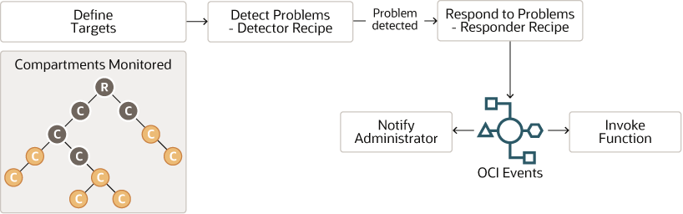
You can use Oracle Cloud Guard to monitor and maintain the security of your resources in Oracle Cloud Infrastructure. Cloud Guard uses detector recipes that you can define to examine your resources for security weaknesses and to monitor operators and users for risky activities. When any misconfiguration or insecure activity is detected, Cloud Guard recommends corrective actions and assists with taking those actions, based on responder recipes that you can define.

Detector Recipe
A set of rules/checks to identify potential security problems. Oracle provides some baseline detector recipes for services like object storage buckets, compute instances, VCN instances, IAM users and groups, load balancers, security lists, and network security groups. You can't update the recipe rule for Oracle-managed recipes. However, you can clone Oracle-managed recipes and create new recipes called user-managed detector recipes.
Recipes for Rules to Detect Problems
- Oracle-managed recipes
- User-managed recipes
- Configuration detector recipes
  - Public bucket
  - Instance has a public IP address
  - LB SSL certificate is about to expire
- Activity detector recipes
  - User added to a group
  - Compute instance deleted
Configuration Detector recipes check resource configurations. For example, check if the storage bucket is public or if there is a NAT gateway or Internet Gateway created in a VCN. Other detector recipes detect activity like creating a dynamic group or adding a VNIC to the VM.
Responder Recipe
A set of rules to either remediate the problem detected or send a notification requesting action. The default responder recipe does not give an option to remediate every problem. You can, however, address that by invoking functions from events. You take corrective measures or remediate the problem from the OCI function.
Like detector recipes, there are Oracle-managed responder recipes and customer-managed responder recipes. Customer-managed responder recipes are a clone of Oracle-managed recipes where you can disable some of the predefined responder rules.
Target
A target defines the scope of what Cloud Guard should check. It includes a list of compartments. When you add a compartment as a target, the Cloud Guard checks all the sub-compartments as well. Targets are defined where compartments, detector recipes, and responder recipes tie together.

Tagging
Tags contain metadata, key-value pairs, that are attached to resources and define their attributes such as usage, cost, or ownership.
Tag Basics
Tag namespace (only applicable to defined tags)
Tag namespace is a container for your tags. It consists of a name and zero or more tag key definitions. Tag namespace is unique across the tenancy.
Tag key
The name you use to refer to the tag. Tag keys are unique across the namespace.
Tag value type
It specifies the data type allowed for the value. There are two supported data types: String and a list of strings.
Tag value
It is the value that the user applies to the tags. Some tags have predefined values. Users must choose one value from the list of values for other tags.
A resource, which is an instance of a service on a compartment, can have one or more tags. Tags assigned to a compartment are assigned to all the resources in the compartment.
There are two ways to assign tags to resources.
Defined Tags
Predefined tags where administrators manage the metadata are more commonly used. For example, to create resource metadata to manage resources or collect data, you can use defined tags. There are three types of defined tags based on their usage and how values are assigned.
- Tags with predefined values
You can create a list of values and associate that list with a tag key definition. When users apply the tag to a resource, they must select a value from the list of predefined values. Use lists of predefined values to impose limits on the values that users can apply to tags.
- Cost tracking tags
Tags that are used when setting budgets to manage cost of resource usage.
- Tag defaults
You can define default tags that will be applied to all resources when they are created in a specific compartment. Setting up tag defaults ensures that the appropriate tags are applied at resource creation without requiring the user who is creating the resource to have access to the tag namespaces. Use tag variables to efficiently create tag defaults for resources created in a compartment. For example:
$(iam.principal.name}, $(iam.principal.type}, ${oci.datetime}
Free-form tags
User-defined unmanaged metadata applied to resources during the life cycle of a resource.

Design and Implement Your Governance Model

The governance model is an evolving, iterative process used to develop a mature and robust model aligned with the needs of your resources and workloads.
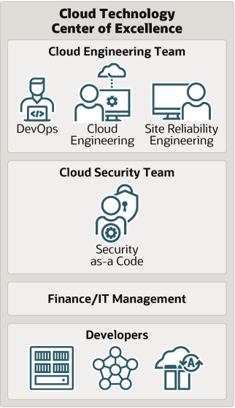
A company's organization structure should leverage a Technology Center of Excellence (COE) team to facilitate the process beginning with baseline governance followed by a phased approach for every workload.
Baseline Governance
Enables you to define governance processes for core and shared cloud resources. You begin with applying the governance model to your resources and set up your architecture to use the governance model. For example, you can define a Networking compartment during baseline governance implementation.
Workload Governance
Enables you to define governance processes for workload-specific cloud resources. Workload governance extends the scope and functionality of your initial baseline governance configuration to govern your workloads. For example, you can now extend the scope of the Networking compartment by creating child compartments to manage your workloads.

Use the Secure Landing Zone
Oracle recommends using the Secure Landing Zone to implement your governance for the tenancy.
The Secure Landing Zone automates the creation of a secure tenancy. The Secure Landing Zone provides the following:
- A set of Terraform scripts that deploy a standardized environment in an OCI tenancy
- Templates that use multiple compartments, groups, and OCI IAM policies to segregate access to resources based on job function
You can configure the resources within the template to meet the CIS OCI Foundations Benchmark settings related to:
- OCI IAM groups and policies
- Networking (VCN, Private Subnet, and Public Subnet)
- Keys
- Cloud Guard
- Logging
- Vulnerability Scanning
The landing zone implements and configures most of the OCI services required for governance.

Note:
The Secure Landing Zone doesn't create any artifacts for cost management and tags. It also doesn't implement advanced Identity Management (Identity Federation and Identity Provisioning or Deprovisioning) and networking (FastConnect setup).

Baseline Governance Lifecycle

A set of baseline security policies and principles that the technology team initially defines and enforces across the cloud.

Organize Resources
Whether you provision single or multiple applications, make sure you organize the resources for growth, flexibility, and accountability that is required to maintain control in the tenancy.
Organize resources based on the following:
- Compartments: A compartment having a specific recipe for an organization
- Resource Location: A region based on where the target audience is located
- Resource Isolation: Appropriate network controls such as Virtual Cloud Network (VCN) and Subnet
Compartment Design
The following image shows you an example of how you can organize your resources in compartments to achieve certain outcomes.
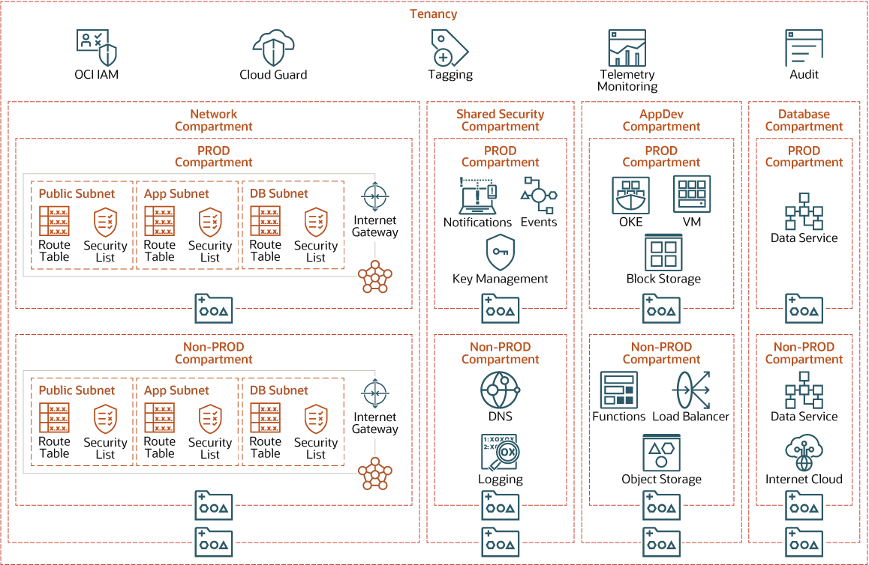
Each organization can use a compartment structure recipe specific to the outcomes they require. You can use the available predefined templates as a foundation to build your organizations structure. The OCI CIS Landing Zone provides a broad compartment structure template covering Network, Security, Applications, and Database resources. You can extend the compartment structure to add separate child compartments to various applications or for different lifecycle environments (Dev, Test, Prod). Get the CIS Landing Zone template images here.
Hierarchical Compartments Model
Defines at what policies you must define at different levels of the compartment hierarchy beginning at the Root level.
Root level
Define IAM policies
Level 1
Define network, shared-security, app-dev, and database policies
Level 2
Define Prod, Non-Prod, prototype policies:
- Network: Network family
  - Prod and Non: Prod VCN and Prod Subnets
- Shared-security: KMS, Logging, Notifications, Vaults
- App-Dev: OS buckets, Boot and Block Volume, FSS
  - Prod: Prod OAC, OIC, FAW
  - Prototype: All prototype services
- Database: Prod AWD, Non-Prod ADW
Developing an effective compartment design is essential in building a governance model. Compartment design can be changed at any time to align when business or process changes occur in your organization. In addition, resources provisioned in OCI can be moved from one compartment to another.
Resource Geographic Location
You must create resources in a geographic region and select the region based on where the target audience is. An application for European customers must reside in a data center in the European region. Within a region, application resources should be spread across availability domains and fault domains to achieve the highest availability. For every resource or workload, you must choose the appropriate region based on several criteria.
Resource Network Isolation
You can't use compartments to isolate resources. You can isolate resources using networking controls. You must organize resources in different VCNs and Subnets to isolate resources. Include resources belonging to the same application in the same VCN and resources from different applications in different VCNs. If two applications need to communicate with each other, you can either share a VCN or pair the two VCNs.

Govern Resource Identity
Establishing identity of an employee is essential for effective resource governance.
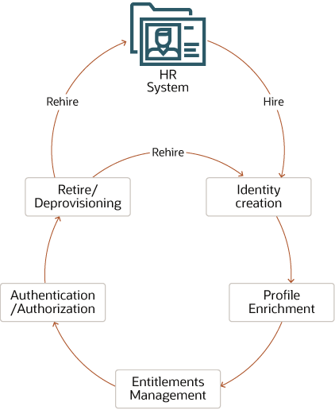
Identity Governance Scenario
When a new hire joins an organization, the HR system creates a user identity and provisions a set of centralized and policy-based identities and their entitlements. The new user gets default access to certain resources and applications known as birth-right entitlement provisioning. Then, depending on the user's organization, group, and role, the user is given access to additional applications and entitlements.
The user can request additional entitlements that go through an approval process to get themselves assigned to those entitlements. When the user retires or leaves the organization, the identity is deprovisioned. If the same user is rehired in the organization, the user can usually claim the same identity but can have different entitlements depending on the group or role they were hired in.
Identity in the Cloud
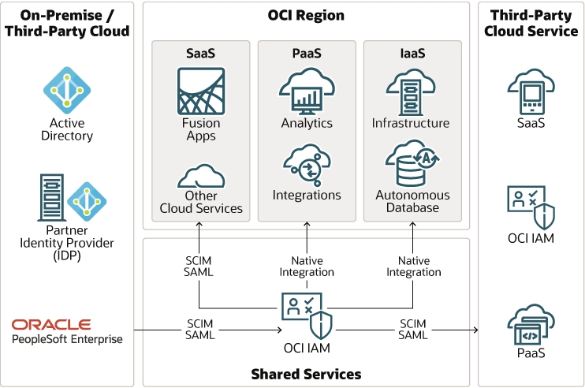
Oracle offers unified identity across IaaS, PaaS, and SaaS using Oracle Cloud Infrastructure Identity and Access Management (IAM). The unified identity to connect all the OCI IaaS and PaaS services have native integrations with OCI IAM. They use OCI IAM both as a user store and a login service. However, SaaS services on OCI, including Fusion SaaS services, integrate with OCI IAM using SCIM 2.0 and SAML standards. Customers can also integrate PaaS services with SaaS using IAM OAuth. They can integrate Oracle Cloud with on-premises or third-party cloud using open standards like SCIM 2.0, SAML, and OIDC.
The unified identity service streamlines the user onboarding and offboarding processes. When a user account is created or removed from the HR system, OCI IAM creates or removes the user account from all Oracle services. The OCI IAM service can also facilitates user account creation and removal from third-party cloud services.
OCI IAM provides a single source of truth for identities in Oracle Cloud. Customers can leverage IAM audit logs to see who has access to cloud systems or resources. They can also run security threat modelling to detect unauthorized access and take corrective measures.

Govern Resource Access
OCI has a deny-by-default security posture. When a tenancy is provisioned, no user other than the tenancy administrator user can access any resources in OCI.
Tenancy administrators can create policies to grant permissions to groups of users on resources within compartments or the tenancy. The following are some sample IAM policies that you can use as a starting point for the compartment structure proposed in the Compartment section.
- Create policies to allow compartment admins to manage all resources in the respective compartment.
  - Allow group security_admin to manage all resources in compartment Shared_Security:Prod
  - Allow group security_admin to manage all resources in compartment Shared_Security:NonProd
  - Allow group network_admin to manage network-family-resources in compartment Network
  - Allow group database_admin to manage database-family-resources in compartment Database
  - Allow group appdev_admin to manage instance-family-resources in compartment App-Dev
- Create policies for compartment admins to use shared resources from other compartments.
  - Allow group appdev_admin to use network-family-resources in compartment Network
  - Allow group appdev_admin to use database-family-resources in compartment Database
  - Allow group database_admin to use network-family-resources in compartment Network
  - Allow group database_admin to use vaults in compartment Shared_Security
- Create policies for auditors and other read-only user groups to read all resources in the tenancy.
  - Allow group auditors to read all resources in tenancy
  - Allow helpdesk-users to inspect all resources in tenancy
  - Allow group announcement_readers_group to read announcements in tenancy
You can also use tags to define IAM policies. You can write a policy to scope access based on the tags applied to a resource using conditions and a set of tag variables. You can control access based on a tag that exists on the requesting resource (group, dynamic group, or compartment) or the target of the request (resource or compartment). The first three sample access policies use requesting resource tags and the last two sample access policies use target resource tags.
Allow any-user to manage instances in compartment HR where request.principal.group.tag.Operations.Project= 'Prod'
Allow dynamic-group InstancesA to manage instances in compartment HR where request.principal.group.tag.Operations.Project= 'Prod'
Allow dynamic-group InstancesA to manage instances in tenancy where request.principal.compartment.tag.Operations.Project= 'Prod'
Allow group GroupA to manage all-resources in compartment HR where target.resource.tag.Operations.Project= 'Prod'
Allow group GroupA to manage all-resources in tenancy where target.resource.compartment.tag.Operations.Project= 'Prod'
You start with three high-level roles for every workload that you onboard.
- Service admin
- Service developer
- Service viewer
Create baseline policies for each role to manage, use, read, and inspect permissions to service instances. You can create policies to give users permission on shared resources to the service administrator. For example, for the Analytics service, you can create the following policies:
- Service admin role
  - Allow group Analytics-admin to manage analytics-instances in compartment App-Dev
  - Allow group Analytics-admin to manage analytics-instance-work-requests in compartment App-Dev
  - Allow group Analytics-admin to use network-family-resources in compartment Network
  - Allow group Analytics-admin to use autonomous-databases in compartment Database
- Service developer role
  - Allow group Analytics-developer to use analytics-instances in compartment App-Dev
  - Allow group Analytics-developer to use analytics-instance-work-requests in compartment App-Dev
- Service viewer role
  - Allow group Analytics-viewer to read analytics-instances in compartment App-Dev
  - Allow group Analytics-viewer to read analytics-instance-work-requests in compartment App-Dev
You can begin the process with these or similar policies and extend the policy model with every new service that you onboard.

Govern Resource Cost
When transitioning from a CapEx model, where many costs are fixed at the implementation of a project, to an OpEx model, where costs scale up and down with the usage of the system, you often require cost management tools to understand, control, and communicate these cloud costs within your organization.
Oracle provides tools that enable you to govern your organization’s spending and optimize expenditures.
- Predict: Set and manage cloud budgets
- Control: Prevent overspending
- Visibility: Ensure accurate cost tracking across departments and projects and analyze which departments, services, and projects are contribute to cloud usage over time
- Optimize: Get granular usage details for invoice reconciliation and identify areas to optimize costs
- Extend: Identify areas to extend usage where necessary
Cost Management
You can use one of these two approaches to control costs.
- Create financial budgets for every team/group of resources and tack usage against those budgets and alert the team administrator if the usage exceeds the budget or is about to exceed the budget.
- Create a limit or quota for every service instance. If a team tries to create more instances than the allocated quota, then the request will fail.
The second approach is restrictive and prevents cost overrun, while the first approach requires manual intervention if the usage exceeds the assigned budget. Compartment trees aggregate budgets and quotas, so child compartments share the total aggregate budget or quota set on the parent.
For example, if compartment Data Science has a budget of $2000, child compartments of DEV and TST share that global budget and will be restricted if either of them exceeds that limit.
Cost Tracking
You can use a budget to set soft limits on the OCI spending by setting cost-tracking tags or by compartments (including the root compartment) You can track all the spending in that cost-tracking tag or for that compartment and it's children. You can also set alerts on budgets to inform management when they exceed the budget. You can view all budgets and spending limits on the OCI Console.
The system evaluates all budget alerts every hour in most regions and every four hours in the Ashburn (IAD). To see the last time a budget was evaluated, review the details for a budget. You will see fields that show the current spend, the forecast and the Spent in Period field showing you the period over which the budget was evaluated. When a budget alert triggers, the recipients configured in the budget alert receive an email.
You can install and use the OCI Cost Governance and Performance Insights Solution app from Oracle Cloud Marketplace linked in the Explore More section.
Cost Control
You can control costs in OCI by limiting the number of service instances created using service limits and compartment quotas.
Service limits help manage the maximum number of resources that can be provisioned in a tenancy, region, availability domain, and compartment. These soft limits restrict provisioning resources which may exceed the limits defined. Only authorized users can request these service limits to be increased or decreased. Service limits enable you to limit the maximum number of service instances of a particular service in a region, availability domain, and compartment.
Compartment quotas are policies that allow administrators to allocate resources with a high level of flexibility by giving tenancy and compartment administrators better control over how resources are consumed in OCI. Compartment quotas are similar to service limits, except service limits are set by Oracle. Compartment quotas are set by administrators using policies that allow them to allocate resources with a high level of flexibility.

Observe and Monitor Resources
You must observe and monitor your resources to ensure the governance model is working to meet your organizational goals.
Cloud Security Posture Management
Cloud Guard is an OCI service that helps you monitor and maintain a strong security posture on Oracle Cloud. Cloud Guard has three essential elements.
- Target is a resource to monitor
- Detector recipes are recipes to detect problems
- Once problems are detected, responder recipes respond to those problems. The response can be a notification or corrective action.
Cloud Guard detects security configuration issues with OCI resources. Based on the probable impact of the issues, it assigns a risk score to the problems. You can monitor aggregated risk scores of the tenancy from the Cloud Guard dashboard. The following are recommendations for using Cloud Guard:
- Cloud guard is a free service and the best practice is to activate Cloud Guard for all the compartments.
- Customize Cloud Guard recipes to define custom risk scores and response action for problems detected.
- Choose to exclude some compartments from making resources available in certain other compartments. For example, if you exclude the Development compartment it can provide you the flexibility to be able to create resources that are not allowed in production compartments.
Cloud Guard supports an allowlist which is a list of exceptions to Cloud Guard policies. For example, if a Cloud Guard policy is set to deny any public object store buckets. If you need to create public bucket for a legitimate use case then you can add explicitly the OCID of the public bucket to the allowlist.
Security Logging
The ability to centrally log all the actions on every cloud resource and be able to audit them in a cloud ecosystem ensures a successful cloud implementation. You can additionally use network flow logs and some of the application logs to detect anomalous behavior. Security and Compliance teams can automate notifications or corrective measures of any undesired incident. Allowing quick actions can alleviate any breaches and threats.
Dashboards and reports based on monitoring, auditing, and logging data can keep the team updated and focused on resolving problems before they become a disaster. You can do the following by setting up security logging:
- Aggregate audit logs, which are turned on by default in OCI, in log groups to monitor them using Logging Analytics.
- Enable network flow logs to detect suspicious network activity.
- Enable service logs for all the services that support service logs. Ensure you choose appropriate log groups while enabling service logs.
- Use the interactive visualizations in Logging Analytics to analyze the data. Using the cluster feature to reduce millions of log entries down to a small set of interesting log signatures makes it easy to review the logs.
- Use the link feature of logging analytics to analyze logs in a transaction to identity anomalous patterns using the grouped view.
If you use a third-party SIEM solution, you can integrate it with OCI using the OCI streaming service and service connector.

Implement Baseline Governance
Oracle recommends using the Secure Landing Zone to implement resource organization (compartment structure) and resource access governance.
In addition to creating a tenancy structure and access policies, baseline governance also requires you to enable other security features like Cloud Guard, Audit, and Logging.
You should also create a tagging structure and cost governance structure as recommended in the following sections.
Tagging
The Tag Namespace in the following table is Cost-Management.
Tag-Key | Sample Key-Value | Description
Name | - | -
CostCenterID | ERP-US, ERP-UK | Project code name
The Tag Namespace in the following table is Operations.
Tag-Key | Sample Key-Value | Description
Environment | Prod, Non-Prod | Lifecycle environment
AppName | Finance, HR | Business unit
AppCI | - | -
OProjectName | Finance-EBS, Finance-ERP | -
Business Owner | ABC.someone@example.com | -
SystemCustodian | ABC.someone@example.com | -
IT SupportGrp | ABC.someone@example.com | -
OS | LIN, WIN | -
Maintenance | Group1, Group2, Group3 | -
Impact | Low, Medium, High | Blast radius across organization
The Tag Namespace in the following table is Govn-Security.
Tag-Key | Sample Key-Value | Description
InfoClass | Public, Internal, Sensitive | -
NetTrustLevel | Corporate (3) / Vendor DMZ (2) / Internet DMZ (1) / Firewall | -
Criticality | T1, T2, T3, T4 | - Tier 1: Most Critical  - Tier 2: Critical  - Tier 3: Non-Critical Business workload  - Tier 4: Non-Critical IT workload
Cost Governance
In the OCI Console, use the Tag Namespaces UI under Governance and do the following:
- Define a tag key named CostManagement.CostCenterID and enable it for cost tracking.
- Assign a key tag value of Finance for the Finance cost center CostManagement.CostCenterID = "Finance" to specific resources.
- Assign a key tag value of IT for the IT cost center "IT" (CostManagement.CostCenterID = "IT") to other resources.
Use the Create Budget UI under Tenancy to create budgets
- Create a budget for resources tagged CostManagement.CostCenterID = Finance.
- Create another budget for resources tagged CostManagement.CostCenterID = IT.
- Configure alerts to notify the recipients using email if costs exceed the predefined budget or the forecast exceeds a set threshold.
You can create a budget for a compartment specific to a tag value. For example, a monthly budget of $500 is allocated to all resources in a project with a Tag Key value of IT in the Cost-Management/Finance Tag Namespace and CostCenterID Tag Key. You can also configure the budget to start on a particular day of the month to align with business requirements. You can then configure it to send alerts to ABC.someone@company.com when the actual spend amount reaches 80 percent of the $500 budget.
Every OCI service has default service limits enforced. You can update the default service limits using the Limits, Quotas, and Usage UI based on your workload. These limits can be set to align with approved boundaries or budgets according to the needs required by those groups.
Control Cost
Create compartment quotas for every compartment in OCI. The following examples show how to create compartment quotas.
- The following example sets the quota for VM.Standard2 and BM.Standard2 compute series to 240 OCPUs (cores) in each AD on compartment App-Dev in the US West (Phoenix) region:
set compute-core quota standard2-core-count to 240 in compartment App-Dev where request.region = us-phoenix-1
- The next example shows you how to create an allowlist and set every quota in a family to zero and then explicitly allocate resources:
zero compute-core quotas in tenancy set compute-core quota standard2-core-count to 240 in tenancy
- This example shows you how to limit creating dense I/O compute resources to only one region:
zero compute-core quotas /*dense-io*/ in tenancy set compute-core quota /*dense-io*/ to 48 in tenancy where request.region = us-phoenix-1
- You can clear quotas by using an unset statement, which removes the quota for a resource. Any limits on this resource will now be enforced using the service limits set:
zero compute-core quotas in tenancy unset compute-core quota standard2-core-count in tenancy
Cost Analysis and Reporting
Cost Analysis and Reporting are two services available to monitor costs and validate that cost control measures are working.
The Cost Analysis tool enables you to analyze how your Oracle Cloud credits are being spent and how consumption compares to your commitment amount. You can use the dashboard to view the spending by service or department, using the compartment or cost-tracking tag and trend lines. This helps you understand how your spending patterns are changing and can help you focus on reducing cost. You can perform cost analysis for a given tag key similar to with budgets.
You can choose specific report types to be run for certain periods and factors. In addition, grouping these reports based on the compartment, tagging, or other group values enables granular reporting for chargeback or analysis.
Usage and Cost Report
Usage reports enable you to gain insights into your billing or create custom billing applications. The reports contain one record per resource. For example, an instance, DB system, or Object Storage bucket per hour with metadata and tags.
A cost report is a comma-separated value (CSV) file similar to a usage report and includes cost columns. The report can be used to obtain a breakdown of your invoice line items at resource-level granularity. As a result, you can optimize your OCI spending and make more informed cloud spending decisions.
Usage reports indicate the quantity of what is consumed. Cost reports indicate the cost of resource consumption. When combined with your rate card, usage reports drive scenarios such as:
- Invoice reconciliation
- Custom reporting
- Cross-charging
- Cost optimization
- Resource inventory
In addition to enabling new billing scenarios, usage reports provide transparency into how the billing system works. Usage reports can indicate how and where rounding occurs within the usage report and how resources that existed for less than an hour were billed.

Deploy
The Terraform code for this solution is available in GitHub. You can pull the code into Oracle Cloud Infrastructure Resource Manager with a single click, create the stack, and deploy it. Alternatively, download the code from GitHub to your computer, customize the code, and deploy the architecture by using the Terraform CLI.
- Deploy by using Oracle Cloud Infrastructure Resource Manager:
  - Click 
If you aren't already signed in, enter the tenancy and user credentials.
  - Review and accept the terms and conditions.
  - Select the region where you want to deploy the stack.
  - Follow the on-screen prompts and instructions to create the stack.
  - After creating the stack, click Terraform Actions, and select Plan.
  - Wait for the job to be completed, and review the plan.
To make any changes, return to the Stack Details page, click Edit Stack, and make the required changes. Then, run the Plan action again.
  - If no further changes are necessary, return to the Stack Details page, click Terraform Actions, and select Apply.
- Deploy by using the Terraform CLI:
  - Go to GitHub.
  - Download or clone the code to your local computer.
  - Follow the instructions in the README.

Workload Governance Lifecycle

Workload governance involves scoping the workload and various characteristics associated with the workload to design governance using the governance model. Workload governance progresses in the following four phases:
- Workload Scoping and Assessment: Identifies the scope of the resources, processes, budgets, and security requirements specific to the workload in question.
- Workload Governance Design and Deployment: Identifies workload-specific guardrails across disciplines specific to security, governance, and budgeting.
- Workload Onboarding: Workloads are onboarded into the environment with the appropriate governance guardrails in place
- Workload Governance Monitoring and Offboarding: Offboarding of assets according to the defined lifecycle of the workload

Scope and Assess Workload
As a first step, you must scope the workload in the gating and review process for teams deploying new workloads into OCI.
Scoping ensures that sufficient business drivers and sponsorship and that the appropriate guardrails are in place to securely accommodate the new workload. Assess the workload to determine if it requires governance and how much governance it requires based on how sensitive and business critical the workload is.

Design Your Workload Governance
Use the data obtained in the initial assessment to design your Tenancy for workload governance.
You assess your workload and make decisions based on the answers to certain questions and determine your required organizational outcomes. You begin with the compartment structure you set up during Baseline governance.
The design process of Workload governance follows the governance model similar to Baseline governance. The following are some examples of the thought process involved in designing your workload governance.
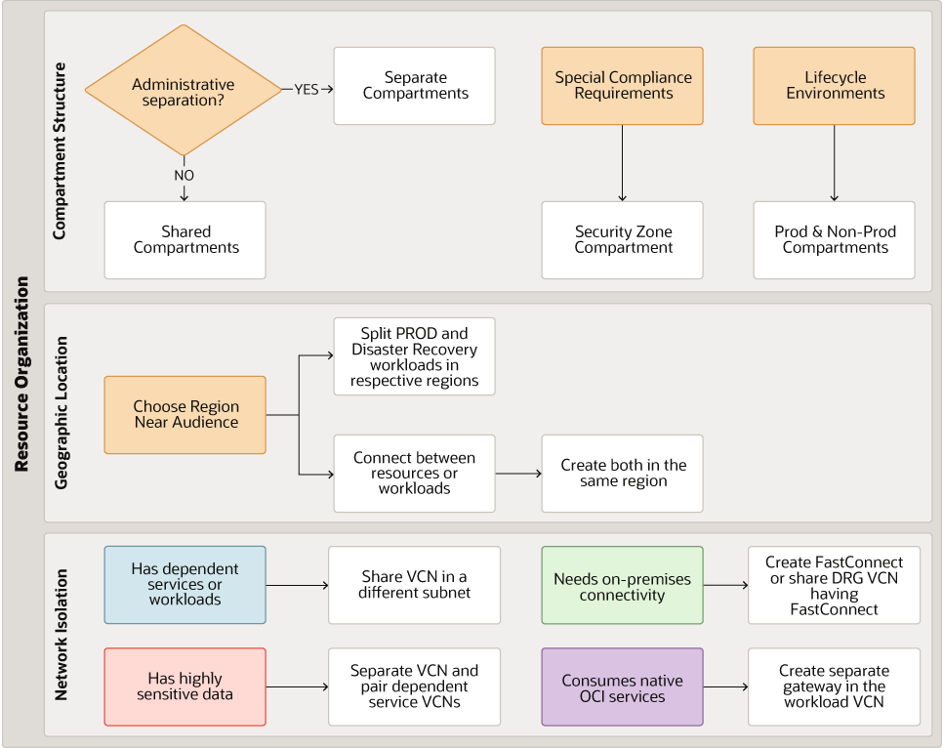
Organize Workload Resources
You initially organize your resource workloads based on the requirements for compartment structure, geographic location, and network isolation.
Consider the answers to these questions for designing your compartment structure.
- Does the workload need administrative separation?
  - Yes: Create a new compartment for your workload resources
  - No: Share your workload compartment with an existing compartment
- Does your workload have special compliance requirements such as HIPAA or FedRamp?
  - Yes: Create a security zone compartment
- Does the workload have lifecycle environments?
  - Yes: Create separate Prod and Non-Prod compartments
Consider the answers to these questions for selecting your workload geographic location.
- Where is your target audience located?
  - Choose a region close to your target audience
- How to separate your workload for production and disaster recovery?
  - Split the production and disaster recovery workloads in the designated production and disaster recovery regions
- Does the workload need connectivity to other workloads?
  - Yes: Create the workloads in the same region
Consider the answers to these questions for deciding your workload network isolation.
- Does the workload have any dependent services or workloads?
  - Yes: Share the VCN in a different subnet
- Does the workload have highly sensitive data?
  - Yes: Create a separate VCN and pair dependent services VCNs
- Does the workload need connectivity with on-premises workloads?
  - Yes: Create Fastconnect setup or share the Dynamic Routing Gateway (DRG) with the VCN that has FastConnect set up
- Does the workload consume native OCI services?
  - Yes: Create a service gateway in the workload VCN
Manage Workload Cost
Managing workload costs includes tracking and controlling costs to avoid overspending due to suboptimal resource usage. You can make decisions to save costs when you set up your workloads and track usage against budgets and control costs based on how you organize your workloads in compartments.
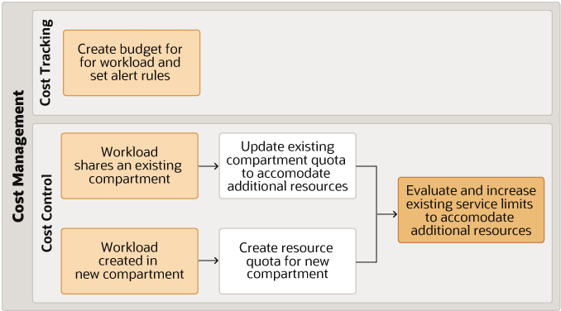
Cost tracking includes setting up budgets and analyzing costs based on resource usage. Create a budget and set up alert rules to notify management or administrators when spending is nearing the budget by setting up limits, quotas, and usage in the Governance section in the OCI Console.
When you are alerted about the spending nearing the budget, you can set up cost control measures based on answers to these questions:
- Does the workload share an existing compartment?
  - Yes: Update the compartment quota to accommodate any additional resources
- Is the workload is created in a new compartment?
  - Yes: Create resources quotas in the new compartment
- Do your current service limits meeting your organizational needs?
  - Yes: Re-evaluate existing service limits and update them to accommodate additional resources
Govern Access
Governing access requires the following steps:
- Identity provisioning
- Identity federation
- Administrative groups and IAM policies
- Privileged account management (PAM)
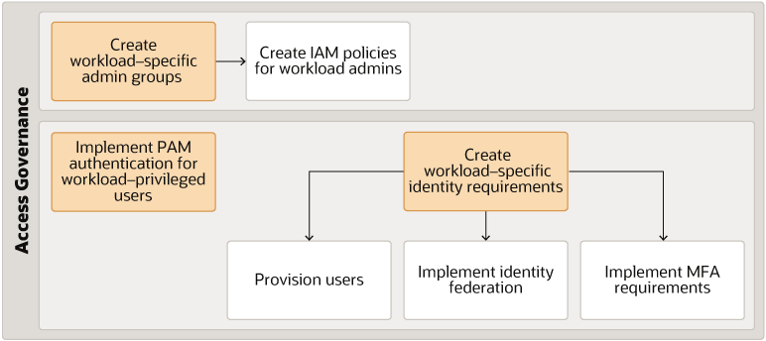
You can implement access governance by creating workload-specific admin groups and then creating IAM policies for workload administrators. You can also implement PAM authentication for workload-privileged users.
If you have workload-specific identity requirements then do the following:
- Provision any workload-specific users
- Implement workload-specific identity federation
- Implement workload-specific MFA requirements
Secure Workloads
Securing your workloads is essential to keep off malicious activity and suspicious events from critical customer data. You can implement workload security by following these steps:
- Enable Cloud Guard
- Enable the Vulnerability Scanning service
- Set up notifications to monitor for suspicious events and create notification rules
Secure Data
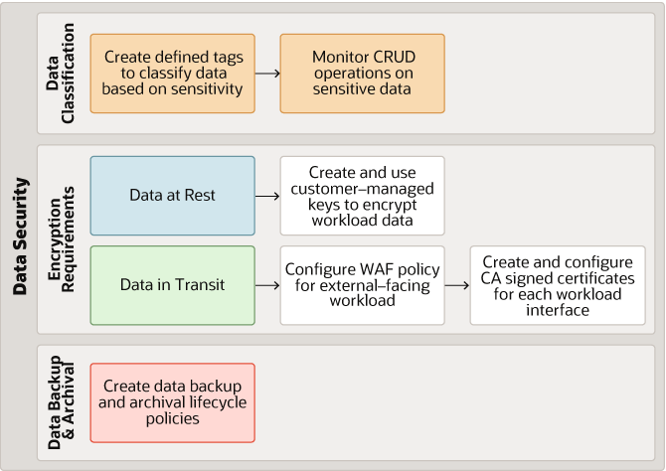
Securing critical customer data requires secure practices during implementation to ensure customer data is safe as well as recoverable in the event of data loss. You can secure customer data by following these steps:
- Classify different types of data
  - Create defined tags to classify data based on sensitivity
  - Monitor Create, Read, Update, and Delete (CRUD) operations on sensitive data
- Identify data encryption requirements for both at-rest and in-transit data
  - For data at rest, create and use customer-managed keys to encrypt workload data
  - For data in transit, do the following:
    - Configure WAF policies for external-facing workloads
    - Create and configure CA signed certificates for every workload interface
  - Set up data backup and archival lifecycle policies
- Plan to set up policies for data backup and archival
Deploy Your Workload
Once you decide on the governance controls specific to your new workload you can do one of the following:
- Codify it using Terraform
- Utilize the OCI command line interface
- Implement your changes using the OCI Console

Monitor, Support, and Offboard Workloads
Setting up your workloads for monitoring and logging for audit purposes is key to implementing observability of your cloud implementation. Follow these steps to implement observability in your cloud implementation.
- Enable workload monitoring and alerting
- Integrate audit logs with SIEM solution
- Enable service and custom logs to set up logging analytics or SIEM
You can continue to leverage Cloud Guard and other security controls to monitor risky configurations of the OCI control plane related to the workload.
Leverage Drift Detection to ensure that what you deployed in the workload's compartment remains consistent with what you defined in the DevSecOps pipeline. Offboard resources when decommissioning workloads using the DevSecOps pipeline.
You can install and use the OCI Cost Governance and Performance Insights Solution app from Oracle Cloud Marketplace linked in the Explore More section.

# END #

