Workload Governance in OCI

Contents

1. Introduction 2
Workload Scoping and Assessment - Phase I 4
Design and Deployment of Workload Governance - Phase II 4
Deploying the Workload inside of the Workload Specific Governance Constructs- Phase III 5
2. Workload Governance Design and Deployment Deep Dive 5
Workload Cost Management 9
Workload Access Management 10
3. Workload Security 11
Data Security 12
4. Observability 13
5. Summary 14

Introduction

Governance involves a set of decisions around the provisioning, administration, stewardship, and off - boarding of cloud resources. This may involve the inclusion of processes such as manual provisioning activities. It can also be codified via workflows and infrastructure as code as organizations mature their processes.
To enable technology governance, companies should implement a Cloud Center of Excellence (CCOE). CCOE's are comprised of representatives from technical and business disciplines such as Site Reliability Engineers, Cloud Engineers and Architects, DevOps, Security, Business Analysts and Compliance personnel. A baseline governance model helps define and implement governance process for core and shared cloud resources, while a workload governance model defines and implements governance processes for workload-specific cloud resources.

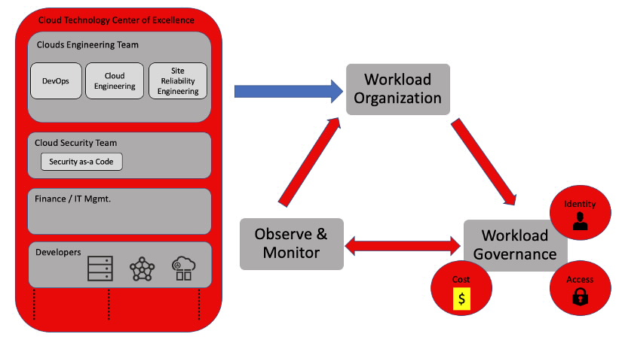

A good starting point for building a baseline governance model is the OCI CIS Landing Zone Framework. The CIS Landing Zone Reference Architecture provides a Terraform-based landing zone template that meets the security guidance prescribed in the CIS Oracle Cloud Infrastructure Foundations Benchmark.

Workload governance involves scoping the workload and various characteristics associated with it and designing a set of governing controls. It's a four-phase process as described below.
Phase I – Workload Scoping and Assessment
Phase II – Workload Governance Design and Deployment
Phase III - Workload Onboarding
Phase IV - Workload Governance Monitoring and Off-Boarding

Workload Scoping and Assessment - Phase I
The workload scoping and assessment phase serves as the first step in the gating and review process. This ensures sufficient business drivers and sponsorship, and that workload context is captured in order to place appropriate guardrails for the workload later in the Workload Design and Deployment Phase.
Some customer's leverage their internal ticketing systems for business units to request space for their workload in their OCI tenancy. This is a great spot to embed an initial assessment questionnaire and have the requestor schedule a meeting with core representatives of the CCOE to engage in a proper scoping exercise.

Design and Deployment of Workload Governance - Phase II
Design and deployment are a critical phase of the workload governance process. In this phase we will leverage the information obtained in the initial assessment to formulate governance constructs to be deployed in OCI. We'll use some sample decision trees to guide us through the design process. The leaf nodes of the decision tree illustrate some recommended actions.
Note that some of the governance artifacts we create for workload governance are an extension of artifacts deployed as part of the existing governance baseline. For example, created a networking compartment in in the baseline governance phase. Generally speaking, will either use the same networking compartment or create a child networking compartment under the original networking compartment structure.

The workload governance design process has six diffrent event sections as described below.

- Workload Resource Organization
- Workload Cost Management
- Access Governance
- Workload Security
- Data Security
- Observability

Deploying the Workload inside of the Workload Specific Governance Constructs- Phase III

Deploying the workload within the confines of the newly formulated guard rails which we defined in the prior phase. The configuration outputs from the decision trees leverage in the workload design phase can be codified using Terraform. Customers can deploy these utilizing their own Terraform stack or via Oracle's Resource Manager which is an Oracle managed Terraform service. Leverage Cloud Guard and other security controls to monitor risky configurations of the OCI control plane related to the workload. Oracle Resource Manager's Drift Detection capability can be used to ensure that what is deployed in the workload's compartment(s) remains consistent with what is defined in the DevSecOps pipeline (i.e., your Terraform configurations). off -board resources when decommissioning workloads via organization's DevSecOps pipeline.

Workload Governance Design and Deployment Deep Dive
Sometimes there's no substitute for a concrete "real-world example". look at a sample workload scenario and how we might begin tackling governance for the workload based on its characteristics and context.
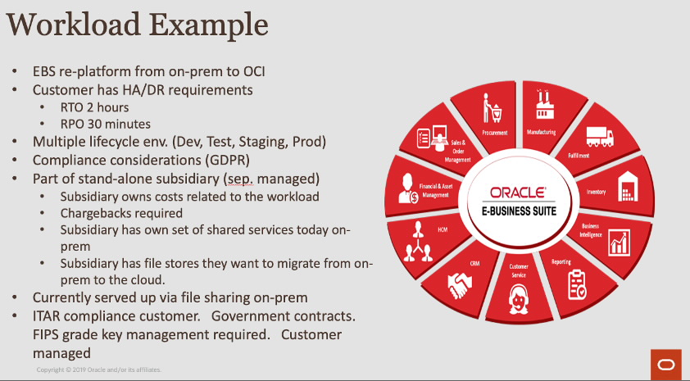

We can see that this workload is onboarding from a wholly owned subsidiary within the company. This subsidiary has a separate IT management structure and compliance requirements which are unique to other workloads in the tenancy. This needs to be taken into account as part of the workload assessment and design process.

Some decision trees to get you thinking about how to approach governance at the workload level. Following each decision tree, I'll accompany it with some commentary relative to the sample workload referenced above to drive context. This example includes EBS but is not intended to be a treatise on EBS Architecture on OCI.

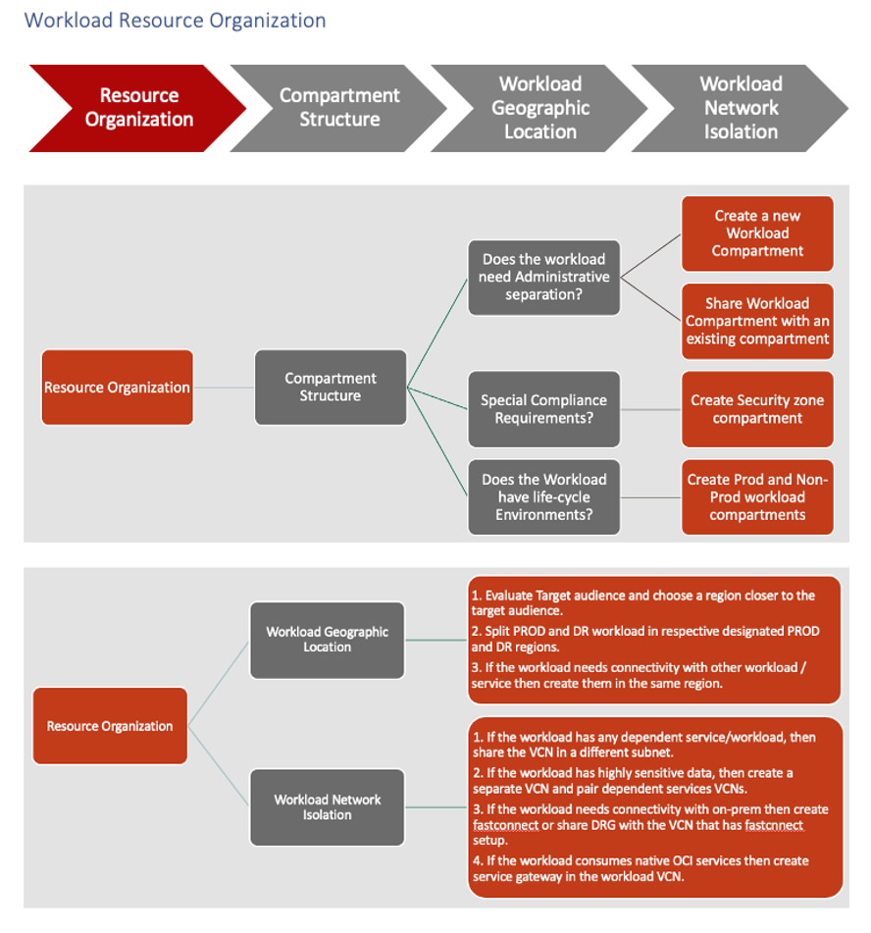

Start with resource organization. subsidiary is located in the UK and for the sake of discussion our existing Landing Zone is only setup for the US East and West Regions. obviously want to make a core modification to the tenancy to accommodate the new workload. Additionally, given the RPO and RTO objectives it's going to make sense to leverage another region that is in the vicinity for disaster recovery which takes existing corporate network deployment into account. pick UK- South-London as our primary region and EU-Amsterdam-1 for the secondary region. fictional customer will leverage Data Guard across these regions in order to facilitate the required RTO and RPO objectives for the data tier. Resync will be used to keep the app-tier in sync per Oracle's Best Practice Architecture for EBS on OCI.
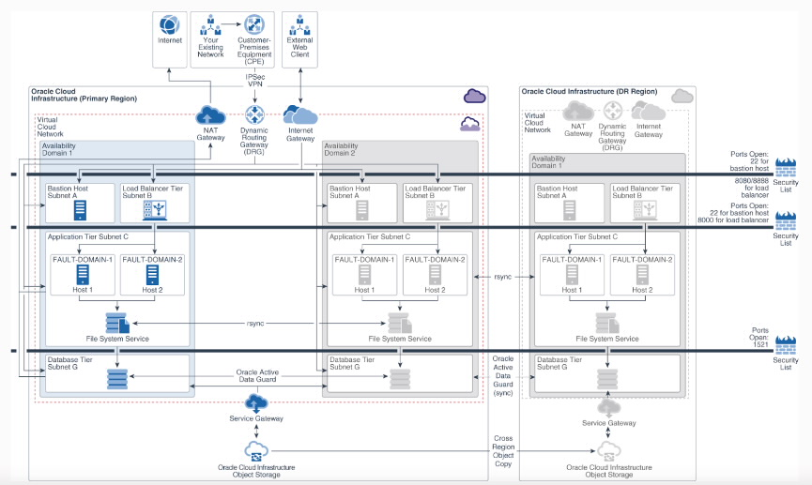

The workload will be placed in dedicated VCN's in these two respective regions for isolation given the stringent security and compliance requirements of the subsidiary. The Core Landing Zone has IGW's and NAT GW's in the US regions but we will not configure routing to transit those constructs. We will create a separate compartment for the workload and sub-compartments for the respective lifecycles. Within those lifecycle compartments we will further organize resources into application and database compartments. A standard Landing Zone contains these entities already but since the workload has special security and compliance requirements and is managed separately from the rest of the organization it will be further compartmentalized.

In collaboration with the UK subsidiary, our fictional CCOE team has decided to leverage the existing network compartment in the core Landing Zone and have the shared network team manage the component for them since they don't have a cloud networking team. The shared network team will stand up Fast Connect Circuits in the proposed UK and Amsterdam regions which will backhaul to the subsidiary's corporate offices in London and Amsterdam. The network team will also setup a Dynamic Routing Gateway (DRG) to facilitate route connectivity across the two VCN's in the London and Amsterdam regions as well as connectivity back to the subsidiary’s offices in those same locations.

Workload Cost Management
Dealing with a wholly owned but completely separate subsidiary, its finances are managed separately as well. For the time being the subsidiary has decided to continue to manage their own IT resources (except for cloud networking) and needs to be charged back accordingly. Look at the decision tree below to structure thought processes.
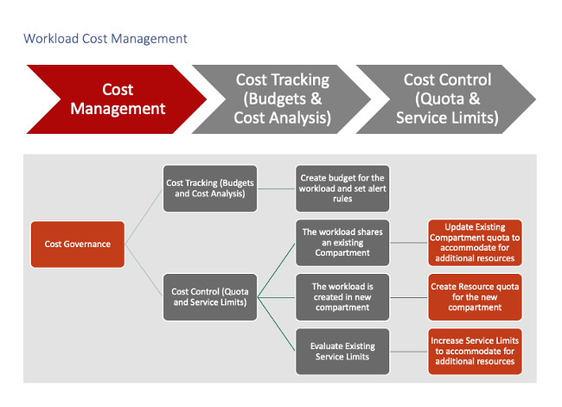
Create separate budgets, quotas and tagging structures for the subsidiary. Since they are financially separate, they will not be leveraging any of the existing quotas, budgets or tagging structures used by the parent. As part of the workload onboarding process the CCOE team needs to conduct some additional fact finding around the subsidiary's budgets and chargeback requirements. Learn more about OCI Budgets and Quotas via the respective links.

Workload Access Management
While baseline governance defines a certain predefined set of roles at the organization level, we still need to address the creation of groups specific to workload. The decision tree below gives some things to think about as we navigate this phase of the design.
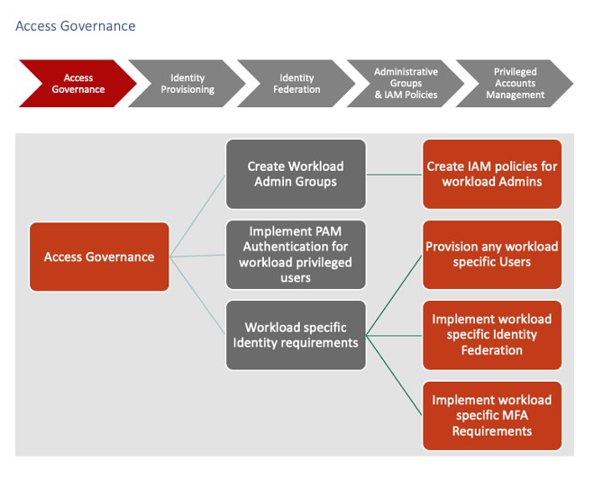
Subsidiary manages their own resources, need their own groups created in IAM to manage these objects. provision them with groups for sub_db_admins, sub_compute_admins and sub_security_audit roles. write policies that are compartment specific and attach them to the aforementioned groups to refine access. Addtionally, the subsidiary has their own Azure Active Directory so we will need to modify our Core Landing Zone to accommodate the new IdP and setup provisioning and group mapping accordingly.

Workload Security
Workload Security is often addressed by way of security services deployed in a common shared services network enclave. These could be vulnerability scanning appliances, endpoint security management servers and the like. Here's another decision tree to get us started.
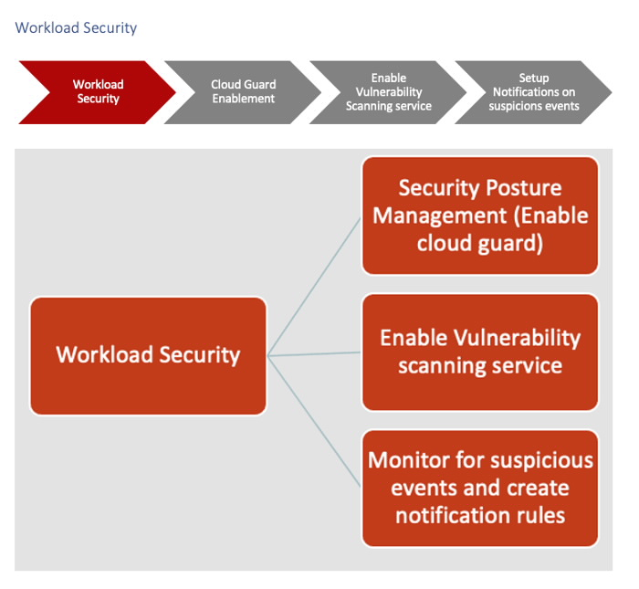

In the case of our fictional subsidiary, they are choosing not to leverage the existing shared scanning service in the tenancy, and they want to continue scanning their own resources using their own 3rd party scanning appliances after moving into OCI. Subsequently we will deploy a new shared services environment that they can leverage to host these services.

The CCOE and the subsidiary have agreed to partner and leverage Cloud Guard for Cloud Security Posture Management. The CCOE will provide the subsidiary with read access to Cloud Guard problems in the tenancy specific to the compartments which they manage.

Data Security

When we talk about data security, we are looking for ways to enact certain controls based on the classification of resources. The decision tree below gives us some examples to consider as it relates to data security and governance.
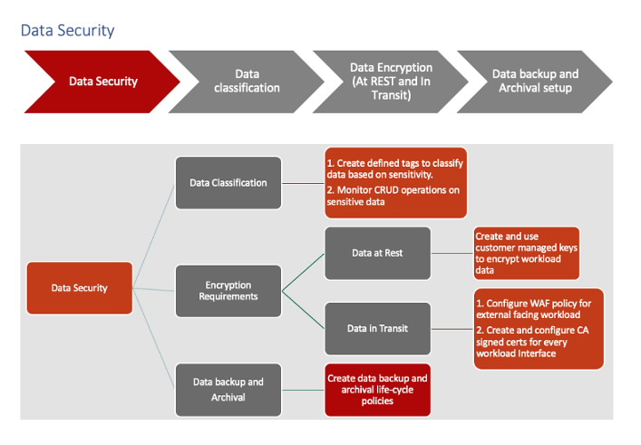

Subsidiary wants to lock down their data as much as possible. If the subsidiary uses a managed OCI PaaS services such as Exadata Cloud Service or Autonomous Database, then much of these capabilities such as encryption and hardening are configured by default. If the subsidiary deploys their own Compute Instances and installs and manages the Oracle database themselves then they will need to make sure they configure Oracle Security Features such as Transparent Data Encryption (TDE) and SQLNet Network Encryption themselves.

Additionally, if compute instances are used to host database installations then they these instances can be tagged in terms of the types of classified data they house by utilizing OCI Tagging. OCI Managed Services support key management natively by leveraging the OCI Vault Service. Learn more about OCI Vault here.

Observability

While the core governance baseline addresses observability of core constructs such as the OCI Audit Log, there are often logging components specific to the introduction of a new workload into the tenancy.
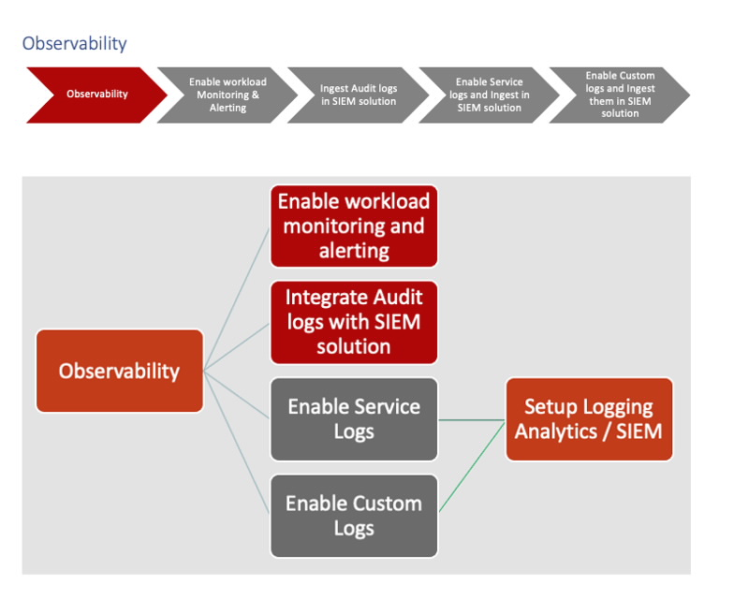
The subsidiary has their own separate SIEM implementation. In this case we can configure application and environment specific security logs as aggregates in a Custom Log Group or Groups and use a Service Connector Hub instance to stream logs to their existing SIEM on-premises in their London datacenter.

Summary
The workload governance decision trees covered in this post are not intended to be fully prescriptive. In other words, they simply won't cover every single contextual permutation that is germane to your IT environment and your business. That's for you to decide in concert with the business units that consume the tenancy that is governed by your company's Cloud Center of Excellence Organization. If anything, this will provide you with a starting point and baseline that you can build upon that can be tailored to meet the evolving needs of your business.
### END ###

