OCI Integration
IAM Design and Azure Federation

Contents

1. Purpose statement 1
2. Overview 1
3. Domain Design 1
4. Group and Access definition 1
5. Azure Federation 1

Purpose statement
The purpose of this document is to illustrate the IAM design and the operational workflow. This document will cover the below topics,
- Domain setup
- Groups, Roles, and policy
- Operational workflow
- Azure Federation

Overview
Cloud admin will be part of the default domain and onboard Client cloud engineer as a cloud admin. Client will create a secondary domain to create service accounts and other cloud engineers’ access to the secondary domain. Please refer to the below diagram.
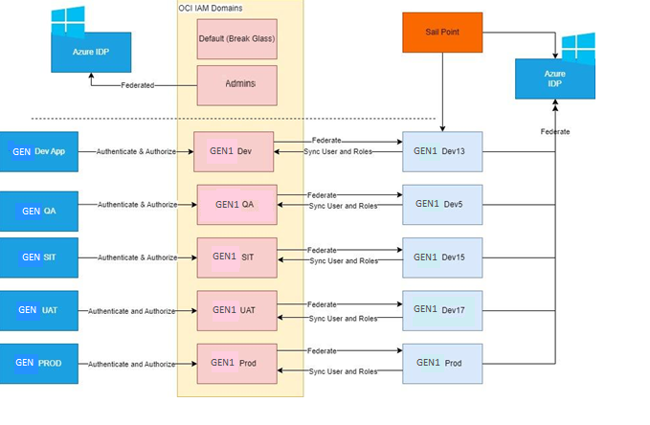
There will be totally five domains as per the above design. The access and policy will be created per domain per environment.

Domain Design
The below diagram elaborates the domains per each env, the identity domains and azure federation as per the requirement.
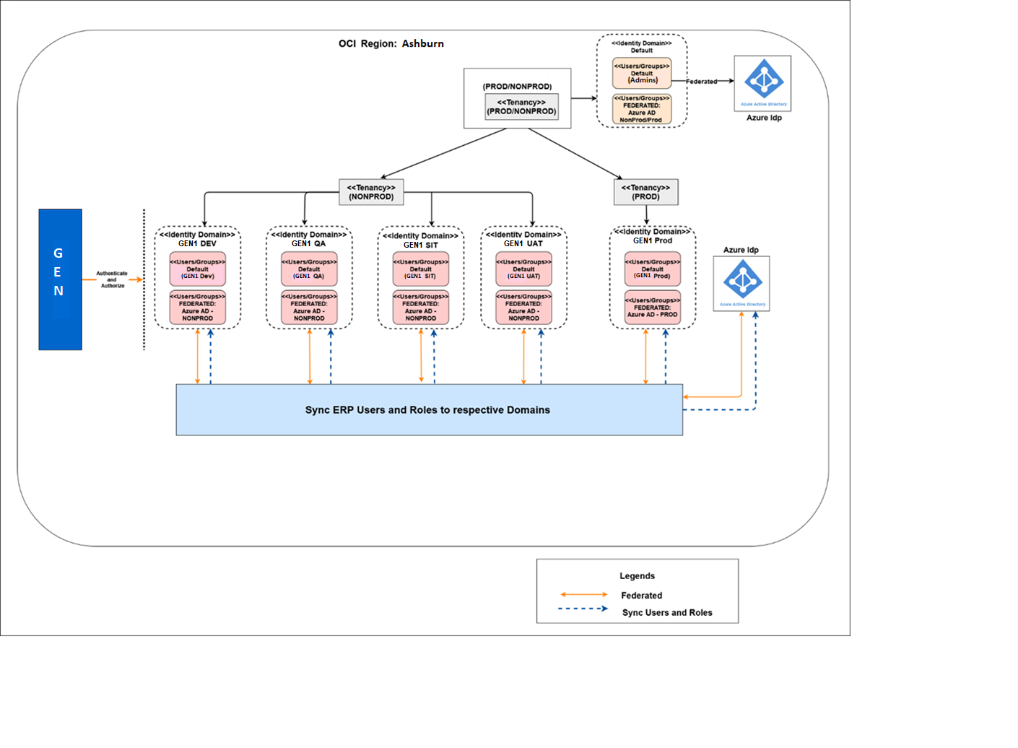
Domains
There will be five secondary domains will be created as per the above with its own identity domains to manage users and roles. Please refer to the requirement capture spreadsheet to complete the required domain details for domain creation.

Group and Access definition
Please find the groups we identified with the respective access to tenancy, compartment and child compartment below.
Groups in Default Domains:
User | Access policy | Description
Cloud Admin | Break glass user / Cloud Admin
Client cloud Admin | Cloud Admin

Cloud Admin Groups
In the secondary domain the following proposed groups refer the requirement capture template.
Group Name | Tenancy | Compartment | Child Compartment
Announcements readers | Tenancy access
AppAdmins | Tenancy access | dev | AppDev
 |  | Prod | AppPrd
 |  | Test | AppTst
 |  | Network
 |  | Security
Auditors | Tenancy access
CredAdmins | Tenancy access
DatabaseAdmins |  | Network
 |  | Security
 |  | Prod | DatabasePrd
 |  | Test | DatabaseTst
EmailFamilyAdministrator | Tenancy access
IAMAdmins | Tenancy access
IntegrationAdmins | Tenancy access
IntegrationDevelopers | Tenancy access
IntegrationViewers | Tenancy access
NetworkAdmins |  | Network
ObjectStorageAdmins | Tenancy access
ObjectStorageReaders | Tenancy access
ObjectStorageWriters | Tenancy access
SecurityAdmins | Tenancy access | Network
 |  | Security
SysOpsTeam | Tenancy access
CostAdmins | Tenancy access

Azure Federation
Architecture
The below architecture diagram explains setting up SSO with Oracle in which Oracle Identity Cloud Service acts as a bridge between the applications and Azure AD. This setup enables scenarios in which users can host Oracle Database in Oracle Cloud Infrastructure while using Azure AD as their identity provider.
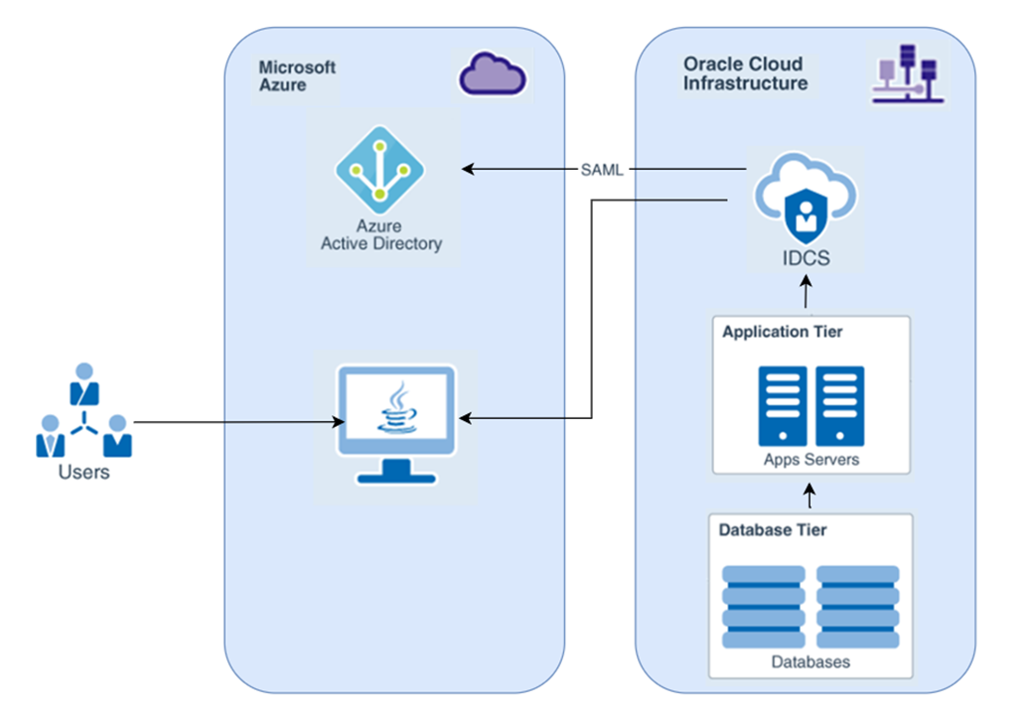
Workflow
The user who needs access will raise a “Access request” as per the current onboarding process/tools. Create the user in the respective Azure and replicate the same to the Oracle ERP.
ERP Users & Role Sync
When the user gets created in Azure IDP for ERP, it will get synced to the Individual IDP providers configured for each domain.

Identity Federation
When the users of VBCS application initiates the login request, they will be redirected to Azure IDP to authenticate and redirect to the respective application with the information to identify and authorize the users in the individual application.
To achieve the above federation, please complete the details required to configure the same in the requirement capture spreadsheet “Azure AD Federation” and refer to the Azure AD federation documentation for detailed steps.

### END ###

