OCI Integration
OCI - Azure AD Federation

Contents

1. Purpose statement 3
2. Overview 3
3. Architecture 4
4. Configuration 5
Step 1: Go to Domains 5
Step 2: Select the Root Compartment 5
Step 3: Add a Application 6
Step 4: Launch Workflow 6
Step 5: Provide the name and description 7
Step 6: Download the metadata 8
Step 7: Save the XML 9
5. Microsoft Azure Portal steps 10
Step 7.1: In Azure portal – go to Active Directory 10
Step 7.2: Go to New Group 11
Step 7.3: Provide the Group name and membership type 12
Step 7.4: Create all Groups page 13
Step 7.5: Refresh the page to view the Group created 14
Step 7.6: Select the Enterprises Application 15
Step 7.7: Select New application 15
Step 7.8: Select the OCI Console 15
Step 7.9: Create & now App is added to your tenant 16
Step 7.10: Verify the OCI Console Enterprise App is created 17
Step 7.11: Single Sign-on and select SAML 18
Step 7.12: Upload the Metadata file 18
Step 7.13: Save the Configuration 19
Step 7.14: Edit the Attributes 20
Step 7.15: Select the Unique User Identifier (Name ID) 21
Step 7.16: Select the Name, Email and Attributes 21
Step 7.17: Add a group in SAML 22
Step 7.18: Select the Security Group 22
Step 7.19: Customise the name of the Group 23
Step 7.20: Save the XML 24
Step 7.21: Edit the SSO config 25
6. Oracle Cloud Infrastructure Steps 27
Step 8: Go to Secondary Domain at OCI Console 27
Step 9: Click Security 28
Step 10:Click Identity Providers 28
Step 11: Select and Add SAML IdP 28
Step 12: Provide the Name and Description 29
Step 13: Upload the XML 30
Step 14: Select the Name, email and SAML ID and attributes 31
Step 15: Create IdP 32
Step 16: Click Activate and then click Close 33
Step 17: Click on the default IdP policy 34
Step 18: Edit the IdP Rules 34
Step 19: Save changes for User name and Password 34
Step 20: Select the SAML application from Secondary domain 35
Step 21: To activate SAML application click on the Activate button 36
Step 22: Edit the SSO Config 36
Step 23: Enter the Entity ID and URL 37
Step 24: Enter the Name ID value and Attributes 38
Step 25: Enter Single Logout URL 38
Step 26: Test the SSO login 39

Purpose statement

The purpose of this document is to illustrate the Azure AD Federation. This document covers the below topics,
- Architecture overview
- SAML Application configuration in OCI
- Azure portal configuration
- SSO configuration in OCI

Overview

This document is for setting up SSO between Azure AD and Oracle Identity Cloud Service. When client move the application to the cloud and provide access to the application through Microsoft Azure, then users have to sign into Azure portal and also re-enter credentials to sign in to applications.
Federated SSO makes the integration seamless and allows the users to authenticate only once to access multiple applications, without signing in separately to access each application.
Identity federation helps enterprises reduce cost, because user accounts don’t need to be created and managed separately in each identity management system. The user-synchronization process ensures that identities are propagated to all the federated systems.

Architecture
The below architecture diagram explains setting up SSO with Oracle in which Oracle Identity Cloud Service acts as a bridge between the applications and Azure AD. This setup enables scenarios in which users can host Oracle Database in Oracle Cloud Infrastructure while using Azure AD as their identity provider.
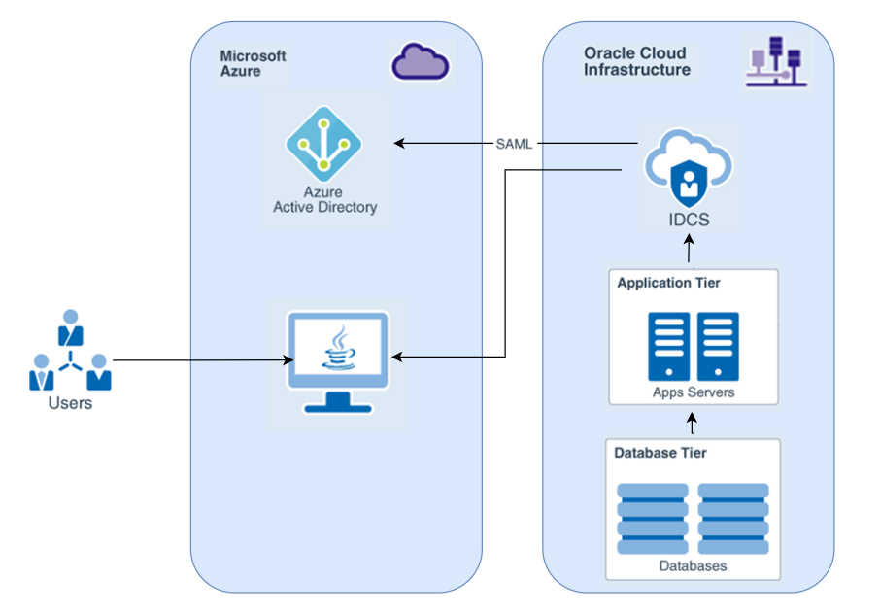

Configuration
Prerequisites:
- Access to Microsoft Azure AD account
- Access to OCI console with Administrator permissions

Step 1: Go to Domains

Login to OCI console and Navigate to Identity & Security > Domains

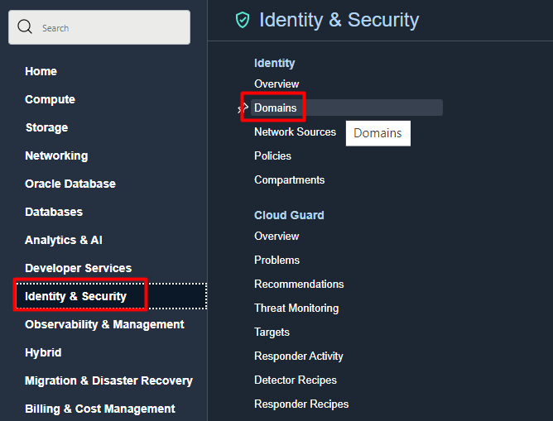

Step 2: Select the Root Compartment

Select a Secondary Domain from the Root Compartment level

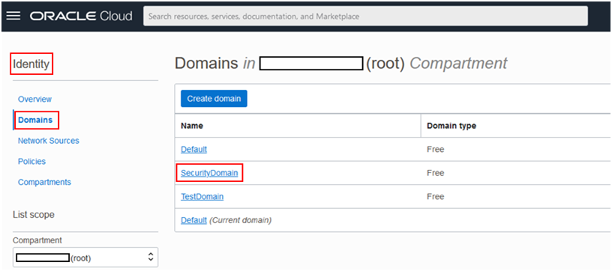

Step 3: Add a Application

Under Identity Domain > select Applications > click Add Application

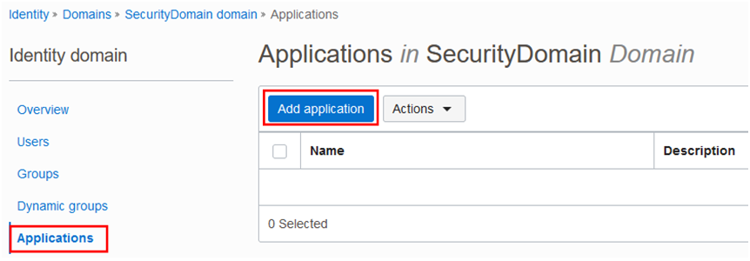

Step 4: Launch Workflow

Select SAML Application and click Launch workflow

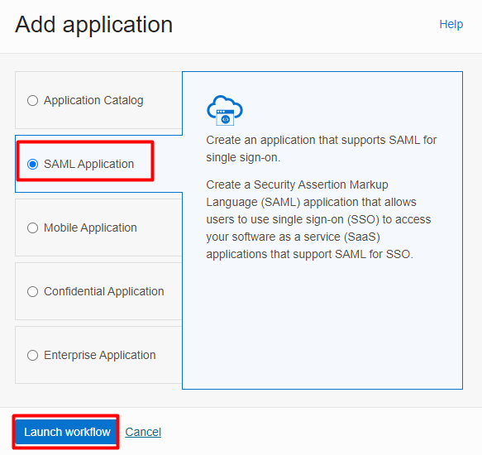

Step 5: Provide the name and description

On the Application details page fill in the following details and click Next
- Name
- Description

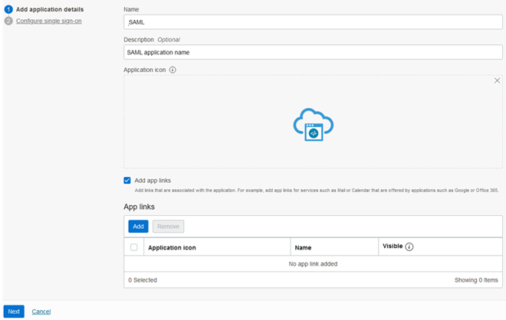

Step 6: Download the metadata

On the Configure single sign-on page click on Download identity provider metadata. Download the IDCSMetadata XML file, we need this file to setup Azure AD and click then Finish
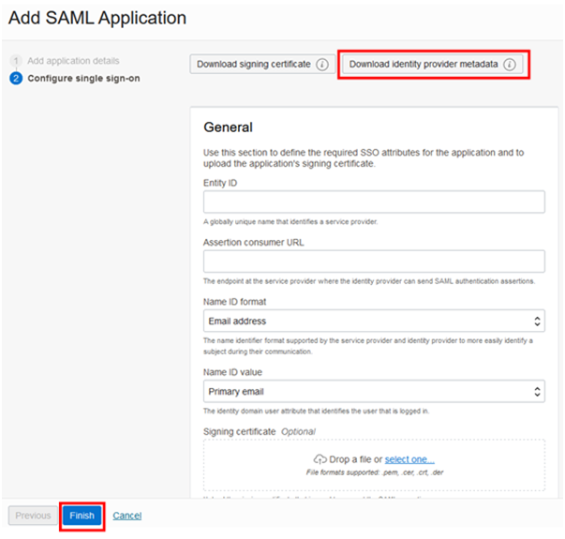

Step 7: Save the XML
Save it as an XML file.
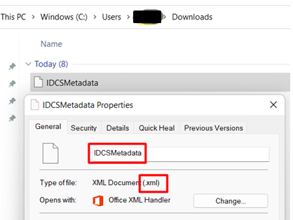

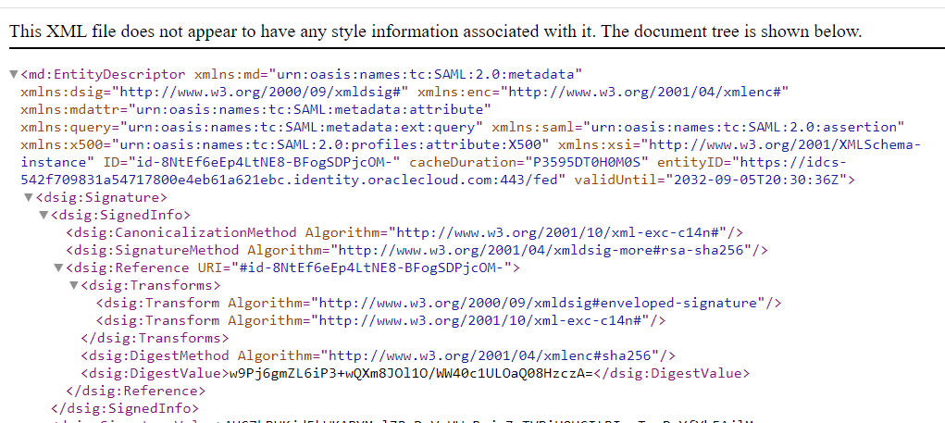

Microsoft Azure Portal steps

Step 7.1: In Azure portal – go to Active Directory

Navigate to Microsoft Azure Portal and Navigate to Active Directory.
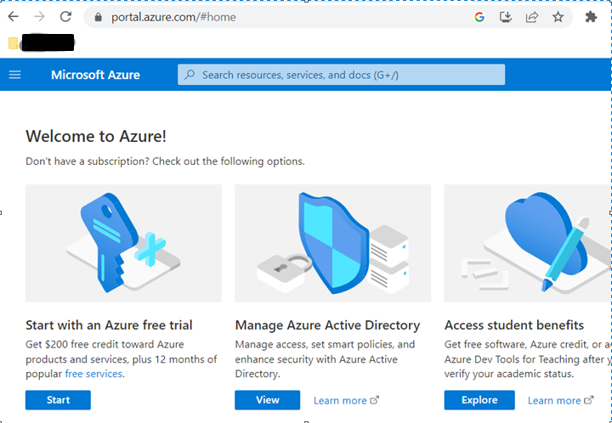

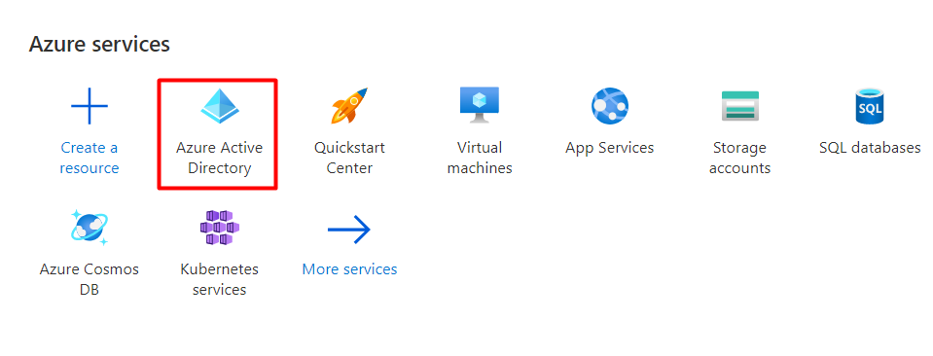

Step 7.2: Go to New Group

Click on Group and select New group

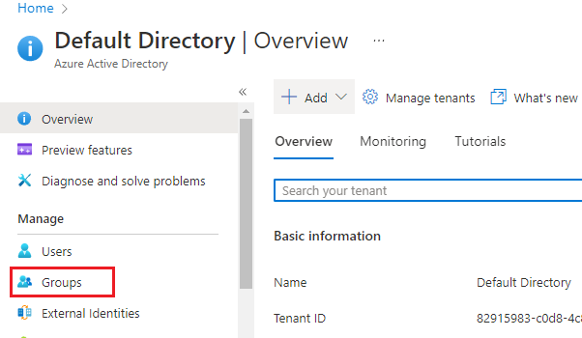

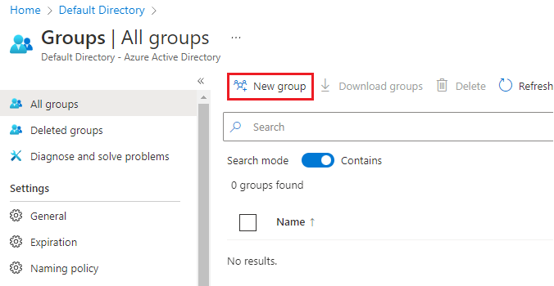

Step 7.3: Provide the Group name and membership type

Select Group type as Security, provide Group Name, Membership type is default set to Assigned, and select Members >> No Members Selected
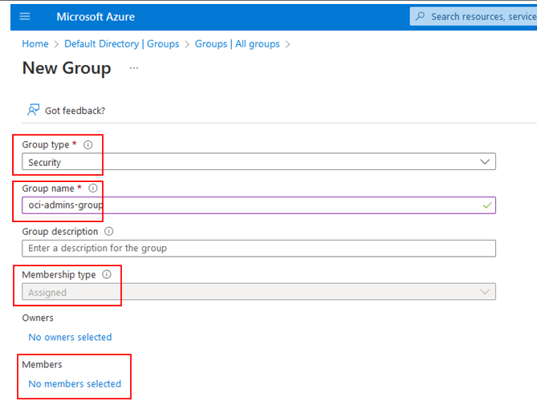

Step 7.4: Create all Groups page

Add Members page will be displayed; search for the Members and click Select and click Create in the All Groups page
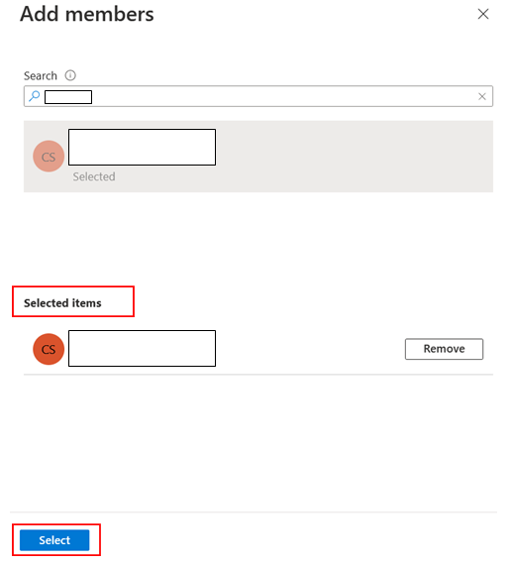

Step 7.5: Refresh the page to view the Group created

Refresh the page to view the Group created. Group Name, Object Id, Group Type and Membership type will be displayed
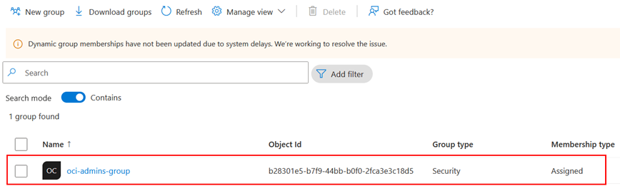

Step 7.6: Select the Enterprises Application

Navigate to Azure Active Directory and select Enterprise Application.
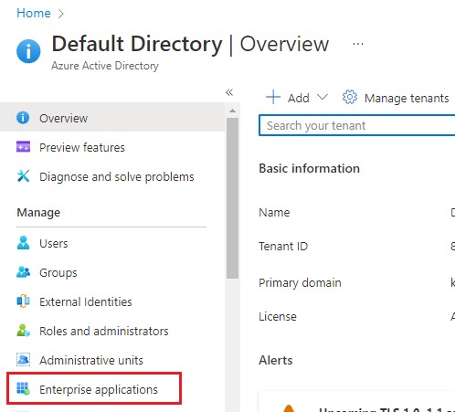

Step 7.7: Select New application
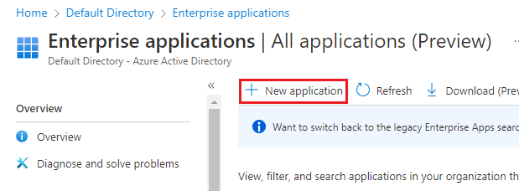

Step 7.8: Select the OCI Console

In the Browse Azure AD Gallery section, type Oracle Cloud Infrastructure Console in the search box, Select Oracle Cloud Infrastructure Console
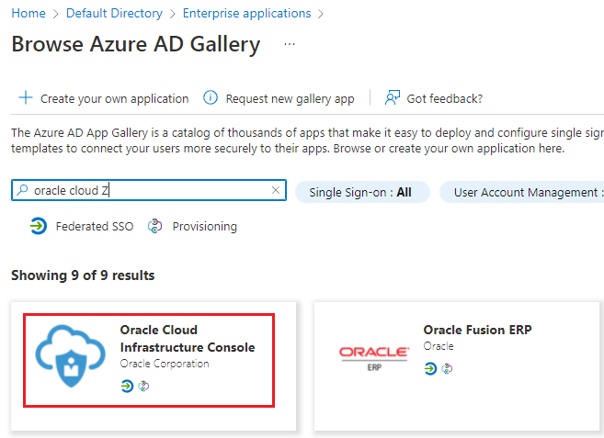

Step 7.9: Create & now App is added to your tenant
Click Create. Wait a few seconds while the app is added to your tenant.
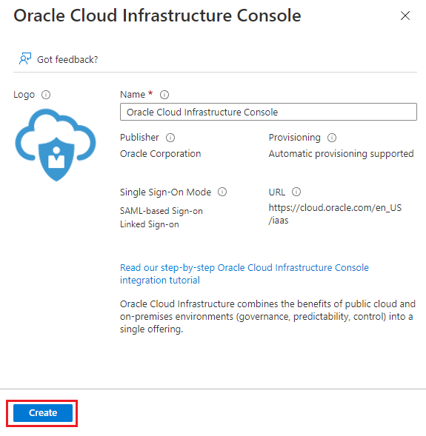

Step 7.10: Verify the OCI Console Enterprise App is created
Oracle Cloud Infrastructure Console Enterprise application is created.
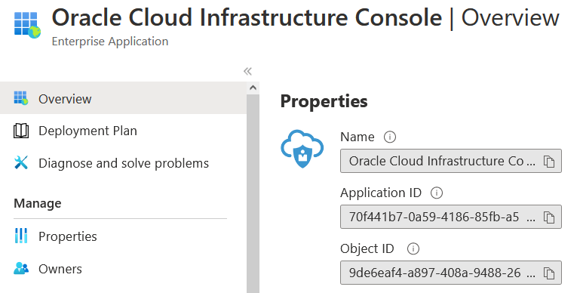

Step 7.11: Single Sign-on and select SAML

From the Oracle Cloud Infrastructure Console overview page, Select Single sign-on, select SAML
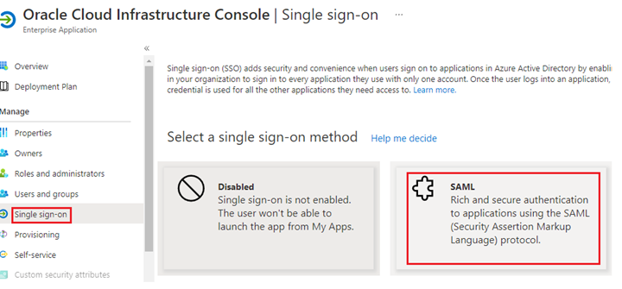

Step 7.12: Upload the Metadata file

On the SAML-based Sign-On with page, click Upload metadata file, and browse the IDCSMetadata XML file you have downloaded from OCI console.
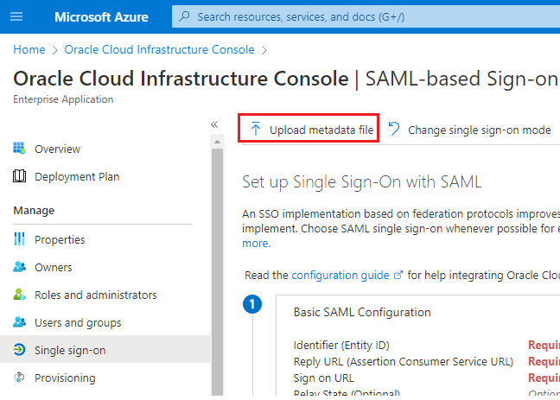

Step 7.13: Save the Configuration

Once the XML metadata file is uploaded, user will be asked to change some parameters, leave default values for Identifier (Entity ID) and Reply URL (Assertion Consumer Service URL).
On Sign on URL, provide the URL of OCI, replace the home region and click on Save to save the configuration. https://cloud.oracle.com/?region=<REGIONNAME>
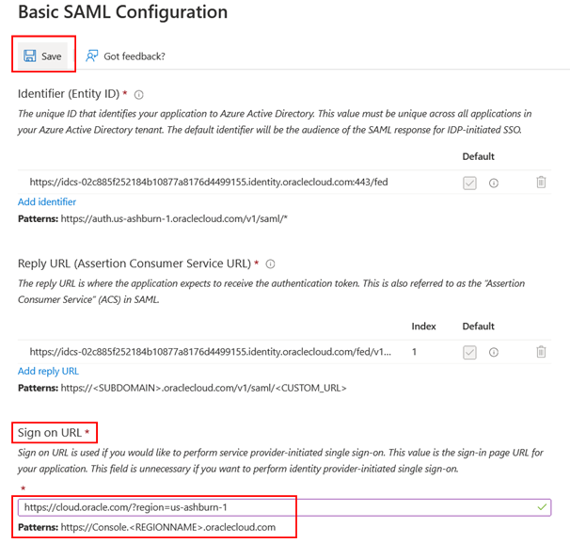
Note: If the Identifier and Reply URL values do not get auto populated, then fill in the values manually according to the requirement

Step 7.14: Edit the Attributes

To configure Attributes and Claims, click on Edit icon to edit the attributes.
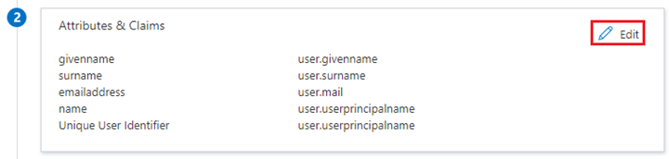

Step 7.15: Select the Unique User Identifier (Name ID)
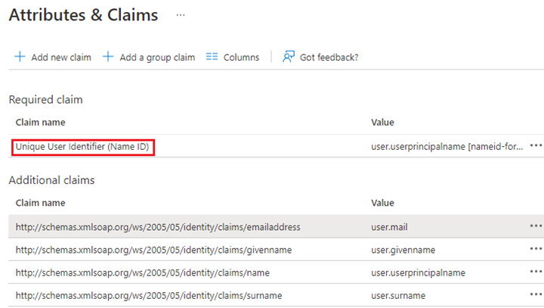

Step 7.16: Select the Name, Email and Attributes

Select the Name identifier format as email address, Source attribute as user.mail and click the Save button

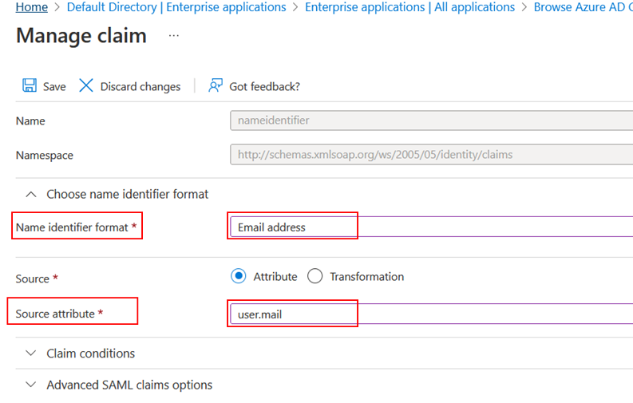

Step 7.17: Add a group in SAML

On the SAML-based Sign-on page, click on Add a group claim button
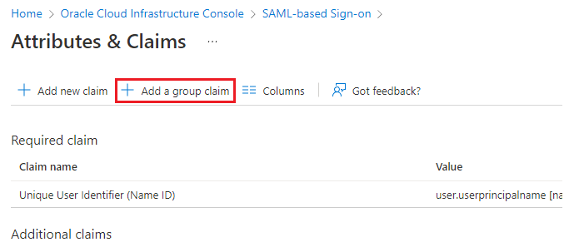

Step 7.18: Select the Security Group

In the Group Claims page, select the Security groups and select Source Attribute as Group ID
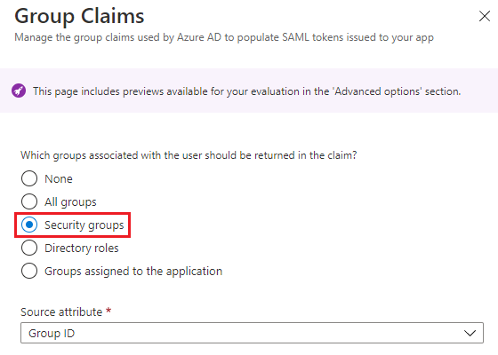

Step 7.19: Customise the name of the Group

From the Group Claims page, expand Advanced options and check Customize the name of the group claim and fill in the following fields:
- Name (required)
- Namespace (optional) text box, type https://auth.oraclecloud.com/saml/claims
- Click Save.
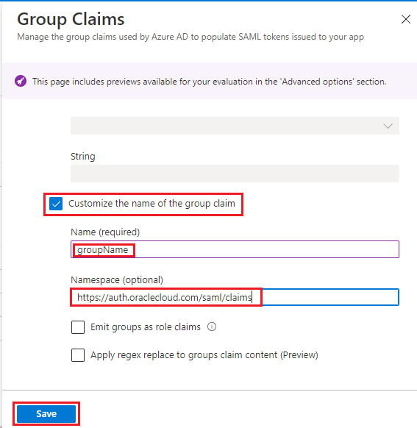

Step 7.20: Save the XML

Go back to the SAML based Sign on configuration page in Azure Portal, In SAML Signing Certificate section download the Federation Metadata XML.
Save the downloaded Oracle Cloud Infrastructure Console XML file and this Metadeta XML file needs to be uploaded in OCI console.
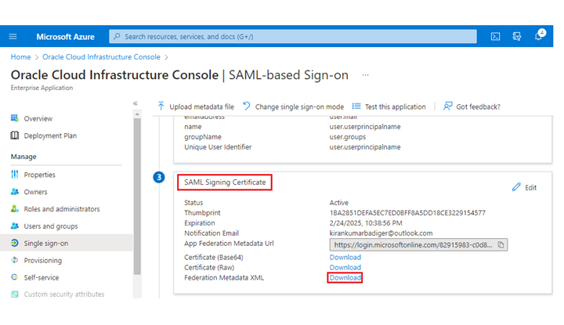

Step 7.21: Edit the SSO config

Collect all the 4 Configuration sections under SAML-based Sign-on page for the OCI team to Edit SSO Configuration
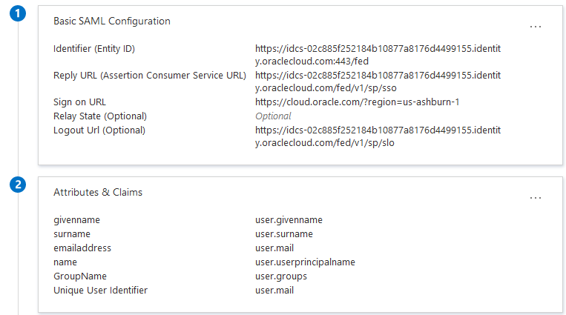
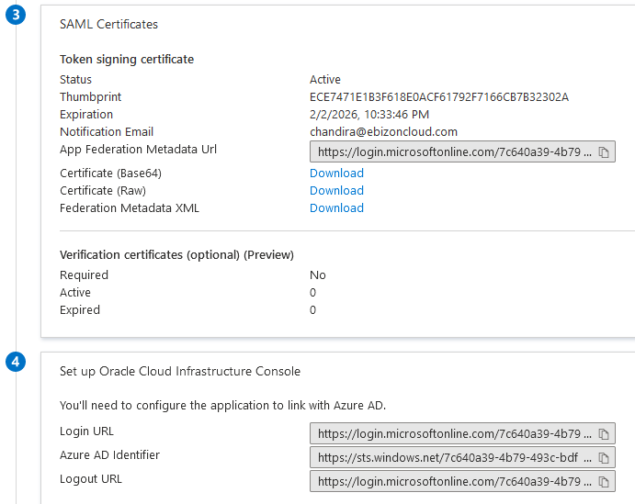

Oracle Cloud Infrastructure Steps

Step 8: Go to Secondary Domain at OCI Console

Login to OCI console and Navigate to Identity & Security > Domains > Select the Secondary Domain from where the Metadata XML file was downloaded.


Step 9: Click Security
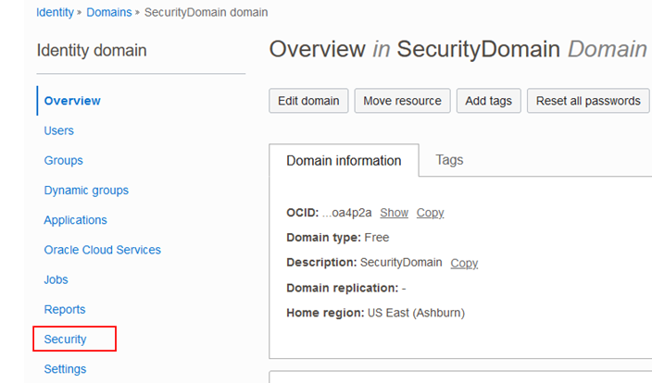

Step 10:Click Identity Providers
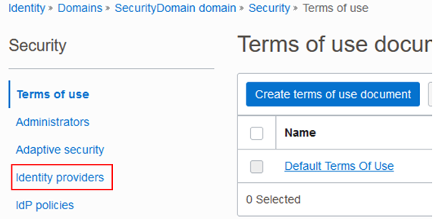

Step 11: Select and Add SAML IdP

Select Add SAML IdP under Add IdP dropdown menu
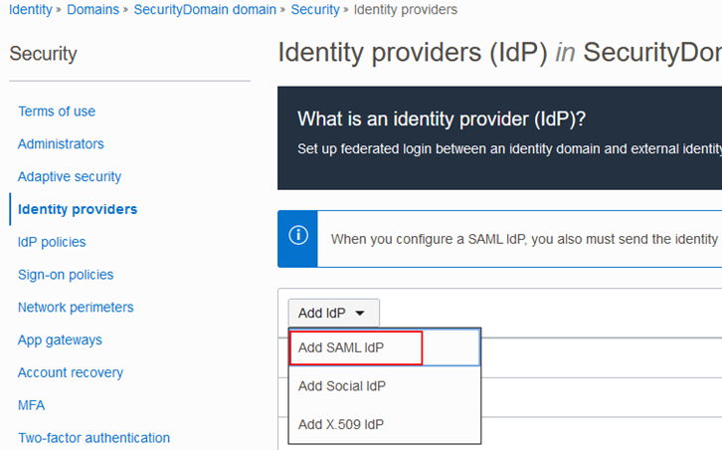

Step 12: Provide the Name and Description

In the Add Details page, enter the Name and Description and click Next
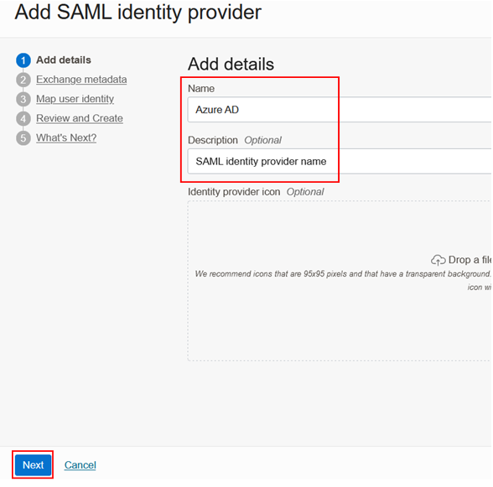

Step 13: Upload the XML

In the Exchange metadata page, select Import IdP metadata, and upload the Oracle Cloud Infrastructure Console XML Metadata file and click Next
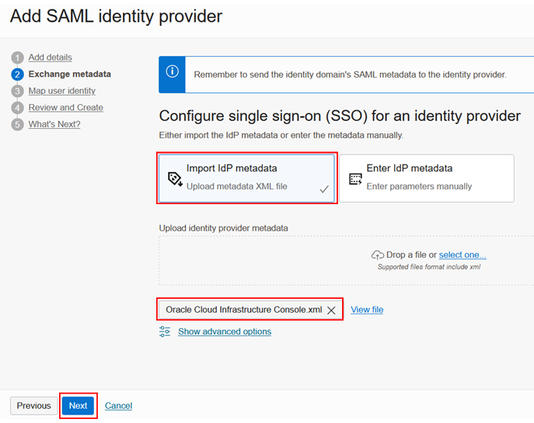

Step 14: Select the Name, email and SAML ID and attributes

In the Map user identity page, under Requested Name ID format select Email address, under Identity provider user attribute select SAML assertion Name ID, under Identity domain user attribute select Primary email address and click Next
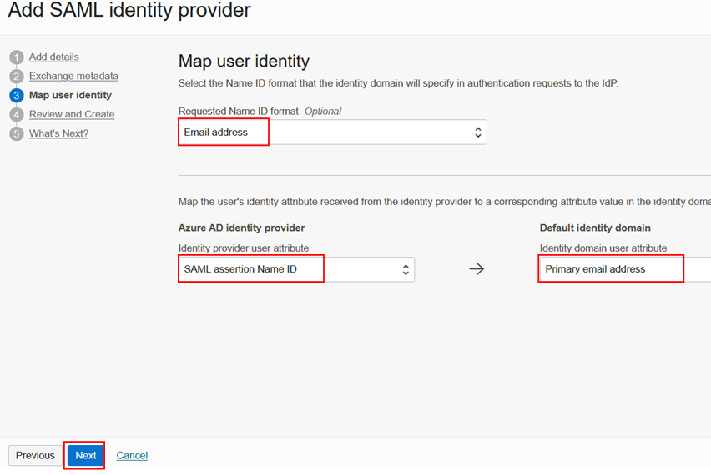

Step 15: Create IdP

On the Review and Create page, click Create IdP
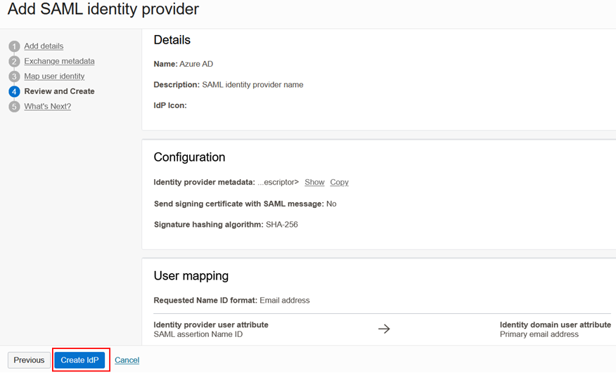

Step 16: Click Activate and then click Close

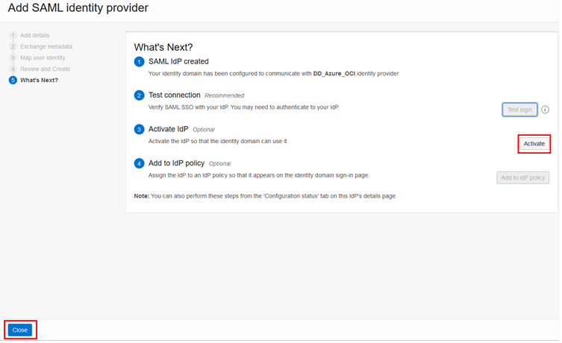

Step 17: Click on the default IdP policy

Under Security select IdP policies and then click on the Default Identity Provider Policy
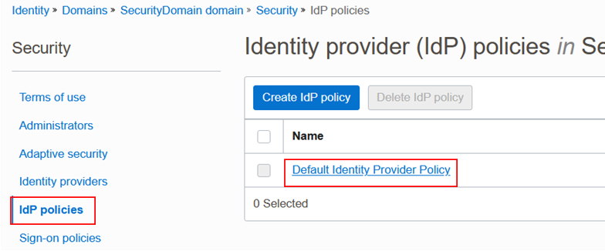

Step 18: Edit the IdP Rules

From the Default Identity Provider Policy details page Edit the Identity Provider rules
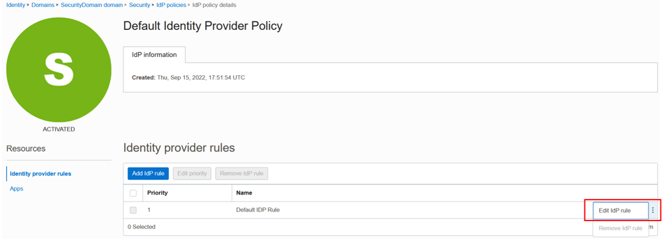

Step 19: Save changes for User name and Password

Rule name is Default IDP Rule, add Azure_AD under Assign identity providers along with Username-Password and click Save changes
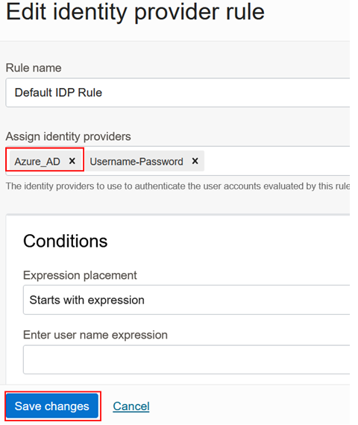

Step 20: Select the SAML application from Secondary domain

From the Secondary Domains details page, click Applications and select the SAML application created previously, from where the XML Metadata file was downloaded.
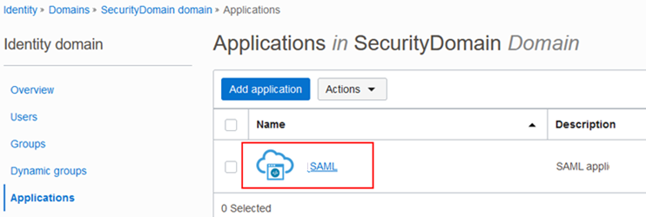

Step 21: To activate SAML application click on the Activate button
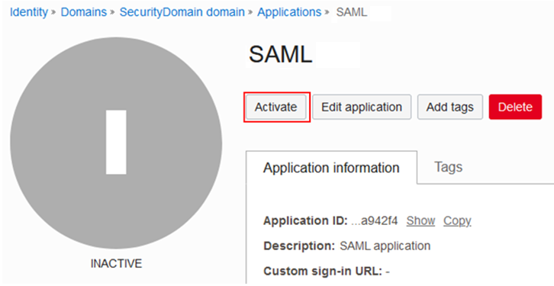

Step 22: Edit the SSO Config

Once the SAML application is activated, click Edit SSO configuration under SSO configuration under Resources
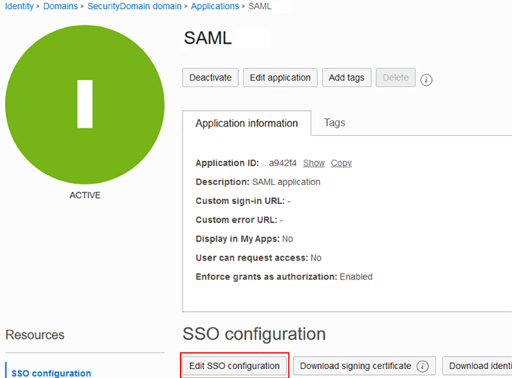

Step 23: Enter the Entity ID and URL

In the OCI Console, under Edit SSO configuration page enter the Entity ID and the Assertion consumer URL from the Basic SAML Configuration under SAML-based Sign-on page in the Azure AD
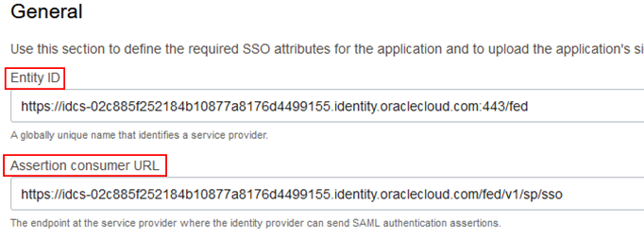
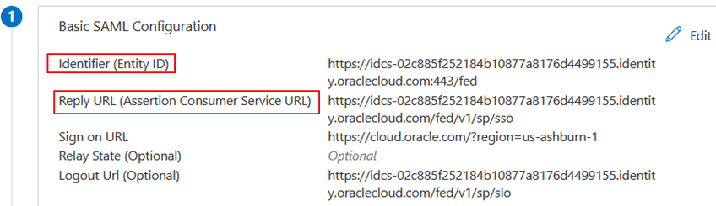

Step 24: Enter the Name ID value and Attributes

In the OCI Console, under Edit SSO configuration page enter the Name ID format and the Name ID value from the Attributes & Claims under SAML-based Sign-on page in the Azure AD
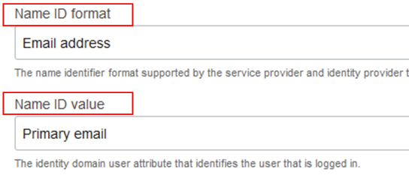

Step 25: Enter Single Logout URL

In the OCI Console, under Edit SSO configuration page enter the Single logout URL and the Logout response URL value from the Set-up Oracle Cloud Infrastructure Console under SAML-based Sign-on page in the Azure AD and click Save changes
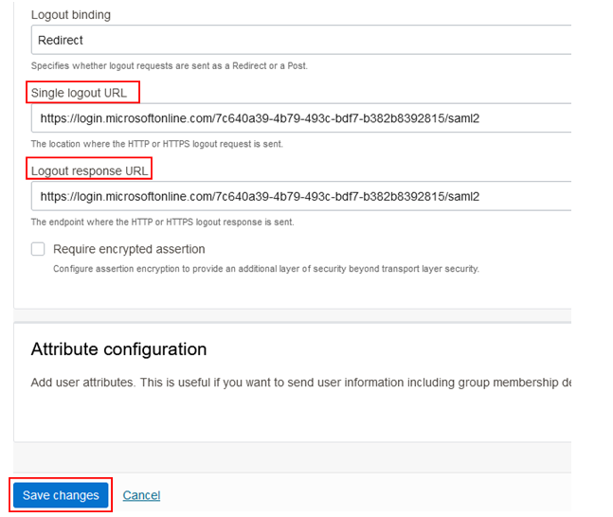

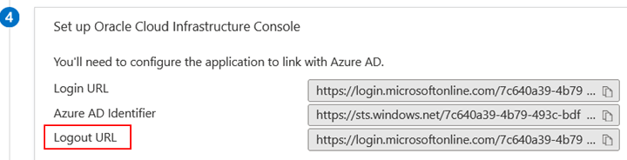

Step 26: Test the SSO login

To test the Service Provider SSO, log out of the Console page and select the Secondary Domain where the Metadata were exchanged to view the Service Provider SSO being added
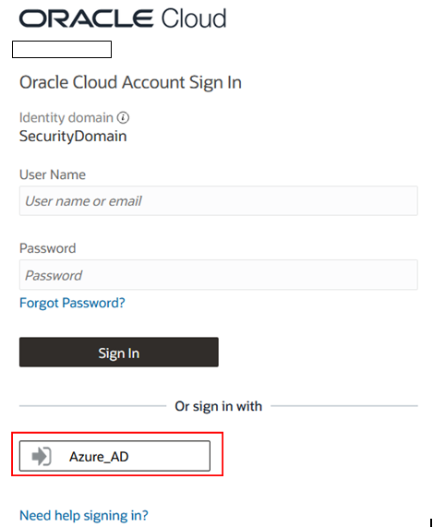

# END #

