Day 0: Planning for the Project

Contents

Overview 3
Step 1: Select Tenancy from Profile 3
Step 2: Tenancy details 3
Step 3: Select the Subscription option 4
Step 4: Select the Universal Credits option 4
Step 5: Select the Billing Schedule option 5
Step 6: Go to Governance and Administration 5
Step 7: Select Limits, Quotas and Usages 6
Step 8: Select the manage Region 7
Step 9: Select the Region 7
Step 10: Select ‘Domain’ option 7
Step 11: Select your compartment 8
Step 12: Select the Domain ( Default ) 8
Step 13: User to create user 9
Step 14: Create User and add user details 9
Step 15: Add User details & add group 10
Step 16: Activate your Account link 11
Step 17: Reset the new password 12
Step 18: Sign in with the new password 13
Step 19: Log in your domain page 14
Step 20: To Enable the Announcements go to OCI Console 15
Step 21: Create an announcement subscription to subscribe 15

Overview

Step 1: Select Tenancy from Profile
Go to Oracle Console page and click on profile then click on Tenancy.
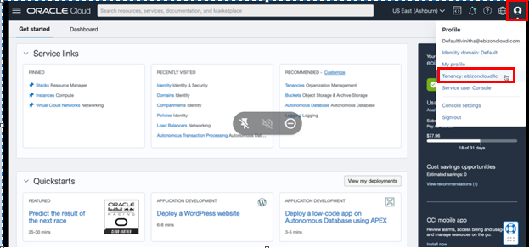

Step 2: Tenancy details
Next, Tenancy detail page you will find Tenancy name, Status, Tenancy (Root) Admin, Tenancy OCID, Home Regions and CSI number.
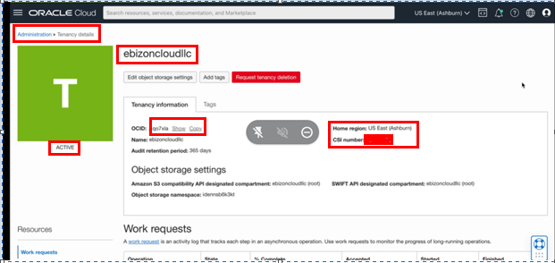

Step 3: Select the Subscription option
For subscription: Click on Hamburger menu on left top of console go to ‘Billing and cost Management’ and click on ‘Subscription’.
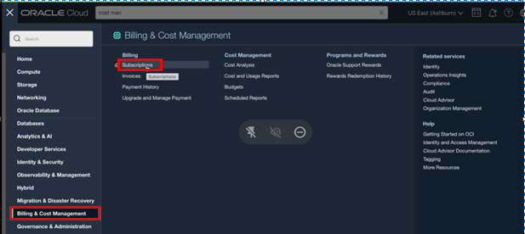

Step 4: Select the Universal Credits option
On Subscription detail page Click on Universal credits.
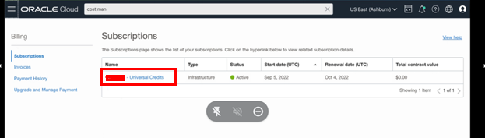

Step 5: Select the Billing Schedule option
Next, On Universal Credits detail page you will find the billing Schedule.
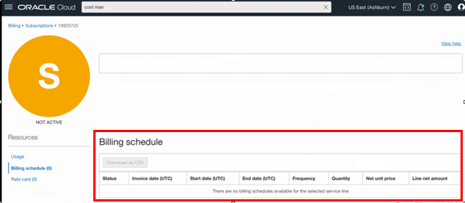

Step 6: Go to Governance and Administration
Click on Hamburger Menu on left top of console go to ‘Governance & Administration’ and click on ‘Limits, Quota and Usage’.
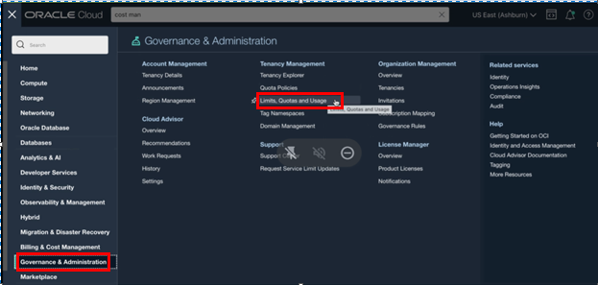

Step 7: Select Limits, Quotas and Usages
Next, ‘On Limits, Quota and Usage’ detail page it’s shows in Your tenancy the maximum number of resources you're allowed to use. You can use quotas to allocate resources to compartments.
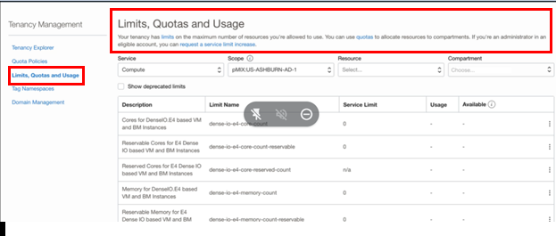

Step 8: Select the manage Region
To know Region on the Console page, click on region and click on Manage resources.
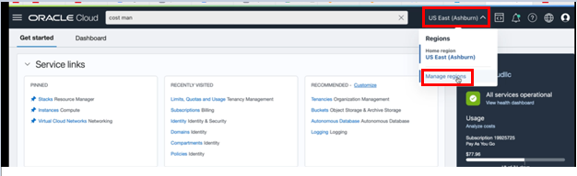

Step 9: Select the Region
Next, On the Manage Regions Detail page it shows your subscribed Regions.
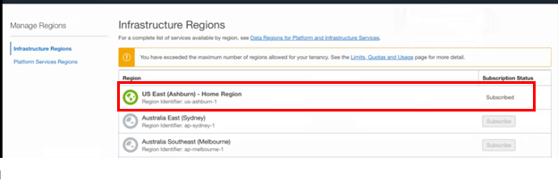

Step 10: Select ‘Domain’ option
For Domain Setup Click on Hamburger Menu on left top of console go to ‘Identity & Security’ and click ‘Domain’.
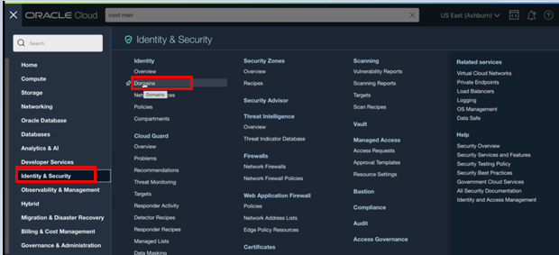

Step 11: Select your compartment
Next, Identity detail page select your compartment and click on Domains.
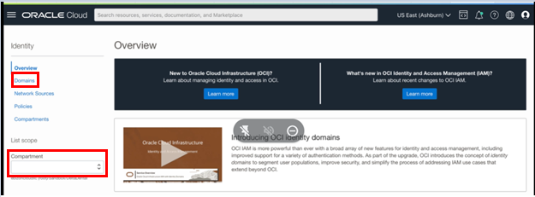

Step 12: Select the Domain ( Default )
Click Next, On Domains detail page Click on Default.
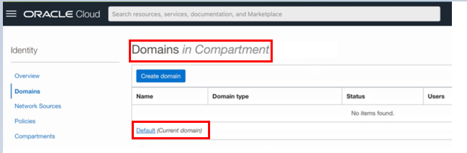

Step 13: User to create user
Next, On Default Domain page click on user to create user.
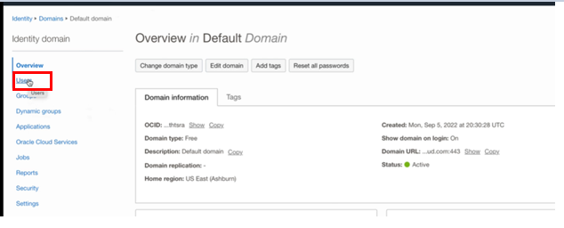

Step 14: Create User and add user details
Next, click on Create User and add user details.

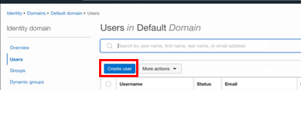

Step 15: Add User details & add group
Add User details and Assign cloud Account Administrator role and add user to group(admin) and click create. Once you Create User, the User will get an email notification.
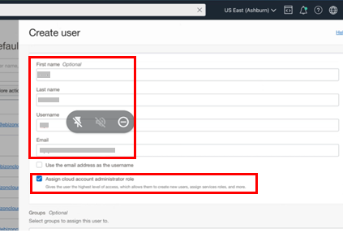
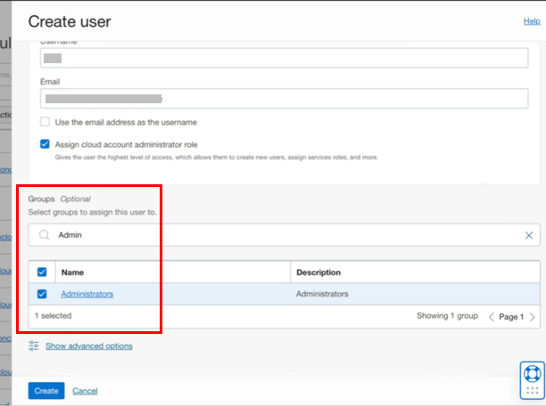
User Detail page
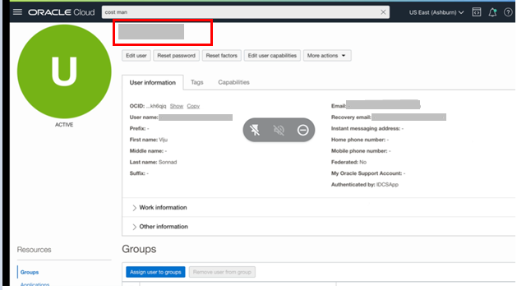

Step 16: Activate your Account link
Click Next, In User email click on Activate your Account link.
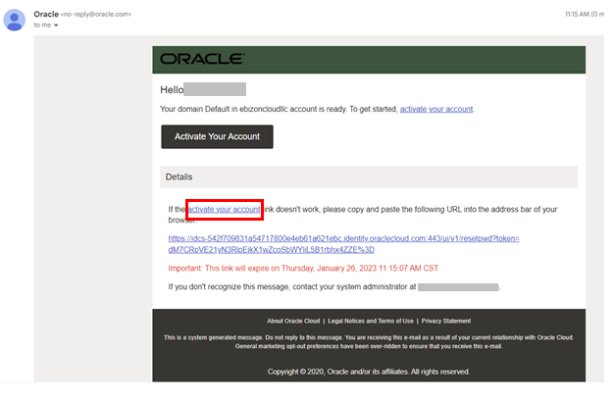

Step 17: Reset the new password
Click Next, the user must reset the new password.
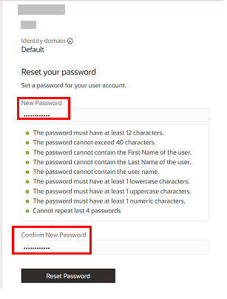

Step 18: Sign in with the new password
Click Next, after resetting the password sign in with Username and the New password.
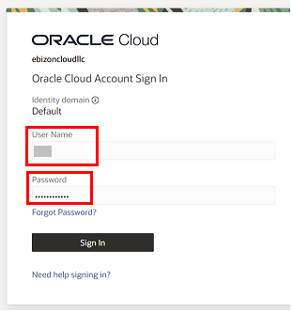

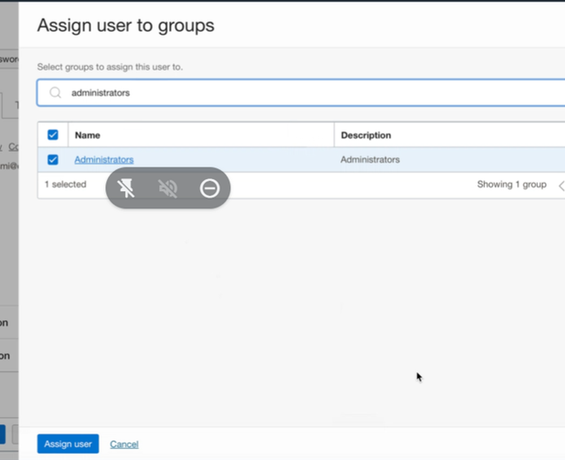

Step 19: Log in your domain page
click next on OCI Console for login

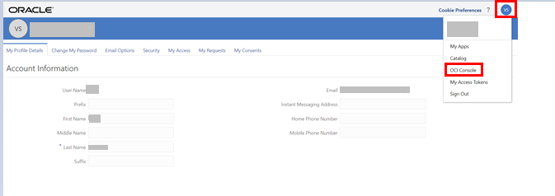

OCI Console page
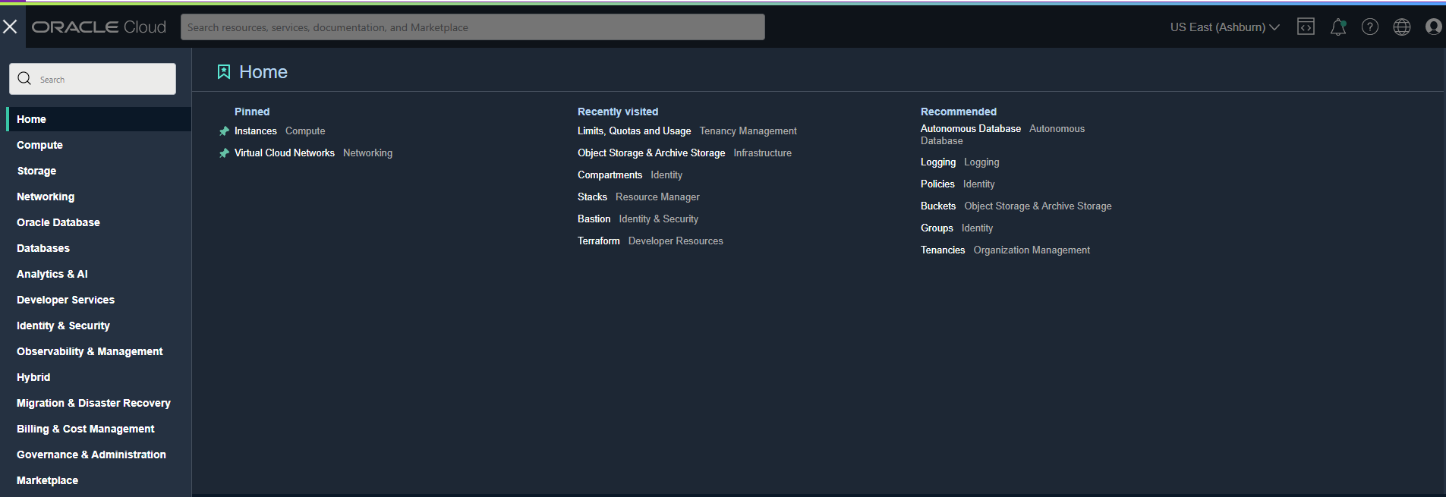

Step 20: To Enable the Announcements go to OCI Console
Click on bell icon it will take you announcements page.
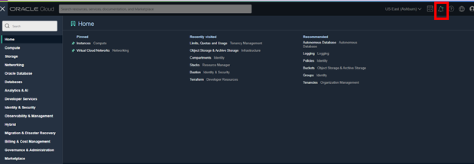

Step 21: Create an announcement subscription to subscribe
Click Next
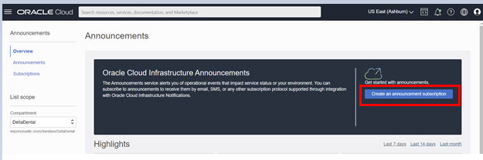

# END #

