Day 1: Activity

Group and Policy Setup and partner onboarding

Table of Content

Purpose statement 3
Group Creation and Assigning Users 4
Adding Policy 8

Purpose statement

The purpose of this document is to define the steps required to set up an oracle cloud Group, assign Users add Policies for the created group and to onboard the implementation partner to set up OCI Infrastructure. This activity is performed by the cloud administrator. This involves a series of step as mentioned below,
- Group Creation and assigning Users to the Group
- Adding Policy to give permission to the Users of the Group

Group Creation and Assigning Users
Step 1: From the OCI Console page, navigate to Identity & Security and select Domains.

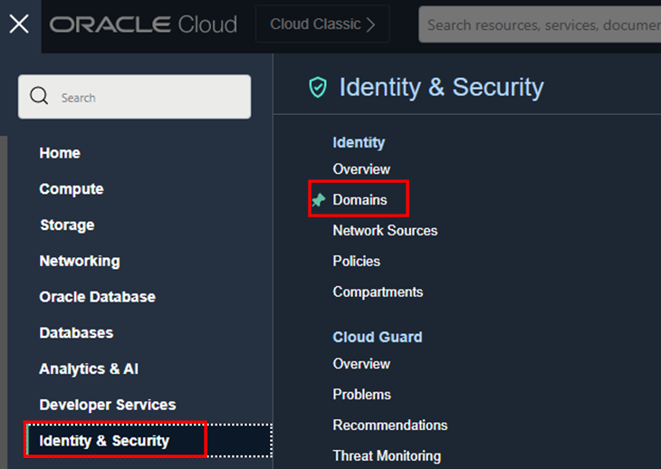

Step 2: Choose the Root Compartment, select the Domain (Cloud-Admins)

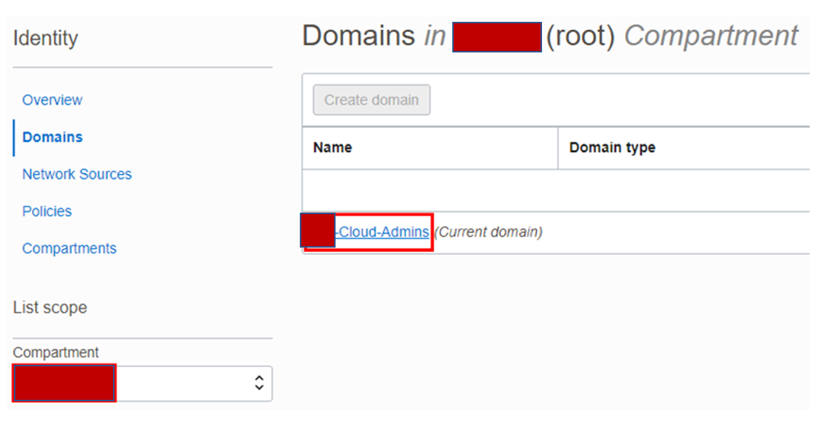

Step 3: Under the Identity Domain select Groups and the click Create group.

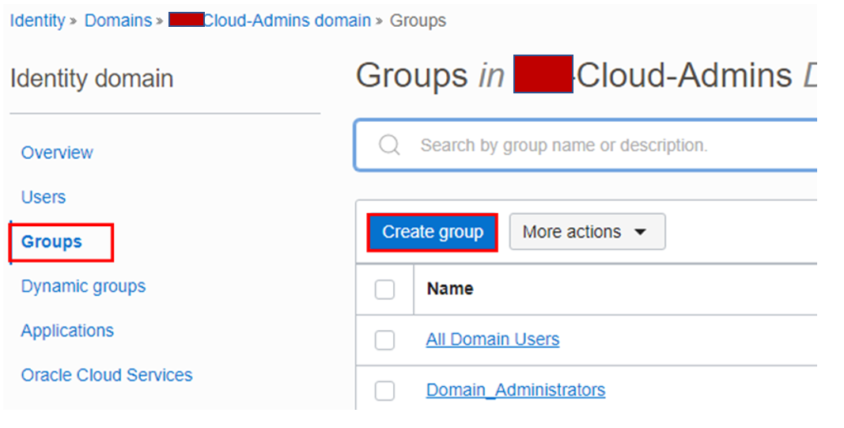

Step 4: Provide the following values:
Name – Administrators
Description – Administrators
Users – Select the Listed Users to be assigned to this Group (OCI Members)
and click Create.

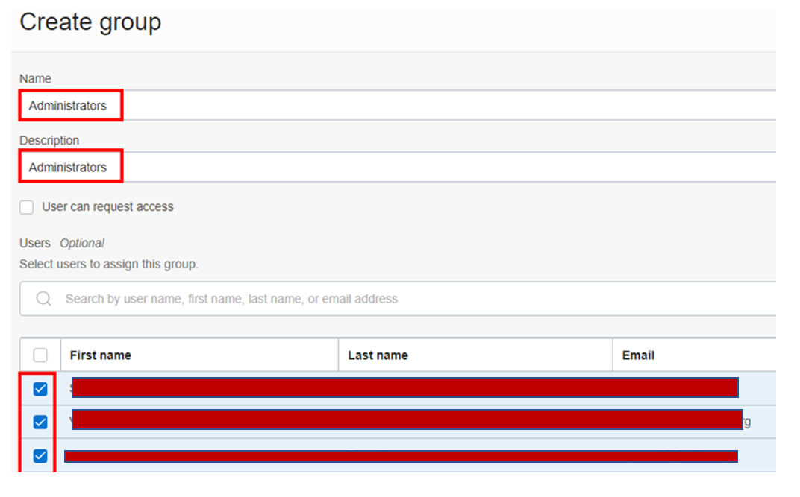

Adding Policy

Step 1: Select the Root Compartment, Under Identity select Policies and click Create Policy

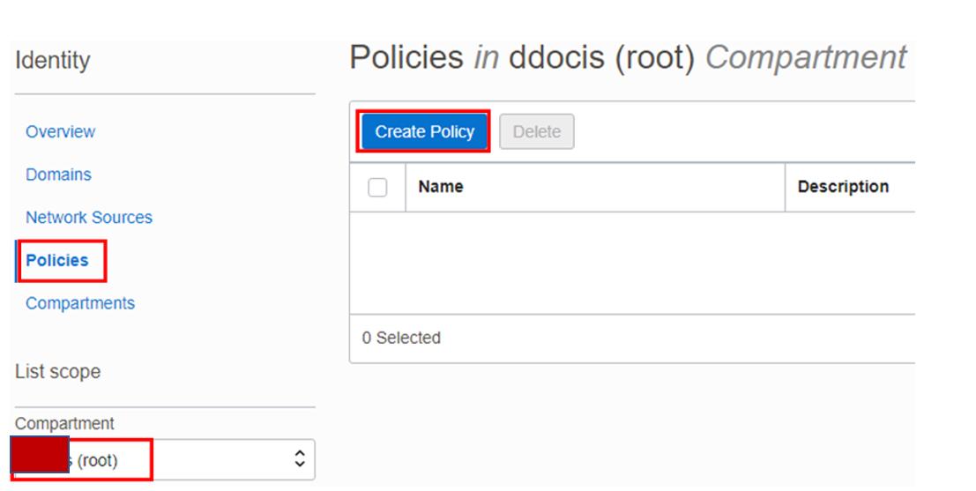

Step 2: Provide the following values:
Name – Administrator-Policy
Description – Administrator Policy
Compartment – (root)
Click Show manual editor.
Enter the following policy to allow the Users from the Administrator Group to manage all resources in the tenancy. Click Create

