Enabling Announcements

Contents

Introduction 1
1. Prerequisites to Create an Announcement Subscription 1
2. Steps to Create Notification Topic 1
3. Steps to Create an Announcement Subscription 1

Introduction

The Announcements service alerts operational events that impact service status or the environment. Subscribe to announcements by email, SMS, or any other subscription protocol supported through integration with Oracle Cloud Infrastructure Notifications.

Prerequisites to Create an Announcement Subscription
- User should have the required access to setup the Announcement subscription.
- Create a Notification Topic.

Steps to Create Notification Topic
Prerequisites:
- User should have the required access to setup the Notification Topic
- Subscriber’s email ID.

Steps:
- From the OCI Console page, go to Developer Services, and then go to Notifications.

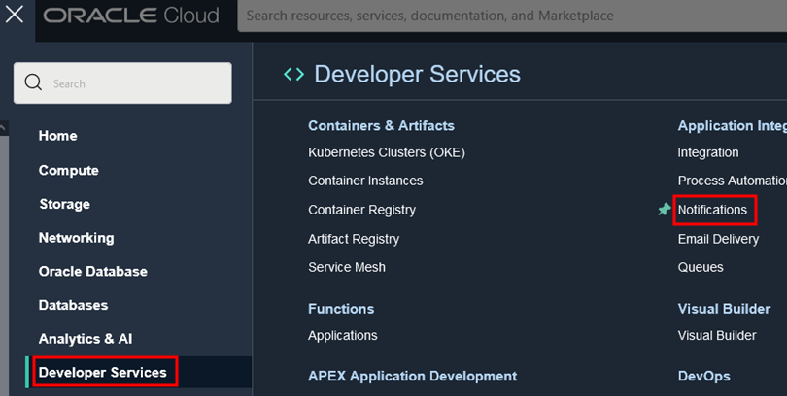

- Choose the Compartment and click, Create Topic.

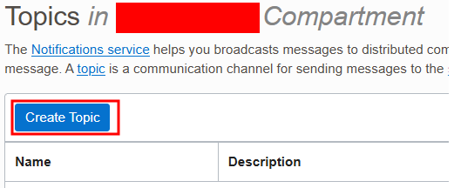

- Provide the following details to create a Topic.
Name:
Description:
Click Create.
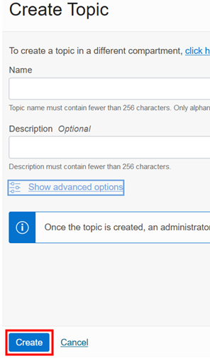

- From the Topics details page, under Resource, click Create Subscription.

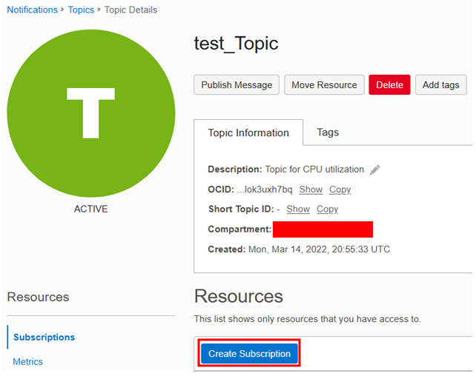

- In the Subscription page, Select the Protocol (ex: Email) and enter the Email-ID and click Create
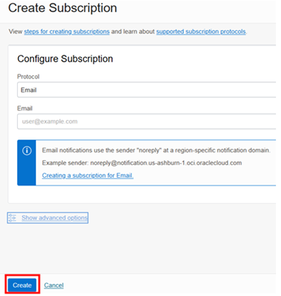

Steps to Create an Announcement Subscription
Prerequisites:
- User should have the required access to setup the Announcement subscription.
- Create a Notification Topic.

Steps:
- From the OCI Console page, go to Announcements by clicking on the Bell icon on the Console page

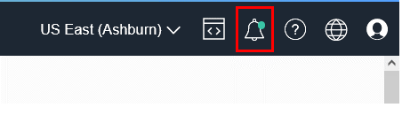

- In the Announcements page, choose the Compartment to which announcement subscription has to be added and then click on the Create an Announcement Subscription

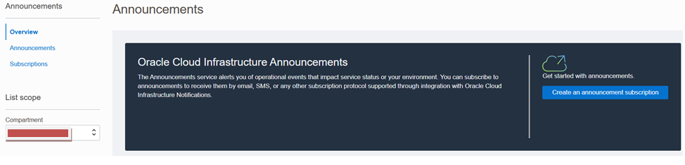

- Click Create announcement subscription

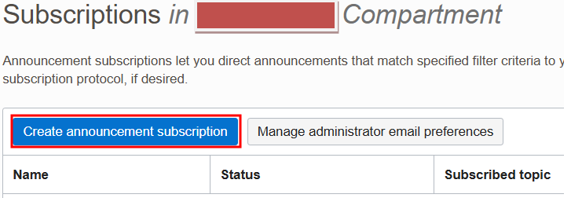

- To Create announcement subscription , enter the following details:
- Name:
- Description:
- Compartment:
- Subscription Type:
  - All Announcement
  - Selected announcements only

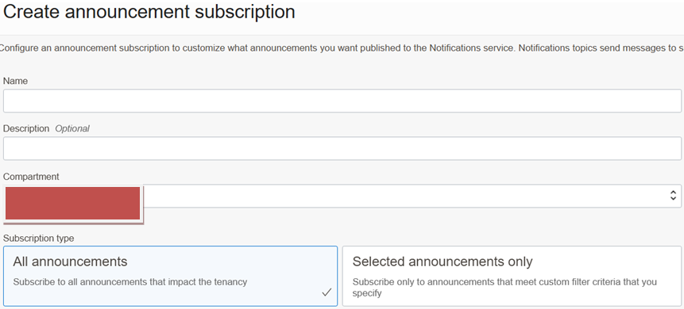

5. Select the Time Zone under Display preferences
6. Select the Notification Topic created previously, in which the Subscriptions receive the Notification message.

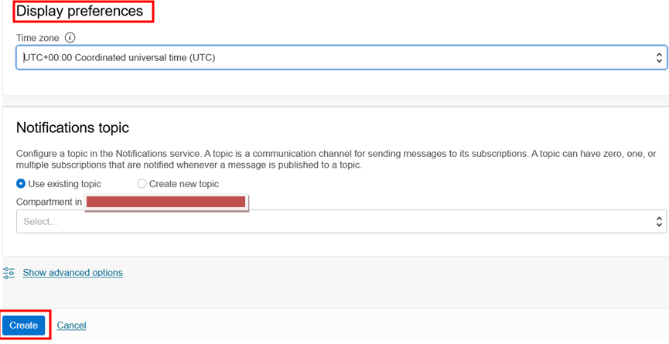

### END ###

