Domain Creation in the OCI

Contents

1. Overview 2
Step 1: Domain Creation 3
Step 2: Provide the parameters for the New domain creation 4
Step 3: Verify the output 6

Overview

An identity domain is a container for managing users and roles, federating and provisioning of users, secure application integration through Oracle Single Sign-On (SSO) configuration, and SAML/OAuth based Identity Provider administration. It represents a user population in OCI and its associated configurations and security settings (such as MFA).

- Identity domains are like other OCI resources. As an administrator, you can create, move, tag, and delete an identity domain. OCI access policies can be written to allow users in a given domain to access resources in other domains. It can also assign user accounts to predefined administrator roles to delegate administrative responsibilities within a domain.

- Each tenancy includes a “default” identity domain created in the root compartment that contains the initial tenant administrator user and group and a default Policy that allows administrators to manage any resource in the tenancy. The “default” identity domain lives with the lifecycle of the tenancy and can’t be deleted.

- We can create additional identity domains within a tenancy. Multiple identity domains are useful when you need separate environments for a single cloud service or application.

- We can upgrade a domain to a different domain type. Each identity domain type is associated with a different set of features and object limits.

- Users in identity domains can request access to groups and applications. Users can also perform self-service tasks such as updating profile information, changing passwords, and configuring settings for 2-Step Verification.

Pre-requisites: Required Policy or Role

To manage identity domain settings, you must have one of the following access grants:
- Be a member of the Administrators group
- Be granted the Identity Domain Administrator role
- Be a member of a group granted manage domains

Step 1: Domain Creation

Go to OCI Console click Identity & Security

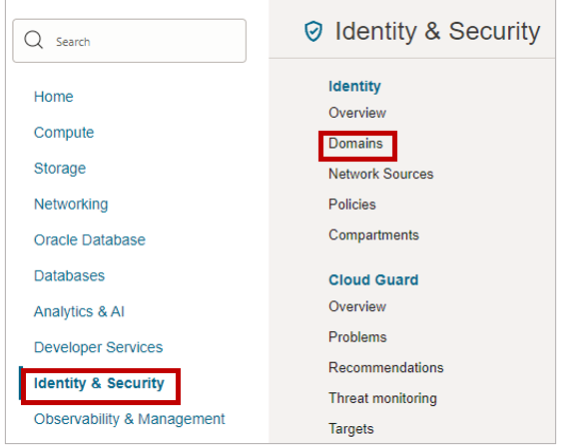

Under Identity click Domains

Select the Compartment

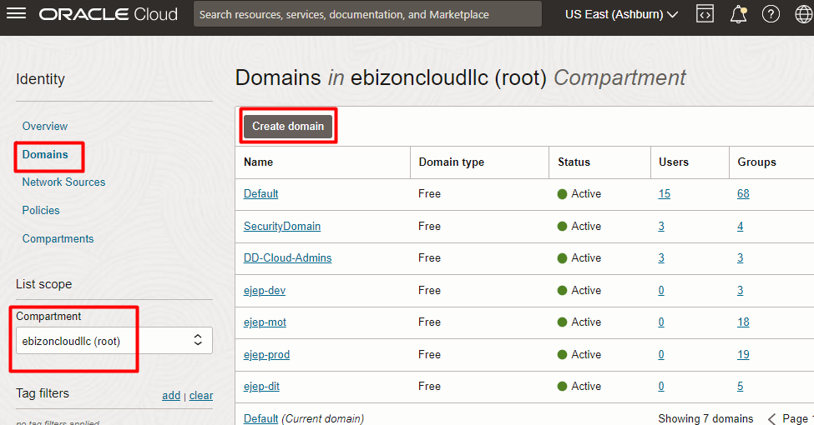

Click “Create Domain”

Step 2: Provide the parameters for the New domain creation

  - Display name: Give the identity domain a name. (Note: Use only letters, numerals, hyphens, periods, or underscores. The name can contain up to 100 characters.)
  - Description Enter a description.
  - Domain type: Choose from one of the available Domain types.
  - Domain administrator: If you want to use your administrative user account for this identity domain, then uncheck Create an administrative user for this account. Otherwise, enter the details of the user you want to administer this identity domain.
  - Optionally, choose a different compartment.
  - To add tagging, click Show Advanced Options and enter the tagging details.

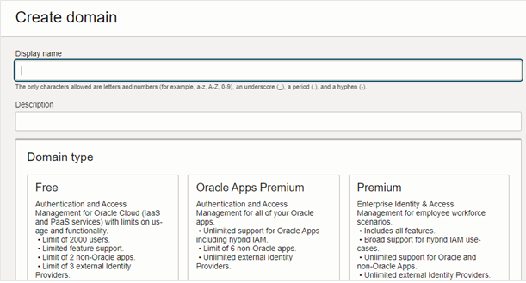

### END ###
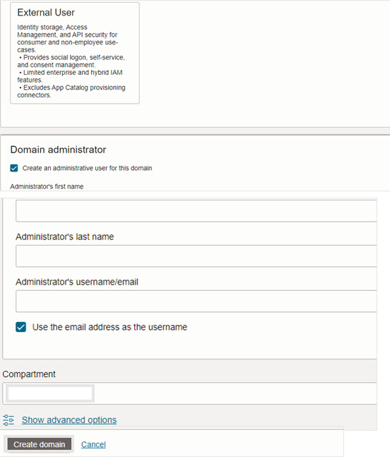

Click “Create domain”

Step 3: Verify the output

Below examples shows the output for “SecurityDomain” creation

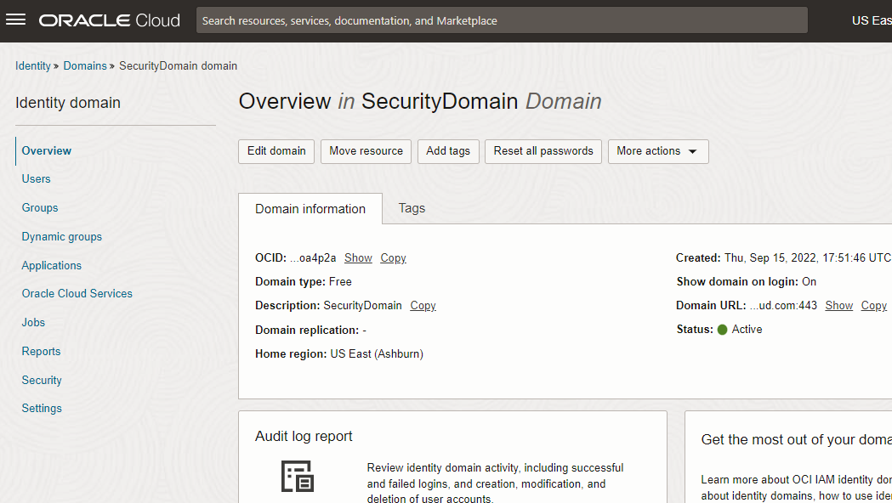

# END #

