IAM Compliance

Table of Contents
Overview 1
Types of Services 1
Regions and Availability Domains 1
Ways to Access Oracle Cloud Infrastructure 1
Listing All Compliance Documents 1
Sorting a List of Compliance Documents 1
Downloading a Compliance Document 1
Compliance- Script 1
Overview 1
Setup 1
Required Permissions 1

Overview

The Compliance Documents service lets you view and download compliance documents.

Types of Compliance Documents
When viewing compliance documents, you can filter on the following types:
- Attestation. A Payment Card Industry (PCI) Data Security Standard (DSS) Attestation of Compliance document.
- Audit. A general audit reports.
- Bridge Letter. A bridge letters. Bridge letters provide compliance information for the period between the end date of an SOC report and the date of the release of a new SOC report.
- Certificate. A document indicating certification by a particular authority, with regard to certification requirements and examination results conforming to said requirements.
- SOC3. A Service Organization Controls 3 audit report that provides information relating to a service organization's internal controls for security, availability, confidentiality, and privacy.
- Other. A compliance document that doesn't fit into any of the preceding, more specific categories.

Types of Services
The services, environments, or business pillars or platforms, to which the documents belong include:
- OCI. Oracle Cloud Infrastructure is a set of complementary cloud infrastructure services that let you build and run applications and services in a highly available hosted environment.
- PAAS. Oracle Platform as a Service (PaaS) provides various platforms to build and deploy applications within the public, private, or hybrid cloud.
- SAAS Services. Oracle Software as a service (SaaS) is a cloud-based software delivery model in which Oracle develops and maintains cloud application software. To view and download documents, users must be subscribed to the supported SaaS services in their tenancy. See the service documentation for information on whether the service is supported.

Regions and Availability Domains
You can use the Compliance Documents service in all regions.

Ways to Access Oracle Cloud Infrastructure
You can access Oracle Cloud Infrastructure (OCI) by using the Console (a browser-based interface), REST API, or OCI CLI. Instructions for using the Console, API, and CLI are included in topics throughout this documentation. For a list of available SDKs, see Software Development Kits and Command Line Interface.
You cannot specifically access Compliance Documents by using the API or Command Line Interface (CLI). Compliance Documents does not have public API, SDK, or CLI support currently. To go to the Console sign-in page, open the navigation menu at the top of this page and click Infrastructure Console. You are prompted to enter your cloud tenant, your username, and your password. Open the navigation menu, click Identity & Security, and then click Compliance.

Listing All Compliance Documents
The Console displays documents available to your tenancy for the currently selected region.
- Open the navigation menu, click Identity & Security, and then click Compliance.
- The Compliance Documents page displays all documents you have permission to view. From this page, you can do the following:
  - Filter. You can filter documents by service or by type.
  - Sort. You can sort documents by name, type, or creation date.
  - Download. You can download documents to your local computer.

Sorting a List of Compliance Documents
You can sort a list of compliance documents by several different criteria.
- Open the navigation menu, click Identity & Security, and then click Compliance.
- By default, the list displays documents according to the document name, in alphabetical order. To sort the list another way, do one of the following:
  - Click Name. The list sorts alphabetically, according to the summary of the announcement. If you begin by viewing the default sort order, the sort order will change to show documents in reverse alphabetical order by name.
  - Click Type. The list sorts according to the type of the document, in alphabetical order by type.
  - Click Created. The list sorts according to the date and time the document was created.
- To sort the list again, repeat the previous step.

Downloading a Compliance Document
You can download a compliance document to access it offline.
- Open the navigation menu, click Identity & Security, and then click Compliance.
- The Compliance Documents page displays all documents you have permission to view.
- Find the document you want to download, click the Actions icon (three dots), and then click Download.
- Review the terms of use.
- When you're ready, select the I have reviewed and accept these terms and conditions check box, and then click Download File.

Compliance- Script

Overview
The Compliance Checking script checks a tenancy's configuration against the CIS OCI Foundations Benchmark. In addition to CIS checks it can be check for alignment to OCI Best Practices by using the --obp flag. These checks review the following OCI best practices in your tenancy:
- Aggregation of OCI Audit compartment logs, Network Flow logs, and Object Storage logs are sent to Service Connector Hub in all regions.
- A Budget for cost track is created in your tenancy.
- Network connectivity to on-premises is redundant.
- Cloud Guard is configured at the root compartment with detectors and responders.
The script is located under the scripts folder in this repository. It outputs a summary report CSV as well individual CSV findings report for configuration issues that are discovered in a folder (default location) with the region, tenancy name, and current day's date ex. <tenancy_name>-2022-12-02_13-50-30/.

Setup

Required Permissions
The Auditors Group that is created as part of the CIS Landing Zone Terraform has all the permissions required to run the compliance checking in the tenancy. Below is the minimum OCI IAM Policy to grant a group the script in a tenancy.
*Access to audit retention requires the user to be part of the Administrator group
Allow group Auditor-Group to inspect all-resources in tenancy.
Allow group Auditor-Group to read buckets in tenancy.
Allow group Auditor-Group to read file-family in tenancy.
Allow group Auditor-Group to read network-security-groups in tenancy.
Allow group Auditor-Group to read users in tenancy.
Allow group Auditor-Group to use cloud-shell in tenancy.

Setup the script to run in a cloud Shell.

Step1: Install OCI

Copy the command and past in Cloud shell to install the python3

python3 -m venv python-venv
source python-venv/bin/activate
pip3 install oci
pip3 install pytz

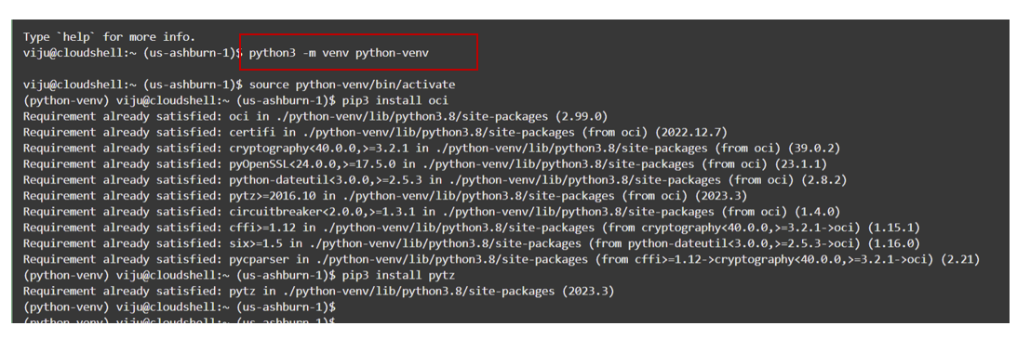

Step 2 Download cis_reports.py

Copy the command and past in Cloud shell.

wget https://raw.githubusercontent.com/oracle-quickstart/oci-cis-landingzone-quickstart/main/scripts/cis_reports.py

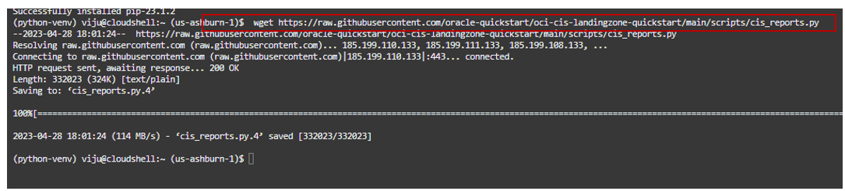

Step 3: To run using Cloud Shell in all regions and check for OCI Best Practices with raw data of all resources output to CSV files.

Copy the command and past in cloud shell.

python3 cis_reports.py -dt --obp --raw

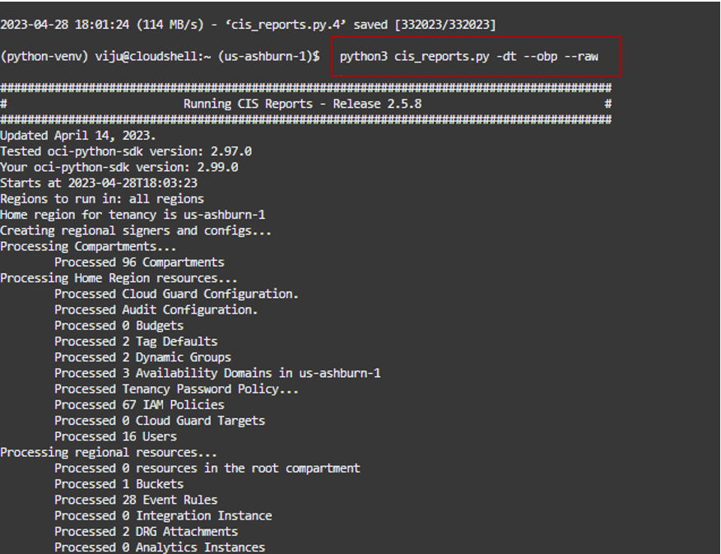

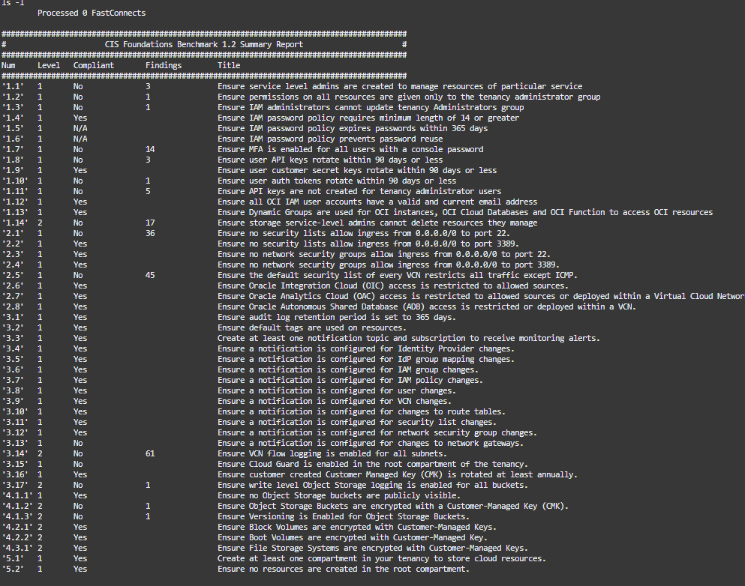

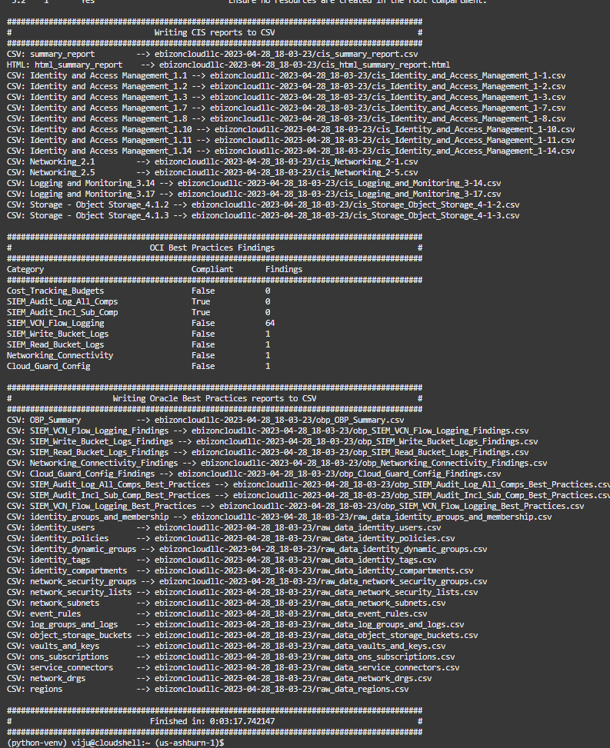

Step 4 To list the file click command below.

Past the command in cloud shell

ls -l

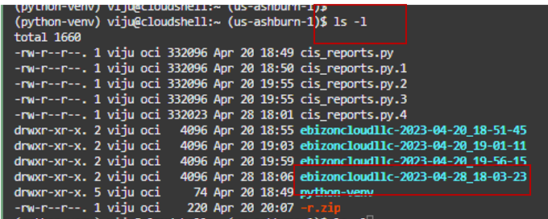

Step 5: To download the report we must zip the file and download the report.

Copy the command to zip the file and past in clous shell.

zip -r [file_name.zip] [directory_name]

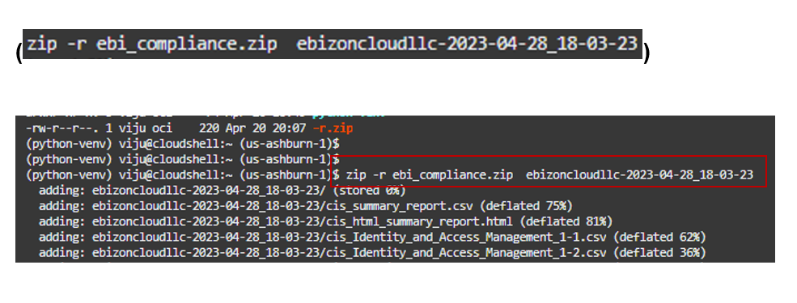

Step 6: Click on setting and download the report.

In downloads give name of the file and download

(ebi_compliance.zip and download)

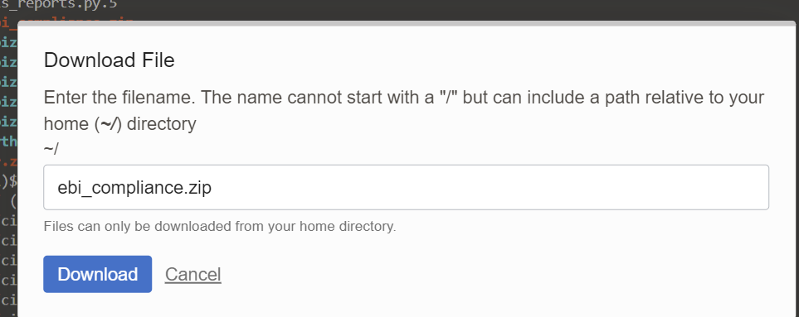

Once you download you will see all these reports

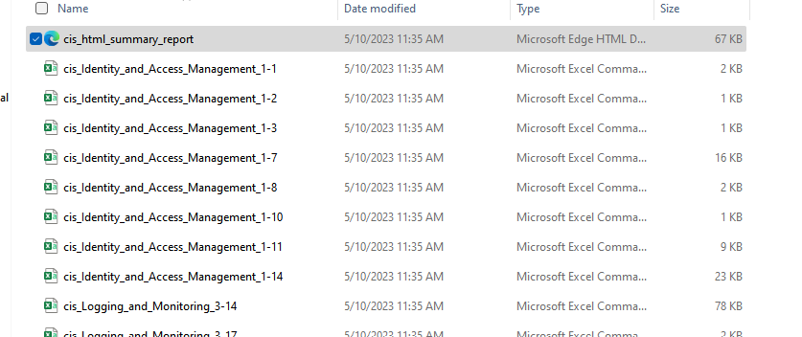

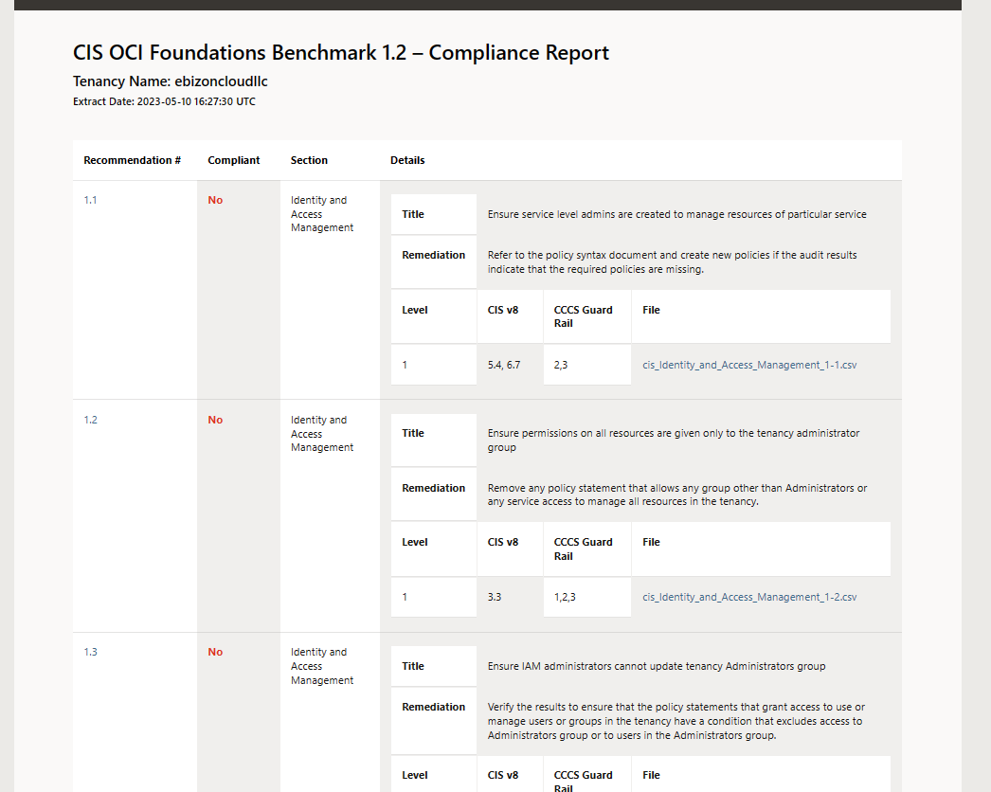

(Refer this for more info
https://github.com/oracle-quickstart/oci-cis-landingzone-quickstart/blob/main/compliance-script.md#overview)

### END ###

