IP Management – BYOIP

Contents
1. Introduction 3
2. Requirements and Preparation 3
3. Limits and Quotas 4
4. BYOIP Process Overview 4

Introduction

Oracle Cloud Infrastructure allows user to Bring your Own IP (BYOIP) address space to use with resources in Oracle Cloud Infrastructure, in addition to using Oracle owned addresses.
BYOIP lets user manage user’s IPv4 CIDR blocks and IPv6 prefixes to align with user’s existing security, management, and deployment policies and achieve:
- Solution continuity and hardcoded dependencies: User’s VCN is an extension of user’s public Internet presence, without needing to reinvent policies and management processes. If user have IP addresses hard-coded in devices or built architectural dependencies on specific IP addresses, using BYOIP user have a smooth migration to Oracle Cloud Infrastructure.
- IP pool management: Some network administrators require the ability to summarize groups of IPv4 addresses into pools and to create resources for deployment such as load balancers, firewalls, or web servers. IP Pool management provides tools to manage reserved public IPv4 addresses. IPv6 does not use IP Pool management.
- IP reputation: Some internet services rely on a contiguous IP address space (such as a full span of IP addresses from 1 through 255) and act as a trusted contact point between services such as major email service providers and mail delivery systems.
Oracle performs a validation process on imported IPv4 CIDR blocks or IPv6 prefixes, and after validation user are notified that they are available for advertisement. User can create one or many public IPv4 pools from this address space by specifying subranges from the BYOIP CIDR block and use IP pools to allocate specific resources. User can start or stop advertisement of the BYOIP routes when needed. IPv6 does not use IP pools, but user can similarly assign prefixes to VCNs and subnets.

Requirements and Preparation

User must have ownership of the public IPv4 CIDR block or IPv6 prefix user want to import into Oracle Cloud Infrastructure, and the ownership must be registered with a supported Regional Internet Registry (RIR). Oracle validates ownership of user’s addresses. Only the following registries are supported, and the addresses must have a specified type or status:

- American Registry for Internet Numbers (ARIN) - "Direct Allocation" and "Direct Assignment" network types

- Réseaux IP Européens Network Coordination Centre (RIPE NCC) - "ALLOCATED PA," "LEGACY," "ASSIGNED PI," and "ALLOCATED-BY-RIR" allocation statuses

- Asia-Pacific Network Information Centre (APNIC) – "ALLOCATED PORTABLE" and "ASSIGNED PORTABLE" allocation statuses

The addresses in the IP address range must have a clean history. We might investigate the reputation of the IP address range and reserve the right to reject an IP address range that contains an IP address that is associated with malicious behaviour.

Limits and Quotas

- User’s addresses can only be imported to a specific Oracle region.
- User can use BYOIP with an IPv4 CIDR block that is a minimum of /24 and a maximum of /8.
- An imported IPv6 prefix must be /48 or larger.
- User can't bring the same address range to more than one compartment at a time.
- User can bring up to 20 IPv4 CIDR blocks or IPv6 prefixes (or combination) to user’s Oracle Cloud Infrastructure account.
- User can assign up to five total IPv6 prefixes per VCN and up to three per subnet. User may assign IPv6 addresses from multiple prefixes to a VNIC if its subnet has multiple IPv6 prefixes assigned.
- BYOIP is not available with Oracle Cloud Infrastructure Free Tier, and must be requested for Pay As User Go services.

BYOIP Process Overview

The steps needed for BYOIP in Oracle Cloud Infrastructure require significant time, so plan accordingly. The process is shown in the following diagram:

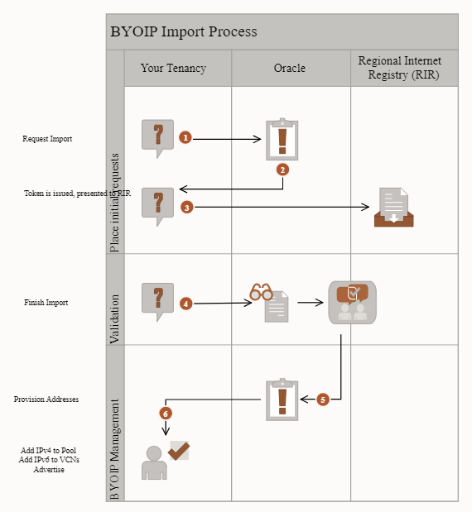

- Within a compartment in user’s tenancy, user request to import a public IPv4 CIDR block or IPv6 prefix user own.
- Oracle issues a verification token. (API users have to modify their token. Console users get a completed token.)
- User add the verification token to the information about that public IPv4 CIDR block or IPv6 prefix kept by user’s RIR service. The details vary depending on the RIR. It can take up to one day for the update to take effect. If user move to the next step before that update takes effect, a day will be added to the total time to complete the process. See To import a BYOIP IPv4 CIDR block or IPv6 prefix for details.
- Create a Route Origin Authorization (ROA) with user’s RIR. As part of the ROA, provide the Oracle BGP ASN. Oracle's BGP ASN for the commercial cloud is 31898, except the Serbia Central (Jovanovac) region which is 14544. The ROA allows Oracle to advertise the BYOIP CIDR block.
- Request that Oracle finish the import request. This workflow takes up to 10 business days to complete, while Oracle communicates with the RIR and verifies that user own the IP addresses.
- Oracle provisions the BYOIP addresses to user’s compartment within user’s tenancy.
- At this point, the BYOIP IPv4 CIDR block or IPv6 prefix is user’ss to manage in user’s compartment. User can add IPv4 addresses to an IP pool, and then use them as reserved IP addresses. IPv6 prefixes do not use pools, and user can directly assign subdivisions to VCNs or the assign the entire IPv6 prefix to a VCN. User can also advertise the BYOIP CIDR Block or BYOIPv6 Prefix to the internet.

To import a BYOIP IPv4 CIDR block or IPv6 prefix

- Confirm user are viewing the region and compartment user're interested in.
- Open the navigation menu and click Networking. Under IP management, click BYOIP.
- Click Import BYOIP CIDR Block. The Import BYOIP CIDR Block screen appears.
- In the Import BYOIP CIDR Block screen, enter a name for the BYOIP CIDR block, choose the compartment, and enter the IPv4 CIDR block or IPv6 prefix user intend to bring to user’s tenancy. Avoid entering confidential information.
- Click Save Changes. The details page for that BYOIP import request appears.
- In the Next Steps section, make a copy of the validation token. The token format depends on the IP version.
Format for an IPv4 CIDR block:
- OCITOKEN: :<cidrBlock> : <validationToken>
Format for an IPv6 prefix:
- OCITOKEN: :<Ipv6cidrBlock> : <validationToken>
While the console presents user with a token that is ready to submit, the API does not. API users need to manually modify the token as shown.
- Create a Route Origin Authorization (ROA) object that authorizes Oracle to advertise the BYOIP CIDR block. Oracle's BGP ASN for the commercial cloud is 31898, except the Serbia Central (Jovanovac) region which is 14544. Set an expiry date at least 6 months in the future. Follow the instructions appropriate for user’s RIR:
    - ARIN
    - RIPE NCC
    - APNIC
- Now add the validation token to the RIR account information associated with user’s address range. Each RIR uses a slightly different method:
  - ARIN: Add the token string in the "Public Comments" section associated with user’s address range.
  - RIPE NCC: Add the token string as a new "descr" field associated with user’s address range.
  - APNIC: Add the token string to the "remarks" field for user’s address range by emailing it to helpdesk@apnic.net. The email must be sent from the APNIC authorized contact account for the IP address range.
- Wait until both the ROA and the token registration is complete (up to a day) before user click the Finish Import button. Otherwise, the process can be delayed up to one day.
- Return to the details page for the BYOIP request and click Finish Import. A confirmation screen appears.
- Click Finish Import, confirming that user would like to validate the BYOIP request. Allow up to 10 business days for Oracle to contact user’s RIR, validate the import, and provision the CIDR block. View the work requests to see the status.

