IP Management – Reserved Public IP with ORM stack

Contents

1. Introduction 3
2. Workflow diagram to deploy the stack 3
3. Create stack for the Reserved Public IP 4
4. Plan the Job 6
5. Apply the Job 8
6. Verify in the Console 9
7. Destroy the stack 9

Introduction

A public IP address is an IPv4 address that is reachable from the internet. If a resource in tenancy needs to be directly reachable from the internet, it must have a public IP address. Depending on the type of resource, there might be other requirements.
Certain types of resources in tenancy are designed to be directly reachable from the internet and therefore automatically come with a public IP address. For example: a NAT gateway or a public load balancer. Other types of resources are directly reachable only if user configure them to be. For example: instances in VCN.
Reserved Public IP:
Think of it as persistent and existing beyond the lifetime of the instance it's assigned to. user can unassign it and then reassign it to another instance whenever user like. Exception: reserved public IPs on public load balancers.

Workflow diagram to deploy the stack
Below diagram shows how the Terraform Artifact are applied in the OCI. While creating a ORM stack, using terraform deliverables Init, Plan and Apply is the flow to provision the resource in the OCI. We can have the deliverables in any of below.
- GitLab/GitHub Repo
- Bitbucket
- Can be in folder/.zip in the local disk
- Object Storage Bucket
- Can be in compartment
- Oracle provided Template


Create stack for the Reserved Public IP

Go to OCI Console Developer Services Resource Manager Stacks select the compartment Create Stack

My Configuration Folder Browse Select the “reserved public ip” folder that contains the terraform Upload

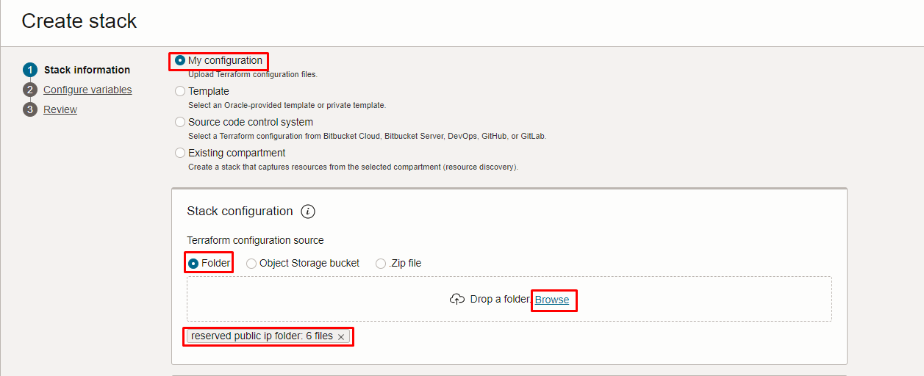
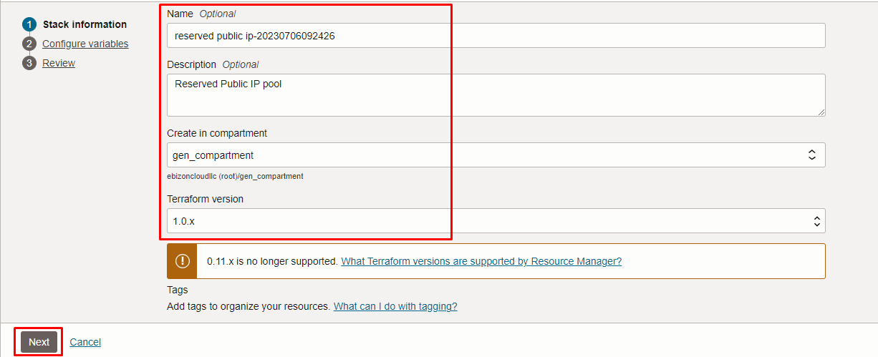
Click “NEXT”

Select the parameters as per the below screen,

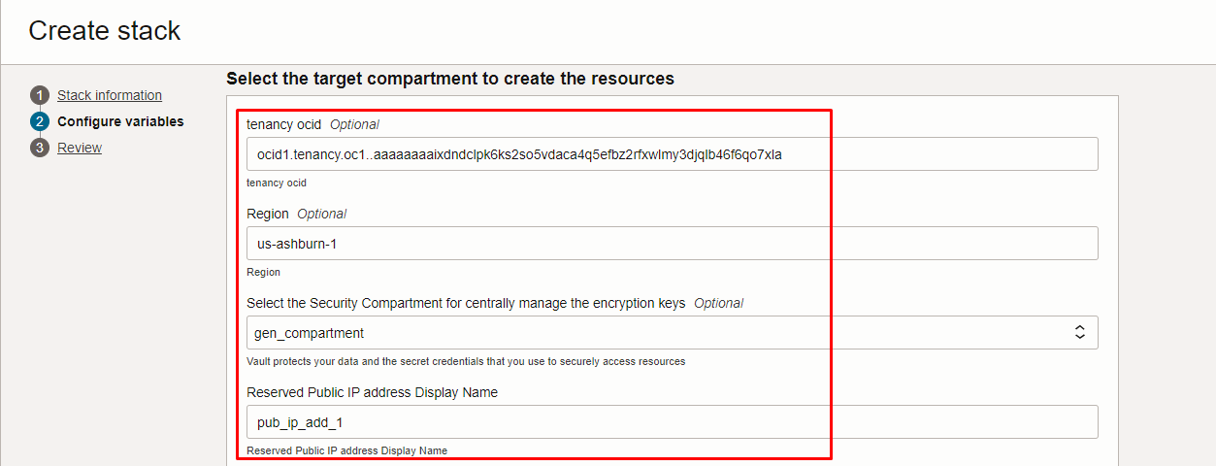
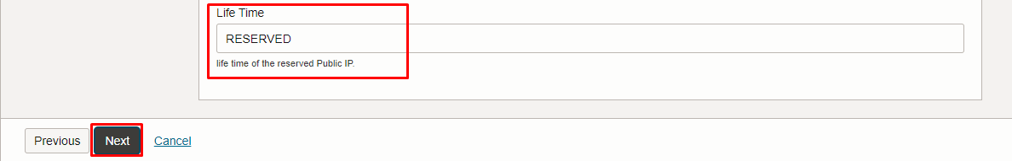

Click “NEXT” Click “CREATE”
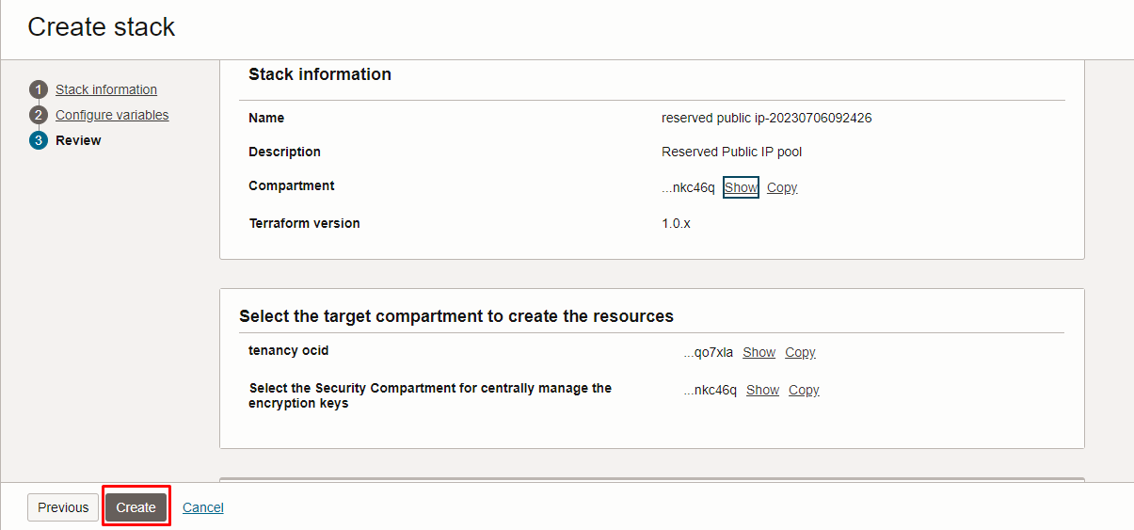

Plan the Job

Click the “Plan”
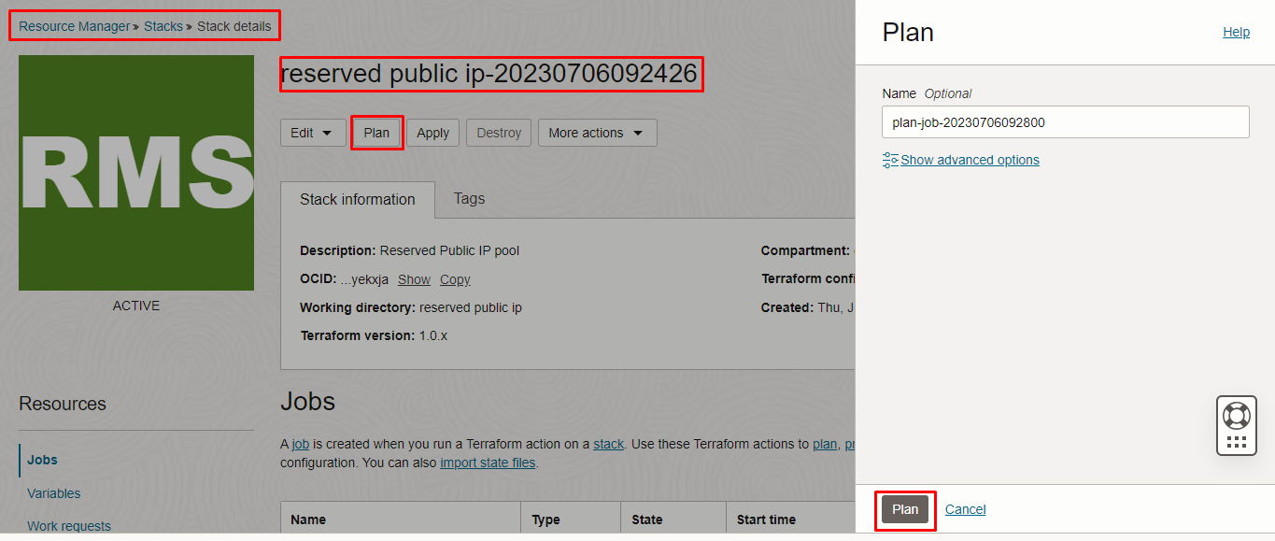

Verify the Plan is successful.

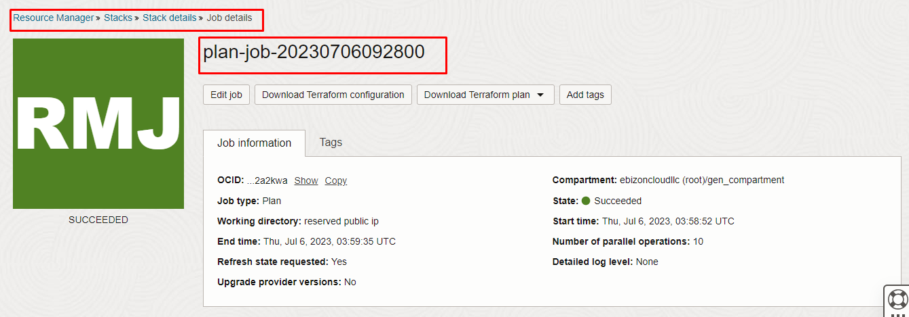
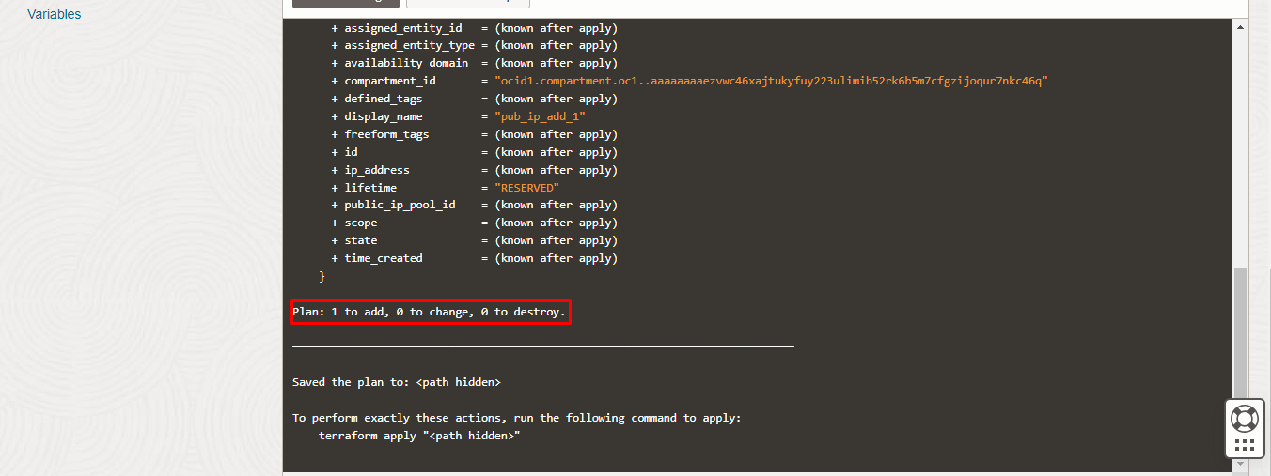

Apply the Job

Once the “plan” is success, now click “Apply”

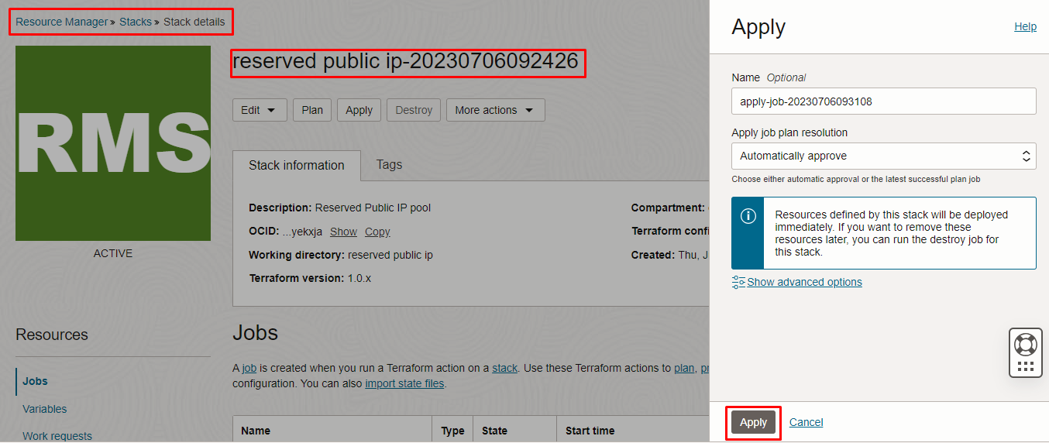
Verify the Apply is successful.
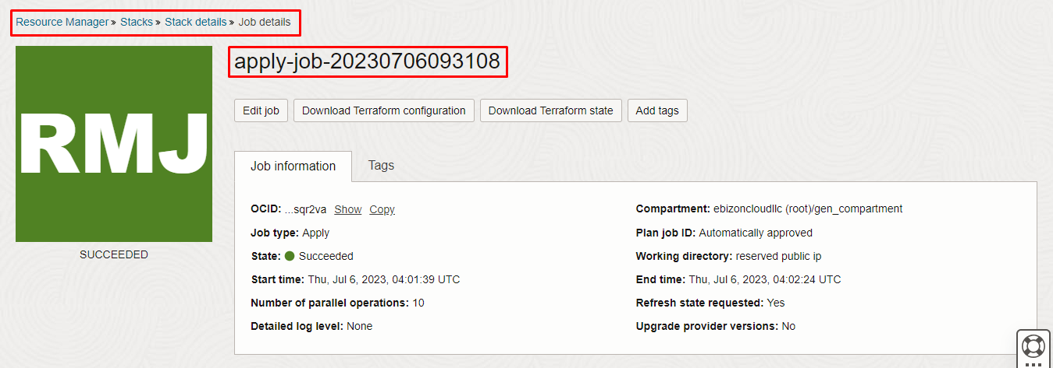
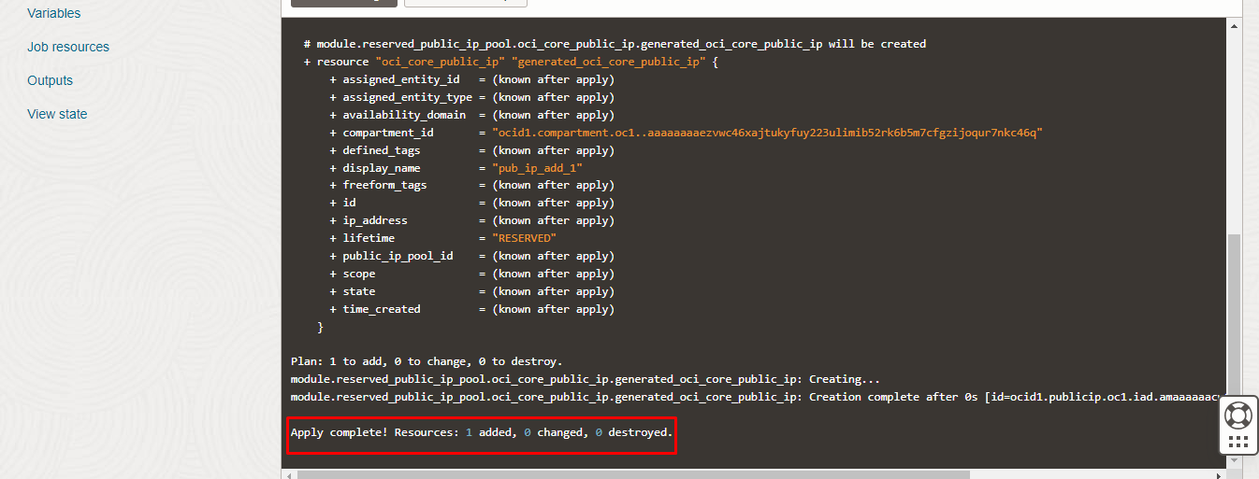

Verify in the Console

Go to OCI Console Networking IP Management reserved Public IP

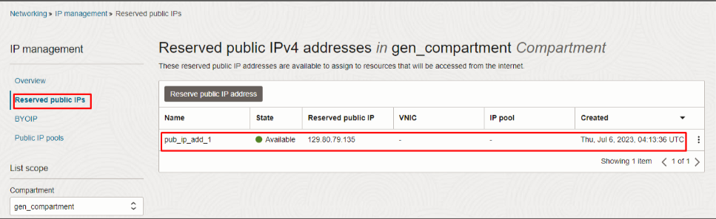

Destroy the stack

Create a destroy job in Resource Manager to release resources associated with a stack and clean up the tenancy. Once destroyed data cannot be recovered from resources.

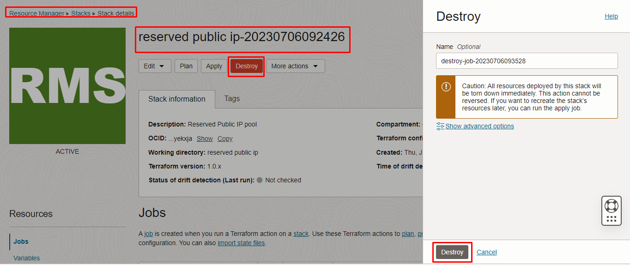

#########END#########

