Database MySQL HeatWave on AWS

Contents

1. Introduction 3
2. MySQL Database 4
3. HeatWave Architecture 4
4. HeatWave Service 5
5. Integration with OCI 6
6. Region Availability 8
7. Identity and Access Management (IAM) 8
8. Security 9
9. How to enabling MySQL HeatWave on AWS 11
10. How to add HeatWave Cluster into Database System 13
11. Pricing & Performance 17
12. Summary 20

Introduction

MySQL HeatWave on AWS is a fully managed service, developed and supported by the MySQL team at Oracle. Oracle automates tasks such as database and operating system patching. Client is responsible for managing data, schema designs, and access.

With MySQL HeatWave on AWS, client can create and manage a MySQL DB System with a HeatWave Cluster to use with AWS applications.

- MySQL Database
- HeatWave
- Integration with OCI
- Region Availability
- MySQL HeatWave on AWS is currently available in five regions. Each AWS Region maps to an OCI region, and requires a subscription to that OCI region.
- Identity and Access Management
- Security

Traditional MySQL Model & ETL with Transactional MySQL Database feeding the Data Warehouse via ETL Processes:

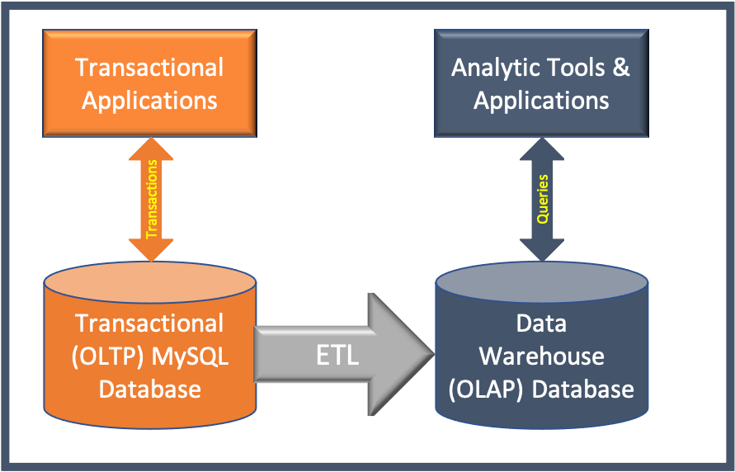

Highlights:

- HeatWave has a brand new engine designed for the Cloud, integrated with MySQL, optimize for OCI.
- New distributed algorithms were invented at Oracle.
- Massively partitioned & parallel architecture for High Scalability.
- Optimize for lower-cost AMD shapes & standard networking.
- Integrated with object store to provide best storage performance and cost.
- Machine learning-based automation to adapt to varying workloads.
- The result is a service that provides the fastest performance for analytics at a lower cost.

MySQL Database

The MySQL Database is built on the MySQL Enterprise Edition Server, which allows developers to quickly create and deploy secure cloud native applications using the world's most popular open source database. It is the only MySQL database that supports HeatWave.

MySQL HeatWave on AWS supports MySQL Enterprise Edition 8.0. Clients can choose from the latest MySQL 8.0 releases when creating a DB System.

HeatWave Architecture

A HeatWave cluster includes a MySQL DB System node and two or more HeatWave nodes. The DB System node features a HeatWave plugin that’s responsible for cluster management, loading data into the HeatWave cluster, query data using HeatWave Cluster, and returning query results to the MySQL DB System. HeatWave nodes store data in memory and process analytics queries.

The number of HeatWave nodes required depends on the dimensions of data and therefore the amount of compression that’s achieved when loading the data into the HeatWave cluster.
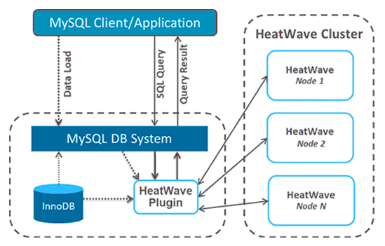

Features of HeatWave:

- New integrated, high-performance in-memory query accelerator – HeatWave is a new, in-memory query accelerator developed for MySQL Database Service. HeatWave uses machine learning to intelligently automate operations such as provisioning, increasing DBA productivity, and reducing costs.

- MySQL delivers real-time analytic – HeatWave accelerates MySQL queries by 400X using massively parallel processing to provide real-time analytics. HeatWave is 2.7X faster than Amazon Redshift using in-memory analytics and it is 1100X faster than Amazon Aurora. it can scale up to thousands of OCI cores.

- Single database for OLTP and OLAP – Oracle MySQL Database Service, with its integrated HeatWave, is the only service that enables database admins and app developers to run OLTP and OLAP workloads directly from their MySQL database.

HeatWave Service

HeatWave is a massively parallel, high performance, in-memory query accelerator that accelerates MySQL performance by orders of magnitude for analytics and mixed workloads.

With MySQL HeatWave on AWS, client can provision DB Systems and HeatWave Clusters. HeatWave consists of a MySQL DB System and one or more HeatWave nodes. The MySQL DB System node is responsible for cluster management, query scheduling, and returning query results. HeatWave nodes store data in memory and process analytics queries.

When a HeatWave Cluster is enabled, queries that meet certain prerequisites are automatically offloaded from the MySQL DB System to the HeatWave Cluster for accelerated processing. Queries are issued from Query Editor in the MySQL HeatWave Console or from a MySQL client or application that interacts with the HeatWave Cluster by connecting to the MySQL DB System.

It scales out to thousands of cores, is 1100X faster than Amazon Aurora, and 2.7X faster than Amazon Redshift at one-third the value. MySQL Database Service, with HeatWave, is that the only service that permits database admins and app developers to run OLTP and OLAP workloads directly from their database. The service is optimized for and exclusively available in OCI.

Integration with OCI

MySQL HeatWave on AWS is integrated with OCI for identity and access management, and for billing and cost management.

When client sign up for MySQL HeatWave on AWS, client is directed to OCI where he must sign up for an Oracle Cloud Account if he does not have one. After signing up, client is directed to the OCI Console to complete the sign-up process. When signing in to the MySQL HeatWave Console, he is directed to OCI for authentication and then back to the MySQL HeatWave Console.

Identity and access management and billing for MySQL HeatWave on AWS is managed in OCI.

The following diagram shows MySQL HeatWave on AWS integration with OCI.

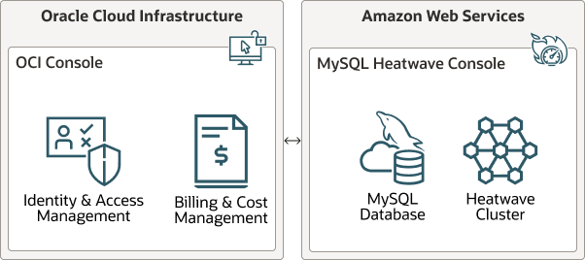
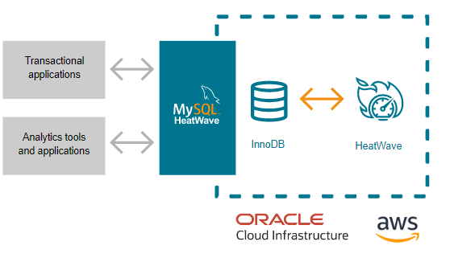
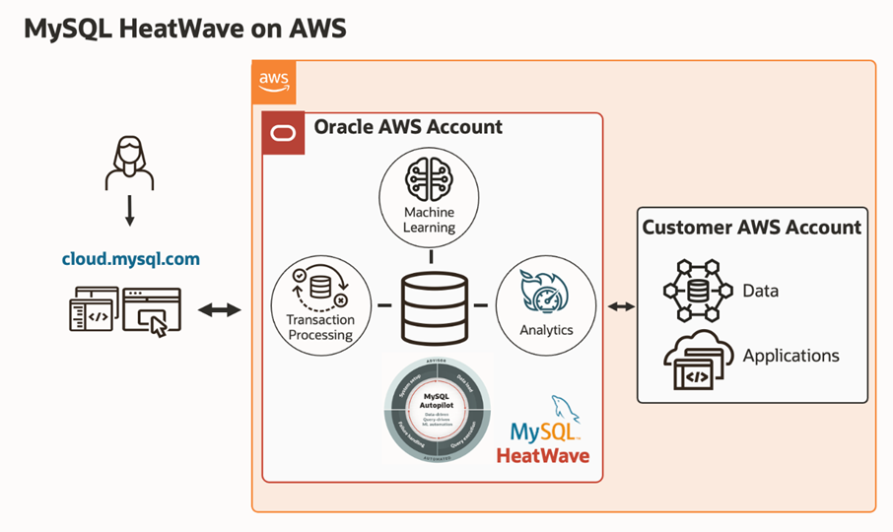

Region Availability

MySQL HeatWave on AWS is now currently available in five regions. Each AWS Region maps to an OCI region, and requires a subscription to that OCI region.

OCI and AWS Regions:
OCI Region name | OCI Region identifier | AWS Region name | AWS Region code
Germany Central (Frankfurt) | eu-frankfurt-1 | Europe (Frankfurt) | eu-central-1
India West (Mumbai) | ap-mumbai-1 | Asia Pacific (Mumbai) | ap-south-1
Japan East (Tokyo) | ap-tokyo-1 | Asia Pacific (Tokyo) | ap-northeast-1
UK South (London) | uk-london-1 | Europe (London) | eu-west-2
US East (Ashburn) | us-ashburn-1 | US East (N. Virginia) | us-east-1

Identity and Access Management (IAM)

MySQL HeatWave on AWS integrates with OCI for identity and access management. MySQL HeatWave on AWS uses predefined OCI Identity and Access Management (IAM) groups to control access to the MySQL HeatWave Console.

MySQL HeatWave on AWS also supports federation with third-party Identity Providers (IdPs).

If regular user (not an Administrator), who needs access to MySQL HeatWave on AWS, contact the Administrator to set up an account. An OCI IAM user account is required to access the MySQL HeatWave Console, and that user must be added to one of the predefined OCI IAM groups.

A separate MySQL user account is required to access MySQL HeatWave on AWS from a MySQL client or application. This can be the MySQL Administrator user specified when creating the DB System or a MySQL user account created on the DB System using CREATE USER . For the MySQL user account, MySQL Administrator will create that.

Security

Oracle considers cloud security its highest priority. The following security features help keep data safe and secure.

- Database access control and account management: MySQL provides security features to control access and manage account.

- Connection Control: MySQL HeatWave on AWS supports a plugin library that enables Administrators to introduce an increasing delay in server response to connection attempts after a configurable number of consecutive failed attempts. This capability provides a deterrent that slows down brute force attacks against MySQL user accounts. The default connection control settings, which cannot be modified, are as follows:

- connection_control_failed_connections_threshold

- connection_control_max_connection_delay

- connection_control_min_connection_delay

- Encryption at rest: The data is always encrypted at rest. MySQL HeatWave on AWS uses Amazon EBS encryption. Boot volumes are encrypted on MySQL DB System and HeatWave nodes, and the database volume is encrypted on the MySQL DB System.

- Encryption in transit: The data is always encrypted while in transit. MySQL HeatWave on AWS supports TLSv1.2 and requires that all MySQL client and application connections are encrypted. For added security, download a signed certificate bundle to enable host name identity verification for connecting clients and applications.

- MySQL Enterprise Data Masking and De-Identification: Use data masking and de-identification to protect sensitive data. MySQL HeatWave on AWS supports various MySQL data masking functions that mask data to remove identifying characteristics and generate random data with specific characteristics. The following data masking functions are supported:

- gen_range()

- gen_rnd_email()

- gen_rnd_ssn()

- gen_rnd_us_phone()

- mask_inner()

- mask_outer()

- mask_pan()

- mask_pan_relaxed()

- mask_ssn()

- Password Validation: MySQL HeatWave on AWS enforces strong passwords with the validate_password component, serves to improve security by requiring account passwords and enabling strength testing of potential passwords. The default value of the variables of the validate_password component are as follows:

- validate_password.check_user_name

- validate_password.length

- validate_password.mixed_case_count

- validate_password.number_count

- validate_password.policy

- validate_password.special_char_count

Make sure applications comply with the password requirements.

- MySQL Enterprise Firewall: MySQL Enterprise Firewall enables database Administrators to permit or deny SQL statement execution based on matching against lists of accepted statement patterns. This helps harden MySQL against attacks such as SQL injection or attempts to exploit applications by using them outside of their legitimate query workload characteristics.

How to enabling MySQL HeatWave on AWS

After enabling MySQL HeatWave on AWS, we will be able to create and manage MySQL HeatWave resources using the MySQL HeatWave on AWS Console, and manage users, groups, regions, and billing in the OCI Console.

Pre-requests:
- Need to enable MySQL HeatWave on AWS in at least one AWS region.
- For enabling an AWS region requires subscribed to the corresponding OCI region like below.

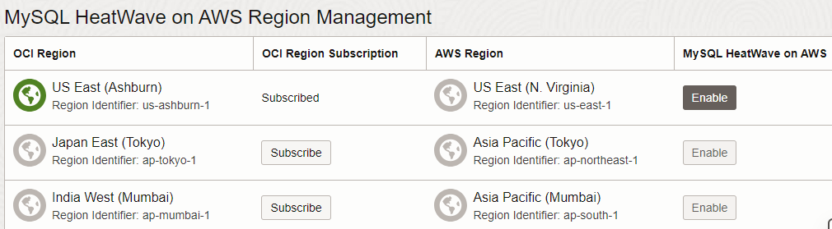

OCI Console Databases MySQL HeatWave on AWS
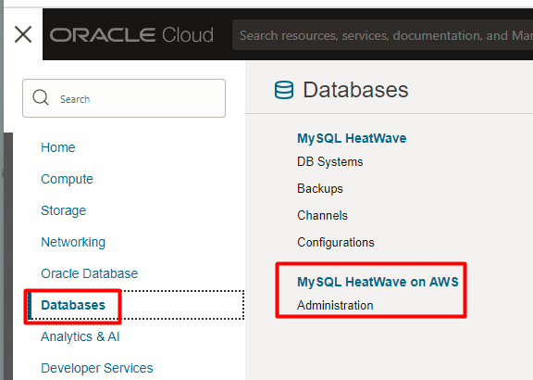
Now click the below button
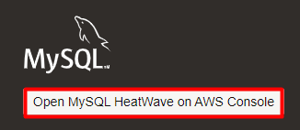
For login,
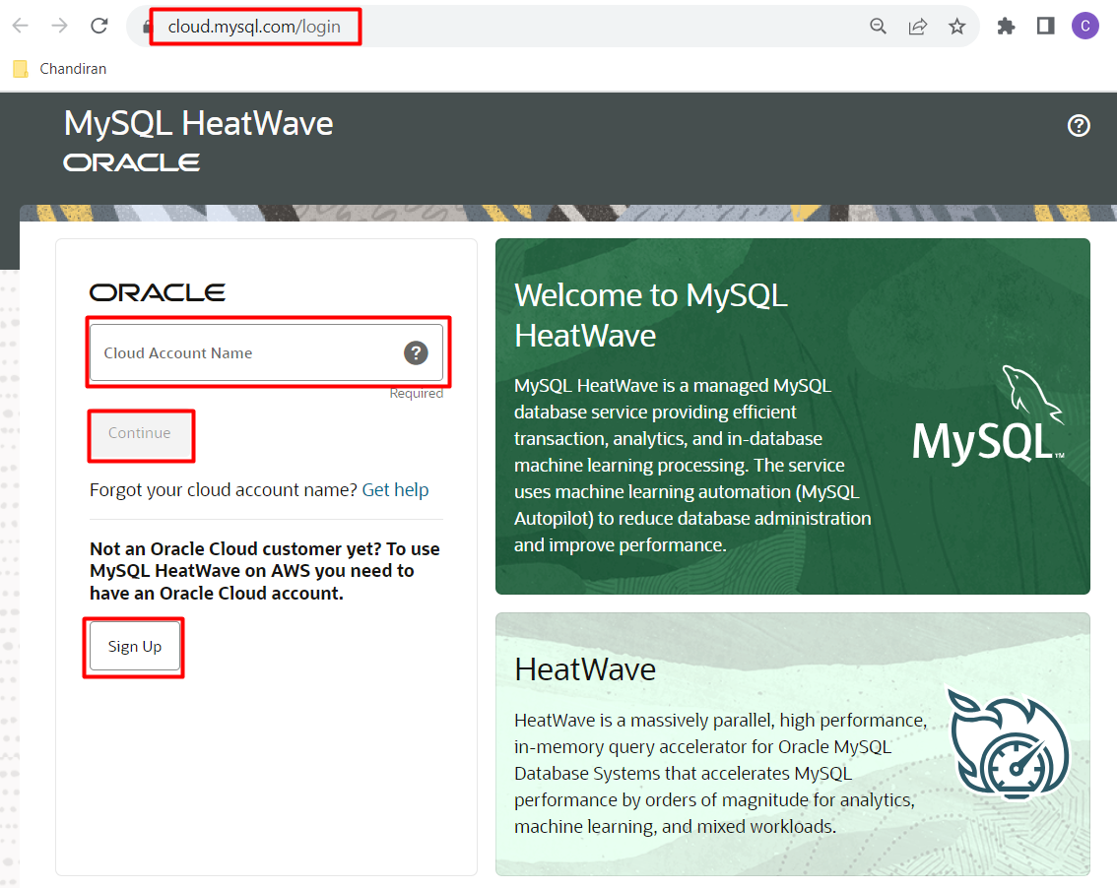

How to add HeatWave Cluster into Database System

Before adding HeatWave Cluster into the Database System ensure the DB System was created using MySQL.HeatWave.VM.Standard.E3 shape.

1) Register & Log in to the Oracle free Cloud account.

2) To add a HeatWave cluster to an existing MySQL DB System:
Open the navigation menu and select Databases. Under MySQL, click DB Systems.
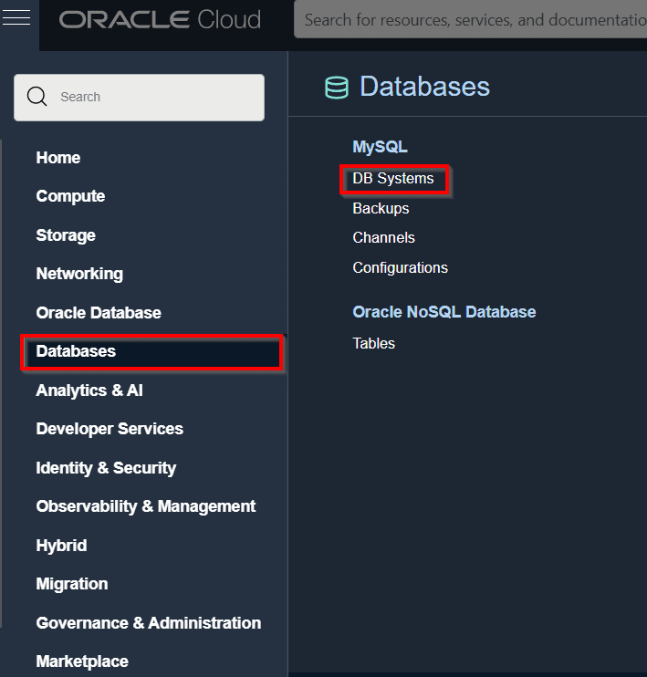

2. Add HeatWave cluster in one of the following ways:

Select the DB System and choose Add HeatWave Cluster from the Actions icon (three dots) on the same line as DB System.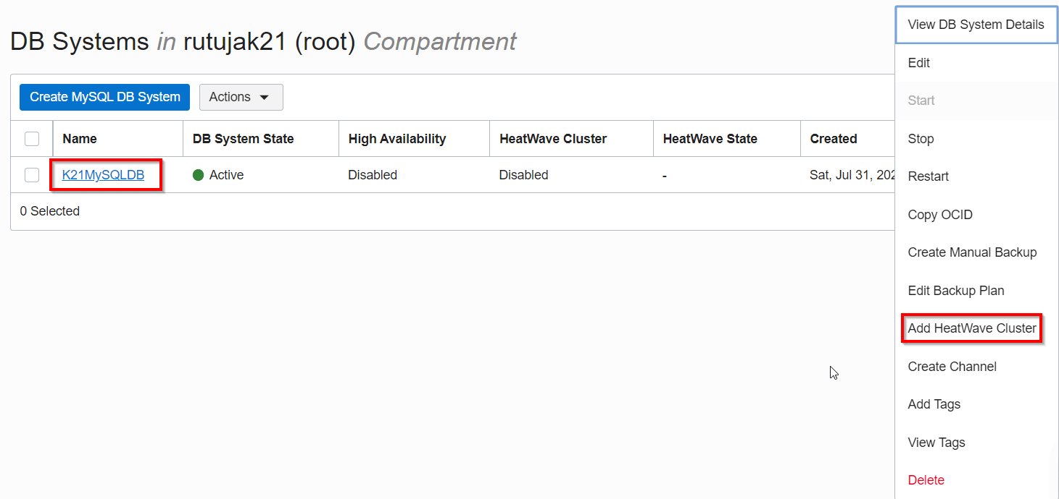

Open the DB System and select HeatWave Cluster from the Resources list. On the HeatWave Cluster Information frame, select Add HeatWave Cluster.

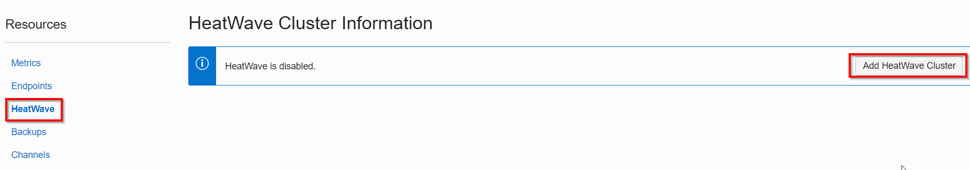
The Add HeatWave Cluster dialog is displayed.
3. On the Add HeatWave Cluster dialog, provide the following details:

Shape: The shape for the HeatWave nodes. Shapes are resource templates, defining the number of OCPUs, RAM, and so on. Click Change Shape to select a shape for HeatWave nodes.

Node Count: The number of HeatWave nodes to create. Optionally, click Estimate Node Count to generate a node count estimate to determine the number of nodes required based on the shape selected and the size of data.

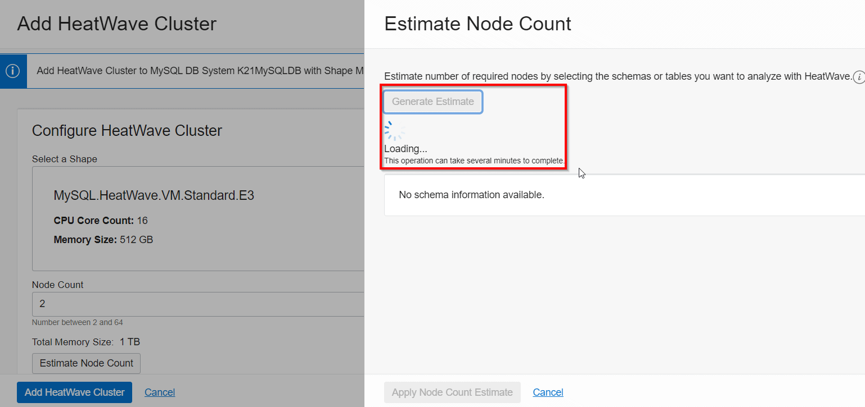
4.Click Add HeatWave Cluster to create the HeatWave cluster.

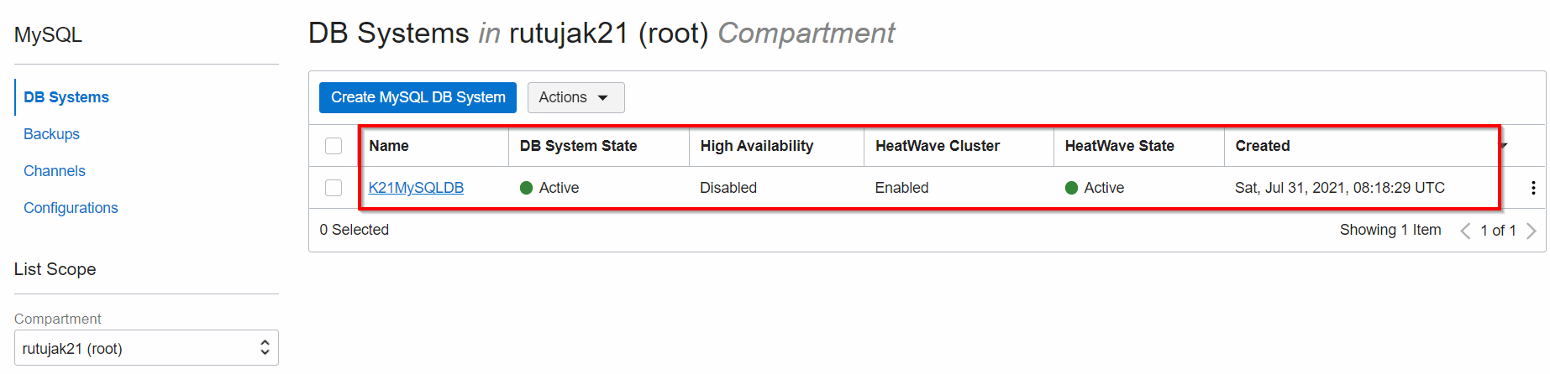

Managing HeatWave Cluster

1.How to load Data into the HeatWave Cluster
Before loading data into the HeatWave cluster, the data/tables have to be prepared.
Preparing tables involves:
Modifying table definitions to exclude certain columns, define string column encodings, add data placement keys.
Specify HeatWave (RAPID) as the secondary engine for the table (Note that InnoDB is the primary engine).
Loading a table into a HeatWave cluster requires executing an ALTER TABLE operation with the SECONDARY_LOAD keyword.
mysql> ALTER TABLE sales SECONDARY_UNLOAD;

2. How to query data using the HeatWave cluster

- If a query accesses a table that is not loaded, the query is not offloaded to the HeatWave cluster for processing.
- Queries that meet certain prerequisites are automatically offloaded from the MySQL DB System to the HeatWave cluster for accelerated processing
- Results are returned to the MySQL DB System node and to the MySQL client or application that issued the query
- When a table is loaded, data is sliced horizontally and distributed among HeatWave nodes
- After a table is loaded, changes to a table’s data on the MySQL DB System node are automatically propagated to the HeatWave nodes
  - No user action is required to keep data synchronized

Pricing & Performance

One MySQL cloud database service for transactions, real-time analytics across data warehouses and data lakes, and machine learning (ML)—without the complexity, latency, risks, and cost of extract, transform, and load (ETL) duplication. Available on Oracle Cloud Infrastructure (OCI), Amazon Web Services (AWS), and Microsoft Azure.

Why choose MySQL HeatWave:

Simplicity of transactions, real-time analytics across data warehouses and data lakes, and ML in one cloud database service: Eliminate the cost and complexity of separate analytics database, lakehouse, ML, and ETL cloud services. Query data in MySQL, in object storage, or across both. Avoid the latency and security risks of data movement between data stores.

Unmatched performance and price-performance: MySQL HeatWave is 6.5X faster than Amazon Redshift at half the cost, 7X faster than Snowflake at one-fifth the cost, and 1,400X faster than Amazon Aurora at half the cost. The price-performance of MySQL HeatWave Lakehouse for query processing is 8X better than Redshift, 18X better than Databricks, 22X better than Snowflake, and 30X better than Google BigQuery.
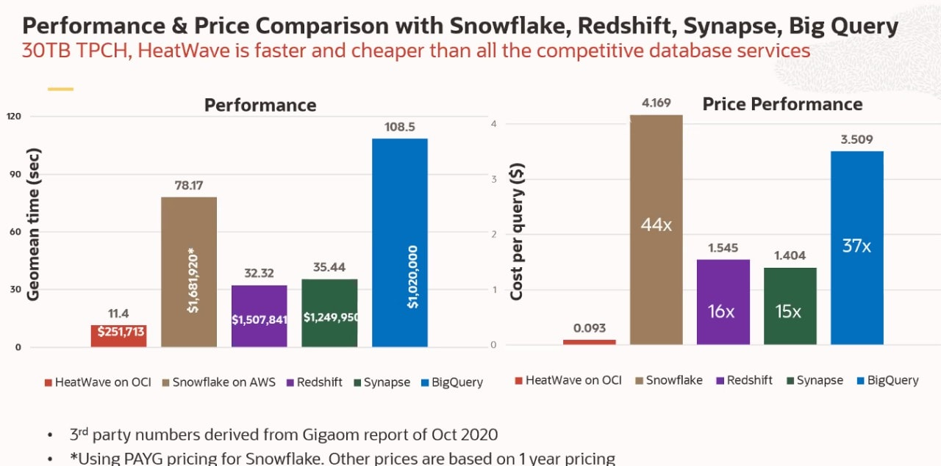
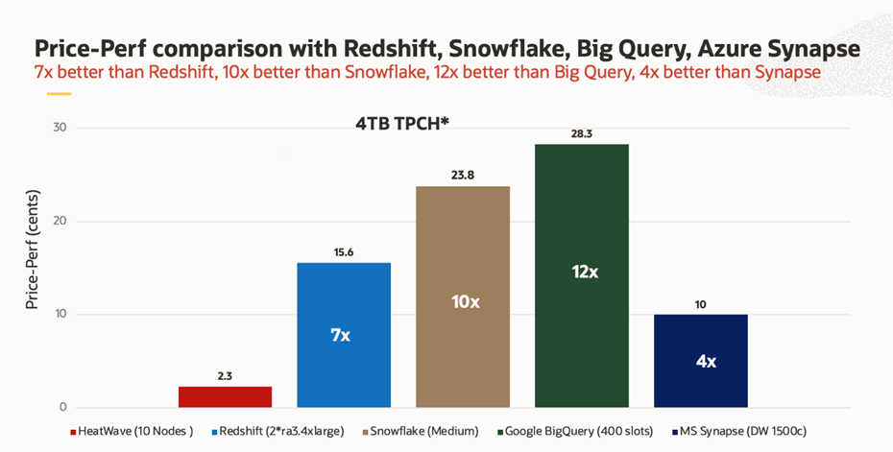

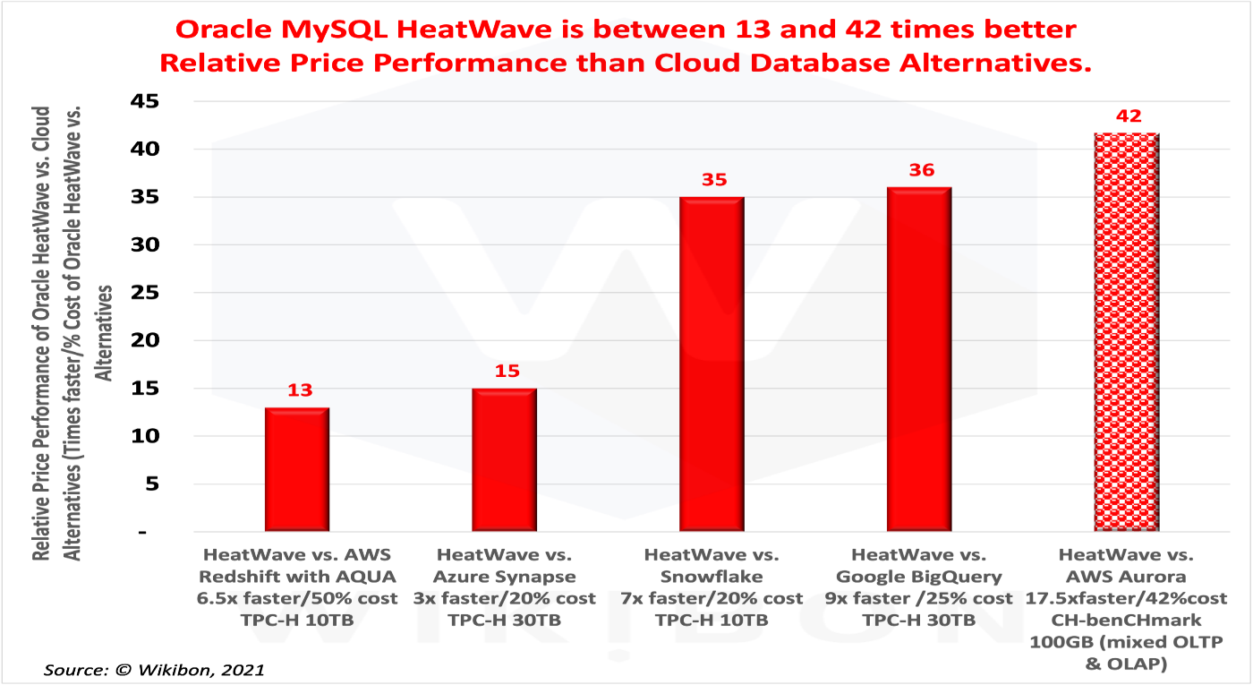

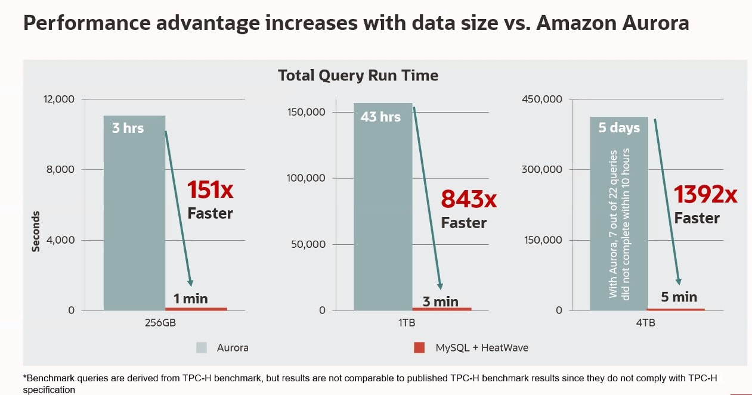

Summary

MySQL HeatWave has delivered an important capability to MySQL users. As a result, enterprise IT early adopters can expect MySQL HeatWave to perform about seven times faster than AWS Redshift or Snowflake at a 2-5 times lower cost. AWS Aurora users should expect higher benefits.

However the most important user benefits of converged OLTP and OLAP databases will come longer term from eliminating ETL and developing smarter transactional applications to automate complex business processes.

Alibaba, AWS, Google, Microsoft, and Snowflake will need some time to rearchitect their IaaS & PaaS platforms to run converged databases properly. In addition, most of these vendors will need to invest heavily in other converged database hardware and software.

Enterprises of every size should plan to run a converged MySQL database for OLTP & OLAP and set a date to eliminate ETL within four years. In addition, users should expect and encourage transactional ISVs to provide integrated OLTP/OLAP databases in their products. As a result, lines of business can plan to integrate in-line real-time analytics with systems of record and radically improve business process automation and costs.

# END #

