Machine Learning

Contents
1. Introduction 3
1.1. Machine Learning in Oracle Database: 3
2. Data Science 4
2.1. Data Science Concepts 4
2.2. Data Science Prerequisites 6
2.3. Create a Project 7
3. Data Labelling 7
3.1. Setting Up Data Labeling 8
3.2. Dataset 8
3.3. Create a Dataset 8

Introduction

Machine learning (ML) is the subset of artificial intelligence (AI) that focuses on building systems that learn—or improve performance—based on the data they consume. Artificial intelligence is a broad term that refers to systems or machines that mimic human intelligence. Machine learning and AI are often discussed together, and the terms are sometimes used interchangeably, but they don’t mean the same thing. An important distinction is that although all machine learning is AI, not all AI is machine learning.

Machine learning services from Oracle make it easier to build, train, deploy, and manage custom learning models. These services deliver data science capabilities with support from favourite open-source libraries and tools, or through in-database machine learning and direct access to cleansed data. Supporting machine learning services provide more streamlined data labelling or improved access to virtual machines.

Features:
- Open source libraries and frameworks
- In-database optimized algorithms
- Choice of deployment
- Model explanation
- Access any data flexibly and easily
- Support for multiple scripting languages

Machine Learning in Oracle Database:

- Machine Learning in Oracle Database supports data exploration, preparation, and machine learning modelling at scale using SQL, R, Python, REST, automated machine learning (AutoML), and no-code interfaces.
- It includes more than 30 high performance in-database algorithms producing models for immediate use in applications.
- By keeping data in the database, organizations can simplify their overall architecture and maintain data synchronization and security.
- It enables data scientists and other data professionals to build models quickly by simplifying and automating key elements of the machine learning lifecycle.

Data Science
Oracle Cloud Infrastructure (OCI) Data Science is a fully managed and serverless platform for data science teams to build, train, and manage machine learning models.
The Data Science overview:
- Provides data scientists with a collaborative, project-driven workspace.
- Enables self-service, serverless access to infrastructure for data science workloads.
- Includes Python-centric tools, libraries, and packages developed by the open source community and the Oracle Accelerated Data Science Library, which supports the end-to-end lifecycle of predictive models:
  - Data acquisition, profiling, preparation, and visualization.
  - Feature engineering.
  - Model training (including Oracle AutoML).
  - Model evaluation, explanation, and interpretation (including Oracle MLX).
- Integrates with the rest of the Oracle Cloud Infrastructure stack, including Functions, Data Flow, Autonomous Data Warehouse, and Object Storage.
- Model deployment as resources to deploy models as web applications (HTTP API endpoints).
- Data Science jobs enable to define and run repeatable machine learning tasks on a fully-managed infrastructure.
- Pipelines enable to execute end-to-end machine learning workflows.
- Includes policies, and vaults to control access to compartments and resources.
- Includes metrics that provide insight into the health, availability, performance, and utilization of Data Science resources.
- Helps data scientists concentrate on methodology and domain expertise to deliver models to production.

Data Science Concepts

Accelerated Data Science SDK
The Oracle Accelerated Data Science (ADS) SDK is a Python library that's included as part of the OCI Data Science service. ADS has many functions and objects that automate or simplify the steps in the Data Science workflow, including connecting to data, exploring and visualizing data, training a model with Atom, evaluating models, and explaining models.
Projects
Projects are collaborative workspaces for organizing and documenting Data Science assets, such as notebook sessions and models.
Notebook Sessions
Data Science notebook sessions are interactive coding environments for building and training models. Notebook sessions come with many preinstalled open source and Oracle developed machine learning and data science packages.
Conda Environments
Conda is an open source environment and package management system and was created for Python programs. It installs, runs, and updates packages and their dependencies. Conda easily creates, saves, loads, and switches between environments on local computer.
Models
Models define a mathematical representation of data and business process. The model catalog is a place to store, track, share, and manage models.
Model Deployments
Model deployments are a managed resource in the Data Science service that allows to deploy models stored in the model catalog as HTTP endpoints. Deploying machine learning models as web applications (HTTP API endpoints) serving predictions in real time is the most common way to productionized models. HTTP endpoints are flexible and can serve requests for model predictions.
Jobs
Data Science jobs enable to define and run repeatable machine learning tasks on a fully-managed infrastructure.
Pipelines
A Data Science pipeline is an executable construct that describes an end-to-end machine learning orchestration that can be run in a repeatable way.
Logs
Integrate the Logging service into Data Science to create and manage custom logs.

Metrics
Monitor the health, capacity, and performance of some Data Science resources using metrics, alarms, and notifications
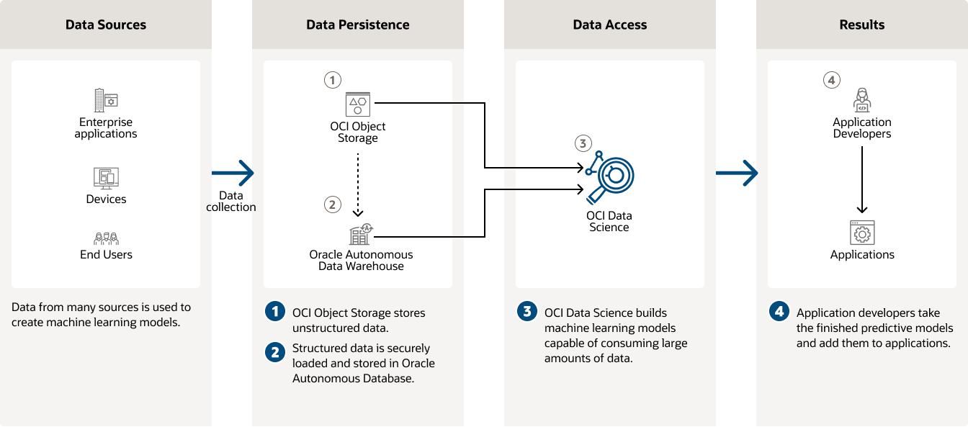

Data Science Prerequisites

Step 1) Create VCN and Subnets
- Create a VCN and subnets using Virtual Cloud Networks Start VCN Wizard VCN with Internet Connectivity option.
- The Networking Quickstart option automatically creates the necessary private subnet with a NAT gateway.

Step 2) Create Dynamic Group
Create a dynamic group with the following matching rule:
ALL { resource.type = 'datasciencenotebooksession' }

Step 3) Create Policies
Create a policy in the root compartment with the following statements:

3.1 Service Policies
allow service datascience to use virtual-network-family in tenancy

3.2. Non-Administrator User Policies

allow group <data-scientists> to use virtual-network-family in tenancy
allow group <data-scientists> to manage data-science-family in tenancy
where <data-scientists> represents the name of user group
3.3 Dynamic Group Policies

allow dynamic-group <dynamic-group> to manage data-science-family in tenancy

where <dynamic-group> represents the name of dynamic group.

Create a Project
Console
- Sign in to a tenancy using the Console with the necessary policies.
- Open the navigation menu and click Analytics & AI. Under Machine Learning, click Data Science.
- Click Create Project.
- Select the compartment to add the project to.
- Enter a unique name (255 character limit) for the project (Optional).
- Enter a description (400 character limit) for the project (Optional).
- Add tags to easily locate and track the resource by selecting a tag namespace, then entering the key and value (Optional). To add more than one tag, click +Additional Tags.
- Tagging describes the various tags that can use to organize and find resources including cost-tracking tags.
- To view the details for the project immediately after creation, select View detail page on clicking create (Optional).

Data Labelling
- Data labeling is the process of identifying properties (labels) of documents, text, and images (records), and annotating (labeling) them with those properties. The topic of a news article, the sentiment of a tweet, the caption of an image, important words spoken in an audio recording, the genre of a video are all examples of a data label.
- Many machine learning techniques require labeled data before they can be used to train machines to complete an autonomous task. Data labeling is thus an integral part of an Artificial Intelligence (AI) or Machine Learning (ML) project. Data Labeling lets to create and browse datasets, view data records (documents, text, and images), and apply labels to build AI/ML models.
- Datasets can be exported as line-delimited JSON for use in machine learning model development. Datasets are accessible and interoperable across other Data and AI services to support supervised training.
- Oracle Cloud Infrastructure Language can be used to create specialized models, but only if labeled data is available for training the model. Data Labeling lets quickly start labeling raw datasets with a minimal number of configuration steps. Thus, it also provides the data labeling experience for Oracle Cloud Infrastructure AI services.

Setting Up Data Labeling
- Set it up, including creating buckets in Object Storage and setting up user policies.
- Create a dataset.
- Generate records in dataset.
- Add labels to documents, images, or pieces of text.
- Export the dataset to Object Storage for use elsewhere.

Dataset

- Datasets are the core resource available in Data Labeling. They consist of data records and their associated labels. Data records represent a document, a single image, or a piece of text. Labels are strings of text, which become annotations when associated with a data record.
- Annotations have other associated data, for example, with object detection, bounding box coordinates. Data records can exist without an annotation. Datasets can be exported as a JSON manifest for use as an input to machine learning model development.

Create a Dataset
Console:
  - On the navigation menu, click Analytics and AI.
  - Click Data Labeling.
  - From the Datasets page in Data Labeling, click Create dataset.
  - In the Add dataset details page, populate the fields as follows:
    - Name
  - Give the dataset a suitable name.

    - Dataset format
  - Click Images, Text, or Documents, depending on whether want to label images, pieces of text, or documents.

    - File type
  - If text as the dataset format, this field is displayed. Select TXT or CSV, depending on whether want to label a text file or a CSV file.

    - Annotation class
  - Select one of the options, Single Label or Multiple Label, for images, text, or documents. Images and text each have a different third option, Object Detection for images and Entity Extraction for text.

  - Click Next.
  - In the Add files page, click Upload local files or Select from Object Storage.
  - In Labels enter the labels to use with dataset. After entering each label, press Return.
  - Click Next.
  - In the Review page, check Dataset details and Files and Labels. If the dataset details need editing, click Edit. If the files and labels details need editing, click Edit.
  - Click Create.
The records are generated when the dataset is created. The dataset state changes to Updating while the records are generated. Only after the records have been created do the files used appear in the dataset details page.
## END ##

