DevOps Overview

Contents

1. Introduction 3
2. DevOps Workflow 4
3. DevOps Concepts 5
4. DevOps Projects 6
5. Environments: 7
6. DevOps Artifacts 7
7. Code Repositories 8
8. Build Pipelines 8
9. Deployment Pipelines 8

Introduction

The Oracle Cloud Infrastructure (OCI) DevOps service is an end-to-end, continuous integration and continuous delivery (CI/CD) platform for developers.
Using this service DevOps engineer can easily build, test, and deploy software and applications on Oracle Cloud. The DevOps build and deployment pipelines reduce change-driven errors and decreases the time customers spend on building and deploying releases. The service also provides private Git repositories to store code and supports connections to external code repositories.
With the DevOps service user can do the following:
- Create private code repositories to store and manage source code.
- Connect to external repositories such as GitHub, GitLab, Bitbucket Cloud, Visual Builder Studio, Bitbucket Server, and GitLab Server.
- Build and test user’s latest changes in a build pipeline with a service-managed build runner.
- Set up a trigger to automatically run your build pipeline from a source code commit or pull request. Optionally run a deployment pipeline on the successful build run for a complete CI/CD automation.
- Orchestrate user’s software deployment across regions to OCI platforms such as Container Engine for Kubernetes (OKE), Compute instances, and Functions.
- Avoid downtime during deployments through the blue-green and canary deployment strategies.
- Automate the complexity of updating applications. Automation reduces the chance of human error that might introduce a security vulnerability.
- Enhance security and reduce risk in delivery. As DevOps enables faster software delivery, security bugs can be resolved quickly by rolling out a fix.

DevOps Workflow
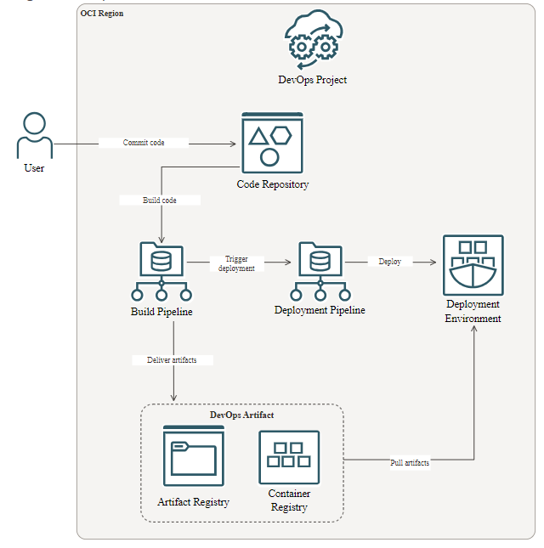

DevOps Concepts
DevOps project:
A logical grouping of DevOps resources needed to implement a CI/CD workflow. DevOps resources can be artifacts, build pipelines, deployment pipelines, external connections, triggers, and environments.
Environment:
A reference to the compute resources to which artifacts are deployed. An environment can be a reference to a Function application, a group of Compute instances, or a Container Engine for Kubernetes (OKE) cluster.
Instance group:
A group of compute hosts. Each instance group can have compute hosts only from one region at a time.
Artifact:
A collection of binaries and deployment manifests that are delivered to the target deployment environment. DevOps artifacts can be a container image, an instance group deployment configuration, a Kubernetes manifest, or a generic artifact. Artifacts can be hosted on OCI repositories: Container Registry and Artifact Registry.
Deployment configuration artefact:
Defines the artifacts to be downloaded to the instance and the location where the artifacts have to be copied. The configuration file also specifies the sequence of commands for deployment.
Code repository:
Private Git repositories hosted by the DevOps service. You can store, manage, and develop source code with the DevOps code repositories.
External connection:
Defines the authorization needed to connect to external repositories. DevOps supports connection to GitHub, GitLab, Bitbucket Cloud, Bitbucket Server, and GitLab Server repositories.
Stage:
A single step in the pipeline. The DevOps service includes predefined stages, which are used in a build or deployment pipeline.
Build pipeline:
Defines a set of stages for the build process: building, testing and compiling software artifacts, delivering artifacts to OCI repositories, and optionally triggering a deployment.
Build specification:
Contains build steps and instructions that are run by the service managed build runner.

Deployment pipeline:
A sequence of steps for deploying a set of artifacts to a target environment. A deployment pipeline contains stages that run sequentially or in parallel.
Rollback:
A way to manage issues identified with the deployment, including releasing a previous successfully deployed version of the software.
Trigger:
A DevOps resource to filter incoming events from a source code repository and trigger an action to start a build run on a matching incoming commit.
Trigger also refers to the deployment pipeline stage to trigger the start of a deployment.
Deployment:
A single run of a deployment pipeline. A deployment contains the state of all the stages running in a deployment pipeline.
Work request:
A way to track an asynchronous running task for a DevOps project.

DevOps Projects
To successfully build and deploy applications by using the DevOps service, first create a DevOps project. A project logically groups the DevOps resources needed to implement a CI/CD workflow.
DevOps resources are:
- Code repositories: In the DevOps service, you can create user’s own private code repositories.
- External connections: You can create a connection to external repositories such as GitHub and GitLab.
- Build pipelines: A build pipeline contains the stages that define the build process for successfully compiling, testing, and running software applications before deployment.
- Artifacts: Artifacts are referenced in a pipeline stage for automated deployment to the target environment. They are used to specify software package versions for deployment.
- Triggers: A build run can be automatically triggered when you commit your changes to a code repository.
- Environments: An environment is the target platform for user’s software.
- Deployment pipelines: A deployment pipeline holds the requirements that must be satisfied to deliver a set of artifacts to the target environment.

Environments:
A DevOps environment is the target platform for software. Create references to different destination environments for DevOps deployment. Before create references to a target environment, user must perform the following tasks:
- Create a target environment supported by DevOps, if it doesn’t exist in the Oracle Cloud Console.
- Supported environments are Container Engine for Kubernetes clusters, compute instances (Oracle Linux and CentOS only), and Function applications.
- Create a DevOps project.
The DevOps service creates references based on the selected target environment. For instructions, see the following topics:
- Creating a Kubernetes Cluster Environment
- Creating a Functions Environment
- Creating a Compute Instance Group Environment

DevOps Artifacts
DevOps artifacts are referenced in a pipeline stage for automated deployment to the target environment. They are used to specify software package versions for deployment. DevOps artifacts can be a container image, a generic artifact, helm chart, or they can be defined inline. The artifact source varies depending on the type of artifact.
Container image repository: Refers to the Oracle Cloud Infrastructure (OCI) Container Registry repository in which Docker images are stored.
Instance group deployment configuration: Refers to the YAML formatted file that is used to manage instance group deployment. The file defines the artifacts to be downloaded to the instance and the location where the artifacts must be copied.
Kubernetes manifest: Refers to the Artifact Registry path, or is defined inline.
General artifact: Refers to any generic software packages to be deployed. See Adding an Artifact in Artifact Registry and Adding an Inline Artifact.
Helm Chart: Refers to the Helm charts that are stored in the OCI Container Registry repository.
Command specification: Refers to a set of custom commands and steps that are run in a deployment pipeline.

Code Repositories
In the DevOps service, user can create their own private code repositories or connect to external code repositories such as GitHub, GitLab, Bitbucket Cloud, Visual Builder Studio, Bitbucket Server, and GitLab Server.
Using this user can,
Create an OCI code repository.
Connect to external code repositories.
Mirror a code repository from GitHub, GitLab, Bitbucket Cloud, or Visual Builder Studio.
Clone a code repository

Build Pipelines
A build pipeline contains the stages that define the build process for successfully compiling, testing, and running software applications before deployment. A stage is an action in the build pipeline. The DevOps service includes the following pre-defined stages that user can use in a build pipeline:
Managed Build: Build and test your software applications.
Deliver Artifacts: Store user’s software applications created from the Managed Build stage in the Oracle Cloud Infrastructure (OCI) Artifact Registry or OCI Container Registry repositories.
Trigger Deployment: Start a deployment pipeline to deploy the output from the build pipeline.
Wait: Pause a specific duration for testing the build pipeline.
User can add multiple stages to a pipeline. Stages can be added in a sequence or in parallel. User can remove any stage from the pipeline. When User do, the stage and its associated resources are deleted.

Deployment Pipelines
A build pipeline contains the stages that define the build process for successfully compiling, testing, and running software applications before deployment. A stage is an action in the build pipeline. The DevOps service includes the following pre-defined stages that user can use in a build pipeline:

Managed Build: Build and test your software applications.
Deliver Artifacts: Store user’s software applications created from the Managed Build stage in the Oracle Cloud Infrastructure (OCI) Artifact Registry or OCI Container Registry repositories.
Trigger Deployment: Start a deployment pipeline to deploy the output from the build pipeline.
Wait: Pause a specific duration for testing the build pipeline.
User can add multiple stages to a pipeline. Stages can be added in a sequence or in parallel. User can remove any stage from the pipeline. When user do, the stage and its associated resources are deleted.

