Oracle Resource Manager

Contents

1. Introduction 3
2. Key features 3
3. Stacks and Jobs 4
• Workflow diagram to deploy the stack 4
• Create Stack 5
• Upload the Artifacts 6
• Plan the Job 8
• Apply the Job 8
• Verify in the Console 9
• Destroy the stack 9
4. Creating a Stack from Bitbucket Cloud 10
5. Creating a Stack from Bitbucket Server 11
6. Creating a Stack from Git 12
7. Creating a Private Template 13
8. Configuration Source Providers 14

Introduction
OCI Resource Manager is a service provided by Oracle Cloud Infrastructure (OCI) that enables to automate the deployment and management of infrastructure resources in OCI. It helps to define, deploy, and manage sets of resources called stacks, which are collections of OCI resources that are created, updated, and deleted together as a single unit.
With OCI Resource Manager, Infrastructure as Code (IaC) used to define the infrastructure resources using Terraform —a popular open-source provisioning tool. Creating a stack by providing a Terraform configuration file that describes the desired state of the infrastructure. Resource Manager then takes care of provisioning and managing those resources in a consistent and controlled manner.

Key features
Stack Lifecycle Management: Resource Manager automates the provisioning and management of stacks throughout their lifecycle. It handles the creation, updating, and deletion of resources based on the provided Terraform configuration.
Plan and Apply Operations: perform a "plan" operation to preview the changes that will be applied to your stack without actually making any modifications. The "apply" operation executes the changes, creating or updating the resources as needed.
Versioning and Rollbacks: Resource Manager tracks the history of stack executions, allowing to view and manage different versions of stack configurations.
Collaboration and Sharing: sharing the stack configurations with others, making it easier to collaborate on infrastructure deployments. Resource Manager provides fine-grained access controls to manage permissions for different users and teams.
Integration with OCI Services: Resource Manager seamlessly integrates with other OCI services, such as Identity and Access Management (IAM), Networking, Compute, and more. This allows you to provision and manage a wide range of resources within your stacks.
Governance and Compliance: Resource Manager helps you enforce governance policies by providing a structured approach to infrastructure deployment. You can define guardrails, validations, and approvals to ensure compliance with organizational standards.

Stacks and Jobs
- OCI Stacks are logical containers that define sets of infrastructure resources. A stack consists of a Terraform configuration file (written in HashiCorp Configuration Language or HCL) that describes the desired state of the infrastructure.
- Stacks enables to define, create, update, and delete resources as a single unit. Stacks are versioned, allowing to track changes over time and roll back to previous versions if needed. multiple stacks can be created to manage different environments or applications within the OCI tenancy.
- OCI Jobs are the execution units for stack operations in OCI Resource Manager. Actions such as creating, updating, or deleting stacks, Resource Manager initiates a job to carry out those actions. Jobs represent the tasks performed on stacks and provide visibility into the progress and status of those tasks.

Workflow diagram to deploy the stack

Below diagram shows how the Terraform Artifact are applied in the OCI. While creating a ORM stack, using terraform deliverables Init, Plan and Apply is the flow to provision the resource in the OCI. We can have the deliverables in any of below.
- GitLab/GitHub Repo
- Bitbucket
- Can be in folder/.zip in the local disk
- Object Storage Bucket
- Can be in compartment
- Oracle provided Template


Create Stack

Go to OCI Console Developer Services Resource Manager Stacks select the compartment Create Stack

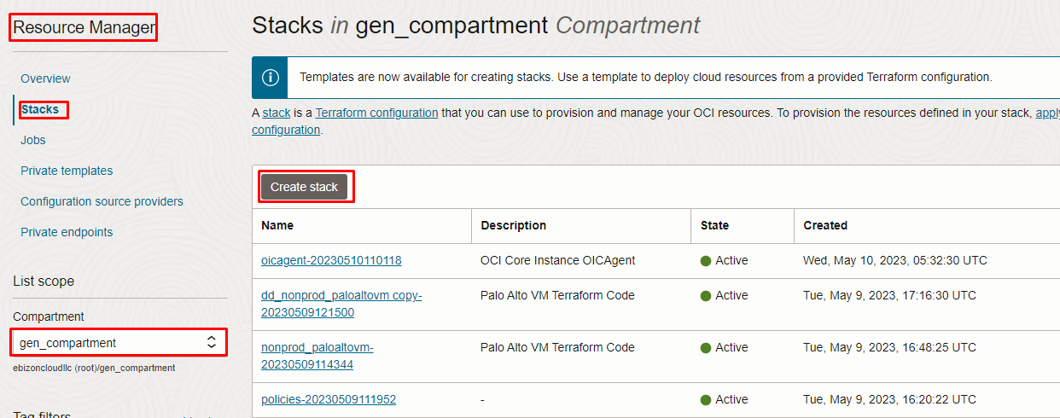

Upload the Artifacts

My Configuration Folder Browse

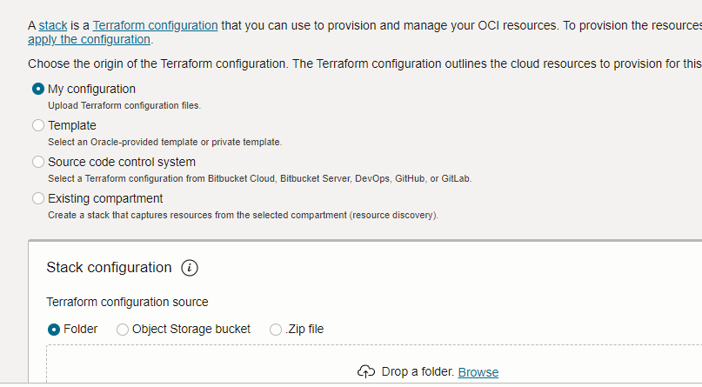

Review the values in the Configure Variables page and click Next

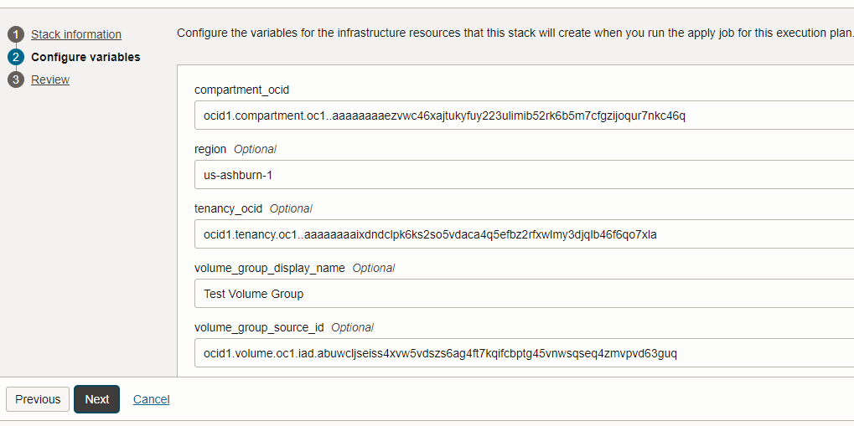

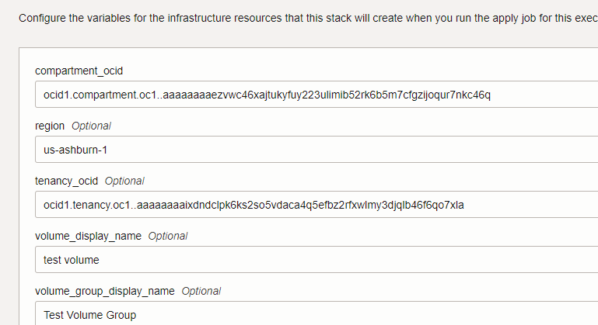
Review

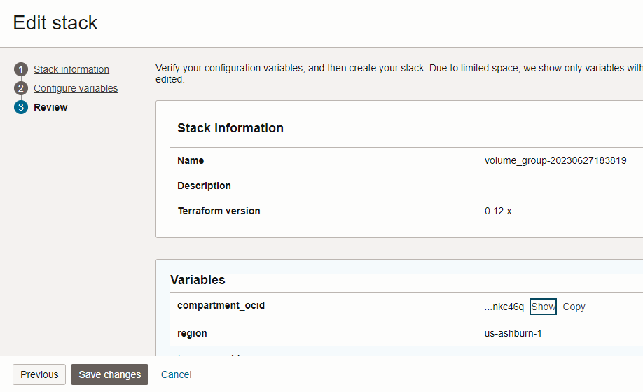
Click save changes and click create

Plan the Job

Click the “Plan”

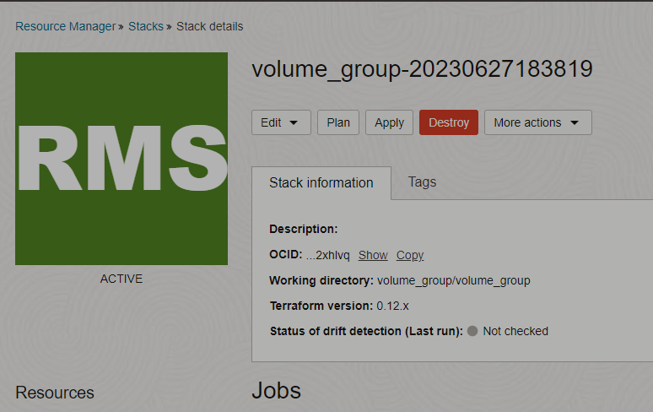

Verify the Plan is successful.

Apply the Job
Once the “plan” is success, now click “Apply”
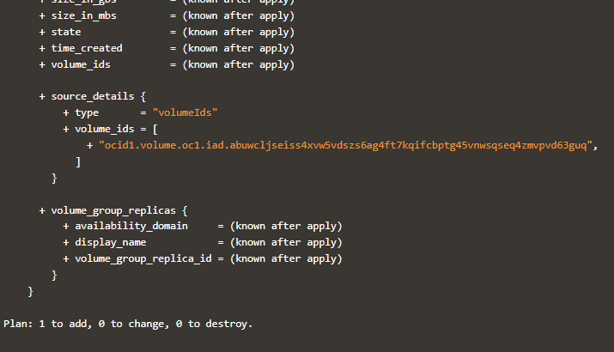

Verify the Apply is successful.
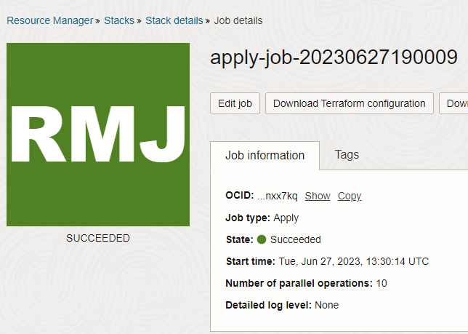

Verify in the Console

Go to OCI Console Storage Volume Group
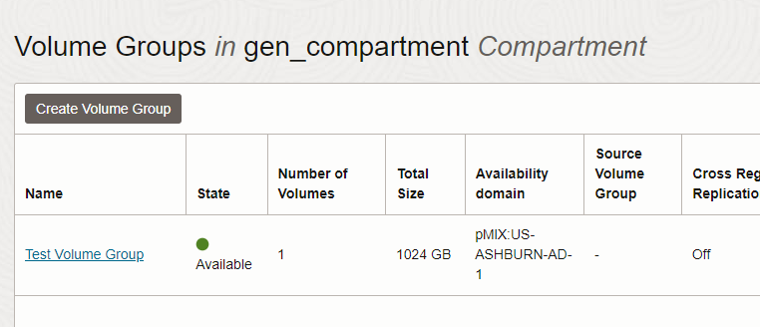

Destroy the stack
Create a destroy job in Resource Manager to release resources associated with a stack and clean up the tenancy. Once destroyed data cannot be recovered from resources

Creating a Stack from Bitbucket Cloud
  - Open the navigation menu and click Developer Services. Under Resource Manager, click Configuration Source Providers.
  - On the Configuration source providers page, select the compartment that contains the configuration source provider.
  - Click the name of the Bitbucket Cloud configuration source provider
  - On the Configuration source provider information page, click Create stack.
The Create stack page opens with the Bitbucket Cloud configuration source provider already selected.
  - Select the Bitbucket Cloud workspace, repository, and branch. The list of branches is limited to 100.
  - (Optional) To use a directory other than the root directory for running Terraform, specify the working directory. This field is visible when the selected branch has directories.
  - (Optional) To use custom providers, select Use custom providers and then select the bucket that contains the custom provider.
  - (Optional) Edit the default stack name and enter a stack description. Avoid entering confidential information.
  - Select the compartment to create the stack.
  - For Terraform version, select the version used by the Terraform configuration.
  - (Optional) Click Show advanced options and assign tags to the stack.
- Tag namespace: To add a defined tag, select an existing namespace. To add a free-from tag, leave the value blank.
- Tag key: To add a defined tag, select an existing tag key. To add a free-form tag, type the key name that you want.
- Tag value: Type the tag value that you want.
- Add tag: Click to add another tag.
  - Click Next.
  - In the Configure variables panel, review the variables listed from the Terraform configuration and change as needed.
  - Click Next.
  - In the Review panel, verify the stack configuration.
  - (Optional) To automatically provision resources on creation of the stack, select Run apply.
  - Click Create.
The stack is created and its Stack details page opens.

Creating a Stack from Bitbucket Server

- Open the navigation menu and click Developer Services. Under Resource Manager, click Configuration Source Providers.
- On the Configuration source providers page, select the compartment that contains the configuration source provider
- Click the name of the Bitbucket Server configuration source provider
- On the Configuration source provider information page, click Create stack.
The Create stack page opens with the Bitbucket Server configuration source provider already selected.
- Select the Bitbucket Server project, repository, and branch. The list of branches is limited to 100.
- (Optional) To use a directory other than the root directory for running Terraform, specify the working directory. This field is visible when the selected branch has directories.
- (Optional) To use custom providers, select Use custom providers and then select the bucket that contains the custom provider.
- (Optional) Edit the default stack name and enter a stack description. Avoid entering confidential information.
- Select the compartment
- For Terraform version, select the version used by the Terraform configuration.
- (Optional) Click Show advanced options and assign tags to the stack.
- Tag namespace: To add a defined tag, select an existing namespace. To add a free-from tag, leave the value blank.
- Tag key: To add a defined tag, select an existing tag key. To add a free-form tag, type the key name that you want.
- Tag value: Type the tag value that you want.
- Add tag: Click to add another tag.
- Click Next.
- In the Configure variables panel, review the variables listed from the Terraform configuration and change as needed.
- Click Next.
- In the Review panel, verify the stack configuration.
- (Optional) To automatically provision resources on creation of the stack, select Run apply.
- Click Create.
The stack is created and its Stack details page opens.

Creating a Stack from Git
- Open the navigation menu and click Developer Services. Under Resource Manager, click Configuration Source Providers.
- On the Configuration source providers page, select the compartment that contains the configuration source provider
- Click the name of the Git configuration source provider
- On the Configuration source provider information page, click Create stack.
The Create stack page opens with the Git configuration source provider already selected.
- Select the Git repository and branch. The list of branches is limited to 100.
- (Optional) To use a directory other than the root directory for running Terraform, specify the working directory. This field is visible when the selected branch has directories.
- (Optional) To use custom providers, select Use custom providers and then select the bucket that contains the custom provider.
- (Optional) Edit the default stack name and enter a stack description. Avoid entering confidential information.
- For Terraform version, select the version used by the Terraform configuration.
- (Optional) Click Show advanced Select the compartment
- options and assign tags to the stack.
- Tag namespace: To add a defined tag, select an existing namespace. To add a free-from tag, leave the value blank.
- Tag key: To add a defined tag, select an existing tag key. To add a free-form tag, type the key name that you want.
- Tag value: Type the tag value that you want.
- Add tag: Click to add another tag.
- Click Next.
- In the Configure variables panel, review the variables listed from the Terraform configuration and change as needed.
- Click Next.
- In the Review panel, verify the stack configuration.
- (Optional) To automatically provision resources on creation of the stack, select Run apply.
- Click Create.
The stack is created and its Stack details page opens.

Creating a Private Template

- Open the navigation menu and click Developer Services. Under Resource Manager, click Private Templates.
- On the Private templates page, select a compartment.
- Click Create private template.
- In the Create private template panel, select the option corresponding to the location of the Terraform configuration (Folder or .Zip file) and then perform one of the following actions to upload the configuration:
- Drag the folder or zip file onto the panel.
- Click Browse and navigate to the location of the folder or zip file.
- Enter a name and optional description for the private template. Avoid entering confidential information.

- (Optional) Enter a detailed description of the private template.
The detailed description is displayed in the Browse templates panel when the template is expanded.
- Click Show advanced options.
- Select the compartment
- A compartment from the list scope is set by default.
- (Optional) Upload an icon to use with the template by performing one of the following actions:
- Drag the icon file onto the panel.
- Click Browse and navigate to the location of the icon file.
The icon is displayed in the Browse templates panel when the template is expanded. A template icon file has the following requirements: PNG format, 50 KB maximum, 110 x 110 pixels.
- (Optional) Click Show advanced options and assign tags to the private template.
- Tag namespace: To add a defined tag, select an existing namespace. To add a free-from tag, leave the value blank.
- Tag key: To add a defined tag, select an existing tag key. To add a free-form tag, type the key name that you want.
- Tag value: Type the tag value that you want.
- Add tag: Click to add another tag.
- Click Create.

Configuration Source Providers

A configuration source provider defines the endpoint information for a source code control system. This integration enables you to achieve continuous integration and continuous delivery (CI/CD) for provisioning your infrastructure. When creating a stack, you can select a configuration source provider and options for the Terraform configuration you want.

#1 Go to Console >> Developer Services >> click Resource Manager

#2 Choose Configuration Source Providers and select Create Configure Source Provider
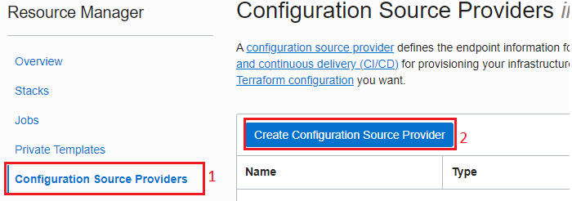
#3 Provide name, optional description and choose the compartment where do you want to create Source Provider
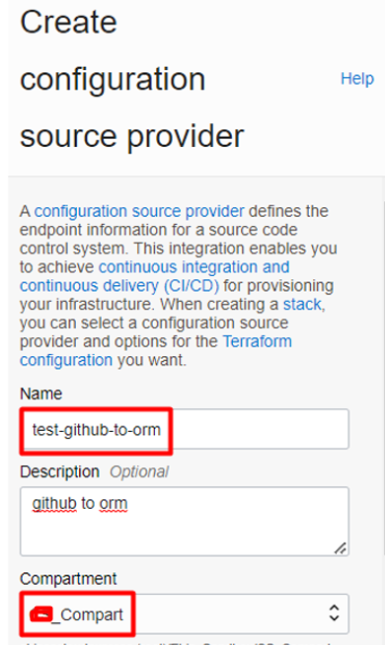
#4 Copy the suitable server URL for your GitHub account.
Example URLs:
Product | Example URL
GitHub Enterprise Cloud | https://github.com/org-name
GitHub Enterprise Server | https://hostname/api/v3
GitHub Free for Organization | https://github.com/org-name
GitHub Free for User Accounts | https://github.com
GitHub team | https://github.com/team-name
GitLab.com product | https://gitlab.com/
GitLab installation (relative URL) | https://example.com/gitlab
GitLab installation (subdomain) | https://gitlab.example.com/

#5 select the Public endpoint and Choose type as GitHub, server URL https://github.com/ (change the URL based on your type of GitHub account) and paste the Personal Access Token created in GitHub.
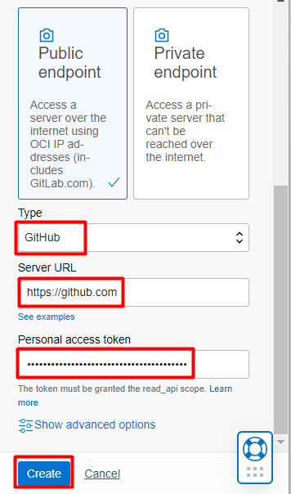

#6 Once it is created, it will be shown in dashboard.
Verify the Connection:

#1 Go to OCI Console ORM Connection Source Providers click the Source provider name
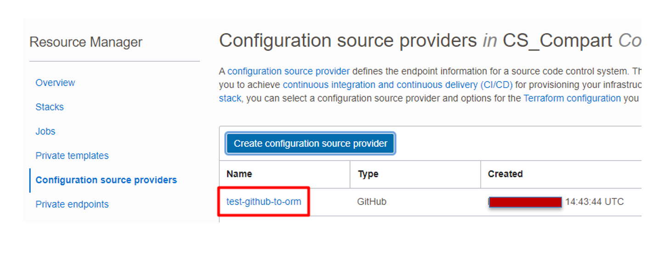
#2 click the “test-github-to-orm” Select the Source Provider to view the details, in details click on Validate connection.
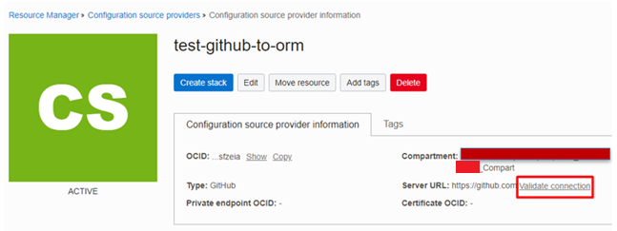
#3 If the connection is succeeded, you will get similar response to below screenshot.
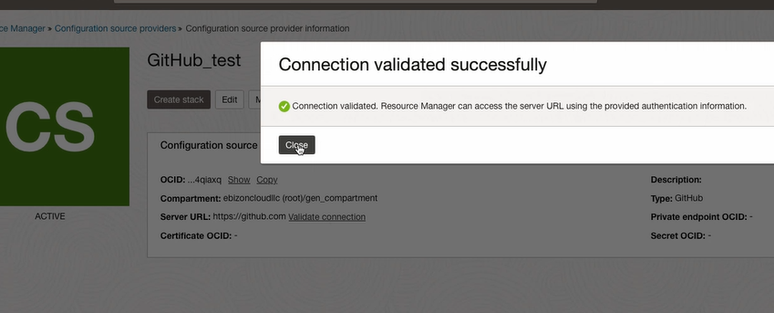

#4 Verify
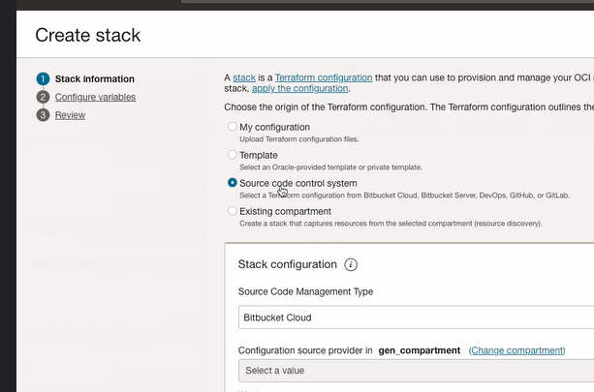
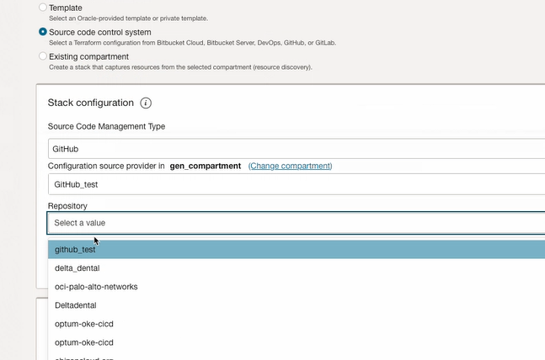

Note: Verify in the dropdown list the Repo is listing or not. If the repo shows in the dropdown list, it means the setup between the OCI and GitHub is successful, else need to troubleshoot.

### END

