Dashboards

Contents
1. Introduction 3
2. Access Dashboards 3
3. Dashboards for Application Performance Monitoring: 3
4.Destroy the Dashboard: 8

1. Introduction
The Console Dashboards service allows to create custom dashboards in the Oracle Cloud Infrastructure Console to monitor resources, diagnostics, and key metrics for the tenancy.
Dashboards gather data from Oracle Cloud Infrastructure (OCI) services to create charts and tables that give a quick view into the resource utilization, billing, and system health. Dashboards are data visualization tools that gather real-time data from the various tiers of an application and display them in charts to help quickly identify outliers and take corrective action either use the Oracle-defined dashboards and widgets for Application Performance Monitoring or create custom dashboards to meet specific requirements.
A dashboard is a collection of widgets. Each widget presents one set of data.
For example, a widget could be a graph showing CPU metrics from the Monitoring service or a bar chart displaying the prevalence of different types of errors. The collection of widgets in a dashboard gives a centralized view of the infrastructure and system health.
Use dashboards to visualize, explore, and analyse application data in easy-to-interpret charts.

2. Access Dashboards

Access the Dashboards page to view Oracle-defined dashboards for Application Performance Monitoring and to create a custom dashboard.
- Sign in to the Oracle Cloud Infrastructure console.
- Open the navigation menu, click Observability & Management. Under Application Performance Monitoring, click Dashboards.
- On the left pane, select a compartment.

3. Dashboards for Application Performance Monitoring:

Dashboards are a critical component to running applications and workloads at scale in the cloud. Using OCI Dashboards, customers can derive insights, observe trends, and diagnose issues, all from a single location in the Oracle Cloud Console

Step 1: This no-cost feature of OCI is easy to find; once log into OCI account, on the homepage, will see a new tab in the top left entitled Dashboard
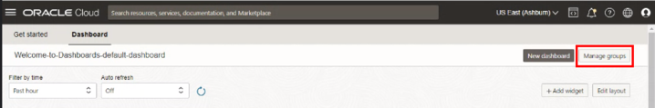

Step 2: Initially land on the Dashboard page, Click on create dashboard group by filling the details like group name, description and compartment and create.
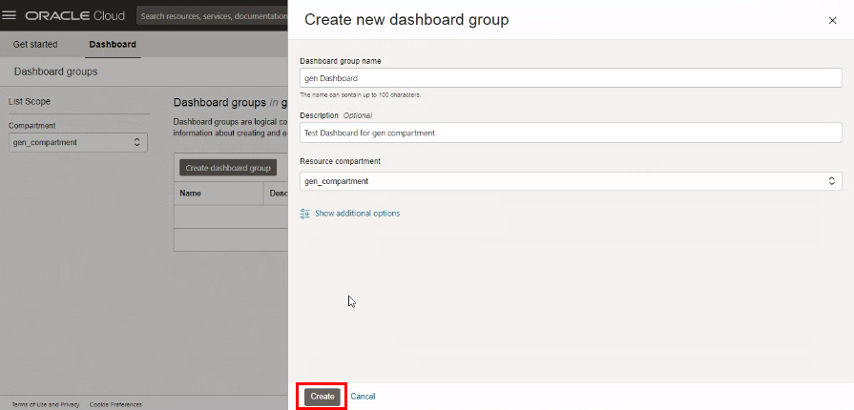

Step 3 : Dashboard group is created
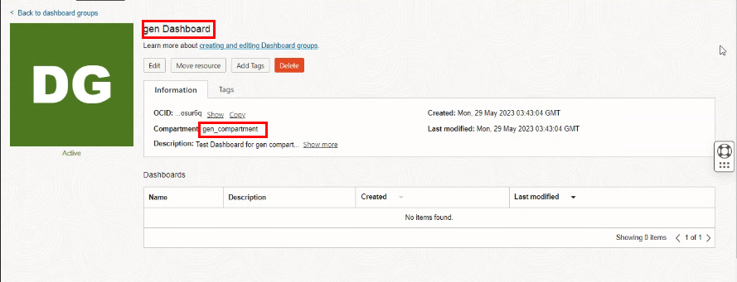
Step 4: After Dashboard group is created, create a dashboard

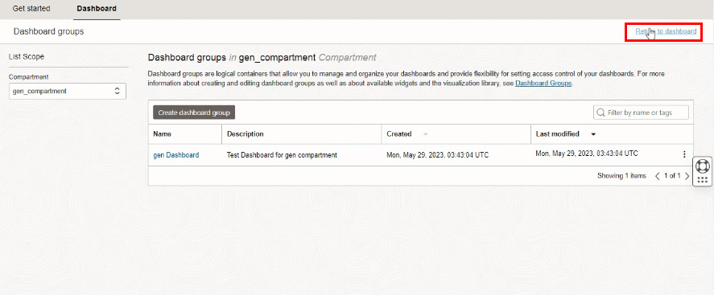
Step 5: Give dashboard a name, place it in a compartment and give a name to the new dashboard group and click the Create button. We now have a blank canvas to start adding widgets

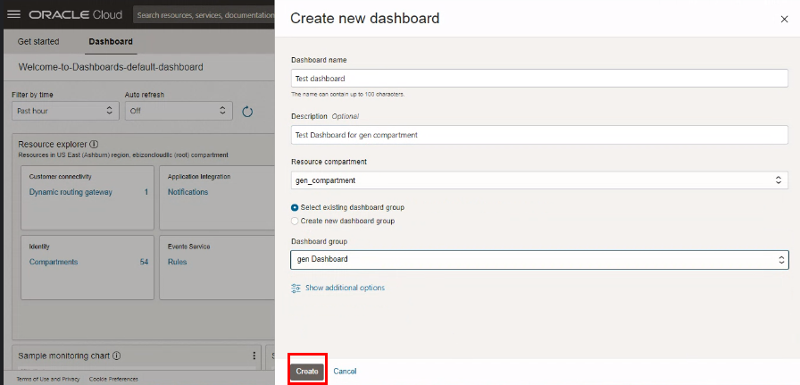
Step 6 : Once the Dashboard is created click on Add widget.
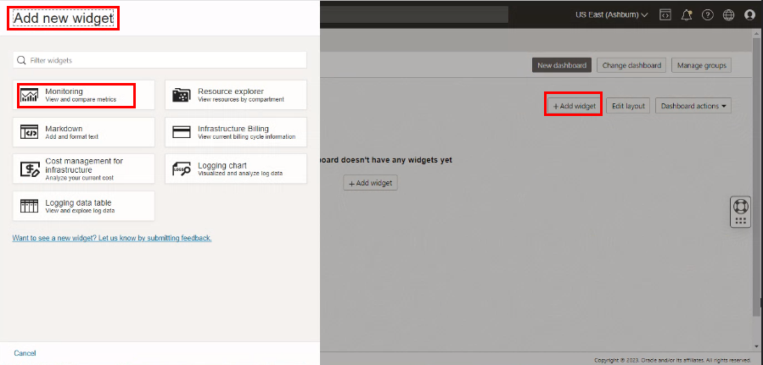
Step 7: Click on Configure
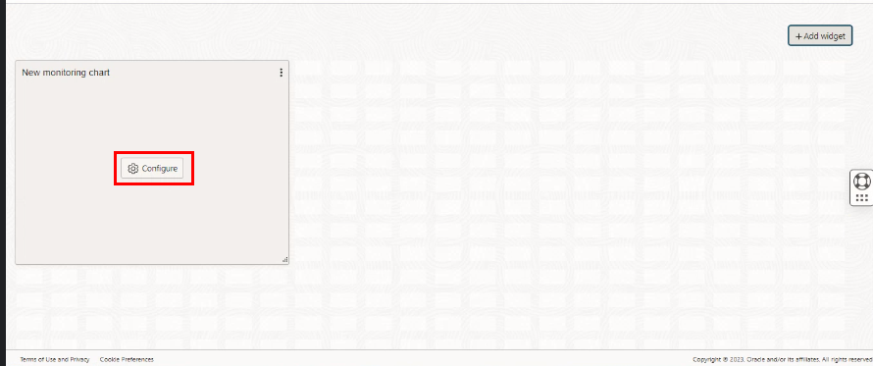

Step 8: Give a name to the widget and using the Monitoring Widget Configuration slider, we start at the top with the Name. Our first metric we can capture is the Object Count of the bucket created. Next, move down to the Configure metric query section and fill in the details and click configure.
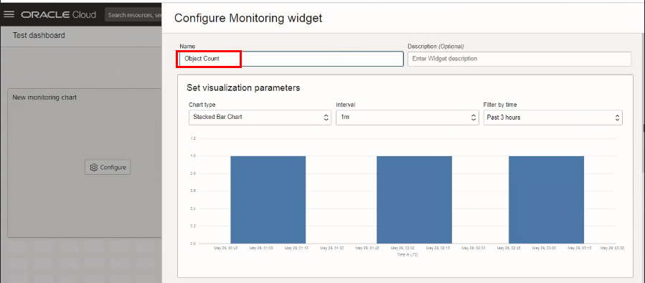
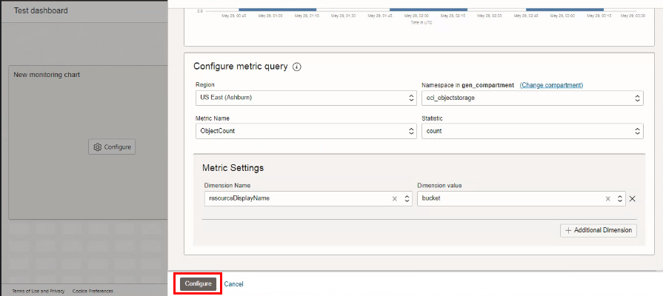
The details of the object storage is displayed in the chart
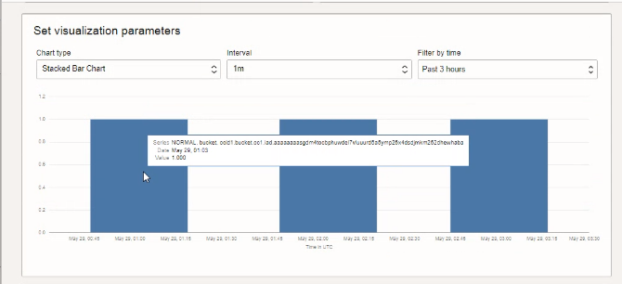
Step 9: Once the Widget is added click on Save. Dashboard is created.
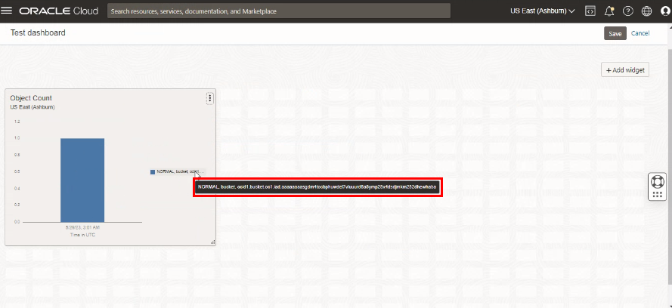
Step10: Check the Dashboard created is added to dashboard group.
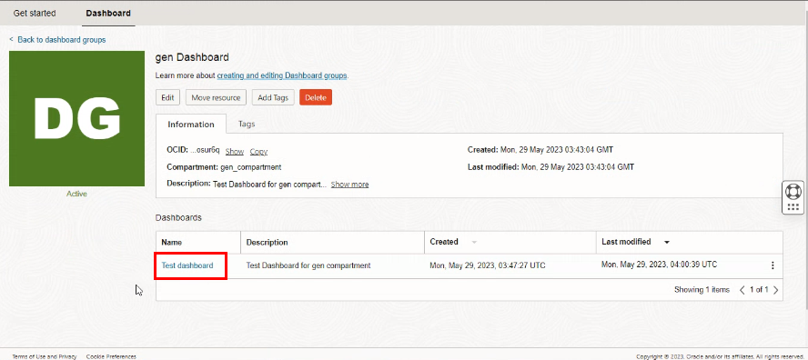

4. Destroy the Dashboard:

First delete the Dashboard created then delete the group.
