Application Performance Monitoring

Contents

1. Overview 3
2. Features of Application Performance Monitoring: 4
3. Prerequisites 4
4. Application Performance Monitoring Policies 5
5. Create an APM Domain 5
6. Create an APM Domain Using the Console 6
7. APM Domain Details 6
8. Trace Explorer 7
9. Synthetic Monitoring 9
10. Application Performance Monitoring Administration 9

Overview

Businesses depend on their applications to deliver core business processes. These dynamics call for proactive steps to ensure that online customers can successfully access information and complete transactions in a timely manner. The Oracle Cloud Infrastructure Application Performance Monitoring service provides deep visibility into the performance of applications and provides the ability to diagnose issues quickly in order to deliver a consistent level of service. This includes the monitoring of the multiple components and application logic spread across clients, third-party services, and back-end computing tiers, on premises or on the cloud.

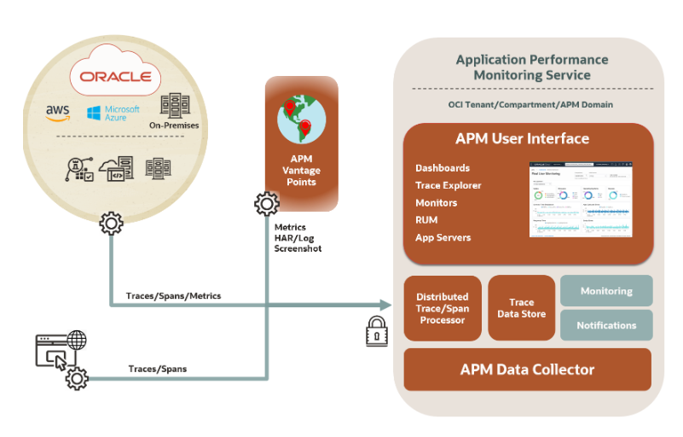

Features of Application Performance Monitoring:

- Distributed Tracing: Collects and processes transaction instance trace data using Application Performance Monitoring data sources, open-source tracers, or directly using API. Distributed Tracing monitors transaction performance, volume, and error rate and notifies you of issues. It analyzes load, usage patterns, performance, and capacity across out-of-the-box and custom dimensions.

- Synthetic Monitoring: Evaluates the availability of the application by testing it periodically from multiple vantage points. This ensures the early detection of availability and systemic performance issues. Synthetic Monitoring also provides deep transaction visibility by correlating monitor execution results to collected traces.

- Real User Monitoring: Provides an insight into the experience of the end user directly from the browser. Real User Monitoring identifies performance degradation by monitoring page load time and user action. It enables complete end-user support by tracking user sessions.

- Server Monitoring: Collects performance and usage metrics from monitored application servers. Server Monitoring provides alerting and charting capabilities by integrating with the Oracle Cloud Infrastructure Monitoring service.

- Use the Oracle-defined dashboards provided with Application Performance Monitoring for a comprehensive view of the performance and availability of the applications and end-user experience in real time.

Prerequisites

Before using the Application Performance Monitoring service, ensure that Oracle Cloud Infrastructure environment is setup correctly to allow communication between the different components and services.
These are the steps to set up Oracle Cloud Infrastructure for Application Performance Monitoring.

Step 1: Create a compartment
Create a new compartment or use an existing one to install and configure the Application Performance Monitoring service.

Step 2: Create users and groups
Application Performance Monitoring users and groups are created using the Identity and Access Management (IAM) service from Oracle Cloud Infrastructure. creating and managing users and groups using the Identity and Access Management (IAM) service.

Step 3: Create policies
Policies allow users and groups to manage the Oracle Cloud Infrastructure resources in a specific compartment.

4. Application Performance Monitoring Policies

Oracle Cloud Infrastructure Application Performance Monitoring service policies allow to grant permissions to work with APM domains (Resource Type: apm-domains). This includes permissions to work with the APM domain work requests, and monitor the systems within the APM domain.
Examples
Here are a few examples of the policies create to provide user groups the permission to use Application Performance Monitoring:
- Allows a user group to list APM domains, work requests, work request errors, and work request logs in APM domains:
- Allow group APM-Users-A to inspect apm-domains in compartment Project-A

- Includes the permissions listed for the inspect verb plus allows a user group to perform tasks such as viewing the details of the APM domains and listing and viewing the details of Synthetic Monitoring scripts and monitors in APM domains:
- Allow group APM-Users-B to read apm-domains in compartment Project-B

5. Create an APM Domain

An APM domain is an Oracle Cloud Infrastructure resource, which contains the systems being monitored by Application Performance Monitoring.
Create an APM domain in a compartment if have the Oracle Cloud Account Administrator role or if the administrator has created a user policy to grant the manage apm-domains permission in the target compartment.create an APM domain in the Oracle Cloud Infrastructure console or using the Oracle Cloud Infrastructure command line interface (CLI).
- APM domain-related tasks are long-running asynchronous operations that result in the generation of work requests.
- A work request is an activity log that tracks each step of an asynchronous operation and enables you to monitor the progress of the task.

6. Create an APM Domain Using the Console

To create an APM domain in the Oracle Cloud Infrastructure console.
- Sign in to the Oracle Cloud Infrastructure console.
- Open the navigation menu, click Observability & Management. Under Application Performance Monitoring, click Administration.
- On the Administration page, in the left pane, select the compartment in which want to create the APM domain.
- On the APM Domains page, click Create APM Domain.
- Enter the required details in the Create APM Domain dialog box:
- Enter a name for the APM domain in the Name field.
- Select the compartment in the Create in Compartment field.
- Enter a description for the APM domain in the Description field.
- Optionally, check the Create as Free Tier Domain check box to create a free domain. If box is left unchecked, the domain will be created as a paid domain.
- Click on the Show Advanced Options if needed to specify tags.
- Click Create.
The APM domain creation request is sent and this begins an asynchronous workflow to fulfill the request. The APM domain is displayed on the APM Domains page, and initially is in the Creating state. After the APM domain is created, the state changes to Active.
Note: The APM domain created is not listed on the page, then must check if the compartment in which created the APM domain is selected in the Compartment field in the left pane.

7. APM Domain Details

On the Domain Details page:
- View APM Domain Information such as APM domain type, the OCID assigned to it, and the Data Upload Endpoint.
- Copy the Data Upload Endpoint for the APM domain to use when configuring data sources such as the APM Java agent and the Browser agent.
- Click Add Tags to use the Tagging metadata system to organize and track the APM domains. For information on Tagging, see Tagging Overview.
- Click Delete to delete the APM domain.
Under Resources, located at the bottom left, see the following items:
- Data Keys
Click Data Keys to view the default Private and Public data keys on the page.
From the Data Keys pane, click Generate Data Key to generate additional Private and Public data keys that can use when configuring data sources. One Private Key (auto_generated_private_datakey) and one Public Key (auto_generated_public_datakey) are automatically generated when a domain is created.
- Work Requests
Click Work Requests to monitor the progress and status of the asynchronous work requests for the APM domain.
- Apdex Thresholds
Click Apdex Thresholds to configure Apdex thresholds for the APM domain.
Use the Apdex thresholds rules created by default in Application Performance Monitoring.
If reporting needs require a different set of Apdex thresholds rules, add or modify the existing ones at any time.
- Span Filters
Click Span Filters to configure span filters that can be used in other APM areas.
Span filters are similar to "saved searches", and provide users with the ability to preserve query conditions that they consider relevant for the respective APM domain. For more information.
- Metric Groups
Click Metric Groups to configure metric groups that allow reporting specified metrics for spans matching the group's filter criteria.
Metric groups are created based on span filters, and provide the ability to push individual or groups of metrics to the Monitoring service for alerting, charting and monitoring purposes.

8. Trace Explorer

Trace Explorer to view traces and spans and identify performance issues and bottlenecks in monitored application, from browser to database.

Application Performance Monitoring includes an implementation of a Distributed Tracing system. It accepts OpenTracing and OpenTelemetry spans, combines them into traces and monitors both traces and individual spans. To enable an application for OpenTracing, each component (JVM, JavaScript, and so on) must be instrumented with a tracer.

Application Performance Monitoring uses various data sources to upload traces and spans. Application Performance Monitoring is also integrated with Oracle Functions and can be enabled to upload and monitor function trace data in Trace Explorer.
how trace data is collected:
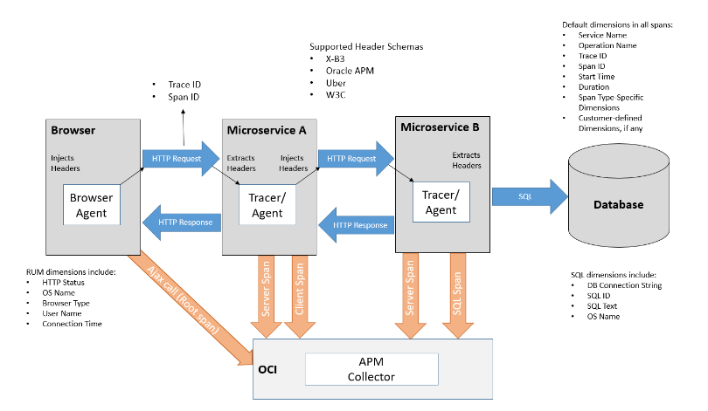

In the diagram:

- The transaction begins with an AJAX call from a Browser and the browser agent injects a trace ID and a span ID for the operation into the HTTP header.
- The next tracer, in Microservice A, extracts the trace ID and span ID, uses the same trace ID and injects a new span ID for the next downstream HTTP call.
- The transaction progresses from one service to another till it reaches the last service, which in this case is a call to the database. Once the call to the database returns, the tracer sends the span data to Application Performance Monitoring. This data includes the trace and span IDs, the duration of the operation, and other dimensions such as the service and operation name, the SQL text and ID, and details specific to the operation.
- As each call returns, the tracers send individual spans for each of the returned calls, containing relevant details about the specific operation that was completed. Eventually, the first AJAX call that initiated the trace is completed, the agent on the browser sends its data as the root span, which marks the trace as complete.
After trace data is uploaded, Trace Explorer enables to explore traces for diagnostics and ensures visibility into all spans in all traces at all times. It provides the use of a simple query language that enables to find, sort, and group spans. use Trace Explorer to:
- Monitor individual traces, view their details, and analyze large sets of traces and spans to identify trends and anomalies.
- Detect slow traces, traces with errors, and those using a specific server or data source.
- Drill down into specific spans, such as page loads and AJAX calls to isolate and identify issues

Use dashboards to monitor application servers and end-user experience in real time.

9. Synthetic Monitoring

Synthetic Monitoring to monitor application or API endpoint and detect potential availability and performance issues before the end user experiences it.
Synthetic Monitoring enables proactive monitoring that helps developers and operators prevent issues before users are impacted. It provides the ability to run scheduled monitors to ensure application availability. Using Synthetic Monitoring, create the following types of monitors, which can run from various geographical locations called vantage points:

- Browser
- Scripted Browser
- REST
- Scripted REST

The Browser and REST monitor types enable the monitoring of a specific URL and the Scripted Browser and Scripted REST monitor types enable to upload a script, which is a recorded user path that is used to simulate user transactions on the application. After creating a monitor, can use Synthetic Monitoring to collect and view metrics, monitor each monitor run, and view an overview of monitor runs in a dashboard.

10. Application Performance Monitoring Administration
Application Performance Monitoring Administration

The Application Performance Monitoring service requires some configuration that can be performed using the Administration menu.When ready, select the I have reviewed and accept these terms and conditions check box, and then click Download File.
Configure APM Domains
After an APM Domain is created, it's displayed on the APM Domains page.
To configure an APM domain, do the following:
• Click on the desired APM Domain name.
The Domain Details page is displayed.
• On the left, you can see the Resources menu with different options.

#END#

