Operations Insights

Contents

1. Overview 3
2. Key features of Operations Insights 3
a. Performance Monitoring 3
b. Log Analytics: 3
c. Configuration and Change Management: 3
d. Incident and Event Management: 3
e. Cost Analysis 3
f. Application Performance Monitoring (APM): 3
2. Capacity Planning: 3
a. Why Capacity Planning? 4
b. Use cases 4
c.Hosts 5
3. Oracle SQL Warehouse 5
4. Exadata Insights 7
a. To access Exadata insights 7
5. ADDM Spotlight 8
a. Database prerequisites 8
6. AWR Hub 9
7. Enterprise Manager (EM) Warehouse 10
a. EM Warehouse Deployment Options 10
b. EM Warehouse Licensing 11
c. Pricing 11
8. Exadata Warehouse 11

1. Overview
Oracle Cloud Infrastructure Operations Insights is an OCI native service that provides holistic insight into database and host resource utilization and capacity. Operations Insights in OCI (Oracle Cloud Infrastructure) is a comprehensive monitoring and analytics solution that provides visibility and actionable insights into the performance, health, and usage of the resources and applications deployed on Oracle Cloud Infrastructure. It offers a centralized platform to monitor, troubleshoot, and optimize the cloud resources.

2. Key features of Operations Insights

a. Performance Monitoring: Operations Insights provides real-time monitoring of the performance metrics of cloud resources, such as compute instances, block volumes, load balancers, and databases. Track CPU utilization, memory usage, network throughput, and other important metrics to identify performance bottlenecks and optimize resource allocation.
b. Log Analytics: This feature allows to collect, analyse, and search logs from various sources, including compute instances, load balancers, and databases. Create custom log sources and apply filters and queries to extract relevant information, troubleshoot issues, and gain insights into system behavior.
c. Configuration and Change Management: Operations Insights helps to track configuration changes made to cloud resources and provides visibility into resource dependencies.
d. Incident and Event Management: The solution provides a unified view of incidents and events across cloud resources. It aggregates alerts from different services and allows to create custom alert rules based on predefined conditions. Notifications are created and set up automated responses, and track the resolution status of incidents.
e. Cost Analysis: Operations Insights offers cost analysis capabilities to help understand and optimize the cloud spending. Track resource utilization, identify cost anomalies, and analyse trends over time. It provides recommendations to optimize resource allocation and reduce costs.
f. Application Performance Monitoring (APM): APM allows monitoring the performance and availability of applications running on OCI. Trace requests, measure response times, and analyse the performance of different components. APM also provides code-level insights, allowing identifying and resolving application performance issues.

2. Capacity Planning:
The Capacity Planning application helps to understand and analyze trends in the utilization of critical database and host resources, such as CPU, storage, or memory. Analyze, compare, and contrast resource usage across multiple databases and hosts. Capacity planning ensures that enterprise databases and hosts have sufficient resources to meet future business needs.
The Capacity Planning application provides with:
- Accurate and agile expense planning and management for core compute resources
- Proactive detection and avoidance of unexpected resource capacity issues
- Deeper understanding of fleet-wide distribution and usage of compute resources
- Insight into database or host-specific trends and patterns of resource usage
Capacity Planning computes forecasts for CPU and Storage on-demand and proactively singles out databases/hosts predicted to have utilization issues within the forecast horizon.
Trend daily and hourly aggregates of resource demand usage upto 25 months over time and project demand into the future for individual databases and hosts or in aggregate.
Identify the under - utilized server for repurposing to reduce operational costs.
View the entire compartmental (or cross-compartmental hierarchy) fleet of databases/hosts and compare the distribution of resources by allocation, utilization, and growth rates.

a. Why Capacity Planning?

Providing sufficient resources is a cloud provider's responsibility. However, as service owners in a cloud-scale environment, we still need to ensure that our application stack doesn't hit scalability limits. Managing scalability limits and efficiently using computing resources on the application level is still highly relevant, even on cloud infrastructure.
Overprovisioning all resources instead of keeping an eye on capacity is highly inefficient. Because infrastructure cost is not zero yet, customers will find underutilized infrastructure quickly consuming the business margin and running out of capacity when application usage suddenly surges.

b. Use cases
Forecast resource requirements
By using the Operations Insights host capacity planning functionality for OCI Compute instances, perform the following analyses:
- Enterprise-wide analysis of resource utilization, capacity planning for OCI Compute instances
- Improve resource utilization by identifying under and over-utilized resources
- Identify systems projected to reach high utilization and deal with spikes in demand that are impossible to plan for ahead of time
- Identify total lead time to expand capacity forecast (via machine learning) based on long-term historic data to project future resource growth
- Track and avoid overspending due to excessive resource usage

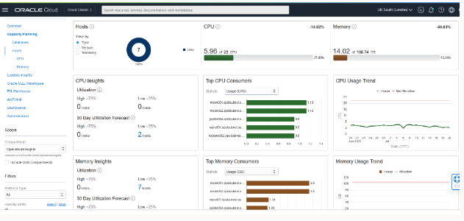

c.Hosts
The same insights can be viewed for host resources as well. Furthermore, hosts can display resource usage by database, or historical top processes running on the host.
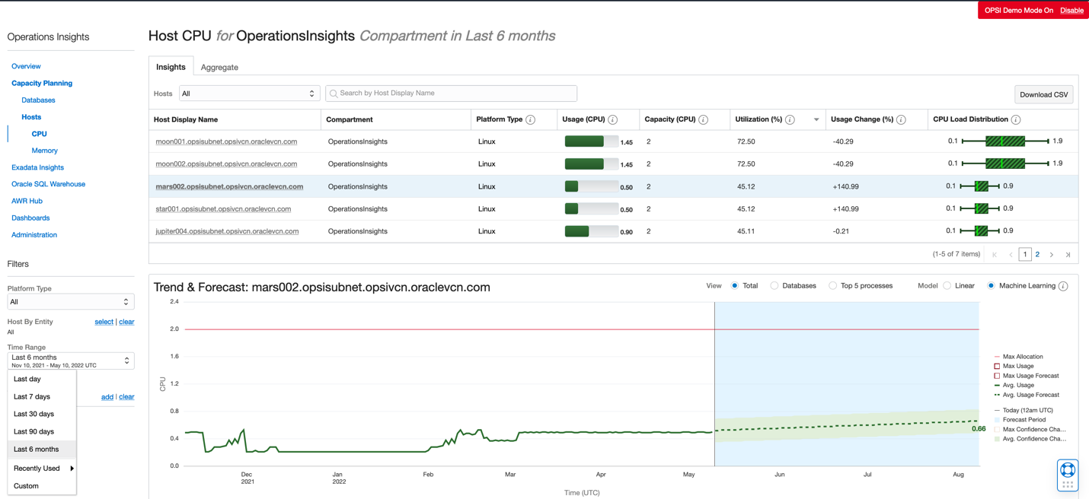

3. Oracle SQL Warehouse
The Oracle SQL Warehouse application makes it easy for you to manage SQL at scale.
Using the Oracle SQL Warehouse application of Operations Insights, analyze the SQL performance problems for enterprise-wide applications across a fleet of databases. In addition, Oracle SQL Warehouse provides trends and key insights to SQL performance issues thereby helping to be proactive in avoiding future problems.
With Oracle SQL Warehouse,
- Collect SQL, execution plan and session data into a long term Oracle SQL Warehouse and store data for 25 months
- Compare SQL execution plan between production, test and development database
- Compare SQL performance trends across databases and drill down to execution plans for analysis
- Identify SQL statements that were good but now turned bad even if the execution plan has not changed
- Auto-detect anomalies by comparing current SQL response time vs. automatic baselines

The Oracle SQL Warehouse enables an administrator to obtain a SQL performance view for the entire fleet in one location. Administrators can see the top resources consuming SQL statements and they are given insights on SQL performance based on variability, efficiency, degradation, and improvement.

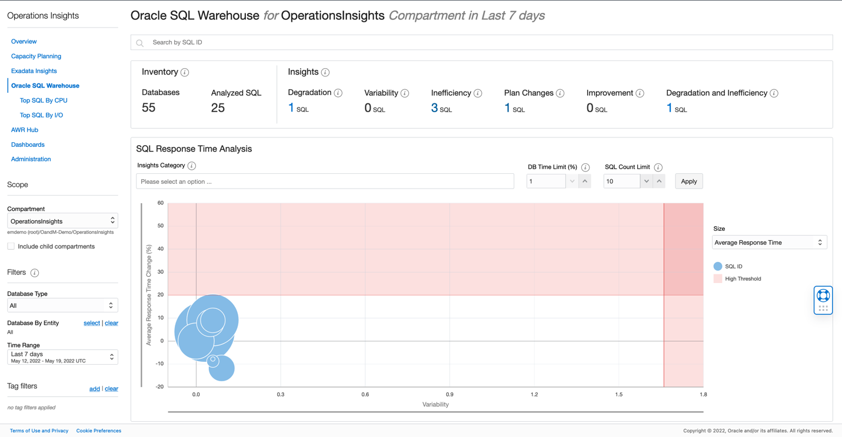
Once a SQL statement has been identified that needs more investigation, a drill down to additional statistics is a single click away.
Additional metrics for the statement are visible on the SQL details landing page. Comparisons can be made between different execution plans of the same SQL statement or how the SQL statement runs on different databases in the fleet.
Additionally, an execution plan can be viewed for the SQL statement with a toggle between hash plan values.
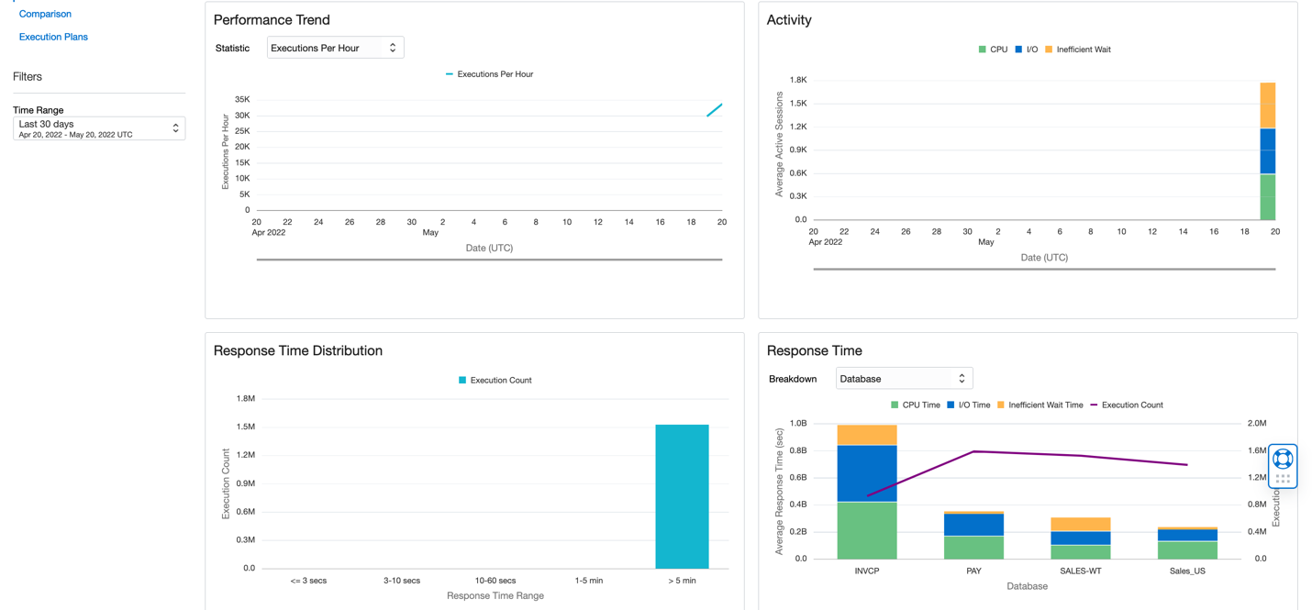

4. Exadata Insights

Exadata Insights analyze the resource utilization of Exadata systems (Database Machines, Cloud Service, and Cloud Customer), and identify the spare capacity for new workloads. This gives view of all Exadata systems across enterprise to help optimize capacity based on proactive planning, and drive database consolidation use cases.
With Exadata Insights,
Analyze resource usage of databases/hosts across the enterprise
Forecast future demand for resources based on historical trends
Compare SQL performance across databases and identify common patterns
Identify SQL performance trends across enterprise-wide databases

a. To access Exadata insights
Step 1: To get a unified view of enterprise-wide resource utilization and performance of Exadata Database Machine systems from the Operations Insights main menu, click Exadata Insights to display the fleet-wide Exadata System Capacity Planning dashboard.
- The Exadata System Capacity Planning dashboard, views the global Exadata System Inventory, resource utilization by CPU, Exadata Storage, Memory, and Input/Output Per Second (IOPS) for all Exadata Systems.

- Compare current and forecasted resource usage between Exadata Systems, and identify which systems could potentially run into problems due to current high utilization, or may run into problems in the future per forecasted high utilization.

- The Current Utilization and Forecast for Exadata Systems table provides a quick view into which systems need immediate attention.

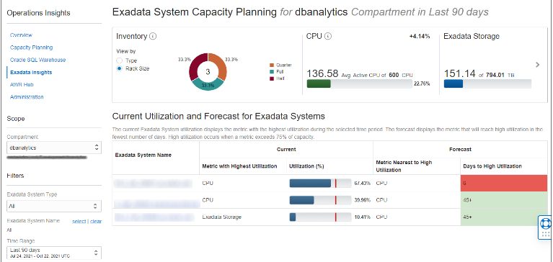

5. ADDM Spotlight

Automatic Database Diagnostic Monitor (ADDM) is an expert system that analyses data captured in the Automatic Workload Repository (AWR) snapshots to review performance analysis.
Operations Insights harvests ADDM data from source databases and highlights these findings and recommendations. Operations insights harvests and stores ADDM data for a duration longer than the event itself, providing with the ability to analyze ADDM findings and recommendations for a collection of events into the past which may no longer exist in the source database.
Supported Versions
ADDM Spotlight supports Virtual Machine, Bare Metal, databases managed by Management Agent, and non PDB databases version 18c and above.
ADDM task results for supported database versions including Oracle Base databases (VM, BM), databases on Exadata Database Service on Dedicated Infrastructure, and databases enabled for Operations Insights via the OCI Management Agent.

a. Database prerequisites

The following is a list of prerequisites required for different database types in order for ADDM Spotlight to collect and present data.

PDB: A one time set of steps need be performed in order to enable ADDM Spotlight in PDBs, these steps do not require a database restart. Log in to the PDB to be enabled as SYS and execute the following statements:

alter session set container=<container_name>;
alter system set awr_pdb_autoflush_enabled=true;
exec dbms_workload_repository.modify_snapshot_settings(interval=>60);
Virtual Machine, Bare Metal, ExaDB-D databases, and Management Agent managed databases: If dbsnmp database user is used to collect the data then no additional steps are required. If any other database user is used to collect the data then log in to the databases to be enabled as SYS and add the following grant to the database user used to collect the data:
If using a common database user (shared between the CDB and PDBs) is being used for monitoring, run the following from the root container:
grant select any dictionary to <dbuser> CONTAINER=ALL
If using a non-common user:
grant select any dictionary to <dbuser>

6. AWR Hub

The AWR Hub collects AWR (Automatic Workload Repository) snapshots from multiple Oracle Autonomous Databases and provides a central location for snapshots. The AWR Hub is a schema in the Operations Insights Warehouse and the data is stored for 25 months.
The Oracle Database Automatic Workload Repository (AWR) collects, processes, and maintains performance statistics for the database that can later be displayed in both reports and views. A built-in AWR repository that exists in every Oracle Database stores this data. AWR data contains important performance statistics about the Oracle Database and can be used for Oracle Database performance, diagnostics, and tuning.
To handle AWR data from multiple databases, Operations Insights provides AWR Hub, a cloud-based repository that collects and consolidates AWR snapshots from multiple databases in OCI tenancy.
The AWR Hub provides a repository to easily generate reports for Operations Insights databases. Up to 25 months of AWR reports can be accessed for the entire fleet in a single location.
With AWR Hub:
- Track and analyze SQL plan changes for workloads within a single database
- Track and analyze SQL plan changes for workloads across multiple databases
- Understand past and present workload (SQL) performance over a period of two years or above.
- Build custom dashboards to plot SQL performance statistics, database waits, CPU usage history, connections established, etc.

AWR Hub configuration steps

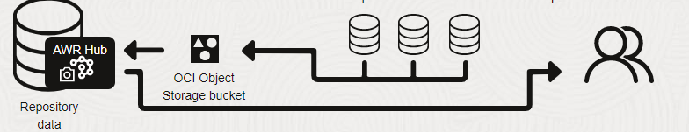

step1. Create Warehouse and AWR
Step 2. Associate bucket with AWR
Step 3. Configure source databases to send AWR snapshots to AWR Hub
Step 4. Create database users, download wallet, and provide access to AWR Hub

7. Enterprise Manager (EM) Warehouse

Oracle Enterprise Manager (EM) provides a single solution to manage all of Oracle deployments, both in data center and in Oracle Cloud. EM Warehouse provides a convenient way to access and analyze this data using cloud-based tools and services.
The EM repository contains critical information such as operational, performance and configuration metrics, and target inventory data for the targets monitored by Enterprise Manager.
EM Warehouse provides easy access to the wealth of information stored in the repository and allows to use preferred analytics tools to analyze the data. use tools such as:
- Jupyter Notebooks
- SQL Queries
- Oracle Analytics Cloud

a. EM Warehouse Deployment Options
There are two options for deploying EM Warehouse that take different approaches to storing EM data and that provide with different data analysis options.
Option 1
Enterprise Manager data is loaded into OCI Object Store. With this option, use the published Jupyter Notebooks, or build own analytics on top of the data in OCI Object Store
Option 2
Enterprise Manager data is loaded into an Autonomous Data Warehouse (ADW) in OCI's Operations Insights service. With this option, write own SQL scripts, applications, Jupyter Notebooks or use Oracle Analytics Cloud for further analysis of the data.
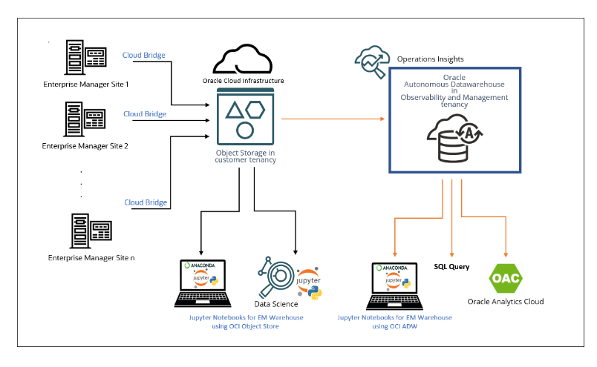
EM repository data is uploaded via Cloud Bridge to an OCI Object Storage Bucket in tenancy. From there, data is transferred via EM Bridge to an Operations Insights Warehouse. EM Warehouse is a schema within the Operations Insights Autonomous Data Warehouse.

b. EM Warehouse Licensing

The use of Enterprise Manager Warehouse (EM Warehouse) features requires an OCI Operations Insights Service subscription.

c. Pricing

The use of Enterprise Manager Warehouse (EM Warehouse) features requires an OCI Operations Insights Service license subscription .
- Oracle Cloud Infrastructure Operations Insights for Warehouse - Extract - Gigabyte Per Month- Oracle Cloud
- Infrastructure Operations Insights for Warehouse - Instance - OCPU Per Hour

8. Exadata Warehouse

The Exadata Warehouse is a central repository for fine-grained Exadata metrics and automatically generated forecasts. It can store data from engineered systems monitored by multiple Enterprise Manager instances, including Exadata, Recovery Appliance, and Oracle Exadata Database Service.

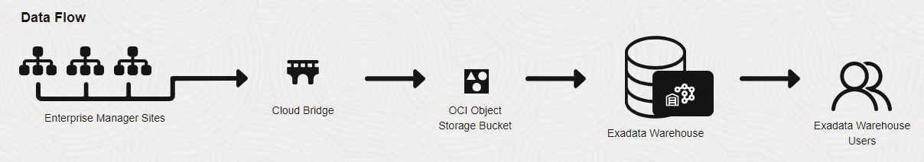

Configuration Steps
1. Provision Autonomous Data Warehouse (ADW) in OCI
2. Create an analytics user/schema in the ADW
3. Create a Cloud Bridge in Enterprise Manager and associate with Object Storage bucket
4. Create the Exadata Warehouse service to associate the Cloud Bridge with the ADW
5. Start the OCI Service data export

Fine-grained data from Exadata components, like storage servers and compute servers, are uploaded to an Autonomous Database. The Exadata Warehouse generates periodic forecasts based on historical data, which are available for queries and export. Older forecast data points are retained for easy comparison.
The Exadata Warehouse resides in an Autonomous Database that specify, the data uploaded to the Exadata Warehouse can be accessed even after data uploads for the Exadata systems have been paused or terminated.
With the introduction of Exadata Warehouse, resource utilization of the Exadata systems can be analyzed to identify spare capacity for new workloads.. The use of Exadata Warehouse features requires OCI Operations Insights service license subscription.
Oracle EM allows Operations Insights' Exadata Warehouse to easily utilize target-level data managed by EM. EM enables the transfer of data from EM targets and Oracle Management Repository (OMR) to OCI Object Storage, where it is easily accessed by one or more cloud-native services such as Operations Insights and Logging Analytics.

#END#

