Roving Edge Infrastructure

Contents

1.Introduction 3
2.Pre-request: 4
3. Use Cases 4
4. Device Options 5
5.Oracle Cloud Infrastructure Requirements 5
6. Best Practice: Tagging Resources 5
7. Pricing and Support 6

1.Introduction

Oracle Roving Edge Infrastructure is a cloud-integrated service that puts fundamental Oracle Cloud Infrastructure services where data is generated and consumed. Roving Edge Infrastructure devices provide high-performance computing, such as analytics, machine learning, and location-based services, and storage capabilities that operate with intermittent or no internet connectivity.
Roving Edge Infrastructure is the extension of your Oracle Cloud Infrastructure tenancy. You request to have virtual machines and objects from your tenancy loaded onto Oracle Cloud Infrastructure devices and device clusters by creating and configuring Oracle Cloud Infrastructure device node or cluster resources in Oracle Cloud Infrastructure. These nodes and clusters function as requests for the corresponding devices, and also indicate what Oracle Cloud Infrastructure-based content is to be pre-loaded, or provisioned, on them. You can synchronize your object storage datasets with your Oracle Cloud Infrastructure tenancy after establishing an internet connection between the RED and your home OCI region.

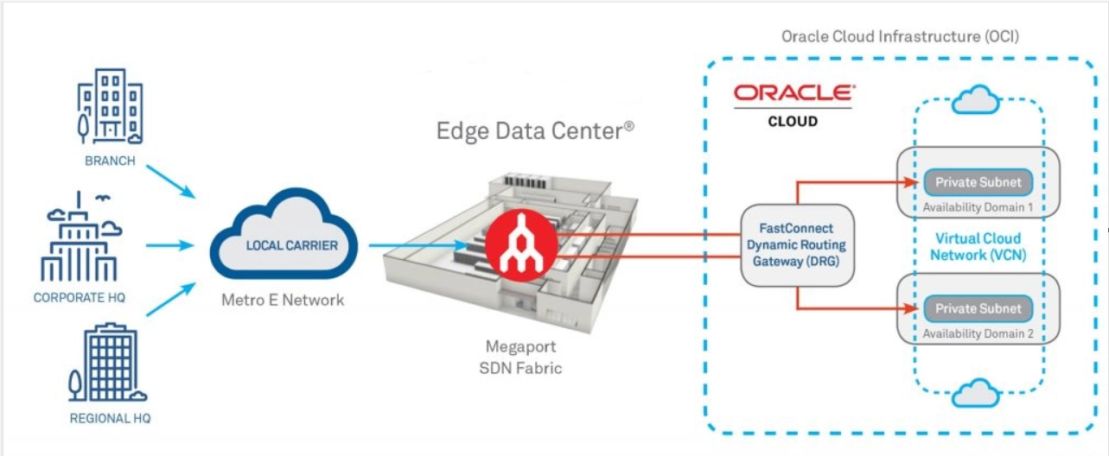

2.Pre-request:

- Experience and understanding of Oracle Cloud Infrastructure services and features. Be comfortable creating and managing service resources such as compute instances, object storage buckets, and Identity and Access Management (IAM) tasks before ordering REDs.

- Expertise in hardware device integration, including cabling and switching. If you are integrating a cluster of REDs, you need a Layer 2 switch and an administrator who understands how to set up a Layer 2 network for the cluster.

3. Use Cases

- Storage and processing of large volumes of images, video, audio, and internet of things (IoT) sensor data generated in environments where WAN connection is latent or unavailable. You can pre-process, filter, compress, and secure the data locally, then transfer it to Oracle Cloud Infrastructure where it can be further processed in the cloud.

- Compute and IO intensive applications, where low latency is paramount, such as tactical reconnaissance or 5G communications.

- Machine learning, where models trained in the cloud are running in disconnected locations to improve efficiency, intelligence and productivity.
- Remote computing requiring elevated security and airtight containment of data.

- Low-latency Oracle Database and Analytics workloads, with more Oracle applications optimized over time.

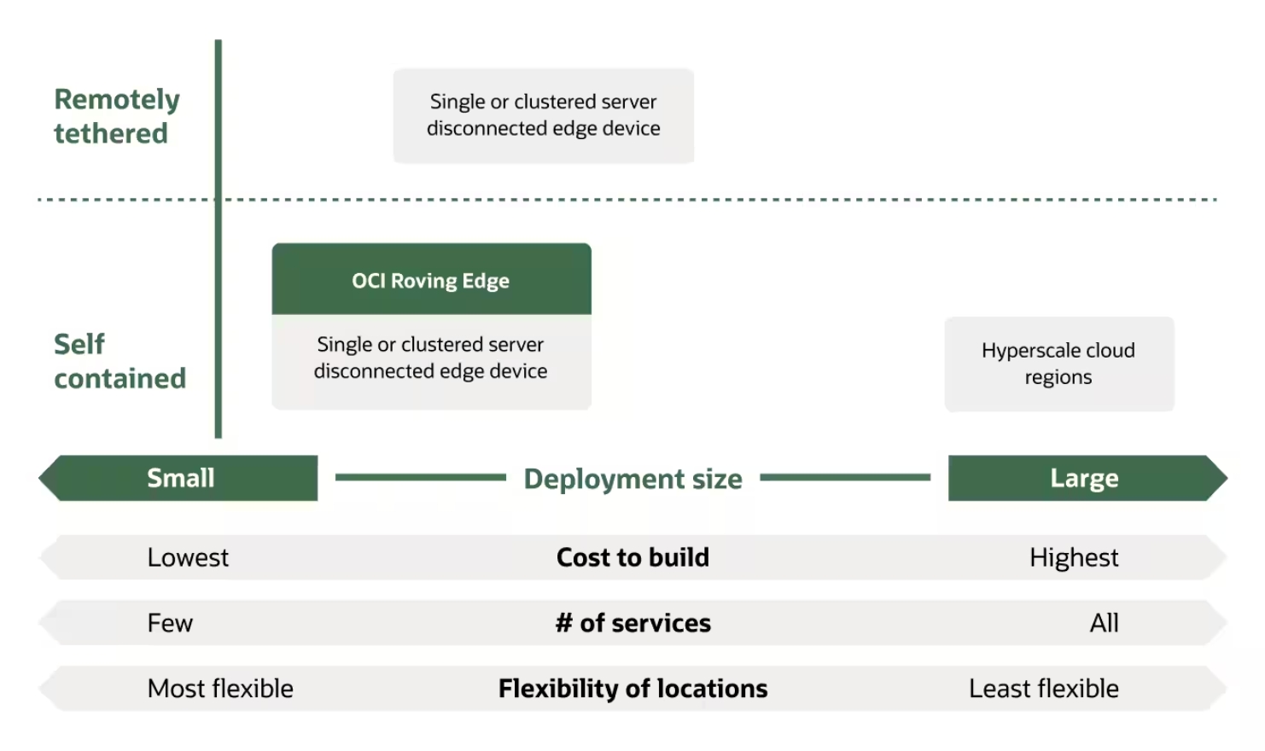

4. Device Options

The physical component is the Roving Edge Infrastructure device, which allows you to transport and establish your Oracle Cloud Infrastructure environment where you need it. Roving Edge Infrastructure device options consist of the following:
- Roving Edge device (RED): A portable high-powered server that has been ruggedized to operate in remote and austere environments. These devices are highly portable and can be set up and taken down as needed.

- Roving Edge Ultra (Ultra): A single device contained in a backpack-like transporter that an individual can carry. Ultra does not require a separate power source. A single person can operate Ultra in a remote or difficult environment where establishment of REDs and clusters is not feasible. Ultra has less storage and computing capabilities than a RED.

- Standalone cluster: A group of 5 REDs connected with a Layer 2 switch working together in the same environment or network.

The Roving Edge Infrastructure devices arrive preconfigured and ready for use. Just power the devices up, configure the network settings, and connect to your local network. You can synchronize object storage data between your Roving Edge Infrastructure devices and your Oracle Cloud Infrastructure tenancy.

5.Oracle Cloud Infrastructure Requirements
Before you can order and set up REDs within your environment, you must perform the following prerequisite tasks:
- Establish an existing Oracle Cloud Infrastructure tenancy.

- Determine what Oracle Cloud Infrastructure-based workloads (buckets and images) you want to be installed on the REDs.

- Determine whether you need a single RED, a Roving Edge Ultra, or a standalone cluster of 5 REDs to meet your needs.

6. Best Practice: Tagging Resources
Apply tags to your Roving Edge Infrastructure resources to help organize them according to your business needs. You can apply tags at the time you create a resource, or you can update the resource later with the wanted tags.

7. Pricing and Support

Oracle provides various methods to assist you in using its products. Open a Support Ticket for more information on pricing and setting up the Roving Edge Infrastructure.

Roving Edge Infrastructure Developer and User Guide can be found in the below link.
Roving Edge Infrastructure Developer and User Guide

