Dedicated_Region_Cloud_at_Customer

Contents

1.Introduction 3
2.Pre-request: 3
3. Self-contained cloud region 4
4.Benefits of OCI Dedicated Region 5
5.Security First 6
6. OCI Dedicated Region use cases 6
7. Pricing for OCI Dedicated Region 7
8. Support 7

1.Introduction

Oracle Cloud Infrastructure (OCI) Dedicated Region brings all of OCI’s public cloud benefits and services (IaaS/PaaS/SaaS) on-prem. Avoid the challenges of building your own cloud by using Oracle cloud experts to install, manage, and support a cloud region with in your data center.Start small then scale on demand as your workloads grow without having to invest in idle resources ahead of time. Operating on-prem, OCI Dedicated Region allows you to retain full control of your data and applications to meet the highest security, regulatory, and data residency requirements. OCI Dedicated Region provides the elasticity and utility of a public cloud with the granular control, security, and predictability of an on-prem infrastructure.

2.Pre-request:

- Business Relationship: You should establish a business relationship with Oracle to initiate the Dedicated Region request. This typically involves engaging with an Oracle sales representative or contacting the Oracle sales team.

- Use Case Evaluation: Oracle will assess your use case and requirements to determine if a Dedicated Region is suitable for your organization. Dedicated Regions are designed for customers with significant cloud workloads, strict data residency requirements, and specialized needs.

- Contractual Agreements: You will need to negotiate and sign a contractual agreement with Oracle that outlines the terms and conditions of the Dedicated Region deployment. This agreement will cover aspects such as service-level agreements (SLAs), pricing, and support.

- Financial Commitment: Dedicated Regions typically involve a significant financial commitment due to their dedicated nature and the associated infrastructure costs. You should be prepared for a long-term commitment and budget accordingly.

- Geographic Considerations: Determine the geographic location where you require the Dedicated Region to be deployed. OCI Dedicated Regions are currently available in select regions globally, and you should choose the one that best aligns with your business requirements.

- Technical Requirements: Clearly define your technical requirements and specifications for the Dedicated Region. Consider factors such as compute, storage, networking, security, and any specific compliance or regulatory requirements applicable to your industry.

- Network Connectivity: Ensure that you have appropriate network connectivity to the Dedicated Region. Oracle provides options for direct private connectivity (such as FastConnect or VPN) to connect your on-premises or data center infrastructure with the Dedicated Region.

- Resource Planning: Plan your resource allocation and capacity requirements for the Dedicated Region. This includes estimating the number of compute instances, storage capacity, network bandwidth, and other resources needed to support your workload.

- Support and Operations: Define your support and operations strategy for the Dedicated Region. Determine whether you will manage the infrastructure yourself or require assistance from Oracle's Managed Services team. Consider factors such as monitoring, patching, backups, and disaster recovery.

3. Self-contained cloud region
Dedicated Region provides all Oracle Cloud Infrastructure’s public cloud services in a self-contained, independent cloud region in a physical location of the customer's choosing. Customers can start small and scale fast (up to more than 450 racks) while retaining full control of their data and services to meet the highest security, regulatory, and data residency requirements. Oracle will install, operate, support, and upgrade each OCI Dedicated Region in the same way we maintain OCI public cloud regions worldwide.

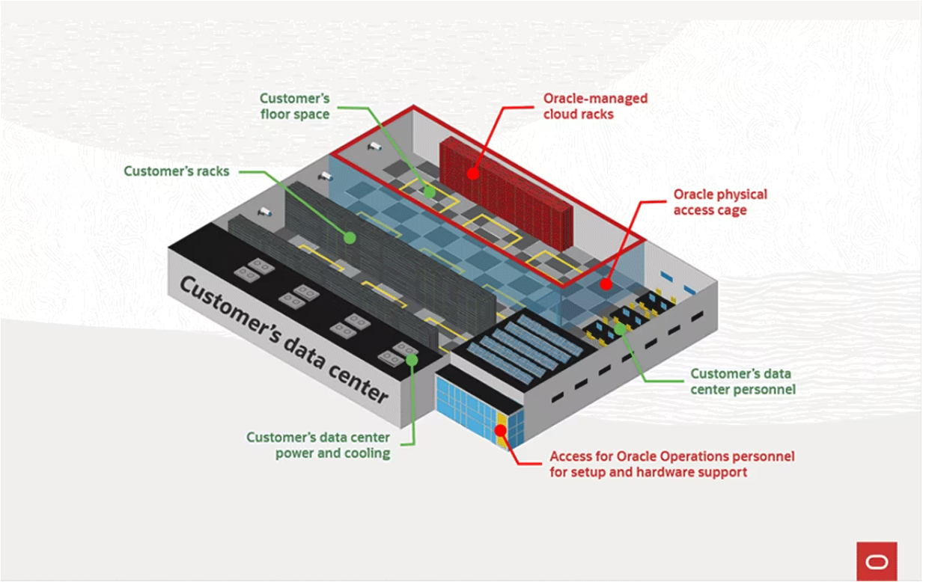

4.Benefits of OCI Dedicated Region

- Identical to OCI Public Cloud

- Start Small, Scale on Demand

- Global Experts Managing Infrastructure

- Meet Data Privacy & Residency Requirements

- Superior Economics

- Single-Digit Millisecond Latencies

- Modernize Enterprise Systems

- Avoid Challenges of Building a Cloud

5.Security First

OCI Dedicated Region provides hardened physical and perimeter network security while enhancing the security of the platform, data, and applications with Oracle security controls and services. OCI Dedicated Region uses the same defense-in-depth architecture approach as OCI, combined with layered security controls.

- The data center is physically secured by restricted access with multiple levels of authorization, clean hardware, and firmware.

- Infrastructure is secured via a management network that’s isolated from the customer’s network, tenants, and compartments.

- Applications are safeguarded by Oracle Cloud Infrastructure Web Application Firewall, Identity and Access Management, Vault, Cloud Guard, and more.

- Data is secured at rest and in motion via AES 256-bit and AES 128 TDE encryption, TLS 1.2, and FIPS 140-2 Level 3–certified hardware for key storage services.

- Observability is performed via security automation, audit logs, Oracle Cloud Infrastructure Monitoring and Reporting, and SIEM monitoring 24/7/365.

- Benefit from zero-downtime patching and OS management—access new security updates as Oracle makes them available in public cloud regions.
- At no additional cost, Oracle certifies services running on OCI Dedicated Region for CSA STAR, SOC 1, SOC 2, SOC 3, ISO 27001, ISO 27017, and ISO 27018; and conducts semi-annual audits.

6. OCI Dedicated Region use cases

Data residency

Meet your governance, regulatory compliance, and data privacy requirements while experiencing the benefits of the public cloud in your own data centres. Enable applications and data to remain on-premises and adhere to data residency requirements.

Low-latency applications
Run latency-sensitive applications in a fully managed, on-premises cloud region. Generate real-time responses to end user applications or communicate with other on-premises systems. Deploy banking applications, payment processing, and risk management services to customers and financial clients from in-country locations to meet data locality requirements.

Modernization of infrastructure and apps
Consolidate legacy apps on high performance cloud infrastructure managed by Oracle. Modernize applications and build cloud native applications with a consistent platform across the public cloud and your data center.

7. Pricing for OCI Dedicated Region

The pricing for OCI Dedicated Region is the same as Oracle public cloud regions. You only pay for services you consume with the same predictable low pricing. You can continue to use all existing Oracle tools like budgets, cost analysis, invoices, and usage reports to monitor and audit usage of the OCI Dedicated Region. Pricing for Oracle public cloud regions are located here: https://www.oracle.com/cloud/pricing/

8. Support

You can continue to use existing tools like the OCI console, SDKs, and APIs to request technical support. Please note that for any physical maintenance, Oracle will schedule a time and require access to your physical facilities. For an additional fee, you may also purchase 24x7 on-site support where an Oracle representative is available to rapidly troubleshoot and fix any hardware related issues. For more details, please see https://docs.oracle.com/en-us/iaas/Content/GSG/Tasks/contactingsupport.htm

