Zero Downtime Migration (ZDM)

Contents

1. Introduction 3
2. ZDM features 3
3. Supported Source Environments 3
4. Supported Database Versions for Migration 4
5. Zero Downtime Migration Capabilities 4
6. Supported migration workflows and targets 5
7. Physical Migrations with Zero Downtime Migration 5
8. Logical Migrations with Zero Downtime Migration 7
9. Install Zero Downtime Migration Software 9
10. Managing the Zero Downtime Migration Service 12
11. ZDM Migration in 8 steps 16
12. Conclusion 20

Introduction
Oracle Zero Downtime Migration (ZDM) is a simple, automated solution for moving Oracle Databases into Oracle Cloud Infrastructure (OCI). Oracle Zero Downtime Migration supports direct and seamless migration of Oracle Databases to any Oracle-owned infrastructure, including Exadata Database Machine on-premises, Exadata Cloud at Customer, and Oracle Cloud Infrastructure.

ZDM features
- Uses MAA best practices ensure zero production downtime
- Standard Edition migration uses backup and restore methodology
- Data is Encrypted using TDE Transparent Data Encryption
- Migrations: Single instance DB to Single instance DB or RACDB and RAC DB to RACDB
- Supports databases 11g, 12C , 18C,19C
- Migration possible with Container based DB with one or more PluggableDB
- DB and OS to be same at source and target
- Leverages FPP Fleet patching and Provisioning framework
- Enterprise Edition migration uses Data Guard

Supported Source Environments

- Oracle Cloud Infrastructure co-managed databases or on-premises environments
- Amazon Web Services RDS Oracle Database
- Linux-x86-64 (all migration modes)
- IBM AIX (using logical migration)
- Oracle Solaris on SPARC (64-Bit) (using logical migration)

Supported Database Versions for Migration
Zero Downtime Migration supports most Oracle Database versions available on Oracle Cloud Infrastructure, Oracle Exadata Database Service on Cloud@Customer, and Oracle Exadata Database Service on Dedicated Infrastructure.
The following Oracle Database versions can be migrated using Zero Downtime Migration.
- Oracle Database 11g Release 2 (11.2.0.4)
- Oracle Database 12c Release 1 (12.1.0.2)
- Oracle Database 12c Release 2 (12.2.0.1)
- Oracle Database 18c
- Oracle Database 19c
- Oracle Database 21c
- All subsequent Oracle Database releases
Some restrictions apply to physical migration work flows.

Zero Downtime Migration Capabilities

- Audit capability - All custom user actions are audited including actions performed by the migration job.
- Work flow customization - Client can customize the migration work flow (marked by operational phases) with client own scripts, which can be run before or after any phase in the work flow.
- Job subsystem - Client can perform and manage database migrations at a fleet scale.
- Job scheduler - Client can schedule client migration job to run at a future point in time.
- Pause and resume functionality - Client can schedule a job pause, and then resume client migration job if needed, which is useful to conform to a maintenance window, for example.
- Suspend and resume functionality - Client can suspend a running job and resume it later, which is useful to circumvent any high workload in the database caused by migration activity, for example.
- Job termination - Client can terminate a running migration job, rather than waiting for it to complete.
- Job rerun ability - Client migration job can be re-run (resumed) from a point of failure.
- Job pre-check - Client can run pre-checks for migration tasks to prevent errors during database migration.
- Compliance - Zero Downtime Migration is compliant with Oracle Maximum Availability Architecture best practices and supports Oracle Database 11g Release 2 (11.2.0.4.0) and later.

Supported migration workflows and targets

- Physical Online Migration
- Physical Offline Migration
- Logical Online Migration
- Logical Offline Migration

Physical Migrations with Zero Downtime Migration

Physical migrations with Zero Downtime Migration use the Recovery Manager (RMAN) and Oracle Data Guard to perform the data transfer from the source to the target database, and can handle the role switch of the target database to primary database for application connections.

Physical Online Migration

Zero Downtime Migration harnesses Oracle Data Guard to perform an online physical migration.
A Zero Downtime Migration online physical migration does the following:
- Backs up the source database to the specified data transfer medium
- Instantiates a standby database from this backup to the target environment
- Configures Data Guard with Maximum Performance protection mode and asynchronous (ASYNC) redo transport mode
- Synchronizes the source and target databases
- Switches over to the target database as the new primary database with minimum downtime
Upon switchover, the target database becomes the primary database, and the source database becomes the standby.
If there is SQL*Net connectivity between the new primary and the new standby after the switchover, the configuration continues to synchronize data (ship redo) from the new primary to the new standby source database. This configuration makes it possible to perform a rollback with minimal downtime, if client need to switch the primary back to the original source database.
However, if there is no SQL*Net connectivity between the new primary and the new standby after the switchover, there is no data synchronization (ship redo) from the new primary to the new standby on the source database. With this configuration client cannot fall back to the original source database.
Note that any fallback operation must be done manually; Zero Downtime Migration does not handle reverse role switches to fall back to the original source database as the primary database.
Note:
- When migrating to the cloud, TDE is mandatory for Oracle Database 12.2 and later releases.
- The source must have TDE configured. The tablespaces on the source do not need to be encrypted. The tablespaces on the target will be encrypted when using backup/restore or restore from service.
- When the target is on-premises Oracle Exadata Database Machine (NON_CLOUD), client can choose to not use TDE and to skip TDE at the source by specifying ZDM_TDE_MANDATORY=FALSE. In this case, the target will not use TDE.
- If the source has TDE enabled, then the target will also use TDE.

Physical Offline Migration
Zero Downtime Migration can perform a backup and restore operation to achieve an offline physical migration.
A Zero Downtime Migration offline physical migration does the following:
- Backs up the source database to the specified data transfer medium
- Instantiates a new database from this backup to the target environment
The offline migration method is similar to cloning a database. The target database has no relationship to the source, so there is no data synchronization or fallback capability. No SQL*Net connectivity is needed between the source and target database servers.
Note that for physical migrations, the offline methodology is the only one that supports Oracle Database Standard Edition 2.

Logical Migrations with Zero Downtime Migration
Online and offline logical migrations using Zero Downtime Migration are described in the following topics:

Logical Online Migration
Zero Downtime Migration harnesses Oracle GoldenGate and Oracle Data Pump to perform an online logical migration.
During a logical online migration, the source database remains online for client connections while data is moved to the target database, using a combination of Oracle Data Pump and Oracle GoldenGate replication.
Note that for migrations to OCI targets client can use the Oracle GoldenGate license from Oracle Cloud Marketplace, which is the Oracle-certified way of deploying the GoldenGate hub in Oracle Cloud Infrastructure.
The “Oracle GoldenGate for Oracle – Database Migrations” Oracle Cloud Marketplace offering now contains a downloadable docker image for Zero Downtime Migration to use with on-premises Exadata Cloud@Customer systems.
The source database can be either a pluggable database (PDB) or a non-multitenant database.
Logical online migration involves two steps:
- Instantiation of target database.
Oracle Data Pump extracts data from the source database and loads it into the target database.
- Real-time data replication between source and target databases.
Zero Downtime Migration completes the migration once both databases are synchronized.
Optionally, client can configure the migration job to pause after replication is set up, and Oracle GoldenGate can continue to replicate data between the source and target databases in real-time until client choose to switch applications over to the target database.

Logical Offline Migration
Zero Downtime Migration can perform an offline logical migration using Oracle Data Pump to extract the data from the source database and load it into a target database.
Offline logical migration means that the source database is not available for client while data is moved to the target database. When using the offline migration method, client must stop updates to the source database before client start a migration. When the migration is complete, the target database and source database do not require any direct SQL*Net connectivity between them.

Supported Logical Migration Targets
Zero Downtime Migration supports logical database migration to the following target databases.
- Oracle Autonomous Database on Shared Exadata Infrastructure (Data Warehouse or Transaction Processing)
- Oracle Autonomous Database on Dedicated Exadata Infrastructure (Data Warehouse or Transaction Processing)
- Oracle Autonomous Database on Exadata Cloud@Customer
- Oracle Co-managed Database Systems:
  - Oracle Base Database Service (Virtual Machine, Bare Metal)
  - Oracle Exadata Database Service on Dedicated Infrastructure
  - Oracle Exadata Database Service on Cloud@Customer
- On premises Exadata Database Machine
- Autonomous Database on Dedicated Infrastructure and Autonomous Database on Cloud@Customer with fractional OCPU allocation, where a fraction of OCPU is allocated per database service, instead of integer OCPU.
Client can specify any predefined fractional service alias available; however, for Autonomous Transaction Processing workloads TP* services are preferred over LOW* services because LOW* is meant for low priority batch jobs.
  - TP_TLS, TP, LOW_TLS or LOW(for Autonomous Transaction Processing workloads)
  - LOW_TLS or LOW (for Autonomous Data Warehouse workloads)

Install Zero Downtime Migration Software
All commands are run as zdmuser.
- Download the Zero Downtime Migration software kit from https://www.oracle.com/database/technologies/rac/zdm-downloads.html to the Zero Downtime Migration service host.
Note:
Review for new patches if required, by reviewing the Patch 33509650: ZDM PATCH USING MOS.
- Create home and base directories.
The home directory is where the Zero Downtime Migration software will be installed.
The base directory is where all of the Zero Downtime Migration configuration files, logs, and other artifacts are stored.
For example:
/u01/app/zdmhome
/u01/app/zdmbase
- Install the Zero Downtime Migration software as a non-root user.
In this example the installation user is zdmuser.
  - Change to the directory to where Zero Downtime Migration software is downloaded and unzip the software.
zdmuser> cd zdm_download_directory
zdmuser> unzip zdmversion.zip
  - Run the Zero Downtime Migration installation script.
zdmuser>./zdminstall.sh setup oraclehome=zdm_oracle_home oraclebase=zdm_base_directory
ziploc=zdm_software_location
    - zmdinstall.sh is the installation script
    - oraclehome is the absolute path to the Oracle Home directory where the Zero Downtime Migration software will be installed
    - oraclebase is the absolute path to the base directory where all of the Zero Downtime Migration configuration files, logs, and other artifacts are stored
    - ziploc is the location of the compressed software file (zip) included in the Zero Downtime Migration kit
For example,
zdmuser>./zdminstall.sh setup oraclehome=/u01/app/zdmhome
oraclebase=/u01/app/zdmbase ziploc=/u01/app/oracle/zdm/shiphome/zdm_home.zip
–zdm
Note that the Zero Downtime Migration service host requires PERL to run the install script.
Hereafter, the oraclehome value is referred to as ZDM_HOME, and the oraclebase value is referred to as ZDM_BASE.
Ignore the following messages which are displayed on the terminal at the end of installation. There is no need to run these scripts.
As a root user, execute the following script(s):
1. $ZDM_HOME/inventory/orainstRoot.sh
2. $ZDM_HOME/root.sh
- Start the Zero Downtime Migration service as user zdmuser.
zdmuser> $ZDM_HOME/bin/zdmservice start
Client must start zdmservice before client can migrate client databases using Zero Downtime Migration.
If client must stop the Zero Downtime Migration service, run the following command.
zdmuser> $ZDM_HOME/bin/zdmservice stop
- Verify that the Zero Downtime Migration service installation is successful.
When client run the following command, the output should be similar to that shown here.
zdmuser> $ZDM_HOME/bin/zdmservice status

---------------------------------------
Service Status
---------------------------------------
Running: true
Tranferport: 5000-7000
Conn String: jdbc:mysql://localhost:8899/
RMI port: 8897
HTTP port: 8898
Wallet path: /u01/app/zdmbase/crsdata/fopds/security
- If necessary, change the default MySQL port.
Zero Downtime Migration uses MySQL internally, configuring it by default on port 8897, as shown in the above zdmservice status example output.

Managing the Zero Downtime Migration Service

Starting and Stopping the Zero Downtime Migration Service
Client must start the Zero Downtime Migration service before client can migrate client databases using Zero Downtime Migration.
Start the Zero Downtime Migration service, zdmservice, as user zdmuser, with the following command.
zdmuser> $ZDM_HOME/bin/zdmservice start(copy)
If client must stop the Zero Downtime Migration service, run the following command.
zdmuser> $ZDM_HOME/bin/zdmservice stop(copy)

Checking Zero Downtime Migration Service Status
Check the status of the Zero Downtime Migration to see if it is running, and other service details.
To check the Zero Downtime Migration service status use the following command.
zdmuser> $ZDM_HOME/bin/zdmservice status
---------------------------------------
Service Status
---------------------------------------
Running: true
Tranferport: 5000-7000
Conn String: jdbc:mysql://localhost:8897/
RMI port: 8895
HTTP port: 8896
Wallet path: /u01/app/zdmbase/crsdata/fopds/security(copy)

Updating Zero Downtime Migration Software
If client already have Zero Downtime Migration software installed on a host, client should always make sure it is the latest available release. Zero Downtime Migration software updates give client the latest features and fixes while retaining existing job information, metadata, and log files.
Before client begin the software update, review the following requirements.
- Updating Zero Downtime Migration to the latest software can only be done from the latest Zero Downtime Migration kit. The current version is 21.3, and update can be done from version 21.2. Verify client software kit version using the following command:

zdmuser> $ZDM_HOME/bin/zdmcli -build

full version: 19.8.0.0.0
label date: 200907
ZDM kit build date: Thu Sep 24 06:22:07 PDT 2020
- Verify that client existing Zero Downtime Migration software install location has at least 15GB free space.
- Verify that client have enough space to back up the existing Zero Downtime Migration home (ZDM_HOME) and ZDM_BASE to the software download location.
- Important: Run the update script from outside of the currently installed Zero Downtime Migration home.
Running the script from within a Zero Downtime Migration home results in home install and uninstall failures and leaves the service in an inconsistent state.
- The path specified in ziploc should have read/write access for zdmuser.
- All of the commands in the following procedure should be run as the existing Zero Downtime Migration software owner. For example, run as zdmuser in the examples that follow.
- Download the Zero Downtime Migration software kit from https://www.oracle.com/database/technologies/rac/zdm-downloads.html to the Zero Downtime Migration service host.
- Change to the directory to where Zero Downtime Migration software is downloaded and unzip the software.

zdmuser> cd zdm_download_directory
zdmuser> unzip zdmversion.zip

- Run the zdminstall.sh script as the exiting Zero Downtime Migration home owner to update the software from the software download location.

zdmuser>./zdminstall.sh update oraclehome=existing_zdm_oracle_home
ziploc=zdm_software_location

- zmdinstall.sh is the installation and update script
- oraclehome is the absolute path to the Oracle Home where the existing Zero Downtime Migration software is installed
- ziploc is the location of the compressed software file (zip) included in the Zero Downtime Migration kit
For example,
zdmuser>/u01/app/oracle/zdm/shiphome/update/zdminstall.sh update
oraclehome=/u01/app/zdmhome
ziploc=/u01/app/oracle/zdm/shiphome/update/zdm_home.zip
- The update script does the following operations.
  - Backs up the existing Zero Downtime Migration home (ZDM_HOME) and ZDM_BASE into software download location
  - Stops the currently running Zero Downtime Migration service
  - Removes the currently installed Zero Downtime Migration home
  - Installs the new binaries in the Zero Downtime Migration home
  - Restores the configuration data.
The new Zero Downtime Migration home will retain all of the details of any migrations run with the previous Zero Downtime Migration home.
- The Zero Downtime Migration service must be manually started after the upgrade. Start the Zero Downtime Migration service as user zdmuser.

zdmuser> $ZDM_HOME/bin/zdmservice start(copy)

Client must start zdmservice before client can migrate client databases using Zero Downtime Migration.
If client must stop the Zero Downtime Migration service, run the following command.
zdmuser> $ZDM_HOME/bin/zdmservice stop(copy)
5.Verify that the Zero Downtime Migration service installation is successful.
When client run the following command, the output should be similar to that shown here.
zdmuser> $ZDM_HOME/bin/zdmservice status

---------------------------------------
Service Status
---------------------------------------
Running: true
Tranferport: 5000-7000
Conn String: jdbc:mysql://localhost:8899/
RMI port: 8897
HTTP port: 8898
Wallet path: /u01/app/zdmbase/crsdata/fopds/security

Uninstalling Zero Downtime Migration Software
Remove Zero Downtime Migration software from the Zero Downtime Migration service host.
All commands are run as zdmuser.
1.Stop the Zero Downtime Migration service
zdmuser> $ZDM_HOME/bin/zdmservice stop
2.Run the following command to uninstall the software
zdmuser> $ZDM_HOME/bin/zdmservice deinstall

ZDM Migration in 8 steps

Step 1 Download and configure ZDM

ZDM needs separate server and OS Linux 7 or later versions.
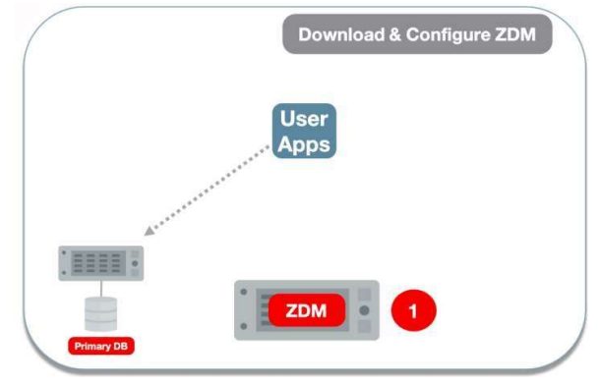

Step 2 ZDM starts Databasemigration
zdmcli migrate command and SSH keys performs the dry-run which evaluates validates migration process and allows any corrective steps prior to execution of actual migration
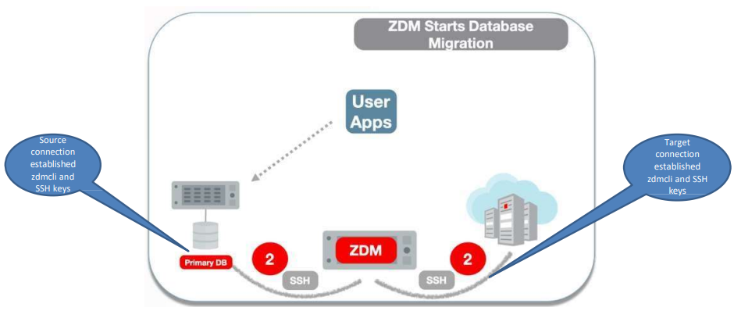

Step 3 ZDM connects source DB to Object Storage in OCI

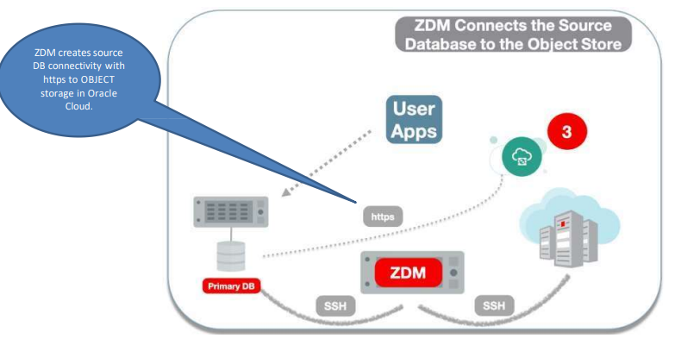

Step 4 ZDM orchestrates transfer of DB backup files
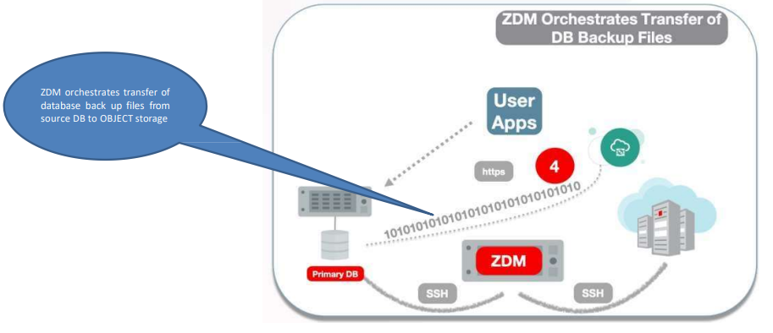

Step 5 ZDM instantiates a standby DB
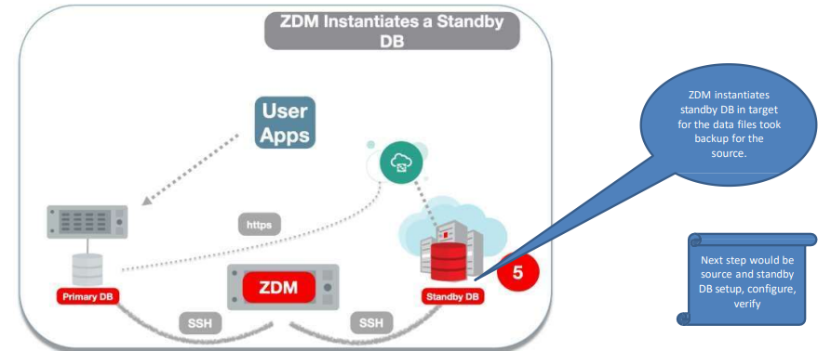

Step 6 ZDM synchronizes Primary and standby
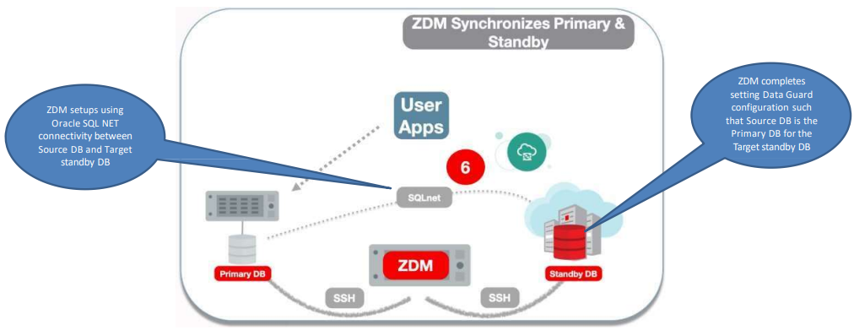

Step 7 ZDM switches over and swaps roles
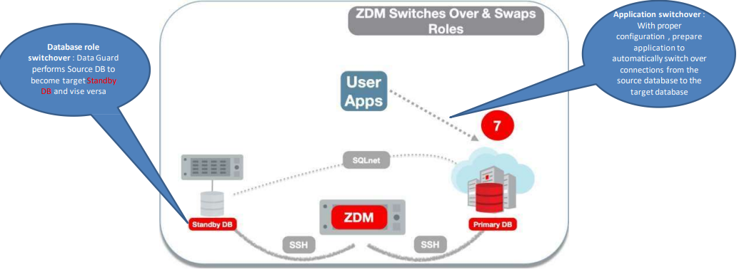

Step 8 ZDM finalizes the Migration process
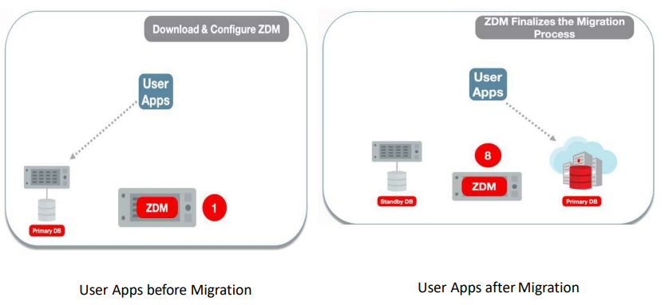

Conclusion
Zero Downtime Migration (ZDM) is a Simple & Efficient, High Availability, Flexible, Cost Effective, Migration customization.

### END ###

