Cost Analysis

Content
Cost Analysis 1
Cost Analysis Overview 2
Required IAM Policy 4
Cost Analysis Query Fields 5
Viewing Query History 11
Forecasting Costs 12
Viewing Costs by Subscription 16
Downloading Your Cost Details Data 17
Saving Reports 18
Cost and Usage Reports Overview 20
How Cost Reports Work 21

Cost Analysis Overview
Cost Analysis is an easy-to-use visualization tool to help you track and optimize your Oracle Cloud Infrastructure spending. You can generate charts, and download accurate, reliable tabular reports of aggregated cost data on your Oracle Cloud Infrastructure consumption.
Use Cost Analysis for spot checks of spending trends and for generating reports. Common scenarios you might be interested in including:
- Show monthly costs for compartment X and its children, grouped by service or by tag.
- Show daily costs for tag key A and grouped by service and product description (SKU).
- Show hourly costs for service = compute or database, grouped by compartment name.

Required IAM Policy
To use Oracle Cloud Infrastructure, you must be granted security access in a policy by an administrator. This access is required whether you're using the Console or the REST API with an SDK, CLI, or another tool.
To use Cost Analysis, the following policy statement is required:
Allow group <group_name> to read usage-report in tenancy
To use Saved Reports, the following policy statement is required:
Allow group <group_name> to manage usage-report in tenanc

Cost Analysis Query Fields
The following table describes the Cost Analysis query fields.
Field | Description
Reports | Select from one of the Default Reports:  - Costs by Service (shown by default when the Cost Analysis page first opens)  - Costs by Service and Description  - Costs by Service and Sku (Part Number)  - Costs by Service and Tag  - Compute Costs by Compartment  - Monthly Costs
Start/End Date (UTC) | Select the start and end date according to the UTC time zone.
Granularity | Granularity (hourly, daily, monthly) is based on the requested date range size. The logic is the following:
Show | Allows you to view the report in terms of Cost or Usage.
Filters | Allows filtering on the following:  - Availability Domain  - Compartment  - By name  - By OCID  - By Path  - Platform (Gen-1 are services which are not OCI native. Gen-2 includes all OCI native services)  - Tag  - By Tag Namespace  - By TagKey + Value  - Region  - Service  - Subscription ID  - Resource OCID  - Product description: The human-readable corresponding name)  - SKU (Part Number): For example, B91444.  - Tenant  - Unit
Grouping Dimensions | - Availability Domain  - Compartment.  - Display as  - Compartment Name  - Compartment OCID  - Compartment Path  - Platform (Gen-1 are services which are not Oracle Cloud Infrastructure native, while Gen-2 includes all native Oracle Cloud Infrastructure services)  - Region  - Resource OCID  - Service  - Service and Product Description  - Service and SKU (Part Number)  - SKU (Part Number)  - SKU (Product Description)  - Subscription ID  - Tag  - Tenant ID  - Tenant Name

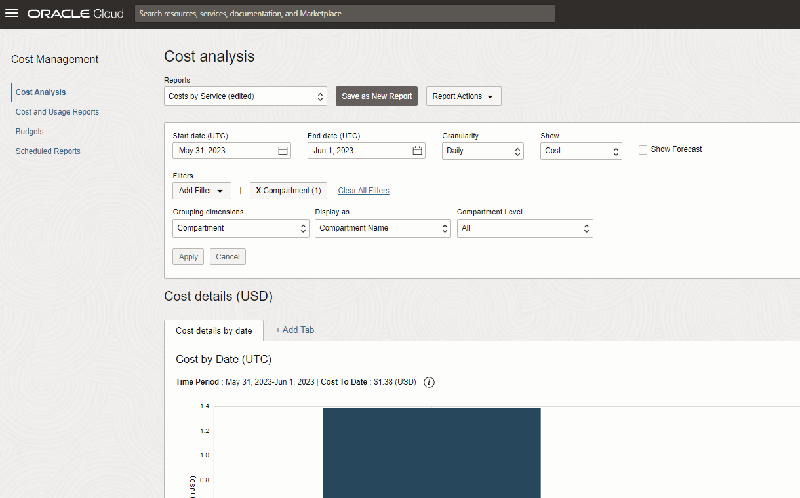

Viewing Query History
You can view your Cost Analysis query history at any time by clicking the Query History link at the top of page. After clicking this link, the Oracle Cloud Infrastructure Logging Audit page opens.
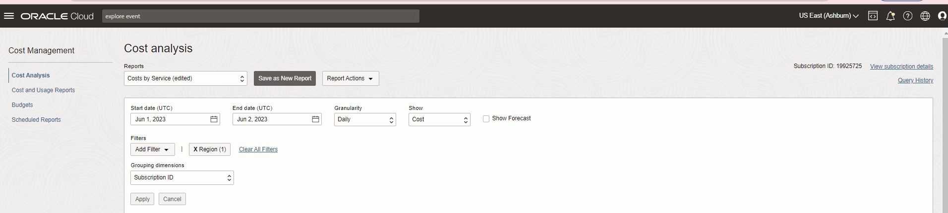
The Audit page is pre-filtered to show the Cost Analysis-related audit events.
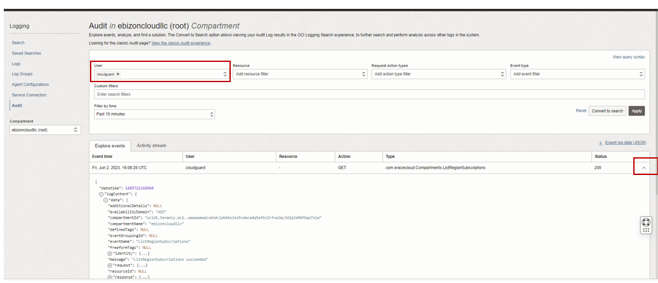

Forecasting Costs
You can use Cost Analysis to estimate future usage and consumption information, based on past usage data.

To view forecast costs:
- Open the navigation menu and click Billing & Cost Management. Under Cost Management, click Cost Analysis.
- Optionally, modify any search parameters, and then select Show Forecast. You can also select Show Forecast first, and then select search settings. In either case, you can view forecast data.
- Click Apply.

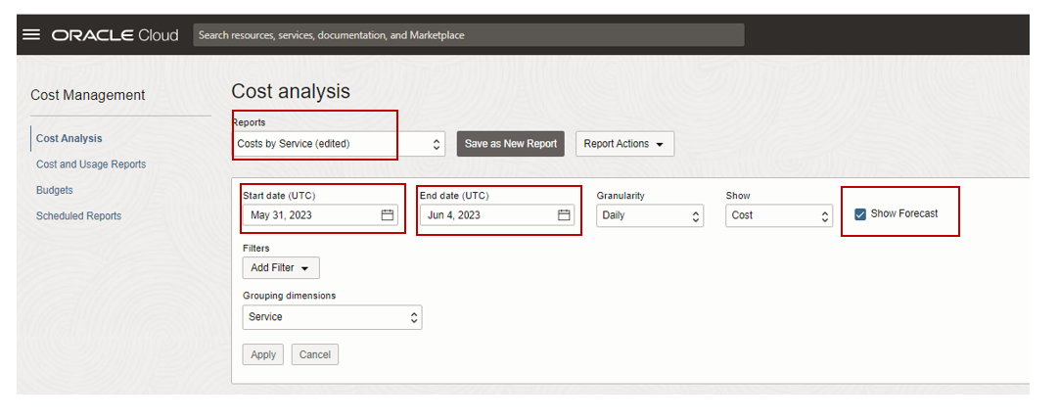
Forecasting Costs
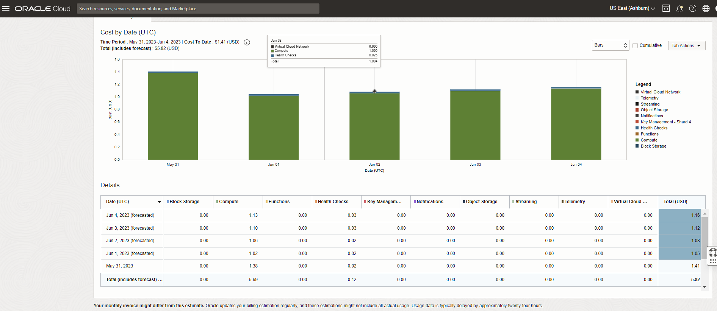

Viewing Costs by Subscription
You can use the Subscription ID grouping dimension to filter by a specific subscription and determine which subscription a tenancy’s usage was attributed against. As a result, you can view the costs associated with a particular or the costs for multiple subscriptions

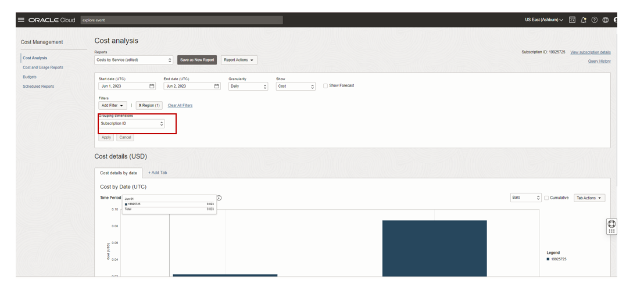

Downloading Your Cost Details Data
From the Tab Actions menu on any Cost details tab:
- Select the Download Table as CSV option to download a CSV file of the data from the current Cost details tab. In the Export Confirmation that opens, click Confirm. You can then download a CSV file with the current date included in the file name.
- Select Download Current Tab as PDF option to export the chart and table data to PDF. In the Export Confirmation that opens, click Confirm. You can then save a PDF file whose file name matches the current Cost details tab name, along with the current timestamp included in the PDF file name.
- Select Download Chart to download a copy of the chart from the current Cost details tab, with the current date included in the PNG file name. Downloading a chart generates a PNG file that corresponds to the chart, inclusive of applied filters, sorting, and grouping dimensions.
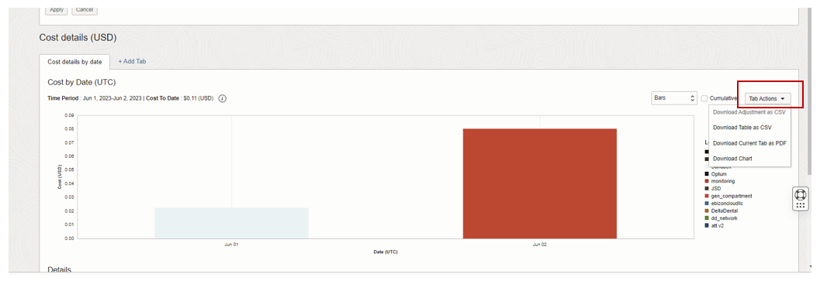

Saving Reports
Use the Report Actions menu to create a saved report. You can later access the report after leaving the Console and returning to Cost Analysis, without having to respecify your set of dates, filters, granularity, or grouping dimensions. After a report has been saved, it can later be renamed, updated, or deleted. A maximum of 10 reports can be saved.
You can create a saved report by modifying one of the predefined Cost Analysis reports, and then save your custom settings as a new report. Your new reports can have your own set of filters, grouping dimensions, granularity, and date range settings.
To save a Cost Analysis report:
- Open the navigation menu and click Billing & Cost Management. Under Cost Management, click Cost Analysis.
- From Reports, select one of the predefined reports, or use the default Costs by Service report.
- Make your preferred query adjustments.
- After you have made changes, the currently selected predefined report name from the Reports menu changes to (edited), to indicate that you have made changes.
- If you are done making changes and want to save them as a new report, from Report Actions, select Save as New Report. The Save as New Report box is displayed.
- In Name, enter a saved report name, and click Save. For the name, avoid entering confidential information. A notification is displayed that your report has been saved, and the report is also selected in the Reports menu.
- Click Apply to apply your new report changes.
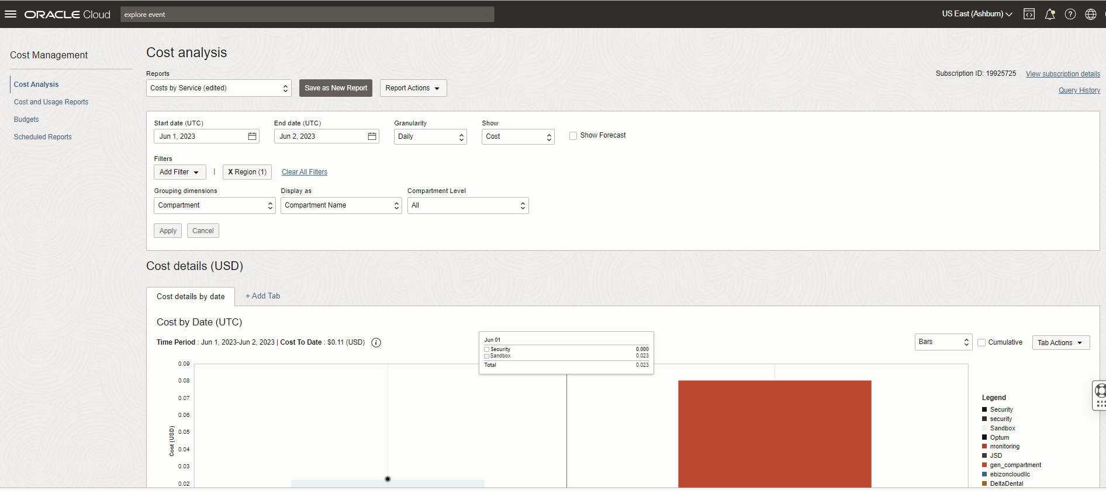

Cost and Usage Reports Overview
A cost report is a comma-separated value (CSV) file that is like a usage report, but also includes cost columns. The report can be used to obtain a breakdown of your invoice line items at resource-level granularity. As a result, you can optimize your Oracle Cloud Infrastructure spending, and make more informed cloud spending decisions.

How Cost Reports Work
Cost reports are automatically generated every six hours and are stored in an Oracle-owned Object Storage bucket. The reports contain one row per each Oracle Cloud Infrastructure resource (such as instance, Object Storage bucket, VNIC) per hour along with consumption information (usage, price, cost), metadata, and tags. Cost reports generally contain six hours of usage data, and occasionally late-arriving data, but the data can be delayed up to 24 hours. Cost reports are retained for one year.

