Governance & Administration
Account Management: Region Management in Oracle Cloud Infrastructure (OCI)

Region management in Oracle Cloud Infrastructure (OCI) refers to the process of selecting and configuring the geographical region where your resources and services will be provisioned and deployed. OCI offers multiple regions globally to cater to the needs of its customers.
Each region represents a separate geographic area that consists of one or more data centers, referred to as Availability Domains (ADs). An Availability Domain is a physically isolated data center within a region. By distributing resources across multiple ADs within a region, you can ensure high availability and fault tolerance for your applications.

Below links gives the guidelines for Selecting a Cloud Region:
https://www.oracle.com/cloud/public-cloud-regions/data-regions/

To determine the subscribed region for your tenancy in Oracle Cloud Infrastructure (OCI).
1. Log in to the Oracle Cloud Infrastructure Console using your tenancy administrator credentials.
2. Once you are logged in, you will be directed to the OCI Dashboard.
3. Click on hamburger menu and select Governance & Administration
4. Click on Account management - Region Management
Infrastructure Regions:

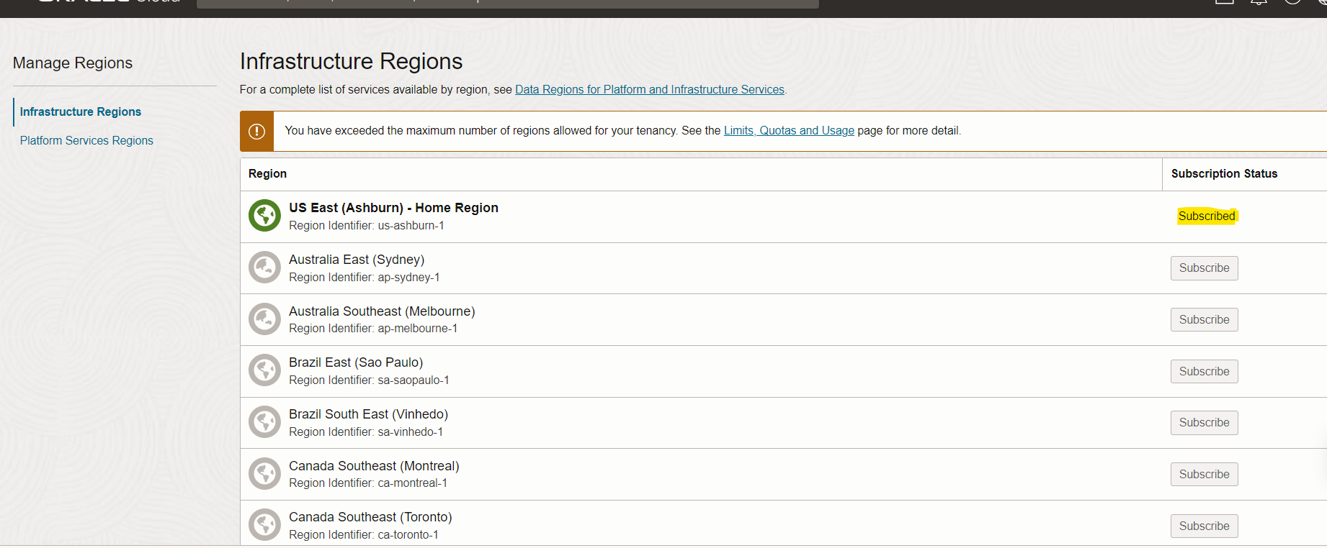

Platform Services Regions:

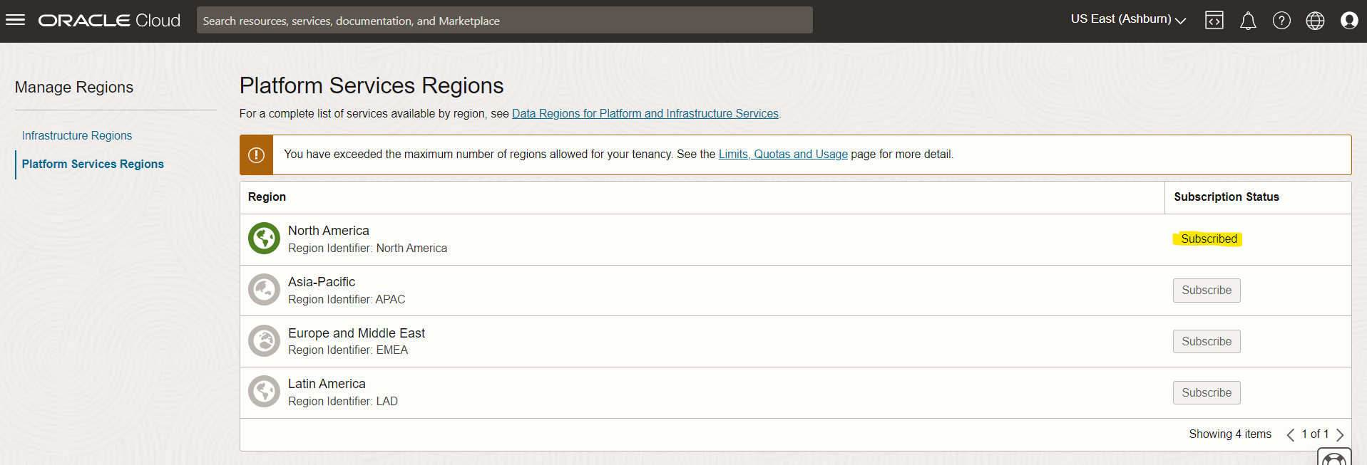

Here are some key points to understand about region management in OCI:
1.Region Selection: When setting up your infrastructure in OCI, you can choose the region that best suits your requirements. Factors to consider include proximity to end-users, data residency requirements, regulatory compliance, and availability of specific services. OCI provides a global footprint with regions across different continents.
2.Region Independence: Each region in OCI is independent and isolated from others. This means resources created in one region cannot directly interact with resources in another region. If you need to establish connectivity or data replication between regions, you can utilize OCI's networking capabilities, such as virtual networking and fast connect.
3.High Availability and Disaster Recovery: By deploying resources across multiple Availability Domains within a region, you can achieve high availability for your applications. In the event of a failure or outage in one AD, resources in other ADs can continue to function. Additionally, for disaster recovery purposes, OCI provides services like Object Storage and Database Backup that support cross-region replication.
4.Service Availability: Not all OCI services are available in every region. Some services may have limited availability or be in preview mode in certain regions. It's important to consult the OCI documentation or service-specific documentation to understand which services are available in your chosen region.
5.Region Expansion: OCI continues to expand its global presence by adding new regions over time. It's advisable to stay updated with announcements and new releases to take advantage of new regions that may offer improved performance, reduced latency, or regulatory compliance benefits.

In summary, region management in OCI involves selecting the appropriate region, leveraging multiple Availability Domains for high availability, considering service availability in the chosen region, and planning for disaster recovery scenarios. By effectively managing regions, you can optimize performance, availability, and compliance for your applications and workloads in Oracle Cloud Infrastructure.

