OCI Tenancy Management

Contents

1. Tenancy Explorer 3
1.1. Work Requests 3
1.2. Resources Supported by the Tenancy Explorer 3
1.3. Required IAM Policy to Work with Resources in the Tenancy Explorer 4
1.4. Navigating to the Tenancy Explorer and Viewing Resources 4
2. Quota Policies 4
2.1. To create a quota 4
2.1. To edit a quota 5
2.2. To delete a quota 5
2.3. Create a quota policy that disallows use of outbound email or notification for the tenancy 5
2.4. Delete a quota policy 6
2.5. List quota 6
2.6. Update created quota to allow notifications in the tenancy 6
2.7. Get Quota 6
3. Domain Management 6
3.1. Required IAM Policy 6
3.2. Adding and Verifying Domains 7
a. To enable governance 8
b. To disable governance 8
c. To update an email 9
d. To remove a domain 9
3.3. Domain Revocation 9

Tenancy Explorer
The tenancy explorer lets view all resources in a compartment, across all regions in tenancy.
The following image highlights these features:
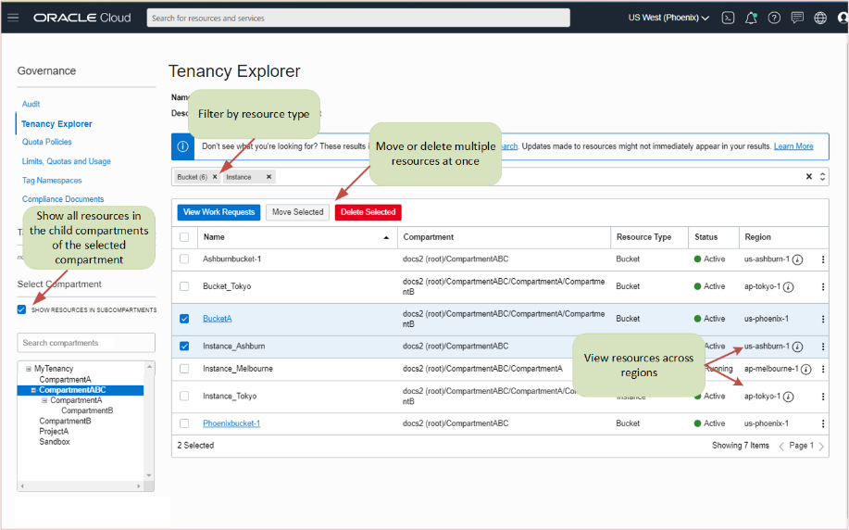
When using the tenancy explorer, be aware of the following:
- If recently created a resource, it might not show up in the tenancy explorer immediately. Similarly, if recently updated a resource, changes might not immediately appear.
- The tenancy explorer displays the resource's region. Use the region selector at the top of the Console to change to the same region as the resource to enable these actions.
- When taking bulk actions, can monitor progress on the Work Requests page.

Work Requests
- Tenancy explorer is one of the Oracle Cloud Infrastructure features that is integrated with the Work Requests API.

Resources Supported by the Tenancy Explorer
- The tenancy explorer is powered by the Search service and supports the same resource types. Most resources are supported.

Required IAM Policy to Work with Resources in the Tenancy Explorer
  - The resources in the tenancy explorer depend on the permissions in place for the resource type.

  - Required Permissions to View Work Requests

  - Work requests inherit the permissions of the operation that spawns the work request.

  - To enable users to list all work requests in a tenancy, use a policy like the following:

Allow group <My_Group> to inspect work-requests in tenancy

Navigating to the Tenancy Explorer and Viewing Resources
- Open the navigation menu and click Governance & Administration. Under Governance, click Tenancy Explorer.

- The tenancy explorer opens with a view of the root compartment. Select the compartment to explore from the compartment picker on the left side of the Console. After select a compartment, the resources that have permission to view are displayed.

- The Name and Description of the compartment are viewing are displayed at the top of the page. To also list all resources in the subcompartments of the selected compartment, select Show resources in subcompartments.

- When viewing resources in all subcompartments, it is helpful to use the Compartment column in the results list to see the compartment hierarchy where the resource resides.

Quota Policies

2.1. To create a quota
- Open the navigation menu and click Governance & Administration. Under Tenancy Management, click Quota Policies.
- On the Quota Policies screen, click Create Quota.
- Enter the following:
  - Enter a name for quota in the Name field.
Avoid entering confidential information.
  - Enter a description for quota in the Description field.
  - Enter a quota policy string in the Quota Policy field.
- Click Create Quota Policy.
Note:
New policies can take up to 10 minutes to start working.

To edit a quota
- On the Quota Policies screen, click the quota want to edit to display the quota policy details page, then click the Edit Quota button.
- Edit the quota.
- Click Save Changes.

To delete a quota
- Delete a quota from the console using the following two methods:
  - On the main Quota Policies page, click the context menu to the right of the quota want to delete, then select Delete.
  - Click the quota want to delete, then from the quota policy detail page click Delete.
- From the Confirm Delete dialog, click Delete, or Cancel.
Using the CLI
Pre-requisites:
- Oracle Cloud Infrastructure CLI is set up on machine per the instructions at Setup and Prerequisites.
- CLI configuration is set up with API keys for the user that has permissions to manage quotas.

Create a quota policy that disallows use of outbound email or notification for the tenancy
Command

oci --profile=<profile-name in oci config file> limits quota create --compartment-id <compartment id> --name <name for quota policy> --description "some quota" --statements file:///users/sme/statements.json

Delete a quota policy
Command
oci --profile=<profile-name in oci config file> limits quota delete --quota-id <quota ocid from console>

List quota
Command
oci --profile=<profile-name in oci config file> limits quota list --compartment-id <compartment id>

Update created quota to allow notifications in the tenancy
Command
oci --profile=<profile-name in oci config file> limits quota update --quota-id <quota ocid from console> --description "updating quota" --statements file:///users/sme/statements.json

Get Quota
Command
oci --profile=<profile-name in oci config file> limits quota get --quota-id <quota ocid from con

Domain Management
- Domain Management allows customers to register their domains with Oracle Cloud Infrastructure, as being their domain, which blocks others from claiming that domain in the future using new cloud accounts.

- OCI customers can redirect new user sign-up attempts that use a corporate email address from that customer's domains.

- They can securely verify ownership of domains, and more easily control spending and management of resources.

Required IAM Policy
To use Oracle Cloud Infrastructure, must be granted security access in a policy by an administrator. This access is required while using the Console or the REST API with an SDK, CLI, or other tool.
To use Domain Management, the following policies are required:
Allow group domainUsers to manage organizations-domain in compartmentA
Allow group domainUsers to manage organizations-domain-governance in compartmentA

Adding and Verifying Domains
For existing customers, follow these instructions to add and verify a domain.
- Open the navigation menu and click Governance & Administration. Under Governance, click Domain Management.
- Click Add and Verify Domain. The Add and Verify Domain panel is displayed.
Note:
- If a policy has not already been created, a Policy Notification is displayed, informing that a default policy must first be created, to allow Domain Management to write notifications in the given tenancy and compartment. Click Add Policy to confirm.

- In the Add and Verify Domain panel, enter the email address of the domain to be added. This email address is used when someone with verified domain tries to create an Oracle Cloud account.
- Agree to the Oracle Notification Service Rates.
- In Domain, enter the domain want to add and verify.
- Click Add and Verify. The domain is added, and the TXT Record field is populated with a generated name and value. Click the copy icon to use the TXT file so can sign into domain's account and add the TXT record information to domain's registrar.
- Click Close to return to the Domain Management page.
The Domain Management page displays the new domain just added. Its information is displayed in the table:
- Domain: The name of the domain.
- Notifications: Links to the Notifications topic. Topics are not created, however, until verification has occurred.
- TXT Record: The generated TXT record.
- Email: The domain email.
- Status: The domain verification status:
  - Pending: Verification in process.
  - Failed: Verification no good after 72 hours.
  - Active: Verified and governance enabled.
  - Disabled: Verified but not governed.
  - Releasing: Customer requested removal (work request triggered).
  - Released: Work request complete, will be removed from the Domain Management page after seven days.
- Date: The last modified date. Updates when verified, enabled, disabled, or if the email was updated.
Once a domain's Status is Active, can do the following:
- Enable or disable governance
- Update the email
- Remove the domain

To enable governance

When first add a new domain, governance is disabled by default, and it status is set to Pending. Once the status has changed to Active, governance can then be enabled or disabled.
Note:
When turning on Enable Governance, it prevents others from creating an Oracle Cloud account with verified domain.
To enable governance for an active domain:
- Open the navigation menu and click Governance & Administration. Under Governance, click Domain Management.
- Click the Actions menu and select Enable Governance. A Turn on Domain Governance confirmation is displayed.
- Agree to the Oracle Notification Service Rates.
- Click Yes, turn on.

To disable governance

To disable governance for an active domain:
- Open the navigation menu and click Governance & Administration. Under Governance, click Domain Management.
- Click the Actions menu and select Disable Governance. A Turn off Domain Governance confirmation is displayed, indicating which domains are to be disabled.
- Click Confirm.

To update an email

To update the email address for an active domain:
- Open the navigation menu and click Governance & Administration. Under Governance, click Domain Management.
- Click the Actions menu and select Update Email. An Update Email box is displayed.
- Enter the new email address and click Save.

To remove a domain

To remove an active domain:
- Open the navigation menu and click Governance & Administration. Under Governance, click Domain Management.
- Click the Actions menu and select Remove Domain. A confirmation is displayed confirming which domain to remove.
- Click Remove Domain.

Domain Revocation
- Oracle regularly checks that a claimed domain is still valid and assigned to the correct owner. If a domain does not pass this verification check, receive an email notification, and have 72 hours to update the TXT record information. If no action is taken, the domain is revoked.

- If the domain is revoked but want to reclaim it, can add and verify the domain again.
#END#

