Oracle Support Center

Contents
1. Introduction 3
2. Key features of Support Center 3
3. Overview of the types of documentation and resources 3
3.1. Knowledge Base: 3
3.2.Product Documentation: 3
3.3. Release Notes: 4
3.4. Patching and Upgrades: 4
3.5. Certifications: 4
3.6. Support Policies: 4
4. My Oracle Support 4
4.1. How to Register 4
4.2. Customer User Admin (CUA) 7
4.3. Create a Service Request (SR) 8
4.4. Information Centers 8
4.5. Support Renewals Process 8
4.6. Additional MOS Help 8
5. Request Service Limit Updates 8
5.1. About Service Limits and Usage 8
5.2. Compartment Quotas 9
5.3. Viewing Service Limits, Quotas, and Usage 9
5.4. Service Limits API Policy 9
5.5. When Reach a Service Limit 9
5.6. Requesting a Service Limit Increase 10
5.7. Limits by Service 10
5.8. Dynamic Limits 10
5.9. Using the API 10
5.10. Fractional Usage and Availability 11

Introduction
Oracle Support Center is a resource provided by Oracle that offers documentation, knowledge articles, and support resources for Oracle products and services.
New and experienced OCI Customers can easily take advantage of Support Center and can access the Support Center either from the top navigation Help Menu or from the Life Raft button. First time users of Support Center will be guided through a simplified automated workflow to link OCI tenant and My Oracle Support (MOS) account. My Oracle Support is 24x7 support ticket management application.
The best part about having support in the OCI Console experience is that browsing context is used to provide focused and targeted documentation recommendations. The documentation links are relevant to the OCI service page, so no more time consuming searching for documentation.

Key features of Support Center
- The new OCI Support Center Dashboard is single pane of glass for all product support and documentation needs.

- The new Support Life Raft button is now available on all Console pages and provides one click access to support whenever need it.

- When create a new support request, only need to describe issue, and Support Center will fill in all the key environment details automatically.

Overview of the types of documentation and resources
Here is an Overview of the types of documentation and resources typically available in Oracle Support Center:

3.1. Knowledge Base:
The Oracle Support Center includes a vast knowledge base that contains articles, troubleshooting guides, best practices, and solutions for common issues encountered with Oracle products.

3.2.Product Documentation:
Oracle provides comprehensive documentation for its products, including installation guides, administration guides, user guides, and reference manuals. These documents provide detailed information about product features, configuration, and usage.

3.3. Release Notes:
Release notes provide information about new features, enhancements, and fixes included in specific product releases. They also highlight any known issues or limitations in the release.

3.4. Patching and Upgrades:
Oracle Support Center provides documentation on patching and upgrading Oracle products. This includes information on downloading and applying patches, upgrading to newer versions, and compatibility matrices for different product versions.

3.5. Certifications:
The certification documentation provides information on certified platforms, operating systems, databases, and other software components that are compatible with specific Oracle products.

3.6. Support Policies:
Oracle Support Center also provides documentation regarding Oracle's support policies, including information on product support timelines, support levels, and service request processes.
Access to the Oracle Support Center and its documentation typically requires a valid Oracle Support contract. Oracle customers can log in to the support portal to access these resources, submit service requests, and interact with Oracle Support personnel.

My Oracle Support
Visit My Oracle Support (MOS) if a technical issue and/or a question about Oracle Primavera Cloud that cannot resolve using information in the Help Center.
On this page
- How to Register
- Customer User Admin (CUA)
- Create a Service Request (SR)
- Information Centers
- Support Renewals Process
- Additional MOS Help

4.1. How to Register
Note: The steps below may be different if using the Cloud Portal.

- Go to My Oracle Support and select Register as new user.

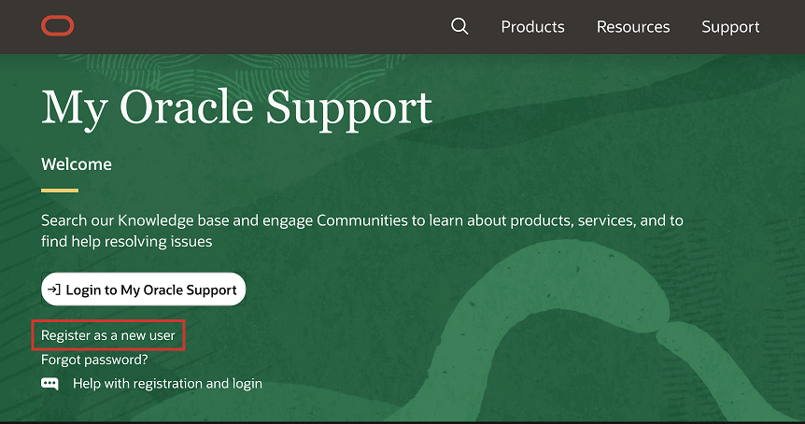

- Fill out the form and select Create Account. Oracle will send an email to verify email address.

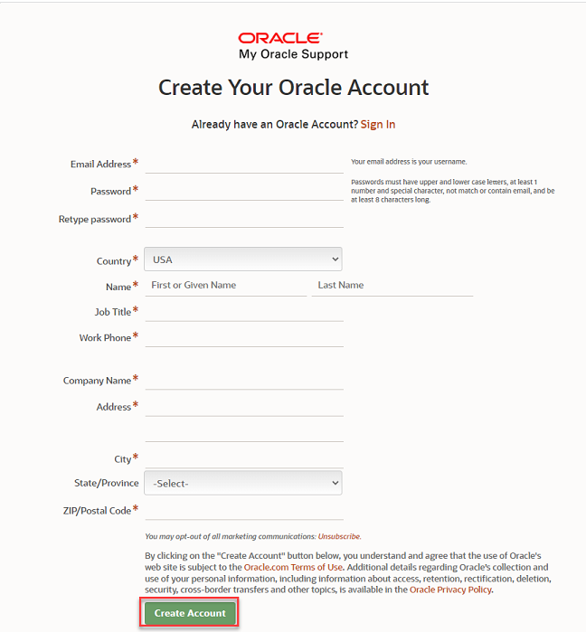
- Once email address is verified, go back to My Oracle Support. Select Login to My Oracle Support. Use the account credentials just created to log in.

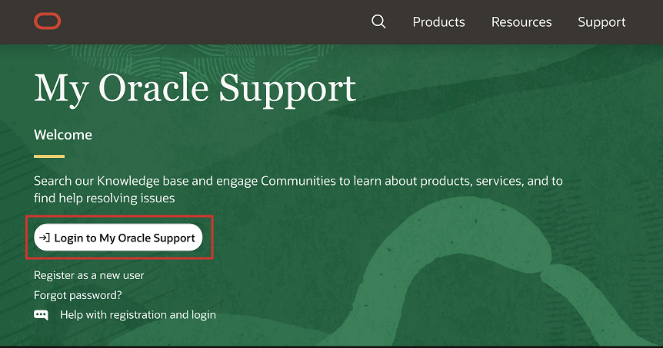

- Once logged in, locate the dropdown featuring name along the upper-right and select My Account.

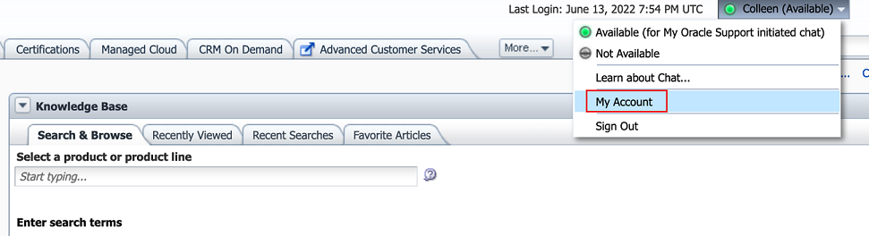

- In the Support Identifiers section, select Request Access.

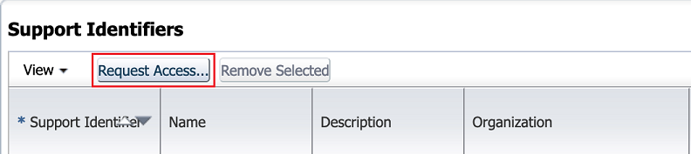

- Enter Support Identifier (SI), along with the first five letters of organization name if prompted. SI is included in the Oracle welcome email.
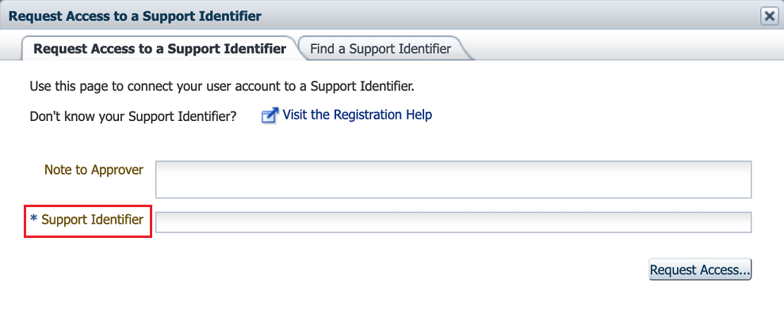
- Select Request Access. The request will then be sent to the CUA for approval.
Once registered, we can search the Knowledge Base and communities, and learn our tips and best practices for using MOS.
Oracle customers who have purchased support have access to electronic support through MOS.

4.2. Customer User Admin (CUA)
The Customer User Admin (CUA) manages all users for their SI. The CUA can approve or deny user access, assign user privileges, and more.
Oracle recommends having at least two CUAs for every SI. The CUA can assign the role to other users by following the steps below.
To assign a user as a CUA:
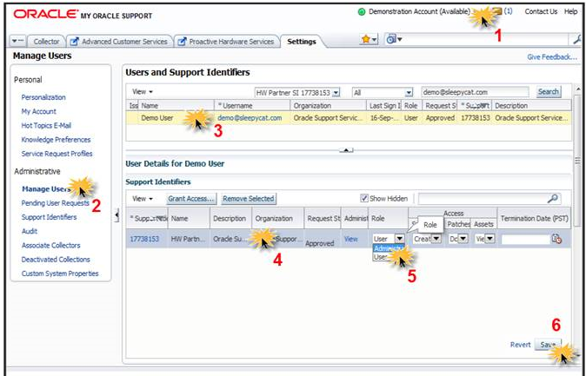
- Log in to My Oracle Support. Select the drop-down menu next to display name, and then choose My Account.
- Select Manage Users under the Administrative category on the left.
- Select the row of the user want to modify.
- Their user details will display below. Select the row.
- In the Role list, select Administrator.
- Select Save.

4.3. Create a Service Request (SR)
To access tutorials on how to create an SR, select the Service Request Management tab.
When create an SR, be sure to enter the correct product information and problem details so that the request is assigned to the proper Oracle Support team.

4.4. Information Centers
Information centers organize documents found on My Oracle Support (MOS) and provide access to:
- Important support and product information, such as links to recently created knowledge base articles and product announcements
- Oracle University training
- Communities where industry peers share best practices

4.5. Support Renewals Process
If it's time to renew support for Oracle products, or auto-renewal of support services.

4.6. Additional MOS Help
- Tips and best practices for using oracle support services are provided in best practices guide.

Request Service Limit Updates
This topic describes the service limits for Oracle Cloud Infrastructure and the process for requesting a service limit increase.

5.1. About Service Limits and Usage
When sign up for Oracle Cloud Infrastructure, a set of service limits is configured for tenancy. The service limit is the quota or allowance set on a resource. These limits are established with the Oracle sales representative when purchase Oracle Cloud Infrastructure. These limits may be increased automatically based on Oracle Cloud Infrastructure resource usage and account standing.

5.2. Compartment Quotas
Compartment quotas are similar to service limits; the biggest difference is that service limits are set by Oracle, and compartment quotas are set by administrators, using policies that allow them to allocate resources with a high level of flexibility. Compartment quotas are set using policy statements written in a declarative language that's similar to the IAM policy language.

5.3. Viewing Service Limits, Quotas, and Usage
We can view a tenancy's limits, quotas, and usage in the Console. Be aware that:
- The Console might not yet display limits and usage information for all of the Oracle Cloud Infrastructure services or resources.
- The usage level listed for a particular resource type could be greater than the limit if the limit was reduced after the resources were created.
- If all the resource limits are listed as 0, this means your account has been suspended.

5.4. Service Limits API Policy
For the resource availability API (usage) the policy can be at the tenant or compartment level:
Allow group LimitsAndUsageViewers to read resource-availability in tenancy
Allow group LimitsAndUsageViewers to read resource-availability in compartment A
For limit definitions, services, and values APIs (only at the tenant level):
Allow group LimitsAndUsageViewers to inspect resource-availability in tenancy

5.5. When Reach a Service Limit
When reach the service limit for a resource, receive an error when try to create a new resource of that type and then prompted to submit a request to increase the limit. So, can't create a new resource until granted an increase to the service limit or delete an existing resource.

5.6. Requesting a Service Limit Increase
Government Cloud customers can't use the procedure here to request a service limit increase. Instead, see Requesting a Service Limit Increase for Government Cloud Tenancies.
Create a resource for which limit has been met, will be prompted to submit a limit increase request. Additionally, can open the request from the service limits page or at any time by clicking the link under the Help menu ( ). This procedure applies to requests for service limit increases.

5.7. Limits by Service
Click a service name to view the default limits. Note the scope that each limit applies to (for example, per availability domain, per region, per tenant, and so on).
Service limits in this topic define their limits in terms of the following pricing models (depending on the service):
- Oracle Universal Credits
- Pay As You Go
- Trial or Free Trial
- Always Free
Many services have the same limits for Pay As You Go and Trial, and are listed as such in the following tables (Pay As You Go or Trial), while some services have different values for Pay As You Go compared with Trial, and so the Trial limit values are listed separately.
Note
Some services have additional limits. To view the latest limit values for a service, also see the Console's Limits, Quotas, and Usage page.

5.8. Dynamic Limits
Some of these limits can appear as Dynamic in the Console's Limits, Quotas, and Usage page. Pay As You Go or Trial customers have access to a dynamic amount of the particular resource, based on tenancy resource consumption and growth. Access to this resource increases over time.

5.9. Using the API
Use the following operations in the Service Limits API to manage limits:
- CreateQuota
- DeleteQuota
- GetQuota
- UpdateQuota
Use the following to manage resource locking:
- ResourceLock
- AddLockDetails
- RemoveLockDetails

5.10. Fractional Usage and Availability
Some resources can have fractional usage and availability, and the Service Limits API reflects this accordingly. If the resource is a fractional one, usage reflects the rounded up value of the fractional usage, and for availability, the rounded down value of the fractional availability. As a result, these fractional availability and usage attributes help indicate the most accurate usage and availability.
#END#

