License Manager

Contents

1. Introduction 3
2. Viewing License Summary Activity 3
3. Adding a License 4
4. Adding your license 5
4.1 Viewing your License attribution 8
5. Importing Oracle Product Licenses 8
6. Product Licenses List 9
7. Viewing Consumption 11
8. Viewing and Working with License Records 12
9. Using Notifications 12
9.1 Monitoring licensing needs 12

Introduction

License Manager is a free, opt-in service that allows to bring own licenses (BYOL) into Oracle Cloud Infrastructure.
Use License Manager to:
- Automate the license portability rules for Oracle Database products to OCI Database PaaS services. This eliminates overhead for Software Asset Managers (SAMs) and developers in an enterprise. A resource can be BYOL, which means Oracles charges for infrastructure, but not licensing fees for software running on it. A resource can also be license included, which means the cost includes infrastructure and the software licensing fee.
- Track license usage for Oracle Database products or third-party products by Compute resources.
- Obtain reporting of BYOL resources that have licensing needs. Monitor and manage a list of email addresses to be notified about the expiration or over-subscription of licenses.

2. Viewing License Summary Activity
The License Manager Overview page provides an overall summary of license activity. The page allows getting quick insights into most utilized licenses, Bring Your Own License (BYOL) resources needing the most licenses by OCPUs, and an overall count of BYOL and license included resources, and licenses at or near expiration.
To view the Overview page and its details, open the navigation menu and click Governance & Administration.
Under License Management, click Overview. The License Manager Overview page opens.
The top of the page has tiles to indicate the totals for:
- Product Licenses: The total number of product licenses.
- BYOL Resources: The total number of BYOL resources. Corresponds to what is listed in the Top BYOL resources by OCPUs table.
- License Included Resources: The count of license-included Database PaaS resources have created in the tenancy.
- Licenses at or near expiration: The total number of license records within 90 days of expiration.

The Top Utilized Product Licenses table displays the following:
Product License: The product license name.
Status: The license status, which can be the following:
- Ok: The license has active license records for Oracle products, and active license records and an image associated for third-party licenses.
- Incomplete: The Oracle product license was created without any active license records within it. For third-party products, the status is Incomplete if there are not any active records or images associated with the license.
- Issues Found: Over-subscribed licenses. The license requirement exceeds the entitlement.
- Warning: Shown for license records when all licensing requirements (mandatory options or base product licenses) are not found in License Manager. Warning is also shown if data has not been updated in more than 24 hours.
- Requirement: What all the resources attributed to a license need, to be considered fully licensed. The licensing requirement is calculated every hour.
- Entitlement: The sum of all license counts in your license records.
- Metric: The metric that matches your licensing terms.
The Top BYOL resources by OCPUs table lists are
- Resource OCID: Click the link to go directly to the particular BYOL resource.
- OCPUs: The total number of OCPUs used by the BYOL resource.
- Compartment: The associated compartment.

3. Adding a License
View and add licenses from the Product Licenses page. Licenses are defined in terms of their requirements and entitlements; according to the metric the license is created.
View the Product Licenses page for overall list of product licenses, and view, add, import, or delete product licenses
Product License: Click the linked product license name to go to the license details page, or select View from the Actions menu.
- Status: The license status.
- Ok
- Incomplete
- Issues Found
- Warning

View License Summary Activity for Status field descriptions.
- Requirement
- Entitlement
- Metric
- License Records

4. Adding your license

Adding license records to License Manager is simple. On the Product Licenses page under Governance and Administration, choose License Manager from home region on the Oracle Cloud Console.
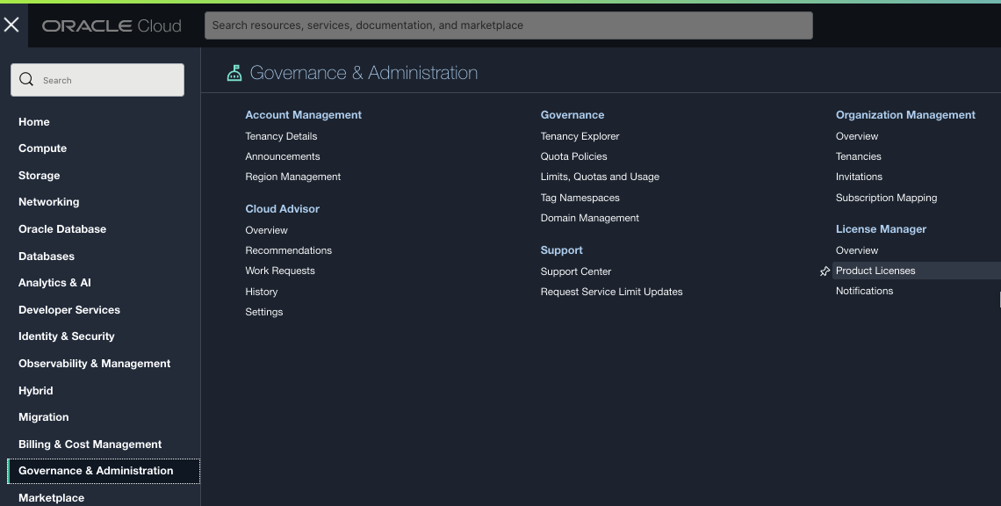
a.Click the Add Product License button.
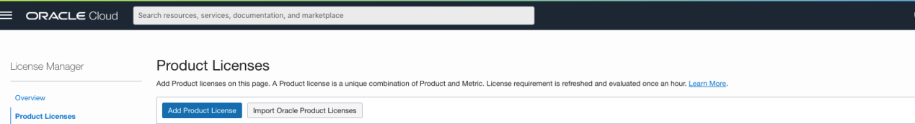

b. In the license creation form, you can choose between Oracle and a third party. You can create a license for a base product, such as Oracle Database Enterprise Edition, by selecting Product and picking it from the menu.
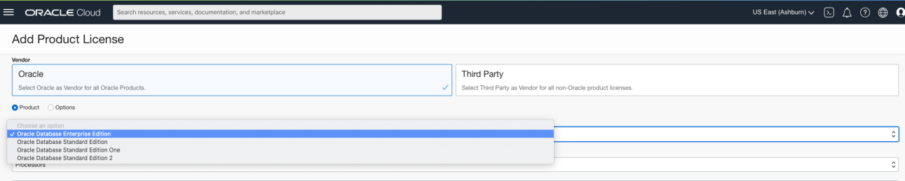
c. You can also choose options, such as Real Application Cluster and multitenant, by selecting Option in the form and picking from the menu.
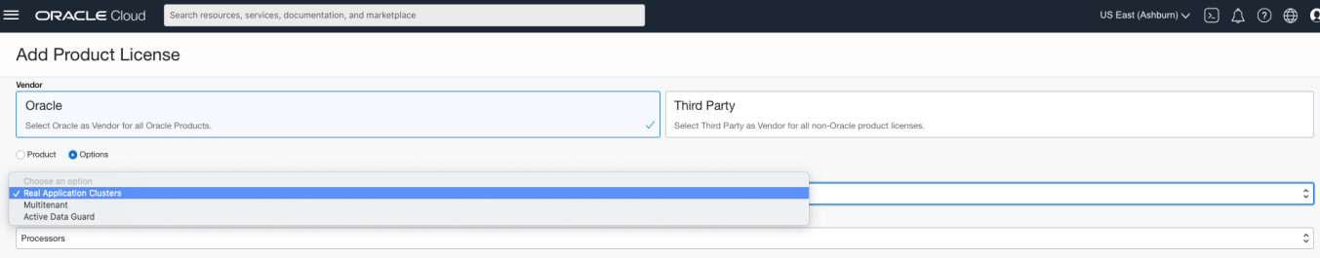
d. Select the metric that matches your licensing terms.
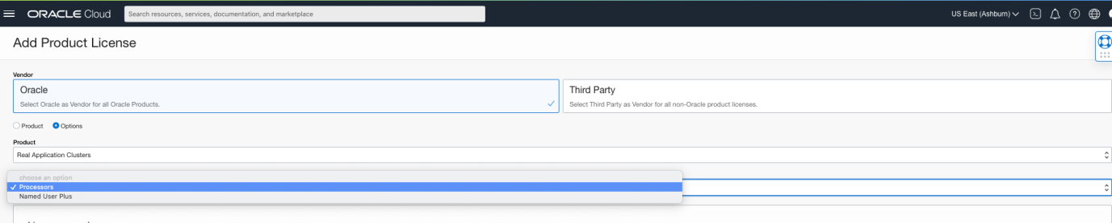
e. Record information such as Customer Support Identifier (CSI) and other metadata, such as whether license is perpetual or if it has a term limit. Record support contract end date and if license is unlimited for ULA licenses or has a specific count associated with it for Full Use licenses.
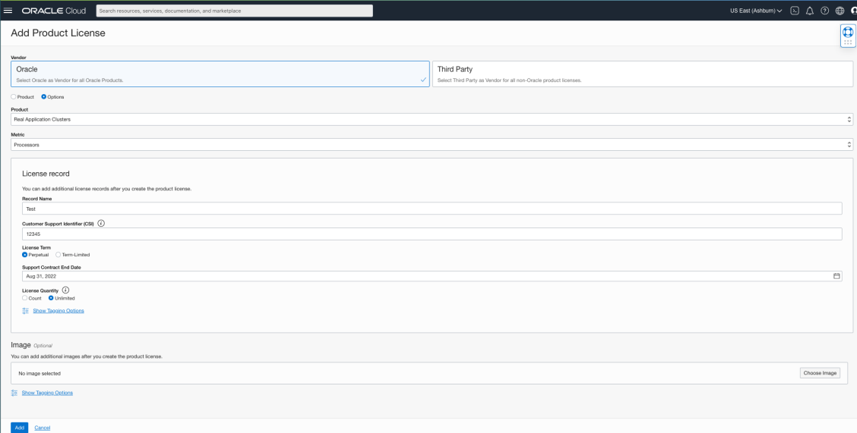
f. To track license utilization on Compute resources, associate a Compute image with license. Under the Image section, select Choose Image.
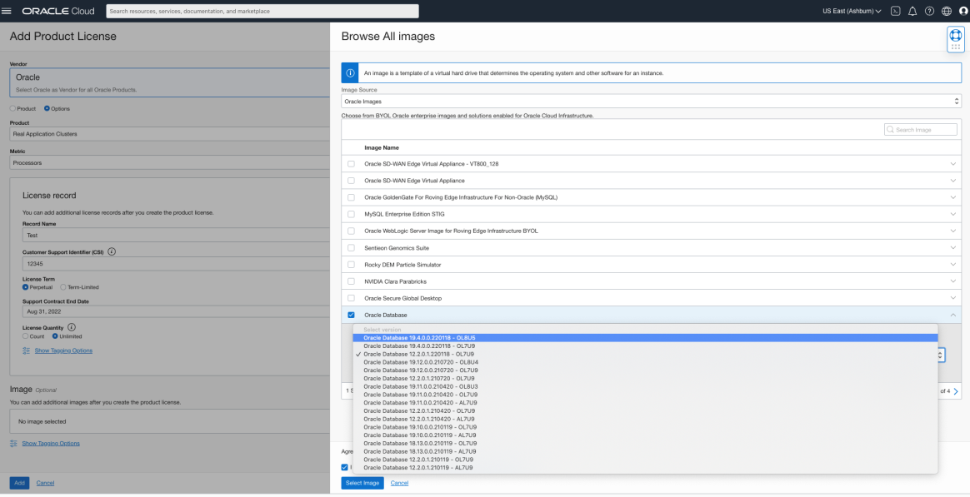
g. The experience for third-party licenses is similar to that of Oracle products. Restricted to OCPUs as option for metrics, so work with vendor to understand how licensing term translates. Click the Import Oracle Product Licenses button on the Product License page.
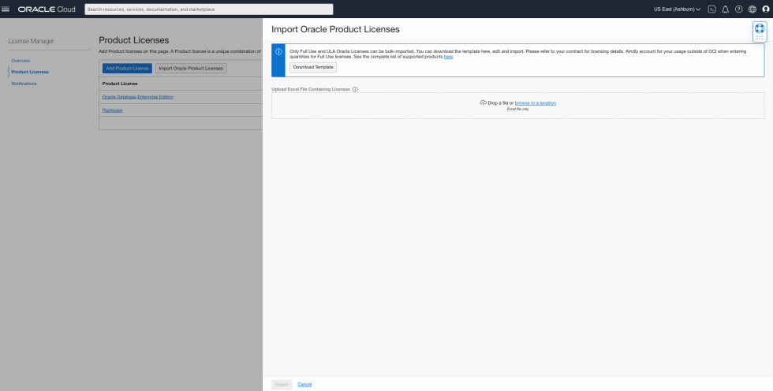

h. Download an Excel template, edit it to match licensing data, and reimport it. The following image depicts a sample file.
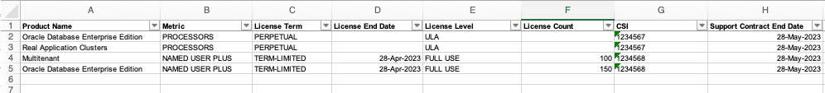

4.1 Viewing your License attribution
License Manager helps with better understand licensing needs and make business decisions based on them

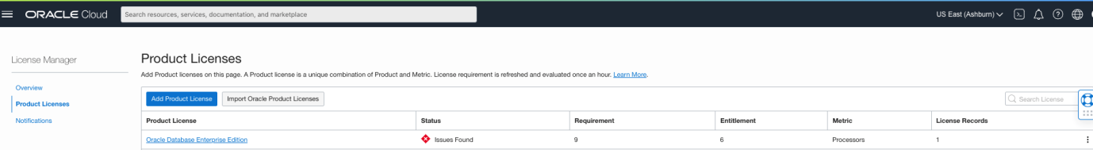

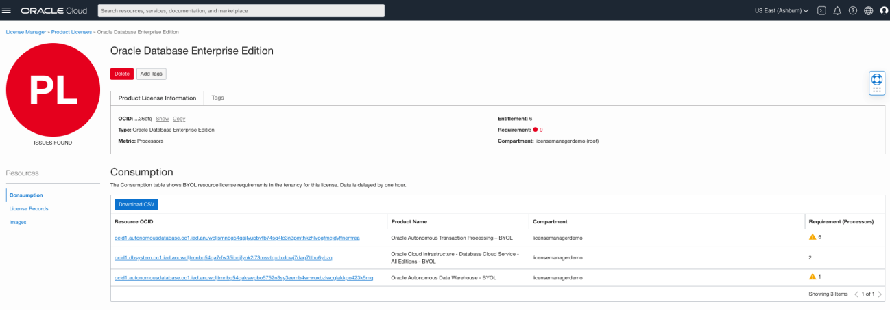

5. Importing Oracle Product Licenses
Perform bulk import of Oracle product licenses, using a predefined Excel template. From the Product Licenses page, download the provided template file, edit it, and then import it to add licenses.
The following types of licenses can be bulk-imported:
- Full Use: Licenses that have a specific count associated with them.
- ULA: Unlimited License Agreement. A count does not need to be entered for ULA licenses.
To import Oracle product licenses:
- Open the navigation menu and click Governance & Administration. Under License Manager, click Product Licenses. The License Manager Product Licenses page opens.
- Click Import Oracle Product Licenses. The Import Oracle Product Licenses panel opens.
- Click Download Template. The default file name is bulkUploadTemplate.xlsx, which can then save to file system and change if needed.
- The template file has the following fields where can enter license information:
  - Product Name
  - Metric
  - License Term
  - License End Date
- License Level
- License Count
- CSI
- Support Contract End Date
- Save your bulk import file.
- On the Product Licenses page, Import Oracle Product Licenses panel, can drag and drop your saved bulk import template, or click browse to a location to upload file. The file appears in the panel.
- Click Import. The file is uploaded and a confirmation message is displayed on the Product Licenses page to indicate how many license records were imported, and if any duplicates were found.

6. Product Licenses List
The Product Licenses page includes a tabular list of all product licenses. The following table describes the fields:
Field | Description
Product License | Click the linked product license name to go to the license details page, or select View from the Actions menu.  The page contains a Product License Information tab, and a Tags tab with tagging information. On a product details page you can:  - View the overall status.  - View or download resource consumption details.  - View, edit, delete, and download license records.  - View or add images associated with a product license.
Status | The license status:  - Ok  - Incomplete  - Issues Found  - Warning
Requirement | What all the resources attributed to a license need, to be considered fully licensed.
Entitlement | The sum of all license counts in your license records.
Metric | The metric that matches your licensing terms.
License Records | The number of records in the product license.
Actions (three dots) menu | Open this menu to:  - View the product license details page.  - Delete the product license.
Drill into the details of a license by clicking its name in the Product License field, which displays the product license details page. The page contains a Product License Information tab, and a Tags tab with tagging information.
View the overall status.
- View or download resource consumption details.
- View, edit, delete, and download license records.
- View, add, or remove images associated with a product license.
The Product License Information tab contains the following information:
- OCID
- Type
- Metric
- Vendor
- Entitlement
- Requirement: Indicates the license requirement status and value. A green status indicates that the product is fully licensed. A red status indicates an overage, for cases where the license requirement exceeds the entitlement.
- Compartment

7. Viewing Consumption
The Consumption table shows BYOL resource license requirements in the tenancy,
- Resource OCID: Click the link to go directly to the particular BYOL resource.
- Product Name: The license product.
- Compartment: The associated compartment.
- Requirement (<type>): The license, where <type> refers to the metric type.
The warning icon indicates that might not have licenses created for mandatory options to meet the licensing needs of a specific resource, per the license portability rules. Resource OCID shown in the Consumption table
Click Download CSV to get a CSV version of the consumption information. The CSV file also has the same field listing as the Consumption table, including a Missing Licensing Requirements field.

8. Viewing and Working with License Records
The License Records table shows all the license records in a product license. The table has the following fields:
- Record Name: Click the linked record name to open the license record details page, or select View from the Actions menu. The following information is displayed:
- OCID
- Entitlement
- Metric
- Support End Date
- Product
- License Term
- Customer Support Identifier (CSI)
- Customer Support Identifier (CSI)
- Quantity
- License Expiration
- Support Expiration Date: If a license is at or near (within 90 days) its expiration date, the status is indicated in this field.

9. Using Notifications

9.1 Monitoring licensing needs
Get a quick insight into most-utilized licenses, resources needing the most licenses by OCPUs, and an overall count of BYOL and license included resources from the Overview page under License Manager.
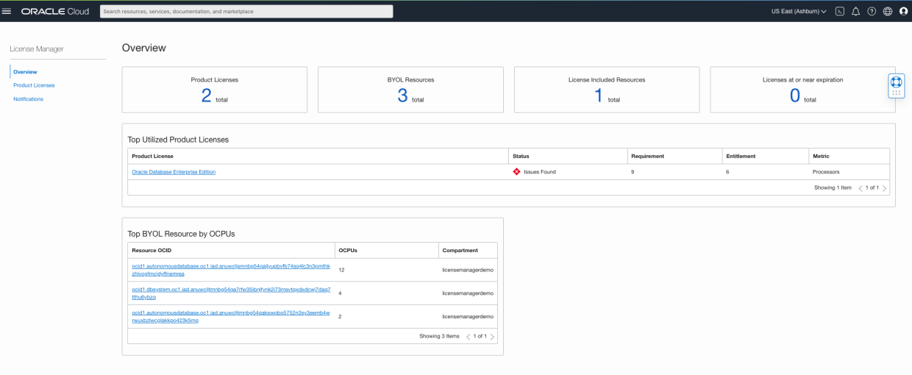
Choose to receive a weekly email notification on scenarios such as oversubscription of licenses or license records at or near expiration by adding the email recipient list on the Notifications page.
