**Micro Service Course**

**Cours:-** [**https://www.youtube.com/watch?v=XsaAvX86alY&list=PLq3uEqRnr_2Hb9M-hz6GPVg_x9TUQ9PJA**](https://www.youtube.com/watch?v=XsaAvX86alY&list=PLq3uEqRnr_2Hb9M-hz6GPVg_x9TUQ9PJA)

**Spring Cloud Config Client - Part 2 of 2 || Spring Cloud Config - Client**

[**https://www.youtube.com/watch?v=ubwCRdNXiiE&feature=push-u-sub&attr_tag=izGJMtDGHqONluQh%3A6**](https://www.youtube.com/watch?v=ubwCRdNXiiE&feature=push-u-sub&attr_tag=izGJMtDGHqONluQh%3A6)

**Spring Security**

**\*\*\*Spring Security using Spring Data JPA + MySQL + Spring Boot**

[**https://www.youtube.com/watch?v=IyzC1kkHZ-I&t=132s**](https://www.youtube.com/watch?v=IyzC1kkHZ-I&t=132s)

**Git:-** [**https://github.com/Java-Techie-jt/spring-security-jpa**](https://github.com/Java-Techie-jt/spring-security-jpa)

**Spring Boot Security Basics**

<https://www.youtube.com/watch?v=krLrHwRvTHc>

**Spring Boot + Spring Security + JWT from scratch - Java Brains**

<https://www.youtube.com/watch?v=X80nJ5T7YpE&t=72s>

**Spring security using ldap | Java Techie**

<https://www.youtube.com/watch?v=ZMQAs_1ro-o>

**1.What is LDAP and how to use in Active Directory**

<https://www.youtube.com/watch?v=mG3yNCHeQiY>

**What is LDAP and Active Directory ? How LDAP works and what is the structure of LDAP?**

<https://www.youtube.com/watch?v=QyhNaY5O468>

**Intro to SAML: What, How and Why**

<https://www.youtube.com/watch?v=0fmNoqz6Urw>

**SAML-based claims authentication in SharePoint 2013**

<https://www.youtube.com/watch?v=utogRYqaRqA>

**SharePoint 2013 OAuth implementation**

<https://www.youtube.com/watch?v=4B-dDGfTSds>

**OAUTH Introduction**

<https://www.youtube.com/watch?v=6uQ44YxUqUs&t=72s>

**What is OAuth2? How does OAuth2 work? | Tech Primers**

<https://www.youtube.com/watch?v=bzGKgC3N7SY>

**\*\*\*What is OAuth 2.0 and OpenID Connect?**

<https://www.youtube.com/watch?v=LyqeHAkxVyk>

**oops**

**Object Oriented Programming (OOPs) Concepts In Java || by Durga sir**

<https://www.youtube.com/watch?v=5NQjLBuNL0I>

**Java Constructors || Need of Constructor || by Durga Sir**

<https://www.youtube.com/watch?v=9wZYkfnkW2c&list=PLd3UqWTnYXOkNiAs0KGdz2V-349MG1iyR>

**JVM Architecture**

[**https://www.youtube.com/watch?v=dncpVFP1JeQ**](https://www.youtube.com/watch?v=dncpVFP1JeQ)

**Java Memory Model in 10 minutes**

[**https://www.youtube.com/watch?v=Z4hMFBvCDV4**](https://www.youtube.com/watch?v=Z4hMFBvCDV4)

**Different Memory Areas of JVM | Core Java Tutorial | Mr. Ramachandra**

<https://www.youtube.com/watch?v=SS6ozRYEKZU>

**Course:-** <https://www.youtube.com/watch?v=xPiaVMh_RmI&list=PLVlQHNRLflP8J1HiUMV1oC02Zu2CKvvuk&index=65>

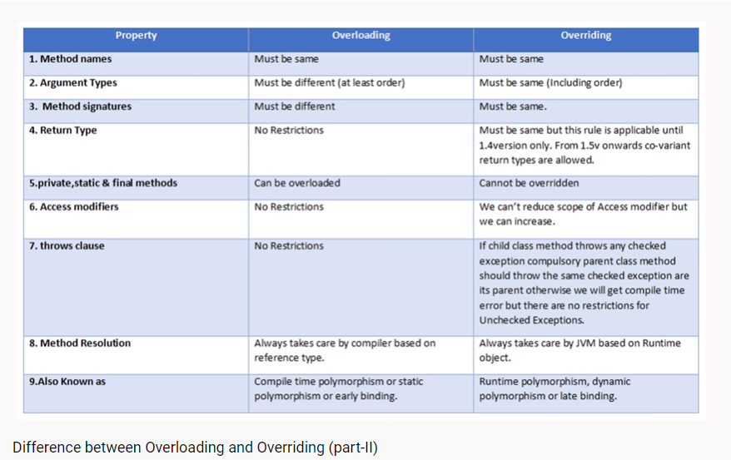

**Automatic concept in overloading**

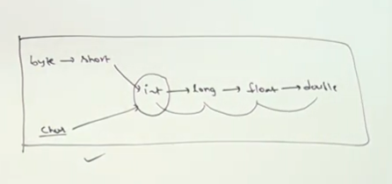

**Difference between Parent p = new Child(); and Child c = new Child();**

[**https://www.youtube.com/watch?v=3xsRywYBfVU**](https://www.youtube.com/watch?v=3xsRywYBfVU)

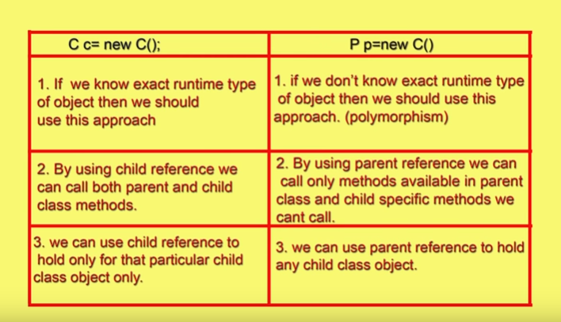

### [java interview questions and answers](https://www.youtube.com/playlist?list=PL3NrzZBjk6m8rEJ4O6Kpk_i1Ah8Le5Od-)

<https://www.youtube.com/watch?v=Ud0zfImgbYw&list=PL3NrzZBjk6m8rEJ4O6Kpk_i1Ah8Le5Od->

**hashcode() in java || The IMPACT of hashcode and equals || java object class || Part 1**

<https://www.youtube.com/playlist?list=PL3NrzZBjk6m95SR6WzhnOGGCjXZpCoO-k>

**TOP 6 difference between Abstract class and Interface in JAVA || Must know facts**

<https://www.youtube.com/watch?v=Ud0zfImgbYw>

**Difference between Overloading and Overriding (part-II)**

<https://www.youtube.com/watch?v=O4CzZUk0VbQ>

**oops concept course :-** <https://www.youtube.com/watch?v=DaAJIMakWKU&list=PLd3UqWTnYXOkwluXExifmJWKkvGa1ywWp>

**Java Tutorials || Java OOPS || Overloading Introduction || by Durga Sir**

[**https://www.youtube.com/watch?v=emlEeppPoXc**](https://www.youtube.com/watch?v=emlEeppPoXc)

**Java Tutorials || Java OOPS || Method Overloading Case Study - 1 || by Durga Sir**

[**https://www.youtube.com/watch?v=T9mY7VH-9Y8**](https://www.youtube.com/watch?v=T9mY7VH-9Y8)

**Java Tutorials || Java OOPS || Method Overloading Case Study - 2 || by Durga Sir**

[**https://www.youtube.com/watch?v=GUH4jaw0ohY**](https://www.youtube.com/watch?v=GUH4jaw0ohY)

**Java Tutorials || Java OOPS || Method Overriding || by Durga Sir**

[**https://www.youtube.com/watch?v=37EbS66bjWs**](https://www.youtube.com/watch?v=37EbS66bjWs)

**Java Tutorials || Java OOPS || Method Overriding Rules Part - 2 || by Durga Sir**

[**https://www.youtube.com/watch?v=RO8uGASr6BM**](https://www.youtube.com/watch?v=RO8uGASr6BM)

**Java Tutorials || Java OOPS || Method Overriding Rules Part - 4|| by Durga Sir**

[**https://www.youtube.com/watch?v=uTZlrW65RpE**](https://www.youtube.com/watch?v=uTZlrW65RpE)

**Java 8 features**

* **Doc:- java.util.stream.Collectors** <https://docs.oracle.com/javase/8/docs/api/java/util/stream/Collectors.html>

**Java 8 tutorial 16 (Streams) - groupingBy, partitioningBy, counting, & mapping Collectors methods**

<https://www.youtube.com/watch?v=CaERsnos5p4&feature=youtu.be>

**Java 8 Stream - How to Sort a List using lambda | Example | Java Techie**

[**https://www.youtube.com/watch?v=ARfzyUz4q7Y&feature=youtu.be**](https://www.youtube.com/watch?v=ARfzyUz4q7Y&feature=youtu.be)

**Java 8 Stream - How to Sort a Map using lambda | Example | Java Techie**

[**https://www.youtube.com/watch?v=aiWP9OaMT-c&feature=youtu.be**](https://www.youtube.com/watch?v=aiWP9OaMT-c&feature=youtu.be)

**1.3 Understand the Differences between JVM vs JRE vs JDK in java in one video**

<https://www.youtube.com/watch?v=RYd_hagCiVk&feature=youtu.be>

**MicroService Course**

<https://www.youtube.com/watch?v=XsaAvX86alY&list=PLq3uEqRnr_2Hb9M-hz6GPVg_x9TUQ9PJA>

**Client side Load Balancer using Spring Cloud Ribbon | Spring Boot**

[**https://www.youtube.com/watch?v=ueyVjOnDHYQ&t=1034s**](https://www.youtube.com/watch?v=ueyVjOnDHYQ&t=1034s)

**Git:** <https://github.com/Java-Techie-jt/spring-cloud-loadbalance>

# PCF (Pivotal Cloud Foundry) Course

# <https://www.youtube.com/watch?v=BAd7by1a7DE&list=PLO0KWyajXMh7Fis7s4rC3gC_W0aCPxvQK>

# <https://www.youtube.com/watch?v=jM2HwFbVtIg&t=6s>

# <https://www.youtube.com/watch?v=bafEegslWoc&t=3s>

# <https://www.youtube.com/watch?v=vzSuYab2q5M&t=1s>

**Agile Course**

**Capacity Planning in Jira**

<https://www.youtube.com/watch?v=H7AcgKGqB74&list=PL9qzuxtBNzgzrUvOlflM1JRiRYeF-PfhC>

**\*\*\*[4 Key] Scrum Ceremonies in Agile Methodology**

<https://www.youtube.com/watch?v=33Fk3r9ZSUg>

**Spring Data JPA**

**Spring Data JPA | Example | Java Techie**

<https://www.youtube.com/watch?v=ugYyGWoh8fE&t=18s>

**Hibernate**

**Hibernate Tutorial | Full Course**

[**https://www.youtube.com/watch?v=JR7-EdxDSf0&t=7s**](https://www.youtube.com/watch?v=JR7-EdxDSf0&t=7s)

**Hibernate Interview Questions**

[**https://www.youtube.com/watch?v=nb4kKVDc4cE**](https://www.youtube.com/watch?v=nb4kKVDc4cE)

**Integration Course**

**Auditing with Spring Data JPA | Java Techie**

[**https://www.youtube.com/watch?v=Pc7Une_5rMs**](https://www.youtube.com/watch?v=Pc7Une_5rMs)

**JPA Auditing Tutorial in Spring BootStep by Step**

[**https://www.youtube.com/watch?v=AZQBzWI3cUg**](https://www.youtube.com/watch?v=AZQBzWI3cUg)

**Spring Boot | Restful API | JPA | Hibernate | MySQL CRUD Tutorial**

[**https://www.youtube.com/watch?v=7NDohpda7YU**](https://www.youtube.com/watch?v=7NDohpda7YU)

**Spring Boot,Restful API,JPA, Hibernate, MySQL CRUD Tutorial**

[**https://www.youtube.com/watch?v=DCZOchCX10s**](https://www.youtube.com/watch?v=DCZOchCX10s)