House Price Prediction - Project Report

1. Project Overview
This project implements an end-to-end house price prediction system using a custom NumPy-based linear regression model. It includes model training, a Flask REST API, and a Streamlit user interface for interactive predictions and visualization.

2. Objectives
- Predict house price from area and number of rooms.
- Provide API endpoints for external integration.
- Provide an intuitive web UI for business/demo usage.
- Publish reproducible model evaluation metrics and diagnostics.

3. Dataset
Source file: data/house_price.csv
Total records: 47
Features: area, rooms
Target: price

4. Model and Training Approach
The model uses standardized feature inputs and solves linear regression parameters with a least-squares formulation. The training pipeline stores model artifacts in the model directory for backend/UI inference.

5. Evaluation Results
Metric | Value
MAE | 1,775.04
RMSE | 2,951.96
R2 | 0.999483
Train Size | 38
Test Size | 9

6. System Architecture
6.1 Training Script: train_model.py
6.2 Backend API: backend/app.py (Flask)
The Flask backend runs on port 5000 and exposes four REST endpoints. The frontend communicates with these endpoints using HTTP requests.
Method | Endpoint | Description
GET | /health | Health check - confirms API is live
POST | /predict | Predict house price from area + rooms JSON body
GET | /dataset | Return full training dataset as JSON array
GET | /model_info | Return model coefficients, intercept, and metrics

5.1 Sample API Call - /predict
Request (POST /predict):
{ "area": 2000, "rooms": 3 }
Response:
{
"area": 2000.0,
"rooms": 3.0,
"predicted_price": 330,662.99,
"currency": "USD"
}

6.3 Frontend UI: frontend/ui.py (Streamlit)
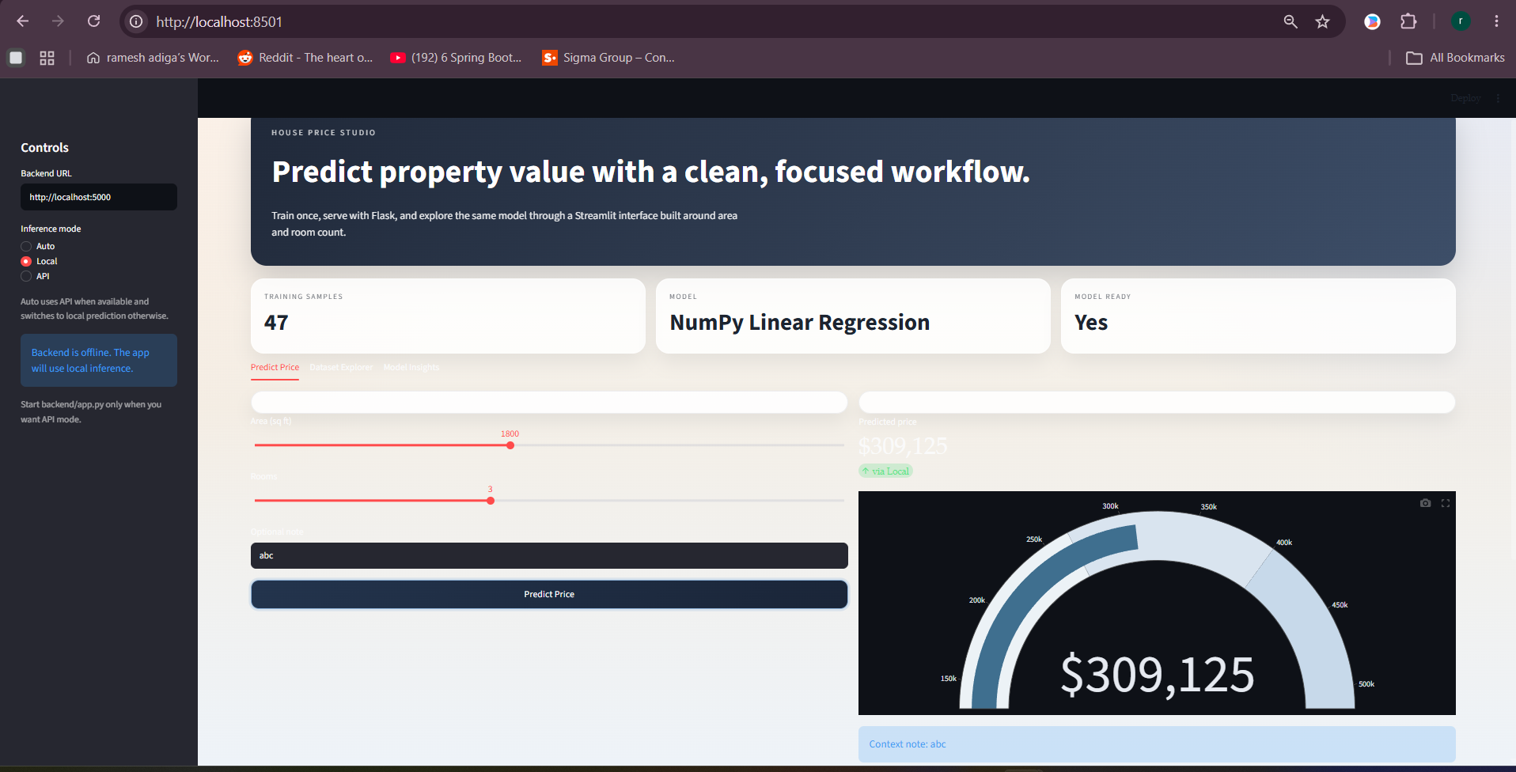
Artifacts: model/model.pkl, model/scaler.pkl, model/metrics.json, model/diagnostics.png

7. API Contract
POST /predict
Request: { "area": 2000, "rooms": 3 }
Response: { "area": 2000.0, "rooms": 3.0, "predicted_price": 347820.50, "currency": "USD" }

8. Diagnostics
Model diagnostics plot generated from training:
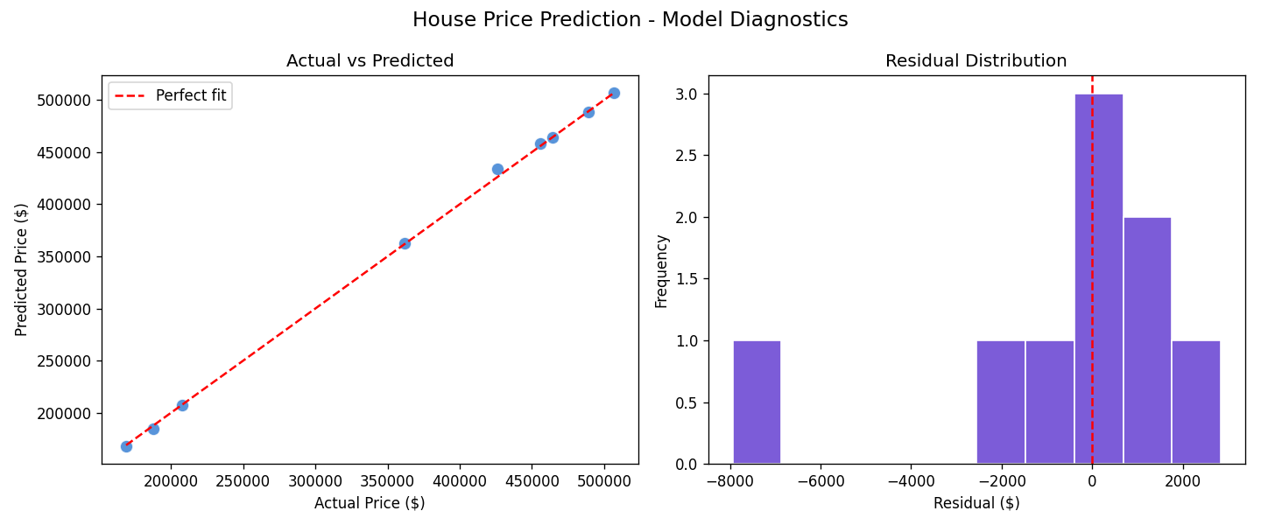

9. How to Run the Project
Step 1: Install Dependencies
pip install -r requirements.txt
Step 2: Train the Model
python train_model.py
Step 3: Start Flask Backend (Terminal 1)
python backend/app.py # runs on http://localhost:5000
Step 4: Launch Streamlit Frontend (Terminal 2)
streamlit run frontend/ui.py # opens http://localhost:8501

10. Conclusion
The project is production-oriented for demonstration and learning workflows, with clear separation between model training, API serving, and frontend interaction.

